

# Report to the Meeting of the

**BOD** 07/2020

(Agenda item: 9)

# Oxford Health NHS Foundation Trust

# Board of Directors

# January 29th, 2020.

# INPATIENT SAFER STAFFING Report Period 4th November to 29th December 2019

**For: Information**

**Executive Summary**

**Ward Staffing**

The purpose of this paper is to provide the Trust Board with an interim exception report in line with the requirements of: “How to ensure the right people with the right skill are in the right place at the right time”, Chief Nursing Officer for England & National Quality Board November 2013. From June 2014, there has been a Department of Health requirement for trust boards to receive monthly updates on ward staffing levels. Ensuring sufficient staffing levels are in place is crucial to deliver safe, effective and high-quality care. This report will be published on our website with a link from NHS Choices website.

The data within the report will outline the staffing levels (for both registered and unregistered nursing staff) on each ward. These figures will be measured against the required figures on a shift by shift basis for the period 4th November to 29th December 2019 (two months roster period) in line with the requirements of the DH Unify reporting process and the data extract is attached (Appendix 1).

During this period:

Average weekly day shifts fill rates for registered staff & unregistered staff were above the Trust target of 85% with 89% or above for unregistered and 100% or above for registered staff.

All wards were above 85% target for average weekly fill rates for registered nurse day shifts during 4th November to 1st December.

During the period 2nd December to 29th December 2019 eight wards were below 85% for registered nurses:

Amber, Cotswold House Oxford, Cherwell, Highfield, Lambourne House, Marlborough House Swindon, Sandford and Vaughn Thomas apart from Amber ward there were above 95% fill rates of unregistered staff. Amber ward unregistered fill rate was 78%

City ward opened on a phased opening and the fill rates were not available during this period.

Average weekly night shifts fill rates for registered staff and unregistered staff across all wards was above the Trust target of 85% rates remained above 100% for registered staff for each week and above 89% for unregistered staff. One ward Wenric was slightly below at 79% for registered staff in the period 4th November to 1st December.

The methods of filling these shifts includes substantive, flexible workers and agency registered staff and further detail in provided later in the report.

The average weekly % agency use was 10.5% an increase from 10.2% in the last reporting period.

Average sickness rates for ward staff were 7.3% an increase from 5.98% in the last reporting period.

This report also includes an update on recruitment work.

**Recommendations**

The Board is asked to note:

* There are processes in place to ensure safe staffing levels on all the wards in the organisation, those wards where there are concerns and the actions being taken to ensure safe staffing including project work and wider recruitment and retention work. There are no exceptions to report that directly link actual staffing levels to adverse outcomes for patients which have been identified through our Governance Structures.

**Author and Title:** Kate Riddle, Deputy Director of Nursing and Clinical Standards

**Lead Executive Director:** Marie Crofts Chief Nurse

*A risk assessment has been undertaken around the legal issues that this paper presents and there are no issues that need to be referred to the Trust Solicitors. This paper links to all the five CQC Domains.*

***Strategic Objectives*** *– this report relates to or provides assurance and evidence against the following Strategic Objective(s) of the Trust*

*Driving Quality Improvement (Goals: patients will be safe from harm; patients will achieve the clinical outcomes they want; and patients and carers will have an excellent experience)*

*Delivering Operational Excellence (Goals: our services will be effective and efficient; information will be translated into knowledge; and our planned surplus will be delivered)*

**Inpatient Safer Staffing**

Period 14th November to 29th December 2019.

**Introduction**

This is the report to the Board of Directors outlining the staffing levels (registered and unregistered) on each ward against their required need on a shift by shift basis. These figures will be measured against the required figures on a shift by shift basis for the period 4th November to 29th December 2019 ( two months roster period)

This report will focus on the percentage of day and night fill rates for registered and unregistered staff. This data is reported to NHSI and provides assurance of actual clinical staffing numbers being achieved. This report will be published on our website with a link from NHS Choices website.

**Management of Staffing Levels**

Anescalation process for the management of staff shortages is in place within each clinical area, to manage staffing safely on a shift by shift basis. As part of this process, senior clinical staff are providing appropriate support to ward teams as and when required. In addition, senior ward staff and immediate team managers review ward staffing levels on an on-going basis; shift by shift basis, and where there are changes in patient acuity. Ward Matrons review staffing daily as a minimum and more frequently where required.

In-patient staffing levels continue to be reported every week and discussed within the Weekly Review Meeting (WRM), which takes place each Monday morning with the Chief Nurse and/or Deputy present. To ensure that staffing levels are under continual review, every ward undertakes a range of immediate actions daily to ensure safe staffing levels are maintained appropriate to the needs of patients. These actions include booking flexible or agency staff via Staffing Solutions, revising rotas, moving staff between wards and utilising additional staff that are not included in the ward numbers as required for example modern matrons.

**Summary position of inpatients wards staffing levels.**

Appendix 1 shows the staffing levels for all wards by ward for the period 14th November to 29th December 2019. The data presented includes details of staffing by shifts and details of registered nursing and unregistered staff skill mix, agency, total ward staff sickness and total ward vacancy figures. The thresholds presented in the table are measured against trust/ national targets and used for exception reporting.

During this period:

**Day shifts fill rates**

Average weekly day shifts fill rates for registered staff & unregistered staff were above the Trust target of 85% with 89% or above for unregistered and 100% or above for registered staff.

All wards were above 85% target for average weekly fill rates for registered nurse day shifts during 4th November to 1st December.

During the period 2nd December to 29th December 2019 eight wards were below 85% for registered nurses:

Amber, Cotswold House Oxford, Cherwell, Highfield, Lambourne House, Marlborough House Swindon, Sandford and Vaughn Thomas apart from Amber ward there were above 95% fill rates of unregistered staff. Amber ward unregistered fill rate was 78%

City ward remained closed temporarily during this period.

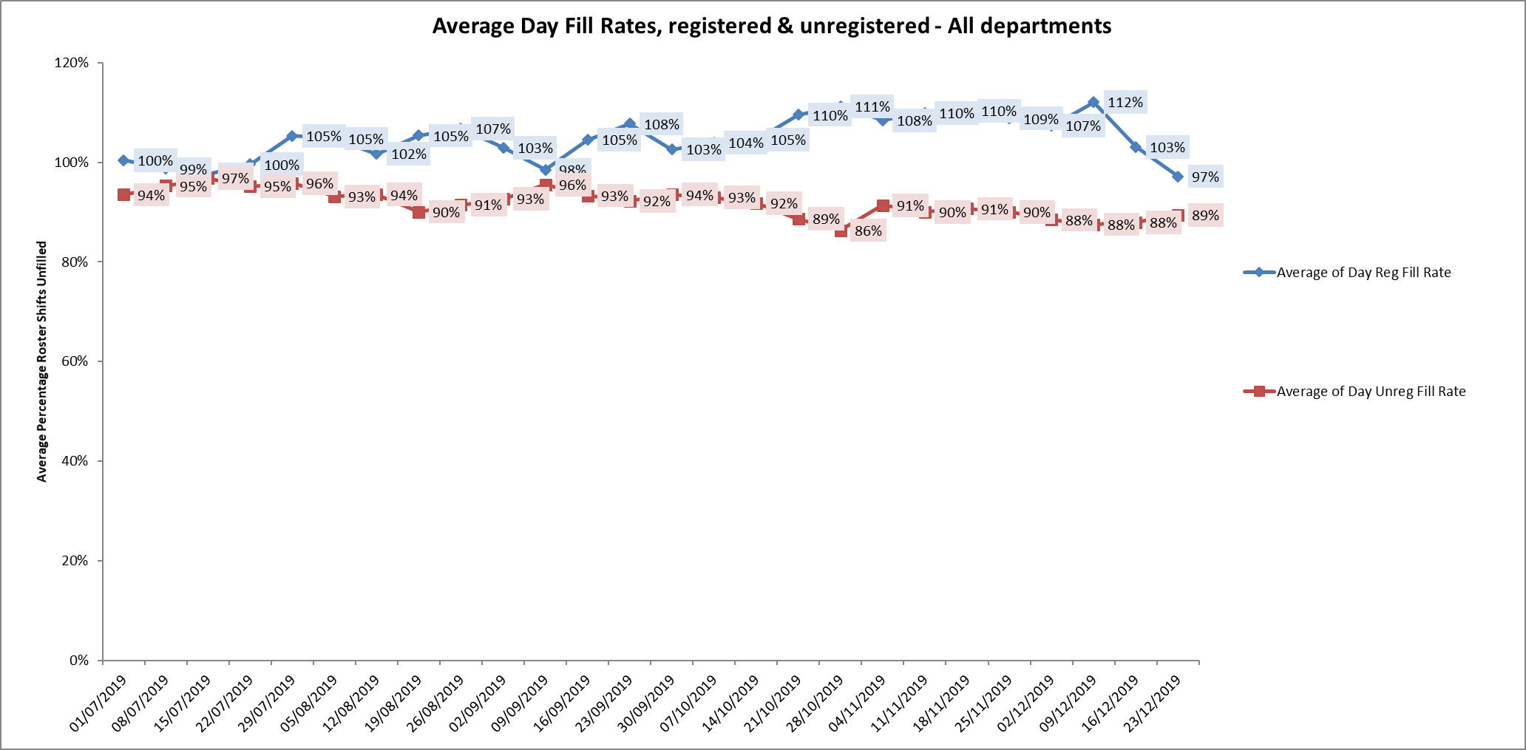

**Night shift fill rates**

Average weekly night shifts fill rates for registered staff and unregistered staff across all wards was above the Trust target of 85% rates remained above 100% for registered staff for each week and above 89% for unregistered staff. One ward Wenric was slightly below at 79% for registered staff in the period 4th November to 1st December.

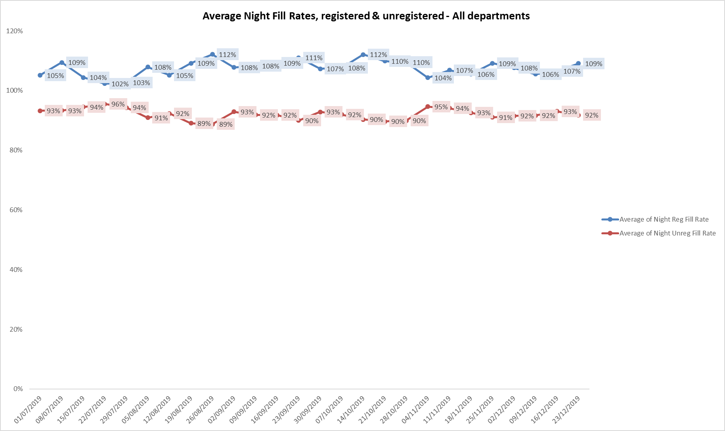

**Registered skill mix**

Thirteen wards had in place an average of 50% or above registered staff skill mix for the period 4th November to 1st December and this increased to fifteen wards in the last period. This is improved from the last reporting period.

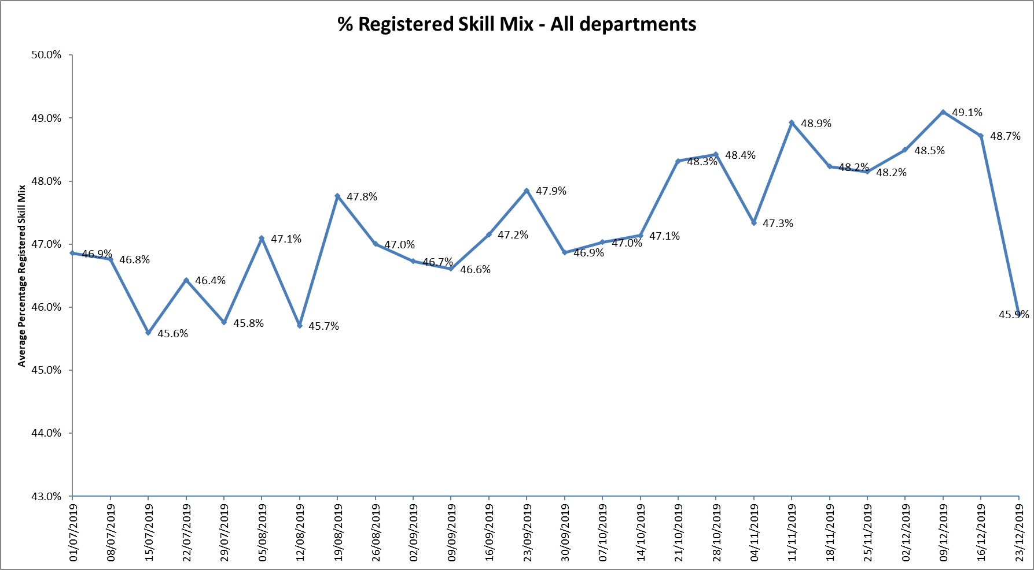

One ward Kestrel was below 35% average for the whole period.

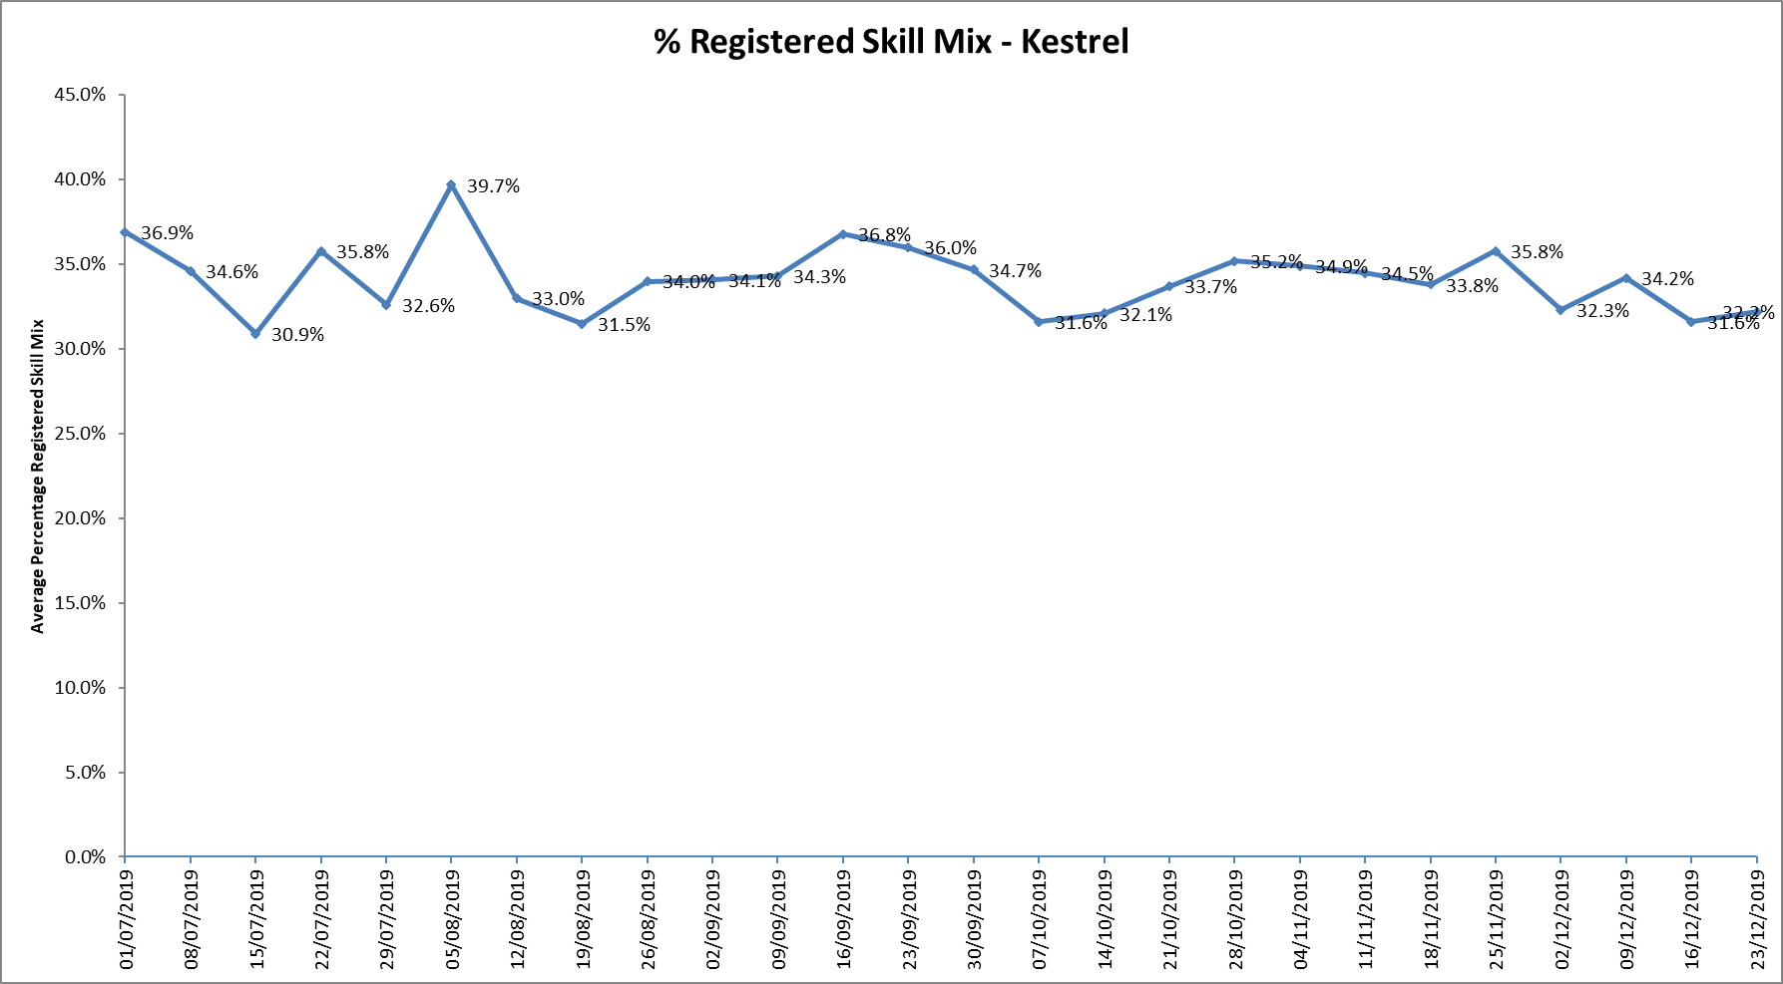

For those wards with below 50% registered skill mix, this is related to the continued registered nurse vacancies. Safe staffing is supported by the ward managers and matrons on the ward working clinically as part of the numbers where required to ensure registered nursing leadership is maintained.

Skill mix is achieved through use of our own staff and trust employed flexible registered workers and agency registered nurses.

**Agency use**

The Trust moved to a new approach to reduce the use of unregistered agency staff in the week of 14.5.18. Ongoing work to reduce use of Trust wide use of agency is in progress. An ‘Improving Quality Reducing Agency’ programme board has been set up, One of the goals of this new Programme is be sustainable and over-arching agency reduction, for both the financial and quality goals.

The board is chaired by the Chief Nurse with the following work streams:

• Engagement & Retention

• Workforce development

• Temporary Staffing

• Rostering & Establishments

• Recruitment

The work streams will include Operational leads, HR leads and engagement from clinical staff including matrons and senior matrons.

Further detail of this project is provided in the HR workforce report.

The average weekly % agency use was 10.5% an increase from 10.2% in the last reporting period. This remains below the peak of 19.1% in February 2018.

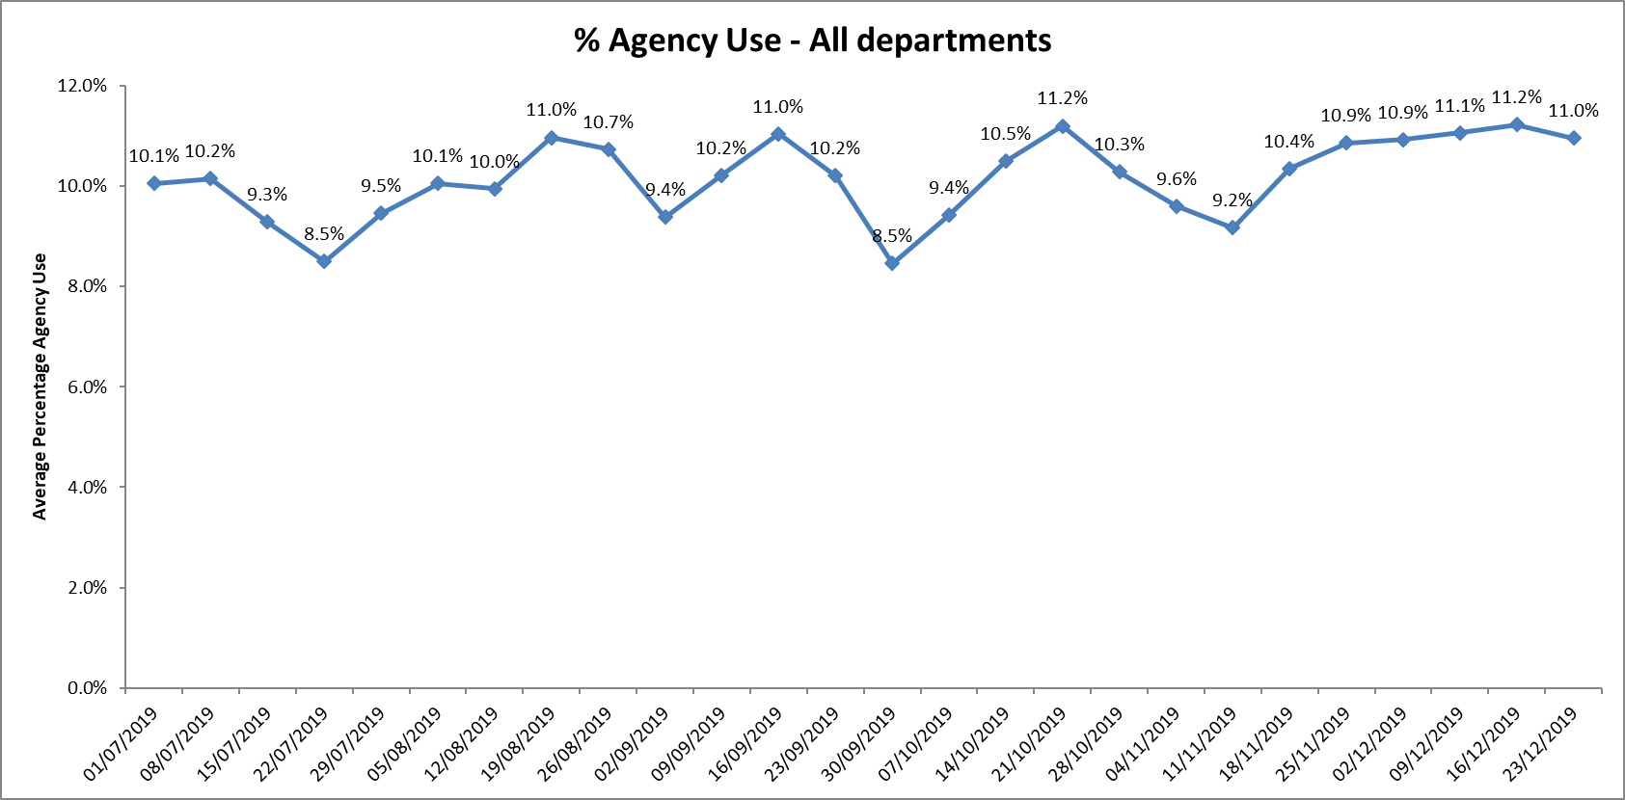

* Nine wards required less than 5% average agency use during first period and this increased to ten wards in the second period.
* Eleven wards required between 5 and 10% average agency in the first period this reduced to six in the second period
* Twelve wards required more than 10% average agency in the first period this increased to sixteen in the second period ( Christmas and New Year)
* Allen Kingfisher, Ashurst wards required above 20% average agency staff throughout this eight-week period. This was related to a mixture of sickness, vacancies and patient acuity

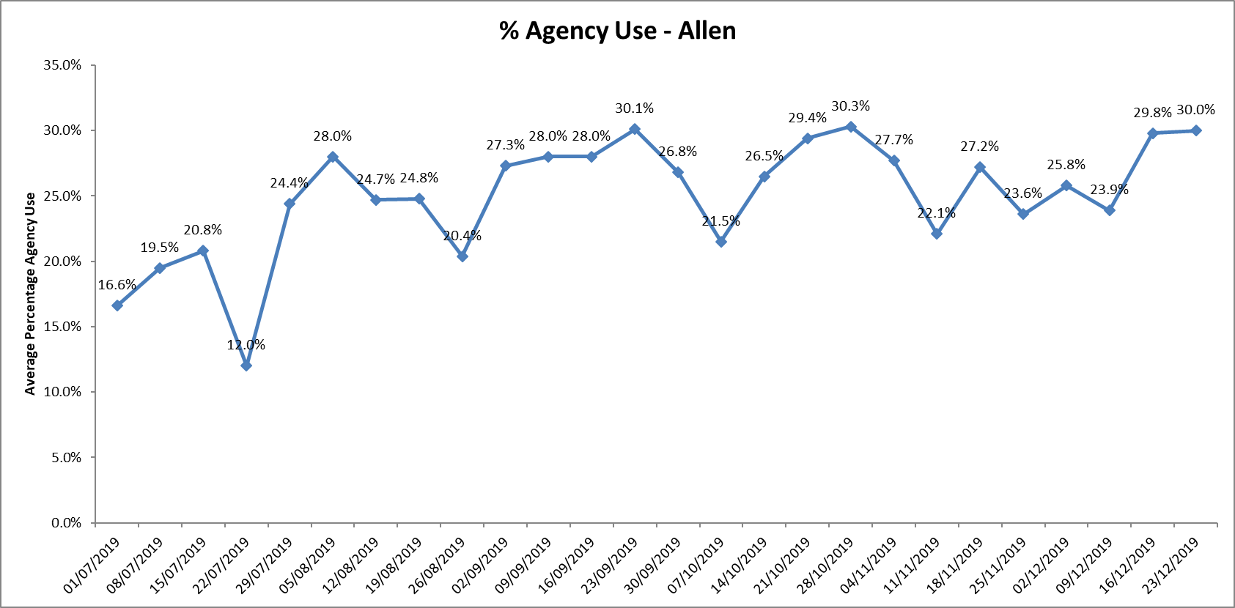

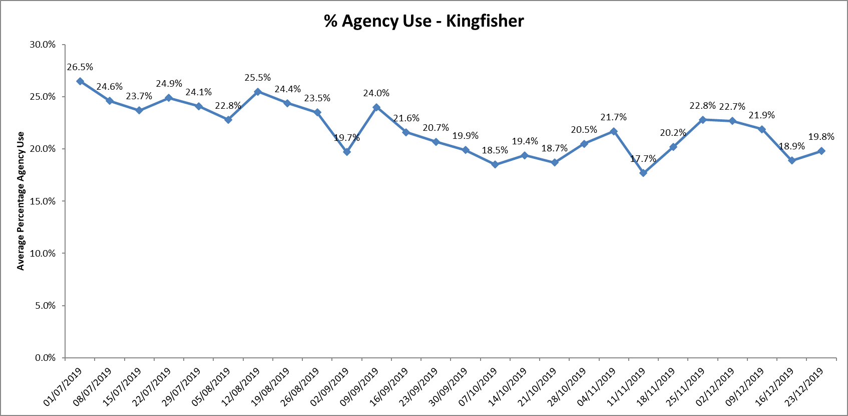

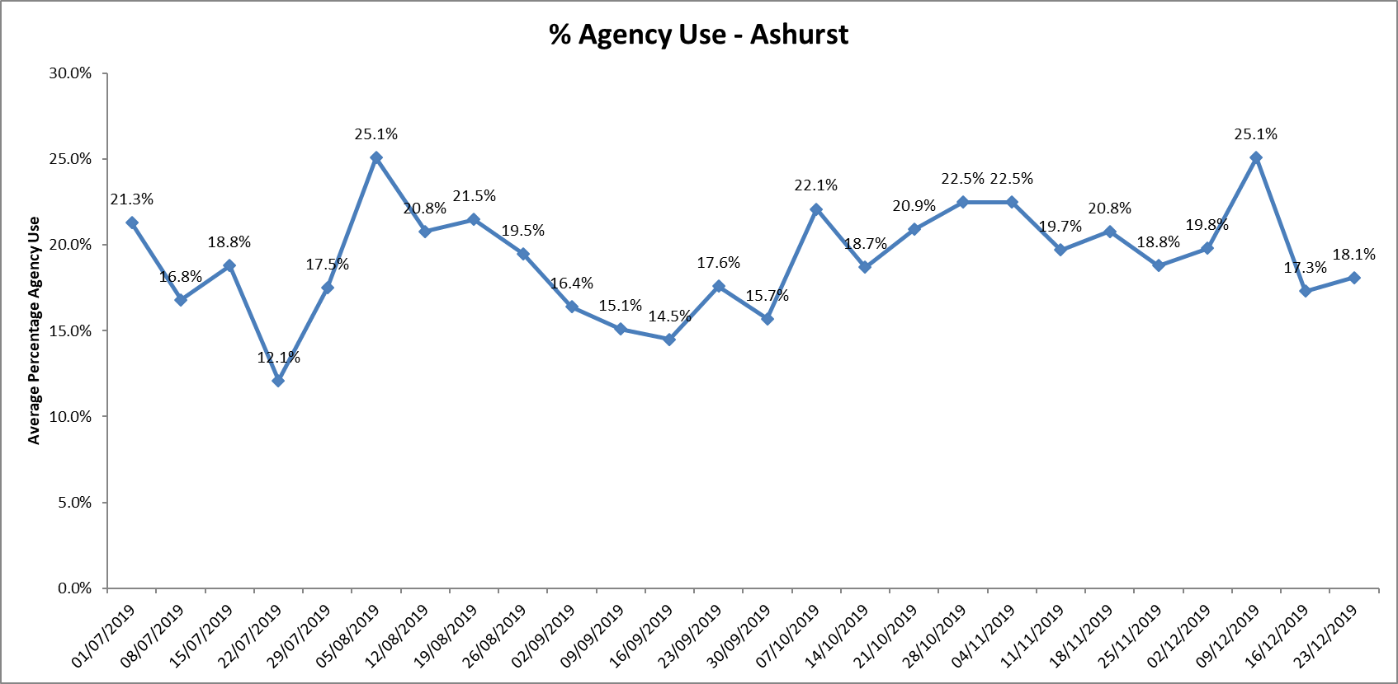

Further detail of agency use and spend is provided in the Workforce report.

**Recruitment and retention**

Nursing recruitment work with Oxford Brookes and Oxford University Hospital Trust continued working together as the Oxford School of Nursing & Midwifery.

It has been strengthened in academic year 2019/20, with timetabled career and employment events scheduled for year 2 and 3 students across all pathways. The second one was completed on January 16th 2019, over 70 students attended to meet clinical staff, discuss preceptorship and ongoing continuing professional development and post qualifying job opportunities. Students continue to be able to have a streamlined recruitment process in year 3.

**Flyer Programme**



Our Flyer Programme, a key part of our retention work, provides evidence-based support and guidance to all newly registered nurses and AHPs, has been awarded a quality mark by CapitalNurse – making us the first trust outside of London to receive the accolade. CapitalNurse are Health Education England exemplar preceptorship framework for the UK.

Preceptorship supports all newly qualified practitioners to make the transition from student and helps develop people’s confidence as an independent professional, combined with refining skills, values and behaviours.

In the first year participants receive seven days’ of training and support on topics such as leading care, patient safety and action learning. Participants have the option to accredit this year and gain 20 credits at Masters level via Oxford Brookes University.

The second year continues action learning and professional development, with signposting and careers discussions to provide staff individualised career pathways.

80 of 87 staff in the first cohort completed the first year in October 2019, a further cohort of 24 staff commenced in March 2019 and the third cohort of 110 staff commenced in October 2019 with a further cohort due to commence in March 2020

The Flyer Programme promotional/information video will be released within the next few weeks.

**Registered Nursing Associate Preceptorship Programme**

This has been put in place and 25 staff are due to complete their 6 month Programme in February 2020.

**Conclusion**

All ward staff and managers continue to make every effort to ensure wards continue to be staffed safely, fill rates remain high for most wards and that we continue to focus efforts on retaining our staff whilst recruiting new nurses to join Oxford Health FT.

**Author and Title:** Kate Riddle, Deputy Director of Nursing and Clinical Standards

