Report to the Meeting of the

Oxford Health NHS Foundation Trust
BOD 08/2020
(Agenda item: 11)

Board of Directors

20 January 2020

Experience & Involvement Report

For: Information

Executive Summary
This report provides an overview on the feedback received from patients and carers and the work to improve people’s experiences, as well as their involvement in service developments. The collection and use of patient, carer and family feedback continues to increase with over 17,000 survey responses from April 2019 to December 2019. The majority of feedback is positive, 94% of people would recommend the service, with the quality of care being rated 4.76 out of 5, however we are striving so that everyone receives a positive experience and patients are involved in every decision about their care and service changes.

The feedback received from patients and carers, formal complaints and serious incidents identify a common theme for improvement around communication and sharing information with patients and their families to enable joint decision making and involvement in care. We continue to strive to involve patients and their families in the quality improvement work we do and incorporate the patient voice into service design.

The report also details the work and progress against the dedicated carers strategy, the imminent changes to the national Friends and Family Test question to be introduced in April 2020, and the results from the 2019 national community mental health patient survey.

Recommendation
The Board is asked to note the report.

Author and Title: Donna Mackenzie-Brown, Patient Experience & Involvement Manager
Jane Kershaw, Head of Quality Governance
Lead Executive Director: Marie Croft, Chief Nurse

- Strategic Objectives – this report relates to or provides assurance and evidence against the following Strategic Objective of the Trust:

Driving Quality Improvement
(Goals: patients will be safe from harm; patients will achieve the clinical outcomes they want; and patients and carers will have an excellent experience)

Introduction
A report on patient and carer experiences is presented to the Caring Quality Sub-Committee quarterly and the Board of Directors as part of the series of quality reports. This report focuses on patient and carer experiences and how we have involved people in service developments. It is structured to align with the National Patient Experience Framework (https://improvement.nhs.uk/resources/patient-experience-improvement-framework/) and to show our work against the Trust’s strategy for experience and involvement objectives including developing co-production, improvement around communication and sharing information with patients and their families to support better joint decision-making, so people are an active partner in their care.

- Leadership
Training
The Experience & Involvement Team continue to facilitate a number of training sessions for staff including teaching during the Quality day of the Management Toolkit sessions for managers and deputies, patient involvement in Quality Improvement training for ‘scholars’ at the Oxford Healthcare Improvement Centre and co-presenting at monthly induction alongside a patient or carer who shares their experiences of services and involvement.

Service level involvement / Co-production
During Quarter 3 (October to December 2019), at least 30 experts by experience have participated in a range of involvement activities across the trust.
These include:
- co-producing a service leaflet for the new Forensic Team
- interviews for a range of staff members including a full ‘service user panel’ for the CEO recruitment process
- Producing a film about the Oxsrad Physiotherapy Clinic and developing a series of films around diversity for mental health settings.
- Co-presenting training around carer awareness to older adult mental health teams
- Oxfordshire and Buckinghamshire mental health governance events
- Suicide prevention focus groups for friends, family and carers to develop resources and website information for those who need support.

Use of patient stories
A range of patient stories have been captured and utilised between October and December 2019 including:

OHFT are working together with Oxfordshire Children’s Commissioners to ensure the voice of young people is strong within the service redesign for Children’s Integrated Therapies by hearing from children and family at each project board and by running focus groups to hear family/ carers views.

A carer whose loved one is accessing Older Adult Mental Health Services in Buckinghamshire shared his lived experiences of dementia as part of a team away day and worked with individual staff to look at improvements to information received at initial assessment.

The National Team for Family Nurse Partnership have requested consent to use the Oxfordshire Team’s series of experience videos captured from local clients in September/October as part of their national work.

- Organisational culture
Strategy update
Experience & Involvement Strategy
The strategy aims to improve how patients and carers feel involved in their care and decision-making, achieved through the following proposed priority areas;

- Leadership at every level
Ensuring staff at all levels have opportunities to involve people who use our services and are empowered to make changes locally.

- Expectation of co-production

We want to develop skills and training to grow confidence in the use of co-production and ensure we are sharing good practice across services and teams.

- Resources
We want to develop more self-management and self-education resources, alongside reviewing the quality and accessibility of information we currently provide to people who use our services.

- Every team takes action on feedback received
We want to review internal systems to identify and challenge those that don’t support positive experiences and develop the use of feedback data to be ‘proactive rather than reactive’.

Each directorate is reviewing and prioritising areas for development around experience and involvement in line with the overarching Trust priorities. Alongside this Trust level actions continue such as; developing co-production training for all staff, developing Trust processes for involvement (such as in recruitment), continuing to review online resources and information for patients/ carers, and empower staff to take action from patient feedback.

Friends, Family and Carers (FFC) Strategy
The FFC annual report was published in November 2019 highlighting the Trust’s progress on our 3 year strategy. Key achievements in the last 6 months include launching a new volunteer carer support role across 3 wards as a pilot to listen and support carers, a new information handbook was developed for our community hospitals in consultation with staff and carers, we launched a new carers resource area on the staff intranet and a new on-line training package was developed with carers for all staff.

Our self-assessment against our objectives shows progress made against all objectives with 3 rating green and 3 rated amber. Work will continue across all the objectives to further develop carer champions across all teams, fully embed the triangle of care ethos and continue to improve information and communication with carers. A summary against the objectives can be seen here:

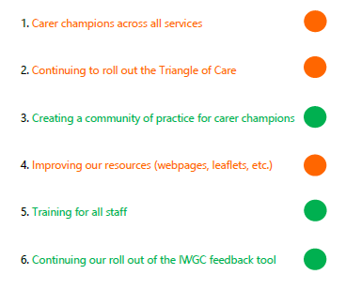

We are now in the final year of the 3 year FFC strategy which will be fully reviewed and evaluated in June 2020. A new strategy will be co-produced with friends, family members and carers across the Trust.

- Effectively Collecting feedback
3.1 I Want Great Care (IWGC)
I Want Great Care is the standardised system the Trust uses to offer/ collect regular electronic and paper survey feedback from patients and carers. In addition to this method we use a range of other approaches ie focus groups, regular patient/ carer groups, telephone interviews, complaints, compliments, patient stories, national surveys. The Trust has received 16,581 responses through the software ‘I Want Great Care’ between 1st April 2019 – 31st December 2019 with an overall average score of 4.76 out of 5 across all the questions asked. The number of responses has increased. 93.81% said they would be likely to recommend (slight decrease from previous year >1%) with 1.77% being unlikely to recommend (slight decrease from previous year <0.22%). (4.42% report neither or don’t know to the question – slight decrease from previous quarter by 1.5%)

This table shows data on reviews received during quarter 3 (1st October – 31st December 2019). The trust received 5,538 which was up from the last 2 quarters and an increase from the same period last year.
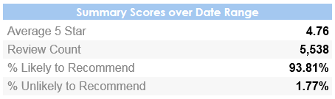

The below graphs show the overall demographic information of those giving feedback and the way this has been provided i.e. a paper survey (off line), on-line or via the apt on a tablet. The source of ‘offline’ denotes those surveys completed via paper and the below graphs show that there has been a decrease in the collection via “tablet” (iPad) and an increase in the use of paper (47% to 59% over the year).

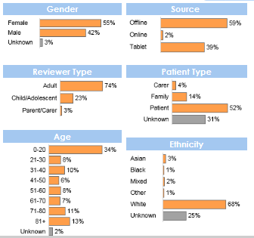

The graph below shows the Trust-wide average score for each question asked through the IWGC survey, out of a maximum of 5, over quarter 3 (1st October – 31st December 2019). The first question around carer satisfaction has recently been added for all Oxfordshire mental health services, the next 5 questions (from top to bottom) are asked by all services (‘dignity to kindness), the bottom 7 questions are those asked on the specific children and young people service surveys. FFT question refers to the national Friends and Family Test, further details below.

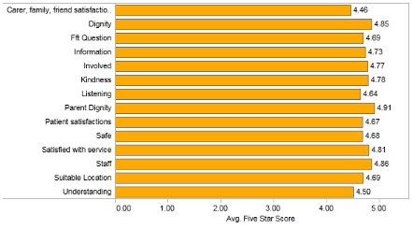

Below are the Trust-wide trends for the first 5 questions asked across all services, showing the average score over the past 9 months (1st April – 31st December 2019). These graphs show that the overall ratings have stayed consistent over the time period with less than 0.20% change in any of the questions scores. This is a trend which is true of the year to date.

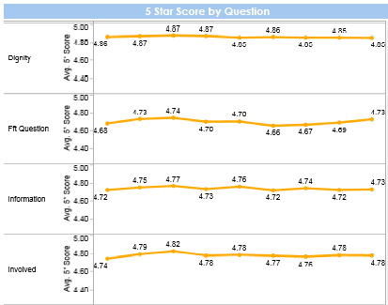
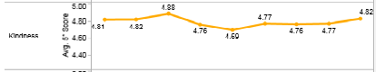

The below graph shows the number of responses received from 1st April 2019, the amount of feedback has remained steady. Almost every clinical service/ team has been set up to collect feedback using ‘I want great care’. Those teams who do not collect feedback within each quarter are contacted to identify any issues or challenges and to offer support. The teams which have collected 0 feedback in a quarter are also reported and discussed at the Caring Quality Sub-Committee.

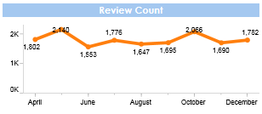

The graph below shows that the average 5-star score has consistently remained between 4.74 and 4.77 out of 5, as shown by the blue line on the top. The difference in percentage (%) for scores shown by the orange line has ranged by 2% + or – each month, on the previous months data.

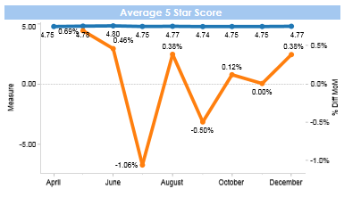

Below are the IWGC reports for 1st October to 31st December 2019 by directorate, these are shared with teams monthly and can be accessed directly by teams. The open text feedback has not been included but it also collected and used by teams. In summary;
- Buckinghamshire mental health services received 441 reviews, an average rating of 4.5 and 89% of people said they would recommend the service.
- Oxfordshire and SWB mental health services received 770 reviews, an average rating of 4.44 and 89% of people said they would recommend the service.

- Community directorate services received 3391 reviews, an average rating of 4.76 and 96% of people said they would recommend the service.
- Specialist directorate services received 894 reviews, an average rating of 4.75 and 93% of people said they would recommend the service.

3.2 Complains, concerns and compliments
In quarter 3 the Trust received 73 complaints, 232 concerns, 113 general enquiries and 760 compliments. The Trust runs 35 PALS surgeries across the inpatient wards and day hospitals on a regular basis. There has been an increase in complaints over the last 4 months and compared to the same period last year, however the % with upheld concerns has not changed. The majority of complaints relate to the mental health services raised by a carer/ family member or the patient themselves. In particular the community mental health teams receive the highest number of complaints mostly relating to the amount of support provided, medication, diagnosis, assessment or how staff have communicated with them. A detailed report at team and service level is provided to the directorates and discussed at the Caring Quality Sub-Committee.

3.3 Friends & Family Test Question (FFT)
Between April to December 2019 93.81% of patients/ carers would recommend the service they received.

The National ‘Friends and Family Test’ (FFT) question will change from 1st April 2020 to “How was your experience of the service?”. The Trust utilises the FFT alongside other focused questions to elicit a range of feedback from people who use our services and we are required to ensure this question is available to all. An implementation plan is currently being developed to ensure a smooth change over during March 2020 from the current national question to the new question.
More information about the FFT can be found at https://www.england.nhs.uk/fft/

3.4 National surveys
The results of the annual Adult and Older Adult Community Mental Health Survey for 2019 have been published.

This service user survey conducted between February and June 2019 looks at 227 usable responses from a sample of 834 clients on the CPA and Non-CPA register who had more than 2 contacts between 1st September and 30th November 2018. This is a national survey that can compare results between Trusts, and we are able to compare year on year with accessible results since 2012.

This year the Trust has performed well. Around half the Trust's scores are in the top-20% range of all Trusts surveyed by Quality Health, and only one question falls into the bottom 20%. Several areas show improvement since the 2018 survey.

The scores for NHS mental health services giving advice with finding support for financial advice or benefits, giving advice for finding or keeping work, or giving information on peer support are the three that score in the intermediate range. The Trust has already made improvements this year in these areas. Embedded workers from Oxfordshire Mind Better benefits for mental health are working within community mental health teams to give support for financial advice and benefits. The Individual Placement and Support team use an employment support model working across Oxfordshire and Buckinghamshire to help unemployed people into work. There will be an individual placement and support team member working with all community adult mental health teams including Early Intervention Services. Peer support co-ordinator roles have been established in both Oxfordshire and Buckinghamshire. The first cohort of Peer Support workers (n=16) who successfully completed the training in Oxfordshire are recruited into posts and another cohort of around 20 people are going through recruitment at the moment. Buckinghamshire services have 19 peer support workers trained and started in placements.

The score for service users knowing how to contact a professional for help if they have a concern has fallen since 2018 and this is the only question for which the Trust falls into the bottom-20% range of scores. Although the Trust fell into the bottom 20% of all Trusts surveyed 95% of people surveyed answered ‘yes’ they did know how to contact the person in charge of organising their care. The national average was 96% so although this result fell into the bottom 20% of all Trusts surveyed this may not be indicative of a Trust wide problem.

The full results are published here: https://www.cqc.org.uk/publications/surveys/community-mental-health-survey-2019

Preparations are currently underway for the sample with data collection for the 2020 survey to begin in February/ March 2020.

- Analysis and triangulation
Themes
The below word cloud shows the 100 most frequently words used by patients who have given a 5* (star) average score in the last 3 months through the IWGC survey. The 5 most used words are:
Good – 692, staff – 578, care/caring – 543/223, helpful – 479 and friendly – 478
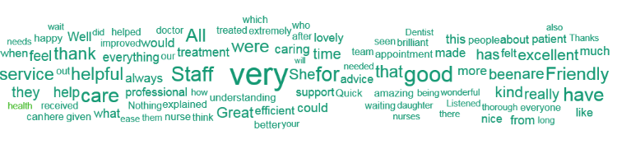

The below word cloud shows the 50 most frequently used by patients who have given an average score of 2.5* (star) or less in the last 3 months through the IWGC survey. The most commonly used word was disappointed which was used in 4 reviews, ‘shocking, decision, danger’ and ‘anger’ were used in 3 reviews and all of the other words shown were used in 2 or less reviews.

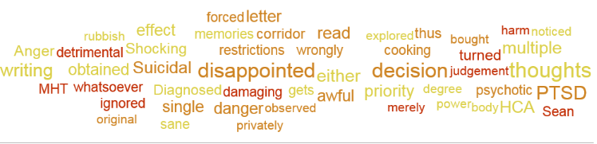

An immediate automatic alert is created for any service who receives a review of less than 3 stars for any reason. This allows the service and Patient Experience Leads the opportunity to monitor, respond and action any improvement feedback which is received in near real time. Services have begun to respond directly to a number of reviews which have been received and it is our aim to develop staff’s ability to respond further over the next 12 months.

The top 3 improvement themes from open comments in the last 3 months have remained as:
- Appointment/Referrals/Wait times/Discharge
- Communication/Information
- Environment/Facilities/Parking
The feedback is being used to inform quality improvement work locally in teams and “you said we did” actions.

- Using feedback to drive Quality improvement
All services aim to feedback to service users/ patients/ families on quality improvement work which has been initiated from feedback. We call this “you said, we did” and this is often displayed on boards, posters or in leaflets. Below are some examples of changes made in the last 3 months:

Adult Mental Health Services: Service users have been involved in the development of a new app called “My journey” which will be used by anyone accessing mental health services to provide information and support. 'Service user feedback indicates that expectations of the service are unclear, decisions are made without the service user, communication between the team and service user can be problematic and information given at point of transfer to primary care is insufficient. Staff report that collaborative care planning and shared decision making is an aspiration that is not always working in practice for several reasons. We believe that service users within the AMHT’s within Oxford Health NHS Foundation Trust should expect planned care and treatment interventions at every step of their journey from the initial point of contact promoting consistency even in the greatest times of crisis and distress. Engaging with mental health services can be a daunting experience. Therefore, our vision is to make our community services more accessible and collaborative. The aim of introducing My Journey within the AMHT’s is to improve the experience of service users using the service and for staff working within the teams.'

Children’s Neuro Development Pathway: A Post Diagnosis Pack is now provided to families at Diagnosis. This resource has been revised in response to parent feedback.

Oxfordshire CAMHS: A ‘Question for the Quarter’ has been developed within all Oxfordshire CAMHS waiting areas to be available in paper format which can be completed and put in a comments box. The question will be developed to gather more information on themes emerging from IWGC or verbal feedback collected. Feedback from each quarter can then be shared with Teams and at the Participation Forum to plan actions. The Question for this Quarter: What information would be helpful for parents to have while they are waiting for their appointment? What format would they like to access that information?

Trust Membership : A member of the learning disability Leading Together Co-production group attended the Council of Governors meeting and gave his feedback on potential developments to enable people with a learning disability to become Governors. The group are also continuing to look at how to make becoming a member of Oxford Health more meaningful for people with a learning disability.

Mental Health Services: Service users of adult and older adult mental health services have been involved in developing new information for “getting involved” in pathway developments. This includes a new webpage and leaflet to promote opportunities for patient representation on steering groups and focus group meetings.

Dentistry: 2 films have been produced to help reduce anxiety about going to the dentist for children, young people and adults with a learning disability. A third film currently being filmed, looking at having a general anesthetic for dental treatment at the Horton.

RECOMMENDATION
The board is recommended to note this report and continue to support the development of experience and involvement work across the Trust.

