Report to the Meeting of the

Oxford Health NHS Foundation Trust
BOD 46/2020
(Agenda item: 11)

Board of Directors

22 July 2020

Community Involvement Update Report

For: [Information]

Executive Summary
The Community Involvement Update report seeks to provide a clear outline of progress and developments within the following core elements of:
- Volunteering
- Oxford Health Charity
- Community Engagement
The bulk of this report was written for delivery in late March 2020 and reviewed the activity of the previous year (2019-20). The report has been delayed due to COVID-19 and additional updates have been provided on activity undertaken during lockdown so far.

Governance Route/Escalation Process
This is an annual report to provide an overview on Community Involvement. It has been agreed by the Director for Corporate Affairs and Company Secretary who has overall responsibility for these areas of work.

Statutory or Regulatory responsibilities
Updated strategy and policy information is provided in the body of the report.

Recommendation
The Board is asked to note the report.

Author and Title: Julie Pink – Community Involvement Manager
Lead Executive Director: Kerry Rogers – Director for Corporate Affairs and Company Secretary

- A risk assessment has been undertaken around the legal issues that this report presents and there are no issues that need to be referred to the Trust Solicitors

- Strategic Objectives – this report relates to or provides assurance and evidence against the following Strategic Objective(s) of the Trust

1) Driving Quality Improvement
(Goals: patients will be safe from harm; patients will achieve the clinical outcomes they want; and patients and carers will have an excellent experience)

2) Delivering Operational Excellence
(Goals: our services will be effective and efficient; information will be translated into knowledge; and our planned surplus will be delivered)

4) Developing Our Business through Collaboration and Partnerships
(Goals: we will work in collaborative partnerships; we will maintain and grow our services where we add value; and we will have strong relationship with our stakeholders)

5) Developing Leadership, People and Culture
(Goals: staff satisfaction will be in the top 20% of Trusts nationally; our staff and teams will be high-performing; and we will recruit and retain an excellent workforce)

Community Involvement Update Report – 2019-20

SITUATION
This Community Involvement Update Report is presented to Board to demonstrate the breadth of activity undertaken in 2019-20 in relation to the following areas:
- Volunteering
- Oxford Health Charity
- Community Engagement
Additional information has been added to show activity undertaken during the COVID-19 lockdown.

BACKGROUND
Community Involvement continues to be an area of positive development for the Trust with increasing activity in all three areas of focus.

The strategic approach undertaken since the inception of the Community Involvement programme in 2017 has been to move through an awareness and engagement journey with members of the Trust and the wider community.

Initial work in 2017/18 and into 18/19 allowed for clarity around existing structures and processes, with new approaches being introduced as required. The primary aims for 2019/20 have been:
- to continue to increase awareness of opportunities to involve the community in Trust and Oxford Health Charity activities
- to celebrate the achievements of individuals and teams engaged in Community Involvement

UPDATE
The following updates demonstrate the current status or progress in the core areas of Community Involvement. It is also of note that the Community Involvement team has increased since January 2020, with the Community Involvement Manager being joined by an Administrator (primarily focused on volunteer recruitment) and a Development Coordinator (paid for through the Oxford Health Charity and focused on promotion and fundraising).

A summary of 2019/20 achievements within Community Involvement is provided in Appendix A.

Activity during the COVID-19 lockdown has been added to each section of the report updates.

Volunteering
As at the beginning of March 2020, there were 194 Trust volunteers involved in roles supporting services. This is an increase of 60 volunteers since March 2019 and almost three times the number of volunteers supporting the Trust since development began in mid 2017.

The graph below shows a comparison between the levels of involvement in generic role areas between 2019 and 2020:

The generic roles have been created to allow for a better understanding of where the support is being given and where there are opportunities for further development. It is clear from the data that while the majority of volunteers are supporting Community Hospital wards, numbers of volunteers in mental health and other roles across the Trust have increased in the last year.

If the same data is viewed across the geography of the Trust, it can be noted that Oxfordshire have the vast majority of volunteers and development in Buckinghamshire and Swindon, Wiltshire and BaNES needs to be a focus for 2020/21.

In addition to these current volunteers, there are 59 volunteers in the recruitment process applying for roles supporting varied services, including:
- COPD (Chronic Obstructive Pulmonary Disease)
- Health Visiting and Well Baby Clinics
- PDPS (Physical Disability Physiotherapy Service)
- Forensic Service Recovery College
- Arts in Healthcare
- Urgent Care

The development of Urgent Care volunteering was recognised by the first national HelpForce Awards in 2019, with Mandy McKendry, Matron for Urgent and Ambulatory Care and driving force behind the development and support of the Urgent Care Volunteer team, winning the Staff Champion award. This celebrated the amazing enthusiasm for introducing community members into this vital community service that she has shown and brought an awareness of the difference volunteers can make to a wider audience of staff and teams.

The Trust continues to receive expressions of interest through the NHS Volunteering project – #Bethehelpforce (https://www.helpforce.community/) with over 150 people registering their interest so far.

Alongside the development of new and varied roles, the focus for 2020/21 will be to introduce a set of training guidelines for all volunteers. These will meet the guidance provided by Skills for Health and incorporate opportunities under development through Health Education England, but will also be sensitive to the needs of our volunteer teams. A review of the Volunteer Toolkit and recruitment materials will also take place to ensure that these stay relevant and meaningful. A particular area of importance in the Toolkit will be the support mechanisms that can be provided for volunteers who have lived experience of both mental and physical health conditions.

Volunteering and COVID-19
The total number of volunteers has increased during this period and the Trust now has 210 volunteers. Out of these, only about 15% are currently active but we hope that this will increase as restrictions reduce.

The focus for this period has been threefold:
- To support existing volunteers
- To bring in new volunteers to support specific COVID-19 roles
- To engage with national and local developments

Support for existing volunteers has been a key part of the work during the lockdown, not least due to the demographics of the volunteer group which has meant that a large proportion of them have had to shield or isolate during lockdown. The majority of ‘normal’ volunteering roles were paused at the beginning of lockdown as wards closed to non-essential visitors and clinics reduced or ceased to run, all volunteers were made aware of what roles would continue and how to get involved in new roles being developed. Guidance has been sent out to all volunteers regularly along with newsletters highlighting good work being undertaken and celebrating Volunteers’ Week in June. All volunteers have been offered opportunities for testing and most recently have been asked to carry out the Trust risk assessment paperwork to initiate discussions about how they may return to their roles when appropriate. All active volunteers have also been offered antibody testing.

New roles to support COVID-19 activities have been developed, including:
- Driving – PPE and Care packs
- Creating with Care – creation of laundry bags, face masks, hair bands (to assist with wearing face masks), teddies, stars
- PPE pack making – supporting City Community teams
- Carer Support Line – supporting carers through a new befriending line
- Dementia patient support – at Witney Community Hospital

Applications for voluntary roles have been higher than usual due to the public support for the NHS but only those able to be placed into roles have been progressed. All others have been signposted to the NHS Responders programme or other local support structures. This has been due to capacity but also to ensure positive and meaningful volunteer relationships can be set up.

Regular webinars and updates have been received through NHS England and HelpForce providing guidance and support on the role of volunteers throughout this period.

Oxford Health Charity
The OHC Strategy, developed at the beginning of 2019, states four key goals:
- Enhance fundraising activity - to enable and facilitate appeals-based fundraising linked to the needs of OHFT patients and staff
- Enable efficient and effective expenditure - to ensure clear and transparent processes are in place to request, suggest and review
- Promote and celebrate OHC - to increase engagement with OHC through all media channels
- Increase resources in support of OHC - to ensure adequate resources are in place to maximise the impact of OHC

A set of performance indicators have also been developed to demonstrate progress against the strategic objectives.

Fundraising activity has increased throughout the year with individuals and teams undertaking challenges and hosting events to raise money for projects like:
- an outdoor gym at Littlemore
- new patient requested items for social spaces at the CAMHS unit in Swindon
- arts and music projects
- gym equipment for physiotherapy teams
- increased activities for Learning Disabilities service users

Expenditure from the OHC has also increased with a focus on supporting fund advisors and teams to explore opportunities for spending from inactive or slow-moving funds. Part of the initial work undertaken in 2018/19 provided an updated set of guidance documents to make requests to the charity more streamlined and effective. Further work has been completed in this year to update these and add clarity to the required steps in both requesting funds and fundraising for particular projects.

The launch of the new OHC website – www.oxfordhealth.charity – in late 2018 has provided a great opportunity to widen awareness and engagement both internally and externally. Traffic to the site has been increased positively through the year with peaks in line with the social media and press release links created through working with the Trust Communications Team. Particularly of note have been the interest levels in stories related to Lucy’s Room, ROSY’s Great Walk annual fundraiser, the Oxford Half for Oxford Health fundraising and the delivery of hand-knitted socks from a Yorkshire charity to the Highfield Unit in time for Christmas.

As previously mentioned, an additional resource has been identified and appointed to support the development of the charity. It is anticipated that this new post will be able to widen awareness of OHC into corporate and community groups as well as offering a more comprehensive support for fundraising by teams within the Trust. Work is already underway on supporting the growing Oxford Half for Oxford Health team for 2020’s half marathon as well as identifying other challenges and events that the charity can be represented through.

A full OHC Impact and Annual Report will be compiled in line with Charity Commission requirements and will be submitted to the Board for approval in late 2020.

Oxford Health Charity and COVID-19
The Oxford Health Cares project was initiated just before lockdown on 23 March 2020 and aims to support staff across the Trust through the provision of care packs. These packs contain non-perishable items which provide staff with a boost to morale.

A team of stakeholders from OHC, Artscape, Creating with Care, Health and Wellbeing and Communications have overseen the development of the appeal and pack creations with regular ‘Teams’ meetings. The logistics and planning work has been taken on by the Community Involvement Manager, the sourcing of donations by the OHC Development Coordinator (with support from other stakeholders where possible) and the creation of the packs by the Artscape Manager (with support from redeployed staff and volunteers). The Estates team have also been a great support in assisting with deliveries through the PPE delivery drivers and movement of large donations.

Despite initial issues with identifying exactly where staff were still operating from or had been redeployed to, the charity now has a list of over 200 teams that are receiving care packs and over 1200 have been sent out to date. A breakdown of the appeal, pictures, a blog of thanks and details of those who have made donations is on the charity website under https://oxfordhealth.charity/appeal/oxford-health-cares/. Feedback on the packs has been collated in Appendix B.

The timeframe for ceasing care packs is under discussion but the aim is to continue to provide these while restrictions are in place. A plan for supporting staff returning to workplaces and as a final Oxford Health Cares delivery are underway, this is likely to be something more individual and managed through service and team leads.

In addition to the care packs, a number of other activities have been linked in with the appeal to support staff and patients:
- Creating with Care Coordinator, Angela Conlan, has been working with the charity to coordinate the production of laundry bags for scrubs/uniform and headbands to relieve the ear pain caused by masks by volunteers. Approximately 2000 items have been created and distributed so far – provided by both community groups, Trust volunteers and other individuals.
- Activity packs have been distributed through Creating with Care to all community hospital wards and three older adult mental health wards to assist patients who are struggling with the impact of isolation in the initial few weeks of the lockdown. A second wave of this project is now being designed with online activity resources created through the OT team for CAMHS and adult mental health wards and community teams with involvement from OHC, Creating with Care and Artscape.
- The Psycho-Social team have created a set of wellbeing and support documents with the assistance of the Health and Wellbeing Team and these have been circulated with the care packs.
- A project for making staff more accessible through large picture IDs is underway through the Allied Health Professionals team, the use of PPE can make staff quite unrecognisable which has a negative impact on patient engagement.
- The charity have also been working with a catering company, A Bit of a Do, to provide scones to a set of randomly selected teams each week. These scones (provided at a discounted rate) are delivered packed up individually with jam and butter to give teams an extra boost. So far 40+ teams have benefitted from this. In addition to this planned food parcel, teams at the Warneford, Slade and the Fulbrook have been recipients of pizza courtesy of 001 Taxis and a local pizza company. Many of the Community Hospital sites have also been provided with cakes and hot food by local companies.
- Despite an initial negative response, OHC has since received 100 Clarins Beauty Sleep packs (worth approximately £40 each). In order to distribute these more fairly than just putting one into half of the care packs sent out, OHC have worked with OHFT HR to randomly select 80 people from the Trust to receive one. The remaining packs will be distributed through senior leaders.
- Staff Governor Vicky Drew has also been working with OHC to identify hotel and restaurant prizes for staff. She has secured hotel stays with dinner and access to spas (where possible) from six hotels so far, including Le Manoir aux Quat’Saisons. One of the hotel stays went to the photo competition winner and the remaining 5 have been awarded at random to one person per directorate between bands 2 and 7. The winner of the Manoir stay will also be transported to and from the hotel by DS Executive Cars as part of their prize.
The total expenditure on all Oxford Health Cares and Oxford Health Cares + projects to date is just under £7500 and has been managed through the Trustwide Fund (4000) under the fund signatories Kerry Rogers and Marie Crofts.

The national team at NHS Charities Together have been working throughout the pandemic to manage donations in support of the NHS. These have been substantial and the team have undertaken to support individual NHS charities through a series of grants. The first stage of grants has been initiated and is to support the wellbeing of staff and patients impacted by the pandemic. The second and third stage grants are yet to be released and will have more specific requirements for receipt and expenditure (at present, stage two grants appearing to be focussed on partnership working and stage three grants on recovery or long term projects).

To date, under stage one, Oxford Health Charity have received two grants, one of £35,000 (the amount given to each NHS charity with membership of NHS Charities Together) and one of £38,500 (based on £7 per staff headcount and provided each member charity). The grants are being managed through a separate fund within the charity – NHS Charities Together Fund (4590) with the same signatories as the Trustwide Fund – Kerry Rogers and Marie Crofts. They are required to meet both the remit of OHC and NHS Charities Together.

To ensure that these grants are put to best use and make the most difference to our patients and staff, a request was sent out through internal communications asking staff to let the charity know what they thought the grant should be spent on. The request was also sent to all Patient Experience and Involvement leads as well as activity and Occupational Therapy teams. In total, 100+ ideas were received with ideas ranging from very simple items to much larger construction projects and have been reviewed for initial consideration about whether they meet the criteria of the grant. Over £35,000 of the grants has been approved and allocated to date and work is ongoing to allocate the remaining funds.

Community Engagement
The HealthFest events for 2019 saw over 750 people engaging with the Trust and partners in September of that year at the first Community HealthFest at Witney Community Hospital and the second Trust HealthFest at the Warneford.

Both events had the same aims:
- To raise awareness of the Trust services and those of its partners/ other local organisations
- To reduce stigma associated with mental health – specifically at the Warneford this is one of the reasons for being linked to Oxford Open Doors, opening our doors and high stone walls to the community
- To increase engagement with the Trust through membership, charity and volunteering opportunities
Teams from across the Trust as well as community groups and organisations took part in the events with 25 different stands in Witney and over 80 different stands or activities at the Warneford. The events were particularly enlivened by music and dance performances organised through Creating with Care and Artscape to demonstrate the impact of music and movement on wellbeing.

Interest in developing HealthFest events in other areas has increased as a result of the successful events in 2018 and 2019, with Community HealthFest activities being planned at the Witney Carnival, Faringdon Health Day and a Healthy Abingdon event. Planning for the third annual Trust HealthFest at the Warneford is also underway with a theme of ‘Thrive with Nature’. This will tie together the work of the OHC Green Spaces appeal, the Green Alert activities underway as part of the Sustainability Strategy, the Green Spaces Framework and work happening at ward/community levels to increase service user engagement with green space activities. Interest in attending the event in September is already being registered with increased links to Oxford Preservation Trust and their development of ‘Oxford Outdoors’ projects.

Community Engagement and COVID-19
Unfortunately, all events planned for the first half of the year have been postponed or cancelled due to lockdown restrictions. Work is ongoing with the Oxford Preservation Trust to explore how HealthFest could be delivered in the Autumn with the focus on ‘Oxford Outdoors’ being key to this.

The lockdown has created a wide range of community responses at both a national and local level which the team have been signposting internally and to volunteers throughout this period. The largest development has been the NHS Responders programme through Good Sam which enables referrals for support ranging through shopping, driving, befriending to prescription pick ups. Locally, groups like the Oxford Hub and smaller street or community level groups (all now being mapped through council websites) have been dedicated to supporting the most vulnerable or isolated.

RECOMMENDATION
This report is for information and to provide the Board with an update on how the Trust is progressing its community involvement agenda.

The continued support from the Board for Community Involvement activities is welcomed.

Appendix A
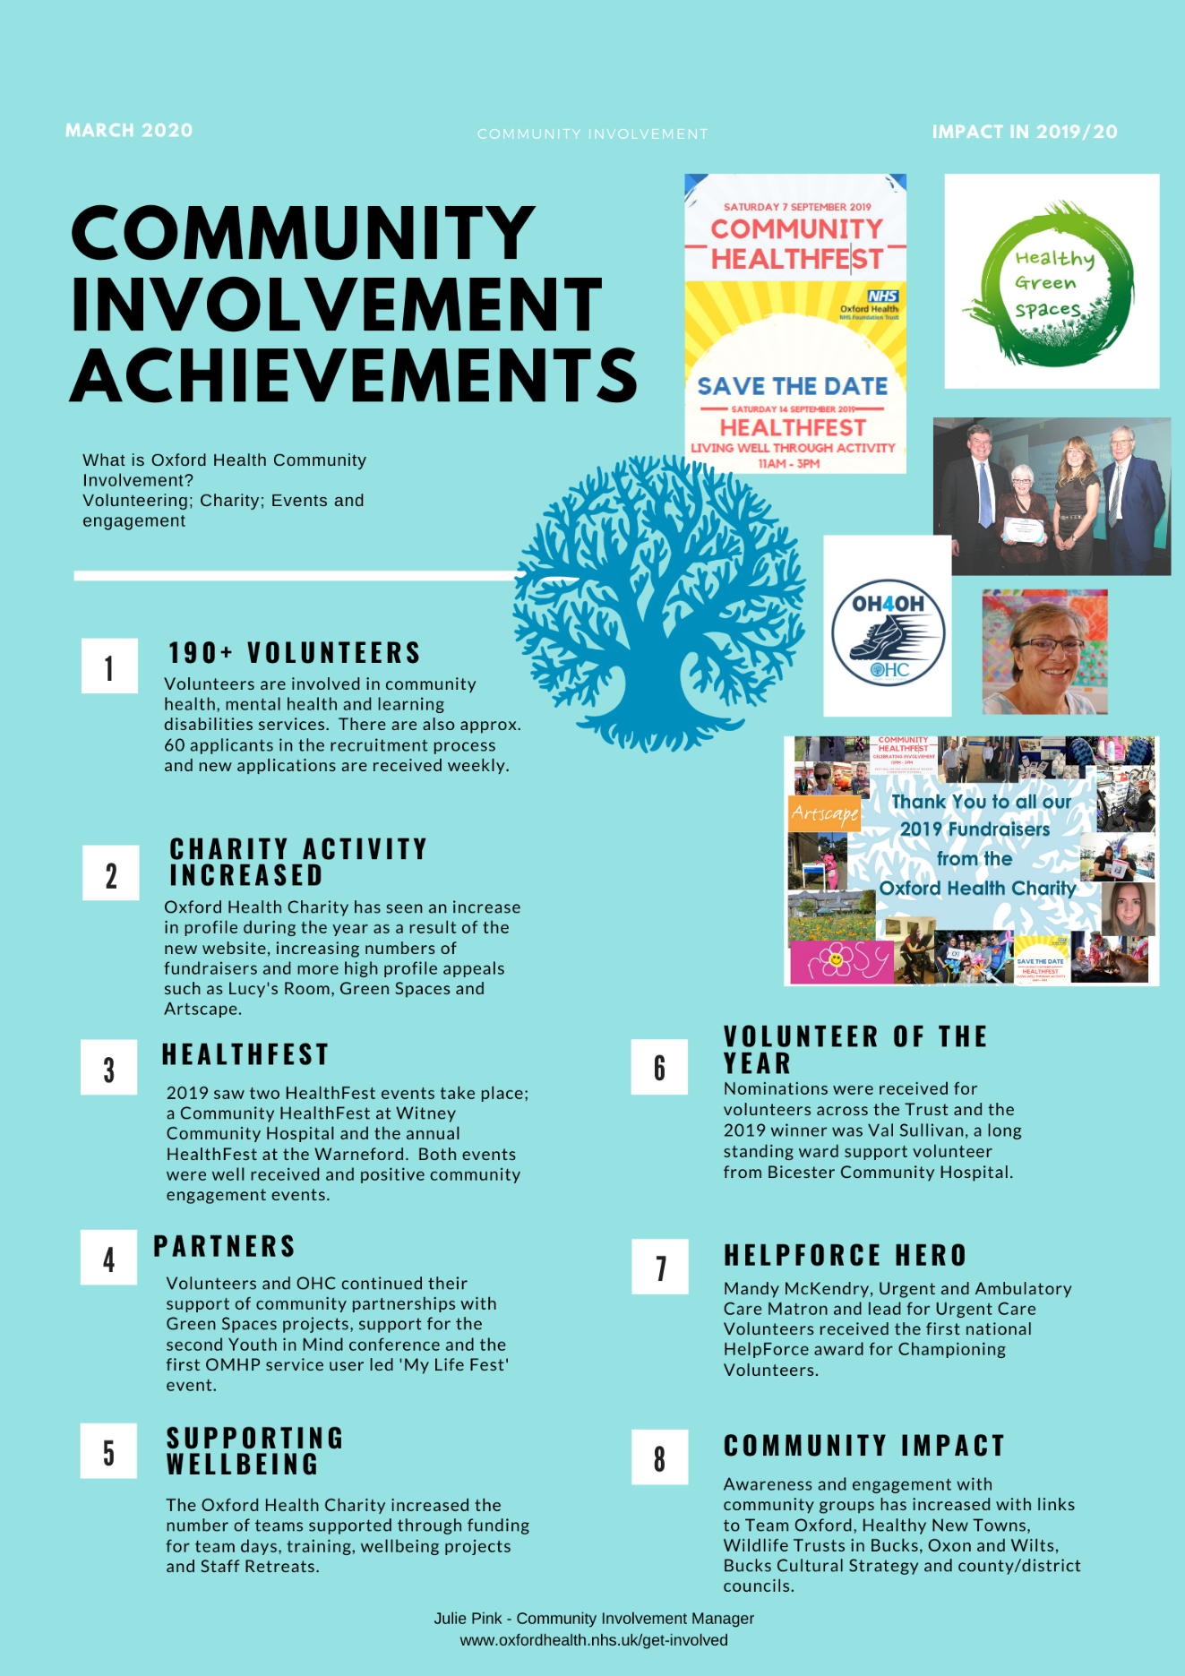
Appendix B
