Report to the Meeting of the

Oxford Health NHS Foundation Trust
BOD 73/2020
(Agenda item: 14)

Board of Directors

26 November 2020

Staff Flu vaccination update report and self assessment

For: Information/Assurance

Executive Summary

This paper is an update to the Board on the staff flu vaccination programme within the Trust which includes the mandated self -assessment The Chief Nurse is leading the campaign with both clinical and operational support from Occupational Health and Testing, Immunisation and Risk Assessment teams. The message being that staff need to protect themselves; their vulnerable patients and their families. This year there is no CQUIN target but nationally the expectation is to offer vaccination to 100% of frontline staff.

Last year 2019/20 we vaccinated 72% of frontline staff which was a 21% increase in the previous year. However with the added complexity of COVID19 the national target is now 100% of frontline staff to be vaccinated. In addition the deadline for completion of the vaccination camping is significantly reduced this year and ends on 31 December 2020 as opposed to end of February in ‘usual’ years.

The Trust is obliged by NHSE/I to complete a self assessment (Appendix 1) for the Board and monitor progress. This has been monitored through our weekly flu vaccination meetings. In addition we have also been asked to upload the details of staff who have been vaccinated to the National Immunisation Vaccination Database (details yet to be confirmed).

The Trust has initially focused on frontline staff because of the vaccines arriving in batches but we are extending this to other staff later this month. The Chief Pharmacist has advised that we can obtain further batches form the national stockpile. The message to non-patient facing staff has been to get their vaccination at their GP or pharmacy.
Our approach this year has seen us:
- double our number of peer vaccinators this year to approximately 52
- offer bookable clinics across the Trust’s geographic bases,
- offer targeted vaccinations for wards and
- offer to arrange peer vaccinators to attend any large training event or team meetings (with suitable infection control procedures in place).
Currently the Trust has not offered any drop-in clinics this year because of the implications for social distancing. However we are now offering Kassam Stadium for a drive through clinic for staff as an alternative.

The Trust commenced the vaccination programme on 1 October 2020. As of 9 November 2020 the Trust vaccination uptake rate (frontline staff only) was 42%.

This report and associated self assessment gives the Board the assurance that there are no significant gaps in our planning or implementation of the staff flu vaccination campaign, however there remains a risk we will not hit the required target of 100% of frontline staff vaccinated by 31 December 2020.

Governance Route/Escalation Process
A similar update paper has been provided to the Executive Directors.

Statutory or Regulatory responsibilities
The Trust is obliged by NHSE/I to report the self assessment and flu vaccination programme to the Board to provide Board oversight.

Recommendation
That the Board is assured by this report and self assessment

Author and Title: Anita Sherwood, Programme Manager / Marie Crofts, Chief Nurse
Lead Executive Director: Marie Crofts, Chief Nurse

- A risk assessment has been undertaken around the legal issues that this report presents and [there are no issues that need to be referred to the Trust Solicitors]

- Strategic Objectives – this report relates to or provides assurance and evidence against the following Strategic Objective(s) of the Trust

1) Deliver the best care possible within available resources
(Goals: delivering the best care possible within available resources through improved safety, effective evidence-based treatments and an improved patient experience to create better outcomes for those who use our services)

INTRODUCTION

This report provides an update regarding the Trust staff flu vaccination programme. This includes:
- our obligations to NHSE/I including the Trust self assessment
- our current situation and key actions to achieve the target
- our current uptake percentage

SITUATION

Vaccination of our frontline staff against flu is one of the best ways to protect our staff; their families and our patients to remain well during the Winter period. With the added complexity of COVID19 this year it is paramount we protect staff and patients from flu.

Currently the Trust flu vaccination programme is led by the Chief Nurse with the support of the Occupational Health team and Testing, Immunisation and Risk Assessment team. The Trust is required by NHSE/I to undertake a self assessment (Appendix 1) and ensure the Trust Board is sighted on the flu plan for this year by December 2020. In addition to the self assessment the Trust has to report to NHSE/I on progress regularly and vaccination rates.

BACKGROUND

Each year every Trust is responsible for planning a flu vaccination programme. This is to enable staff; patients and families to be protected against flu and is a key plank of the NHS strategy to support staff and patients through the Winter period.

For several years this campaign has formed part of the national CQUIN programme – with financial imperatives. However, in 2020/21 this additional funding has been paused due to COVID-19 priorities.

Last year (2019/20) the Trust achieved a vaccination rate of 72% of its frontline staff which was a 21% increase on the previous year.

ASSESSMENT

This year the flu vaccination campaign is being led by the Chief Nurse as executive sponsor. This ensures the programme is clearly based and messaged around improving quality for patients and supporting our staff and their families to stay well.

In order to ensure we achieve as close as possible to 100% vaccination rate for frontline staff the flu vaccination planning group has a robust project plan and weekly meetings to monitor progress and determine any gaps. The vaccination programme has ensured staff are offered the vaccination as locally as possible to either their base or home (given current circumstances) to ensure improved compliance. With this in mind we have recruited 52 peer vaccinators compared to 18 in 2019/20.

The first tranche of vaccines were administered immediately and online clinic slots fully booked the first week. A process for managing vaccine stock offered to wards has been introduced so that any unused stock is returned to Occupational Health and redistributed. We introduced a new MS Bookings system for clinics so that staff can book appointments themselves in order to help manage demand and encourage staff to have easy access to clinic availability. This allows us to forecast demand until the end of November and adjust locations or promote clinics as appropriate.

Currently the Trust vaccination rate as of 9th November is 42% of frontline staff. In 2019/20 at this point of the campaign the Trust uptake rate was 29% of frontline staff. In addition the deadline for completion of the campaign is end of December rather than end of February as in previous years.

NHSE/I have produced a self assessment document (Appendix 1), similar to last year, which needs Board oversight. The flu vaccination programme leads have assessed Trust progress and actions against this and currently there are no significant gaps. We do not currently have a vaccinator in every clinical team however we have significantly improved recruitment of peer vaccinators this year to provide a more comprehensive offer across the Trust’s geography.

The current progress of staff groups immunised compared to last year uptake for the same period is shown in the charts below.

Chart 1: Flu Vaccine Uptake by Staff Group in 2019/20 and 2020/21 (Support staff are receptionists, cleaners, porters, ward clarks, etc)

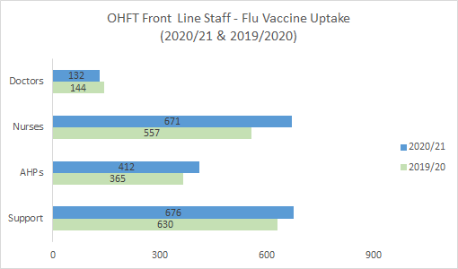

Chart 2: (%) Flu Vaccine Uptake by Staff Group in 2020/21

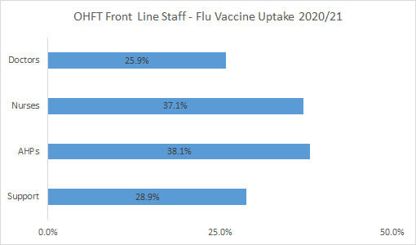

Chart 3: Flu Vaccine Uptake by Directorate in 2019/20 and 2020/21 (Corporate Services include bank staff)

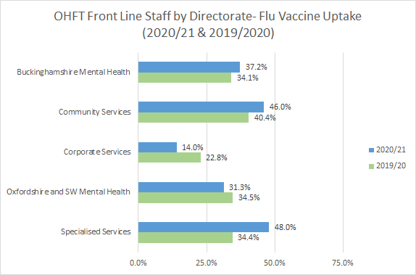

Summary of current actions (linked to self assessment):

- Weekly meeting in place with executive leads and key senior operational leaders
- Ongoing work to cleanse staff data to ensure an accurate baseline is reported to NHSE/I
- In-house database capturing information on staff who have consented or declined allowing analysis to target messaging to staff and clinic locations
- 52 peer vaccinators offering clinics across Oxon; Bucks and BSW (improved position from 18 last year)
- Occupational Health incorporating offer of flu vaccinations when other vaccinations taking place with staff
- Scheduled attendance by peer vaccinators / sessional vaccinators to support uptake in wards or pre-arranged team meetings in order that staff do not need to travel unnecessarily
- Payment to bank staff who attend work to be vaccinated
- High profile communications campaign based on protection is underway and on going throughout the campaign period – involving personal staff stories and peer vaccinators on posters and a flu video which includes the Chief Nurse
- Ensuring that flu vaccination is on each team meeting agenda to raise the profile on a weekly basis
- Vaccinations offered in a drive-through clinic in Oxford from mid-November

Key risks / issues:

The flu vaccinator programme has a risk log and key risks are discussed at the weekly meetings together with mitigation in place for any identified risk. The main risks and concerns are outlined below:

- Non achievement of target percentage (100% of frontline staff)
Mitigation: This is monitored on a weekly basis including focusing on those teams and services with low uptake
- Vaccine delivery schedule – we have 4800 vaccines which does not equate to all frontline staff (if including all bank staff)
Mitigation: The Trust is targeting frontline staff, including any bank staff working during the autumn/winter this year. We have a robust process for ensuring those receiving the vaccine at their GP surgery or other venue they advise us of this fact (currently approx. 4 %). We have requested additional stock from the national stockpile
- Lack of peer vaccinators and access to the vaccination locally for staff
Mitigation: improved recruitment of peer vaccinators this year, clinics arranged across the geography of the Trust and a structured process for wards and for other pre-arranged team meetings to undertake vaccinations (including offers to night shift staff); reduce the need for staff to travel some distance for the vaccination
- Data base of staff not accurate therefore percentage is not correct
Mitigation: Introduced an online live system for peer vaccinators to check the database of consent forms before giving vaccinations and immediately capturing evidence of vaccinations given. This information is cross checked against Electronic Staff Records to cleanse the data

RECOMMENDATION
That the Board is assured by this report and associated self assessment

APPENDIX 1 SELF ASSESSMENT CHECKLIST
A | Committed Leadership
A1 | Board record commitment to achieving the ambition of vaccinating all frontline healthcare workers | Update at Quality Committee- Board level Committee acknowledgement and commitment to achieve the ambition  Chief Nurse regularly sends reminders within comms about staff responsibility to have vaccination  CEO Blog includes reminders and support for staff vaccination
A2 | Trust has ordered and provided a quadrivalent (QIV) flu vaccine for healthcare workers | Ordered December 2019 for frontline healthcare workers.
A3 | Board receive an evaluation of the flu programme 2019/20, including data, successes, challenges and lessons learnt | Update report to Quality Committee – Board level committee
A4 | Agree on a board champion for flu campaign | Confirmed as Chief Nurse
A5 | All board members receive flu vaccination and publicise this | Frontline Board members have received vaccination and published pictures on intranet
A6 | Flu team formed with representatives from all directorates, staff groups and trade union representatives | Flu delivery team meets every week.  The chief nurse meets with staff side on a weekly basis to ensure any issues or concerns are addressed
A7 | Flu team to meet regularly from September 2020 | Flu team meet monthly from July then weekly from September.
B | Communications plan
B1 | Rationale for the flu vaccination programme and facts to be published – sponsored by senior clinical leaders and trades unions | Rationale and facts published on the intranet and include blogs from peer vaccinators. Posters; briefings and multiple other communications available to staff.  Specific comms to all staff from Chief Nurse as exec lead
B2 | Drop in clinics and mobile vaccination schedule to be published electronically, on social media and on paper | Owing to COVID-19, booked clinic slots have been offered to all frontline staff across the Trust footprint, published electronically and in comms updates twice a week. Additional opportunity for drive-through clinic offered in November.
B3 | Board and senior managers having their vaccinations to be publicised | Pictures of frontline Board members having vaccinations have been publicised
B4 | Flu vaccination programme and access to vaccination on induction programmes | All frontline staff are able to access vaccination and peer vaccinators scheduled attendance at any large meetings/training sessions. When Occ Health carry out any routine frontline staff immunisations for other vaccines, they also offer flu at the same time. Induction currently online so no face to face contact.
B5 | Programme to be publicised on screensavers, posters and social media | Posters and update on social media/intranet have been added.
B6 | Weekly feedback on percentage uptake for directorates, teams and professional groups | Weekly % update reports produced with effect from mid-October (example charts in this Board paper)
C | Flexible accessibility
C1 | Peer vaccinators, ideally at least one in each clinical area to be  identified, trained, released to vaccinate and empowered | PVs were identified, trained and released by teams to vaccinate across the Trust – doubling of number of peer vaccinators this year.
C2 | Schedule for easy access drop in clinics agreed | No drop in clinics have been arranged this year to date owing to social distancing but drive through clinic offered from mid-November.
C3 | Schedule for 24 hour mobile vaccinations to be agreed | Schedule published online and on request for night shift start/end times scheduled in both Oxon and Bucks
D | Incentives
D1 | Board to agree on incentives and how to publicise this | Reimbursement of costs for anyone who has attended elsewhere is detailed in FAQs, promoted through comms and also explained in the ‘consent/ decline form’. Offer to pay bank staff attending vaccinations has been made. Last year had a super draw for vouchers for staff – not progressed with this in 2020/21
D2 | Success to be celebrated weekly | Blogs updated on intranet, social media updates, twice weekly progress updates

