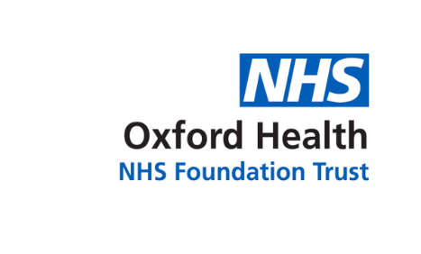

Report to the meeting of the

Oxford Health NHS Foundation Trust

Board of Directors
RR/App 05/2020
(Agenda item: 21)

22 July 2020

Complaints & PALS Annual Report

1 April 2019 to 31 March 2020

Executive Summary
This is the annual report on formal complaints, PALS contacts, MP enquiries and compliments received by Oxford Health NHS Foundation Trust during 1 April 2019 to 31 March 2020. This paper provides assurance that the Trust is meeting the legal regulations for the Care Quality Commission’s outcome 16: complaints. Local Authority Social Services and NHS Complaints (England) Regulations 2009, the NHS Constitution and patient’s rights, and the Ombudsman’s principles of good complaint handling 2008.

Key highlights:

- 253 complaints were received between 1 April 2019 and 31 March 2020 which is a 15% increase when compared to the previous year.
- 51 formal MP enquiries from 1 April 2019 to 31 March 2020 and 72 informal enquiries.
- The Patient Advice and Liaison Service received 2065 contacts during the year which is an increase (13%) when compared to the previous year (2018/19) when 1800 contacts were received.
- OHFT received 2863 compliments between 1 April 2019 and 31 March 2020.
- Six current ombudsman (PHSO/LGO) cases.
- Over the year 203 actions were identified across the Trust following the completion of a complaint investigation.

There continues to be a high number of extension requests across Directorates (64%) resulting from a delay in allocation of complaints and a lack of availability of staff to undertake the investigation due to annual leave, sickness and current work pressure. The average response time to a complaint is 44 days.

Oxfordshire, BaNES, Swindon and Wiltshire Mental Health Services received the highest number of complaints (104) and sought the most extension requests during the time. Trust-wide of the 207 complaints investigated and responded to, 59% were fully or partially upheld. The ombudsman reviewed 12 closed complaint cases in 2019/20 of which two have moved to investigation. There has been an increase in the number of PALS cases being received across the year. The adult mental health teams continue to receive the highest numbers of concerns/complaints. Most complaints were made by carers/family members. The Trust receives the most concerns and complaints in the category of ‘all aspects of clinical care’ (393) of which 102 related to insufficient care in the community, 39 related to medication issues, 24 quality of care). 193 related to staff attitude/behaviour, 172 cases were about communication/information sharing.

Strategic Objectives
This report relates to or provides assurance and evidence against the following Strategic Objective(s) of the Trust:

1) Driving Quality Improvement
(Goals: patients will be safe from harm; patients will achieve the clinical outcomes they want; and patients and carers will have an excellent experience)

Recommendation
The Board is asked to note and use the annual report to make improvements to care.

Author and title: Claire Price, Complaints & PALS Manager
Lead Executive Director: Marie Crofts, Chief Nurse

Complaints & PALS Annual Report: 1 April 2019 to 31 March 2020
Themes and Outcome

Introduction
This is the annual report on formal complaints, patient advice and liaison service (PALS) contacts, MP enquiries and compliments received by Oxford Health NHS Foundation Trust (OHFT) between 1 April 2019 and 31 March 2020. This paper provides assurance that the Trust is meeting the legal regulations for the Care Quality Commission’s regulation 16: receiving and acting on complaints.

Highlights
OHFT receives complaints relating to services provided by the Trust. The Trust also receives a variety of enquiries and requests for help and information through PALS and from local MP’s. The Trust remains up to date with complaints management, although there continues to be a constant flow of complaints being received. Many concerns and complaints continue to be resolved locally by front line members of staff that can resolve these promptly. This can also prevent an escalation of the complaint. Key highlights from the report are as follows:

- Between 1 April 2019 and 31 March 2020, OHFT received 253 complaints which is an 15% increase when compared to the previous year when 215 complaints were received. The number of complaints received by quarter is broken down as follows; 52 complaints in Quarter One (April to June 2019), 59 complaints were received in Quarter Two (July to September 2019), 70 complaints in Quarter Three (October to December 2019) and 72 complaints were received in Quarter Four (January to March 2020).
- OHFT received 51 formal MP enquiries from 1 April 2019 to 31 March 2020 and 72 informal enquiries.
- PALS received 2065 contacts during the year which is an increase (13%) when compared to the previous year (2018/19) when 1800 contacts were received. The breakdown of the type of contacts is detailed below.
- OHFT received 2863 compliments between 1 April 2019 and 31 March 2020 which is a 5% decrease when compared to the previous year.
- We have six ombudsman (PHSO/LGO) cases open. In 2019/20 the ombudsman made enquiries about 12 closed complaint cases of which 2 have commenced to an investigation.
- Over the year 203 actions were identified across the Trust following the completion of a complaint investigation.

The Trust continues to actively monitor the key themes identified within complaints received alongside information produced through other sources of feedback such as Serious Incidents, Legal Claims, Inquests and HR investigations. Discussions to triangulate the information take place on a weekly basis at the Trust-wide Clinical Weekly Review Meeting. The main reoccurring theme for improvement across the Trust is how involved patients and families feel in decisions about their care, including related matters around confidentiality, information provided and communication with staff members.

Number of Complaints Received
There has been an increase in the number of complaints between 1 April 2019 and 31 March 2020 when 253 complaints were received, compared to the previous year when 215 complaints were received. This is an 15% increase over a 12-month period. As shown in the graph below, Trust-wide there have been increases in specific months (Sept, Oct, Feb and March) however no significant trend showing consecutive points above/ below the average. When broken down to service line, the area to highlight is the adult AMHTs which had 2 consecutive points above the mean in February and March 2020 however this was not continued into April, May or June 202020 complaints were re-opened and further investigations were undertaken to resolve the concerns raised. 29 complaints were withdrawn during this period and were dealt with locally through the PALS.
Oxfordshire, BaNES, Swindon and Wiltshire Mental Health Services received the highest number of complaints (35 in Q4 and 101 in 2019/20), Community Services (18 in Q4 and 66 in 2019/20), Buckinghamshire Mental Health Services (12 in Q4 and 61 in 2010/20), Specialised Services (6 in Q4 and 21 in 2019/20) and Corporate Services (1 in Q4 and 4 in 2019/20).

The largest group of complaints were received from relatives/carers (n=114) and 96 complaints were received from patient’s/service users.

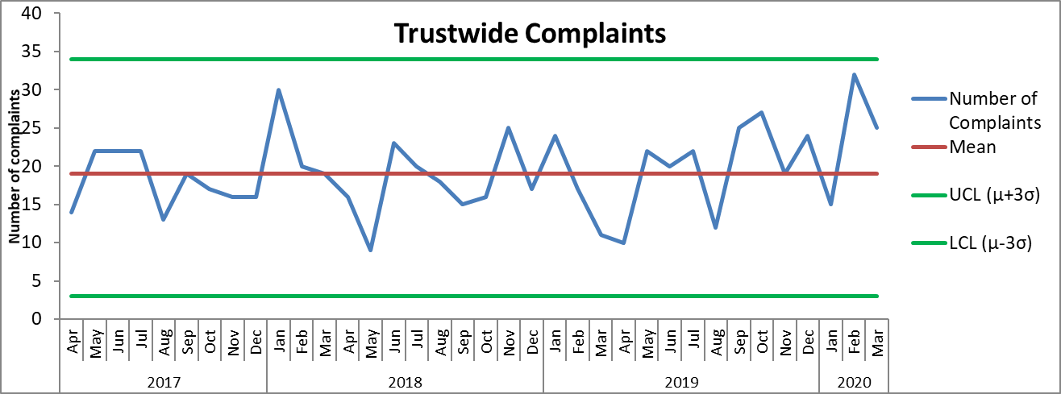

Timeliness of Responding
Between 1 April 2019 to 31 March 2020, 253 complaints have been received, of which 100% were acknowledged by the Complaints & PALS Team within the NHS Complaints Regulations (2009) of three working days. Of the 253 complaints which have been investigated and responded to, all of these (100%) were within a timescale agreed with the complainant. There continues to be a high number of requests for extensions by investigating officers across the Trust, average response time in days is below. Out of the 207 complaints which have been investigated and responded to, 133 cases had an extension in place. This is 64% of the complaints which we have responded to and impacts on the timeliness of complaint responses. The issues relate to either a delay in the allocation of a complaint, an investigating officer being unable to complete the investigation within time due to their workload, the case being complex and for 15 cases these related to pauses due to the response to the COVID-19 outbreak. The figures broken down by Directorates are as follows; Buckinghamshire Mental Health Services 38 complaints were extended (62% of investigations), Oxfordshire, BaNES, Swindon and Wiltshire Mental Health Services 57 cases (56% of investigations), Community Services 27 cases (41% of investigations), Specialised Services ten (48% of investigations) and Corporate Services one case. The number and themes from complaints, as well as extensions and delays are monitored and reported on a weekly basis.

There are concerns around the length of time is takes for formal complaints to be investigated and responded to. In Oxfordshire, BaNES, Swindon and Wiltshire Mental Health Services the average number of days from 1 April 2019 for responding to a complaint is 41 days (currently the longest time it has taken is 144 days). Within Buckinghamshire Mental Health the average number of days for responding to a complaint is 40 days and the longest timescale was 126 days. Within Community Services the average number of days for responding to a complaint is 34 days and the longest timescale since 1 April 2019 was 103 days. In Specialised Services the average number of days is 37 days and the longest time is has taken is 76 days.

Grading of Complaints
All complaints are graded based on severity of harm to patient using a national risk matrix with a rating of green, yellow, orange or red. From the 253 complaints received, 208 (82%) were graded green, 31 (12%) were graded yellow; 13 (5%) complaints were graded orange and one (1%) complaint was graded red. The graph below shows the number of complaints received by month and by risk rating.

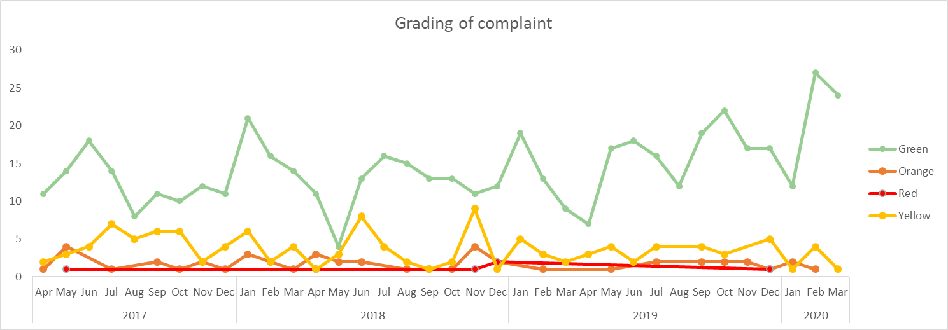
Outcome of Complaints
Of the 207 complaints which have been responded to, 57 complaints were upheld (28%), 78 complaints were not upheld (38%), 65 complaints were partially upheld (31%) and for seven cases there was no evidence to prove or disprove (3%). The graph below shows the outcomes of complaints since January 2016.

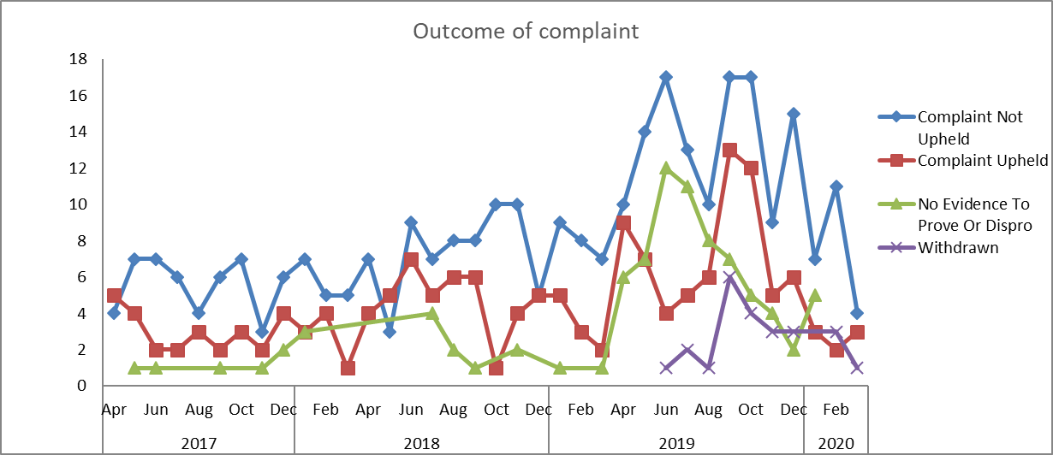

After the investigation into each complaint, if there are any upheld elements or any improvements in practice identified then an improvement plan is developed by the investigating officer, in liaison with the relevant service manager/ward manager. Between 1 April 2019 and 31 March 2020, of the 207 complaint which have been responded to, 203 actions have been identified. The number of actions broken down by Directorate are as follows; Buckinghamshire Mental Health Services (n=46), Oxfordshire, BaNES, Swindon and Wiltshire Mental Health Services (n=72), Community Services (n=74), Specialised Services (n=11) and Corporate Services (n=0). At the time of writing this report, there are 33 actions which require completion and are within time. The completion of actions is monitored centrally with weekly and monthly reporting.

Detailed below are some actions which have been taken following the completion of an investigation:

- All staff to be reminded that when a professionals only conference/meeting is called, an explanation of the rationale for this is made to the family in order that feelings of being excluded are minimised, unless there are clear safeguarding reasons why families would not be advised of professionals only meetings. (CAMHS Bucks Getting More Help).
- To ensure that the letter sent to the patient and GP, following the initial assessment, includes that consent was gained to share information and with whom. Team to amend templated letter that is sent to the GP and patient after the initial assessment to include details of consent obtained and who the patient has given consent to. (Diabetes Service).
- Training for all staff on how to manage difficult calls/hostile interactions with parents. Written guidance to be provided to all staff, including in line with harassment guidance; this will be included in all local induction. (CAMHS Oxon Neuro).
- Group facilitators to ensure that at “Meet & Greet” that new members are in receipt of the timetable, group rules and a copy of the welcome pack. (Complex Needs Service, Bucks).
- Training for staff member to facilitate improved management of patients with autism. (Dental Services).

Parliamentary Health Service Ombudsman (PHSO) & Local Government Ombudsman (LGO)
At the time of writing this report, there are six current cases which are open with the Parliamentary Health Service Ombudsman (PHSO) and Local Government Ombudsman (LGO). Between 1 April 2019 and 31 March 2020, the PHSO/LGO made 12 enquiries relating to closed complaints. Of these 12, two have commenced an investigation. At the time of writing this report 6 cases remain open and under investigation.

Patient Advice & Liaison Service (PALS)
Between 1 April 2019 and 31 March 2020, the PALS Team managed 1,023 local concerns, 896 general enquiries, 126 PALS Surgery feedback/comments (not including concerns) and 20 pieces of feedback via social media. The PALS team are continuing to look at expanding the availability of PALS Surgeries held in clinical services across the Trust to help to resolve concerns and issues at a local level, if possible, before a complaint is raised.

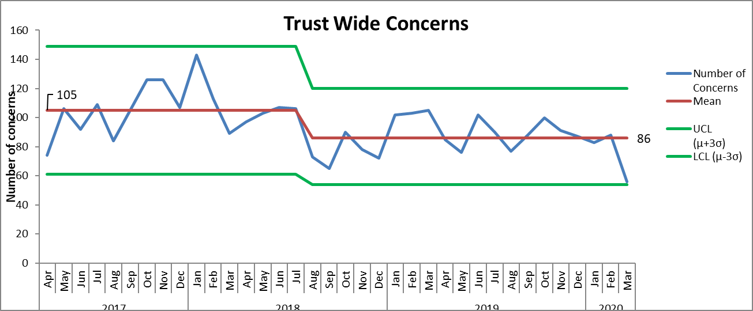

The team also runs the PALS volunteer initiative which focuses on volunteers attending PALS surgeries and being given the opportunity to listen to people’s experiences on our wards. At present the team has two volunteers going onto the following wards months; Abbey Ward, Oxfordshire Stroke Rehabilitation Unit, Linfoot Ward and Wenrisc. Further work is being taken to recruit more volunteers.

PALS Surgeries:
The PALS Team currently runs 38 PALS surgeries across the Directorates focused on wards and day hospitals. PALS surgeries are a valuable way of seeking feedback about people’s experiences, both positive and negative, and about working with ward staff to resolve issues of concern at a local level, in a timely and positive manner. This is a snapshot of some of the themes/trends following the feedback received from PALS Surgeries across the Trust in Quarter 4. Each piece of feedback is discussed and shared with the ward/team manager or deputy and resolved. Any issues concerning are also appropriately escalated;

An overview of the whole year (2019/20) showed that in the early part of the year there was an increase in concerns in forensic wards, especially Evenlode, about staffing levels as this was having an impact on patients being able to have their escorted leave, as some patients require two members of staff to escort them during leave and staffing levels meant that this was not always possible. There were also lots of concerns about the waiting times for the Complex Needs Service at the beginning of the year, however changes in their processes has led to a reduction in waiting times for assessments. Similarity there were lots of concerns about the waiting time for a care coordinator, especially within the Aylesbury AMHT, this was due to a lack of substantive staff and sickness within the team. CAMHS Neuro also have experienced high numbers of concerns about their waiting times, although there have been no changes in the length of waiting times, there has been a decrease in the number of concerns being raised and it is likely that increased communication has had a positive impact.

Day Hospitals across Oxon & Bucks
This area continues to have no concerns raised although there is also very little PALS Surgery feedback for this area due to there being fewer PALS Surgeries taking place. One comment made about the Chiltern Day Hospital was that it could do with updating as it has stayed the same for several years.

Forensic Wards
There were no themes coming out of the feedback received from these wards. Interestingly, if you exclude the PALS Surgery data, we hardly had any contact from forensic wards during quarter 4. We received one COVID-19 related case on Wenric Ward, where the mother of a patient was unhappy with the patients all eating together and not practicing social distancing. Furthermore, there have been two reports of aggressive and threatening behaviour from staff on Kennett Ward.

Mental Health Wards
On Phoenix Ward there was a theme in relation to patients disputing whether they should be on their section or to ask how they can go about being discharged, as they feel they do not need inpatient care, this was being raised across the year. On Ruby Ward we had three comments from people who found staff rude, threating or uncaring. Across the other mental health wards, we received questions/concerns around leave or the MHA in terms of how to get discharged.

Community Hospitals
Most of the contacts recorded for Community Hospitals came from PALS Surgeries and relate to food, as always this is a mixture of positive and negative comments. There were three comments about the delay in responding to a call bell, but these were across three different wards.

Children & Young People’s Mental Health Services (CAMHS)
Within CAMHS Neuro we have seen a decrease in concerns raised about the waiting list pressures, we only had five in Q4, although we did see this come up across all areas of CAMHS but not so much that there was a theme in any area.

Marlborough House (CAMHS)
There has been a theme of patients raising concerns that the heating was too cold at night and that the bedding was inadequate for cooler temperatures, but this was raised with the ward manager who was already aware of the issues, which was being resolved. This was over a couple of surgeries earlier in the year.

Adult Mental Health Teams (AMHT)
A theme coming out of the Aylesbury AMHT seems to be insufficient care in the community with eight people feeling there is a lack of support available to them and that staff seem unhelpful and disinterested. There were also two concerns raised around how the team handled situations when people called out of hours or in crisis as staff were reportedly unhelpful. Similarly, with the Chiltern AMHT we saw four concerns around the quality of care provided, although there does not seem to be a theme in the sense that there were different reasons given for why patients do not feel they are receiving the standard of care they would expect. Compared to the other AMHT’S we received more concerns for City & NE AMHT than any other AMHT (detail of numbers in graph below) believed to be due to high number of vacancies and as a result a high use of agency staff. In Q4 we only had 8 contacts regarding Oxon North and West AMHT and 6 about Oxon South AMHT.

The graph below shows the number of concerns and complaints received about the City and NE AMHT.

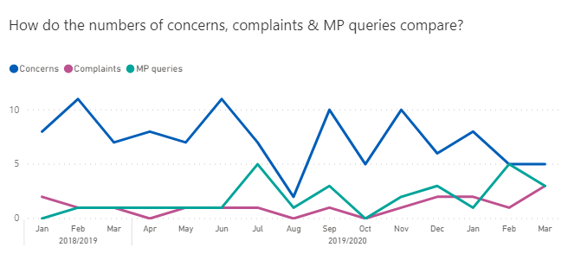

Older Adult Community Mental Health Teams (OA CMHT’s)
For the Oxford teams we received 13 contacts but only four were concerns. Within Bucks it was much the same but there were two concerns about the length of wait for an appointment and two about people feeling unsupported in the community.

District Nurses
We have received quite a few contacts for District Nursing during Q4, some themes seem to be about insufficient care, issues regarding medical equipment and lack of professionalism. However, these are scattered across different teams.

Analysis of themes from concerns and complaints
The Trust receives the most concerns and complaints in the category of ‘all aspects of clinical care’ (393), see graph below. Of which 102 related to insufficient care in the community, 39 related to medication issues, 24 quality of care). 193 related to staff attitude/behaviour (42 were about rude behaviour, 36 were about a lack of professionalism and 24 were about staff being uncaring or uncompassionate), 172 cases were about communication/information sharing (39 were relating to incorrect information being shared, 33 were about poor communication with a relative/carer and 29 were about poor communication with a patient

The graph below shows trust-wide numbers of concerns, complaints and MP enquiries related to all aspects of clinical care over time.

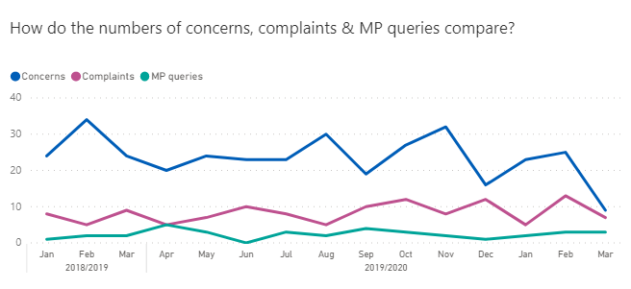

The seven teams with the highest number of complaints and concerns in 2019/20 are highlighted below;

AMHT Oxon City & North East: 66 formal complaints, 60 green, five yellow and one red (57 closed, 27 upheld and 5 partially upheld) and 395 concerns. 206 related to all aspects of clinical care (91 related to insufficient care within the community, 32 related to medication issues and 15 were about care planning). 77 cases related to communication/information sharing, 48 were about staff attitude/behaviour and 43 related to appointments/referrals.

AMHT Bucks Chiltern Team: 52 formal complaints, 49 graded green, one graded orange and two graded red (50 cases closed, 14 upheld and six partially upheld) and 191 concerns. 108 cases related to all aspects of clinical care (31 related to insufficient care in the community, 17 related to care planning issues, 13 related to medication and 12 related to assessments). 39 related to staff attitude/behaviour, 33 related to communication/information sharing and 16 related to admission/discharge/transfer.

AMHT Bucks Aylesbury Team: 40 complaints, 40 graded green, four graded yellow, one graded orange and four graded red (45 closed, 28 upheld and 2 partially upheld) and 260 concerns. 139 related to all aspects of clinical care (52 related to insufficient care within the community, 21 related to care planning, 13 related to a request for a change of care team and 10 related to medication issues). 59 cases related to the attitude/behaviour of members of staff. 49 related to communication/information sharing and 25 related to appointments/referrals.

AMHT Oxon North & West: 34 complaints, 29 graded green, three graded yellow, one graded orange and one graded red (32 closed, ten upheld and seven partially upheld) and 107 concerns 66 related to all aspects of clinical care (35 related to lack of care within the community and 10 related to medication issues). 25 related to staff attitude/behaviour, 19 related to communication/information sharing and 10 related to an appointment/referral.

AMHT South Oxon: 30 formal complaints, 23 graded green, four graded yellow, two graded orange and one graded red (27 closed cases, 14 upheld and three partially upheld) and 98 concerns. 57 related to all aspects of clinical care (24 related to insufficient care in the community, eight related to medication issues and six related to care planning). 22 cases were about communication/information sharing, 13 related to staff attitude/behaviour, 11 related to admission/discharge/transfer and eight related to medical records.

Allen Ward: 15 formal complaints, eight green, six yellow and one orange (14 closed cases, eight upheld) and 146 concerns. 35 related to all aspects of clinical care (eight related to the quality of care, seven related to medication issues, 5 related to care planning and four related to restraints). 26 related to staff attitude/behaviour, 21 related to the environment/facilities and 19 related to communication/information sharing.

Ruby Ward: 16 formal complaints 16 formal complaints, eight graded green, seven graded yellow and one graded red (13 cases closed and four upheld) and 161 concerns. 55 related to all aspects of clinical care (14 related to medication issues, 13 related to the quality of care and 6 cancellation of leave). 25 related to staff attitude/behaviour, 24 related to admission/discharge/transfer, 17 related to communication/information sharing and 15 related to the environment/facilities.

Compliments
The Complaints and PALS Team centrally collates the compliments sent to teams within the Trust including thank you letters and cards. In 2019/20 a total of 2,863 compliments were received; Oxfordshire, BaNES, Swindon and Wiltshire Mental Health Services received 811, Community Services received 1468, Buckinghamshire Mental Health Services received 338, Specialised Services received 233 and Corporate Services received 13.

Extracts from compliments
“Our son is now safely back at home. Thank you so much for all your support and for taking such good care of him. Please extend our sincere thanks to the entire staff. Your support and professionalism were key for our son’s recovery and to enable his safe return home. Again, our deepest thanks for all your help and support and for the fantastic staff you have at Sapphire Ward.” Sapphire Ward

“My father was sectioned in October 2019. He had recently been diagnosed with frontal temporal dementia and was struggling to cope. When he was first admitted he and his family were in shock. It took some months to come to terms with the situation. The staff at this hospital have a hugely difficult job. They are dealing with wide ranging needs and I have huge admiration and respect for the service they provide. My father was there until June this year, so we saw a lot of life on the ward and the difficult situations that they manage. Many countries have no similar service, vulnerable adults and their families have no such facility to access. I am grateful for the efforts of the Amber Ward Team. My father sadly could not return home but eventually we did find a suitable local care home where one of us visit every day. He is settling and does smile and laugh making the odd joke which I thought was an impossibility 6 months ago. Our system is not perfect, but we do have a system for which I express gratitude. Thank you, one particular staff member and Amber Ward Team.” Amber Ward

“Thank you so so much for helping me through this time in my life. You have changed my opinion on counselling completely. I now know I can get through this myself. I can’t thank you enough for everything you have done for me. Psychological Therapies

“Thank you for looking after our son for so many months. Your care has been much appreciated”. Ashurst Ward

“Coming from my heart, I would like to thank you for giving up your time to help me through a part of my life that has been challenging. Time is really our most valuable resource, so to give yours for the benefit of others shows that you are a very special person. I will always be grateful for your calm support”. CAMHS Wiltshire

“The staff are very good and do their best to help. I was a bit concerned about coming in, but it has been absolutely fine”. Allen Ward

“Thank you so much for all your help and support you really are a fountain of knowledge. You are all an amazing team and have taught me so much. I am so grateful for the experience. Thank you all again”. Oxfordshire Community Heart Failure Team

“Thank you for your call earlier. Was lovely to hear from you. As promised a little picture of T sitting up un-aided. The last 7 months have gone by so quick and I'm sure T wouldn't be progressing as well as he is, if it weren't for you seeing and treating him from 3 weeks old.’ Children’s Integrated Therapies

“I just wanted to report back on a very satisfactory experience I had at the Out of Hours Clinic in Manzil Way. Everything about it was a credit to the NHS. The doctor who triaged the call was sensitive and efficient, the receptionists at the Clinic were helpful and welcoming, and the doctor who saw me was exceptionally thorough, painstaking and professional”. Out of Hours Service (East Oxford Health Centre)

“I can only speak highly of the staff that in the midst of an incident, a clear explanation was given about what was happening and a gentle yet professional manner. Staff always treat me with respect, engage in conversation and make me feel like a human being”. Woodlands House

“D shared that he does not know what he would do without the support from the LDT. The support he has received has really helped him to ‘look on the bright side’ and carry on. D thanked the team for all the help and support”. Community Learning Disability Team (North)

“Everything is ok here. We all get on very well and the staff are good. It’s good that we get the chance to go out and get the stuff for cooking the meals. We can’t blame anyone else if the food is bad!”. Lambourne House

Recommendation
The committee is asked to note and use the annual report to make improvements to care.

Claire Price, Complaints & PALS Manager
30 June 2020

