RR/App_BOD 23/2020
(Agenda item: 26)
DRAFT Trust Strategy
Oxford Health NHS Foundation Trust
2021 – 2026
November 2020 – Draft for Board update

Introduction and Contents
This strategy aims to give the Board of Directors a summarised view of the Trust’s key priorities, objectives and strategic aims to 2025. The document has been developed based on a ‘frame, diagnose and treat’ methodology with a comprehensive series of metrics that will demonstrate performance over time.
The Trust has a framework of strategies and plans that underpin this overarching strategy and will develop further documents where required to deliver the strategy. These enabling documents describe both what the Trust is aiming to achieve, what approach will be taken and what difference it will make to patients, staff, carers and families. One page summaries of these enabling strategies are included as appendices [to follow in final draft].
Given that Oxford Health Foundation Trust is primarily a community-based service provider delivering both physical and mental health services, the strategy has been structured to reflect these major service areas and also the broader Trust as a whole. Sections have also been developed to describe specifically the critical strategic enablers of Workforce and Sustainability.
The Trust recognises that the next five years will present many opportunities and challenges. Especially in the shadow of COVID19 the effects of which may be present for years to come. However, with a strategic focus on setting realistic and achievable targets, supporting and developing leaders and staff, developing a great culture where people want to work, making the Trust efficient and sustainable and delivering the best possible care

for its patients, the Trust has both the opportunity and capability to make a real difference to the communities it serves.

Section | Contents | Page
1 | Vision and values
2 | About the Trust
3 | Strategic Context – where is the Trust now?
4 | The Trust Strategy & Objectives
5 | What are we aiming to achieve by 2025?
 | - Mental Health
 | - Community Health
 | - Children & Young People
 | - Learning Disabilities & Autism
 | - Research & Development
 | - Workforce Planning
 | - Finance and Sustainability
6 | Strategic framework – from vision to metrics
Appendix
1 | NHS Long Term Plan Objectives
2 | Equality & Inclusion Strategy Summary
3 | Digital Strategy Summary
4 | Estates Strategy Summary
5 | Integrated Strategic Assurance Framework

Section 1 – Vision and Values
This section summarises the Trust’s vision and values. The following sections of this document then set out the Trust’s strategic context, its response and how it aims to measure progress and effectiveness against its objectives and ultimately, its vision.
Oxford Health Foundation Trust’s vision is:
‘Outstanding care by an outstanding team’
The aim of the new vision over the next five years is to continue the theme of delivering outstanding care but to refocus the vision from people to teams. Although only a subtle change in wording from the previous vision statement, the Board of Directors have decided that being a great place to work and focusing on its culture and becoming ‘one team’ is vital to achieving the Trust’s strategic ambitions. In the discussions at the Board, it was also decided that supplementing the vision statement with a qualifying statement to help explain its vision should be included and the following has been provisionally agreed:
Working together to deliver the best for communities, our people, and the environment

The Trust will work towards it vision through its values (which remain the same as in the previous strategy) of being:
Caring
- Put people and patients first
- Be understanding
- Show respect
- Listen and communicate
Safe
- Create a safe environment for patients and staff
- Be self aware
- Be open and honest
- Give and receive help
Excellent
- Strive to be the best (quality improvement culture)
- Take pride
- Learn and improve
- Work together
- Be professional in everything we do

Section 2 – About the Trust
Oxford Health Foundation Trust is a community focused public benefit corporation. The Trust provides community based physical and mental health services across a broad geographical area that includes Oxfordshire, Buckinghamshire, Wiltshire, Bath and North East Somerset. Services are primarily delivered in community settings but the Trust also has a number of inpatient facilities for both mental and physical health. From a population perspective, the Trust provides services to in excess of two million people and has an annual operating income of circa. £340m. The Trust’s overarching aim is to provide the best possible clinical care and health outcomes for the patients it serves, their families and carers. Oxford Health works in partnership with a range of other organisations to that end.
Oxford Health employees around 6100 staff (whole time equivalent of 4560) which includes medical staff, therapists registered nurses, health care workers support staff and other professionals including psychology, dental staff, social workers and paramedics deployed in 260 teams operating in 150 sites.
In Oxfordshire, the Trust is the main provider of community health services and delivers these in a range of community and inpatient settings, including community hospitals. OHFT mental health teams provide a variety of healthcare services in the community and from inpatient settings across its geographical area of responsibility. The Trust also provides a range of specialised mental health services that include forensic mental health, child and adolescent mental health and eating disorder services across a wider geographic area including support for patients in Berkshire, the South East and Wales.
The Trust works with a number of local Clinical Commissioning Groups (CCGs) – primarily Buckinghamshire and Oxfordshire. Specialised services - that include Forensic mental health, eating disorders and community dentistry are commissioned directly by NHS England Specialised Commissioning. In addition to NHS Commissioners, the Trust also works with a number of local authority care partners – including Oxfordshire, Buckinghamshire, Swindon Borough and Northamptonshire.

Section 3 – Strategic Context
Where is the Trust now?
The context in which this strategy has been developed is significantly different from the previous strategy of 5 years ago (2014 – 2019). Immediately prior to the outbreak of the COVID-19 pandemic, the Trust was primarily focusing its strategic efforts on the delivery of the NHS Long Term Plan (LTP). A summary of the LTP objectives are shown in Appendix 1 [for final draft].
Setting aside for a moment the new challenges of delivering health and care services in a COVID-19 context, the Trust had already identified a number of strategic issues that would bear adversely on its ability to deliver the person-centred care that lies at the heart of the national NHS Long Term Plan. The greatest of these is the difficulty in recruiting and retaining enough clinical staff and insufficient funding to meet the increasing demands for core services, particularly in Oxfordshire.
Additional factors such as a rapidly changing commissioning landscape, an increasing demand that is beyond funded capacity, excessive caseloads, a rise in public expectations and a developing risk all play a part in the underlying strategic context over the term of this strategy.
Looking at each of the strategic factors in turn:
Retention and recruitment – Being able to recruit and retain a sufficient and suitably skilled workforce is proving to the most significant challenge, not just for the Trust but also for the broader health and care system. With the effects of Brexit and the introduction of tuition fees for student nurses already having an impact across the sector, finding enough nurses and medical consultants is proving to be extremely difficult and the position over the next three years is unlikely to improve. Although the Government has recently indicated that additional funding will be made available to the NHS, that will not resolve the workforce issues in isolation.
Evidence from recent reports by NHS Improvement shows that there are a significant number of nurses that are qualified but are no longer active in the profession (estimated at 23,000). In addition, it has also been recently reported that many GPs were retiring by the age of 55 due to the pressures of increasing caseloads and lifestyle reasons.
One of the major challenges for the Trust, as across the NHS, is in retaining its workforce. Increasing caseloads and a lack of stability in teams owing to frequent recourse to temporary staff all create stress and low morale. More needs to be done to tackle these widespread problems if the Trust is to encourage existing staff to stay and attract new people into the NHS.
Fundamental to this strategy and its accompanying plan, is to change the employment experience at OHFT for the better to improve recruitment and stem the tide of premature departures.
Insufficient investment by commissioners - As a major provider of community based physical and mental health services, the Trust has seen a significant increase in the demand for its services over the past four years.
The average number of referrals received in 2016/17 was 13,136 per month compared to 15,782 per month in 2019/20; an increase of 20%.
Fig 1. Total number of referrals to Trust Services (2016 – 2019)
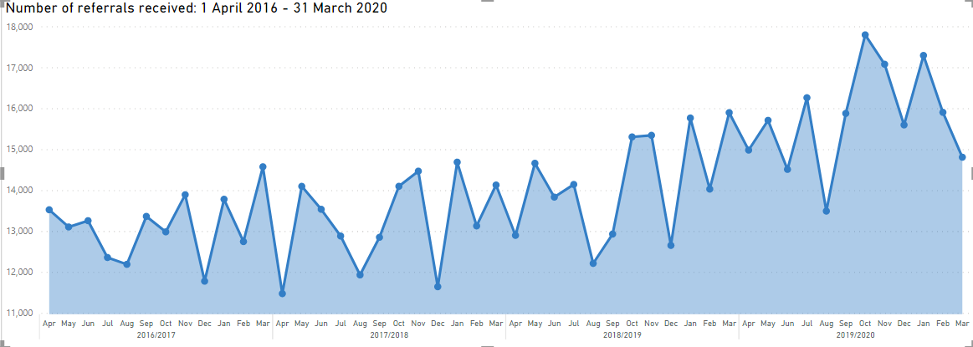
Given that annual investment by commissioners has remained essentially flat during the period of the previous strategy, the number of referrals and the pressure on the Trust’s workforce has increased considerably. Although commissioners have now all broadly achieved the minimum mental health investment that has been set out nationally, funding for both physical and mental health services remains below what is required for the needs of the population. This has resulted in detrimental consequences for service quality and instances where the Trust has fallen below one or more of its self-declared values of “Caring, safe and excellent” and sometimes all three. Whilst the Trust has already taken steps (and continues to do so) to identify new and more efficient ways of working to release both cashable and non-cashable savings, further investment or ‘caps’ will be required if the Trust is to achieve its strategic aims.
Population increase - The health and life expectancy of the population covered by Oxford Health is generally better than the England average, although there are localised areas of deprivation and poor health. In general, life expectancy is increasing, which is a success for both public health and medical science. An unwanted consequence for health services, however, is that this often results in more elderly patients with one or more long term and complex conditions. The consequences for individual trusts and the wider system are obvious and will require an integrated health and social care approach to minimise the need for hospital admissions.
In addition to the population living longer, significant population growth, fuelled by extensive house building programmes across the region, can be expected. The Trust must therefore prepare itself for further significant increases in demand for both mental health and community services leading up to 2025 and beyond.
Integrated Care Systems - The NHS Long Term Plan (published in 2019) sets out that the future of healthcare is to be increasingly collaborative. As a result, systems of integration are replacing the processes for competitive procurement and tendering that have been foremost over recent years and as such, commissioning arrangements in the area will change significantly over the coming years.
Integrated Care Systems (ICS) are how the NHS Long Term Plan intends to achieve a step-change in collaboration and integration to improve health outcomes for people and the quality and efficiency of the services providing healthcare. Integrated Care Systems place individual healthcare organisations within a larger geographical footprint (often sub-regional) within which to design and deliver healthcare services.
A key feature of ICSs is their focus on improving the overall health of populations across larger areas. They intend to do this by using a shared database for that area to have a single view of identifying and responding to the greatest health needs and risks, and to best allocate preventative services that reduce instances of ill-health and a future need for hospital admissions. At the present time, the ICSs are in the early stages of development and there is still significant organisational and cultural change that has yet to be worked out.
The potential move to delegated commissioning where existing providers of service are able to commission and deliver their own health and care services offers an opportunity for the Trust to re-evaluate its portfolio and provide new ways of working in the medium to longer term.
As a founding member of the Integrated Care System across Buckinghamshire, Oxfordshire and Berkshire (BOB) the Trust is now playing a key role in the design and delivery of healthcare services at scale. However, the Trust operates with earned autonomy overseen by a Unitary Board of Directors and a Council of Governors. With the rise of Integrated Care Systems and a national drive to join up health and care services, including the consolidation of GP practices into Primary Care Networks (PCNs), the Trust has to recognise and react to changes to its sphere of influence in the health and care services of the future.
While a lot of detail is yet to be worked out, any transition brings uncertainty and risk and the Trust must play an active role in understanding and directing the developments as the system evolves, in particular identifying where the Trust is best placed to lead and influence and where it may be better placed to support other healthcare providers.
Covid-19 response 2020 - This strategy was developed immediately prior to the coronavirus pandemic and subsequent response, lockdown restrictions and measures. As with all other NHS and key services, the virus response period (particularly during its peak) was an intensely challenging time for Oxford Health and its partners. Significant changes were made to how the organisation operated during this time, in particular the switch to digital ways of working and staff and services were continuously under intense pressure. The impact of this on staff, patients and families will continue for many months and potentially years. Recovery and restoration work began in earnest in June 2020 and will inform the direction of this strategy over the short-medium term. The key priorities following the first wave of the pandemic are to:
- embed the learning and to build upon all the positive improvements that have been rapidly made during the Covid-19 Response phase;
- make the necessary cultural changes to ensure that positive changes are not reversed;
- take advantage of any new opportunities to adapt how the Trust works and really focus on supporting the Trust’s people, leadership and culture agenda.

Section 4 - The Trust Strategy
The NHS Long Term Plan presents new challenges and opportunities for the Trust. Following on from the strategic review led by Lord Carter in 2016/17, there is now an expectation that all Trusts will deliver services in line with national best practice. This expectation poses a significant challenge to the Trust given the strategic context and challenges that have been set out in Section 3.
In setting out its strategy, the Trust is consolidating its response and corresponding activities into a core set of objectives that focus on:
- Quality
- People
- Sustainability
- Research and education

These strategic objectives have been developed into a new integrated strategic assurance framework that allows activities to be aligned and managed using one approach. The diagram in Appendix 6 shows how the strategic framework has been assembled and informs the structure of future reporting to the Executive Team and Board of Directors.
Further details on the strategic objectives, along with the measures that will be used to monitor and track progress against each objective, are described below and in Section 6 [to follow in final draft].
The four strategic objectives for the Trust that will guide future planning, activity and decision-making are:

- Quality – Deliver the best possible care and outcomes

- People - Be a great place to work

- Sustainability – Make the best use of our resources and protect the environment

- Research and education - Become a leader in healthcare research and education

Deliver the best possible care and outcomes

The Trust should realign services in a systematic way to maximise the value of the clinical staff that it has available. That will mean:
- Identifying and focusing Trust resources on core services and those where the Trust has a specific duty;
- Improving our feedback processes to better understand and improve overall patient experience;
- Continuing to develop our preventative offers and skills to reduce future need and demand for care;
- Ensuring our services remain safe and embed strong processes to learn from practice including a systematic review of learning over time
- Improving the quality and experience of care through collaboration and integration opportunities – for example, integrating community and primary care and health and social care;
- Supporting and developing leaders within the Trust so that quality improvement can be embedded within the culture;
- Wherever possible, give people greater opportunities to manage their health themselves;
- Being a leader in integrated care and establishing person centred models – particularly in our areas of expertise e.g. mental health, learning disabilities and autism and community services.

In support of the focus on quality, the Trust has already created Oxford Healthcare Improvement (OHI) which provides a focal point for learning, collaborating and improving the safety and quality of the care that the Trust provides. The principal aim is to support the Trust to work towards the adoption of a more open, coherent, and systematic approach to improvement and organisational development, one which is owned by everyone so that the Trust can become an outstanding provider of integrated services.
OHI seeks not only to continuously improve the services for patients but, crucially, aims to enhance the working lives of staff, thereby improving morale and, hence, productivity and retention. The principal approach for all quality improvement is to focus on the training and development needs of the leaders and managers throughout the organisation.

Be a great place to work
The Trust has long recognised that its workforce, partners and volunteers are its greatest asset. Developing strong leadership and a great culture for everyone is a foundation stone for the Trust. Securing and developing a highly skilled, experienced and motivated workforce is key in the delivery of high quality, safe and efficient services. A specific challenge for all partner organisations will be to capitalise on the investment in the NHS Long Term Plan and attract, develop and retain a workforce that is supported to deliver care in the best and most appropriate way. Within this priority, it is proposed that:
- The Trust focuses on the development of a ‘great’ culture that retains staff and is a place where people want to work
- The People, Leadership and Culture sub-committee of the Board supports a systematic review and programme of change to develop a fair and inclusive culture with strong leadership that supports and develops staff;
- Coaching and mentoring, in particular for middle management and aspiring leaders becomes available to all
- The Trust improves its workforce planning capabilities – attraction, retention, training and career planning;
- Develops a strong and stable workforce that has a broad range of skills that are flexible and can adapt to future healthcare needs;
- The Trust develops leadership networks that allows its workforce to collaborate and share ideas and improvements;
- The Trust focuses as a primary objective on improving equality, diversity and staff engagement initiatives that tackle the underlying causes of stress, bullying and harassment;
- Annual Performance Development Reviews (PDRs) are carried out effectively and that aspiring leaders and managers are identified, assessed and developed
- The Trust supports its leaders and managers in decision making and in managing in times of risk, pressure and uncertainty.

Make the best use of our resources and protect the environment
Ensuring that the Trust’s workforce has access to modern and reliable equipment, systems, information and places of work is fundamental to the delivery of high quality, efficient and effective services. By focusing on the development of staff and the delivery of high-quality core services, the Trust has the potential to release resource for re-investment. This will, as a result improve the existing conditions and go some way to contributing to the additional costs and efforts required to achieve the NHS Long Term Plan ambitions.
The NHS Long Term Plan clearly highlights the importance of increasing digitally enabled care to improve access, outcomes and experience. One of the many NHS Long Term Plan ambitions is to design and adopt new models of service provision that provide patients with more options, better support and joined up care.
Harnessing the power of digital to transform services and to open up new opportunities is a core enabler for this strategy. The foundations for such a move have been firmly laid during the Covid-19 pandemic and the Trust must continue to build on and invest in the development of digital services as an alternative to the traditional ways of working within the NHS.
The Trust has already started to invest in digital enablers that will transform service delivery for both patients and staff and was awarded Global Digital Exemplar (GDE) status in 2017. As part of a national programme sponsored by NHS Digital, the Trust has already delivered a number of benefits that will enable the development of self-care, reducing the number of face to face appointments, supporting people to stay well by managing their own health and allowing more people to stay at home. Within this priority, it is proposed that the Trust:
- Reviews its financial management disciplines with a view to the better alignment of budgets against priorities
- Continuing the work that has already been started to improve budget/cost centre management and the controls over authorised expenditure
- Reviews its current service portfolio and identifies what parts of
the estate could be re-purposed or released as part of new ways of working;
- Identifies how the efficiency of care delivery can be monitored and the information used to improve services (e.g. waiting times) and target future investment;
- Increase use of analytics to inform decision making to best meet need and prevent ill-health (collaborating with local partner public services to understand population needs to inform preventative services and be able to act more proactively);
- Removing unnecessary overheads that consume clinical time that have no value to patients;
- Jointly designs and creates its pathways of care using experience from patients, population insights (e.g. priority groups) and from research and innovation;
- Identifies and agrees where further investments in IT and Digital will be made to reduce face to face contacts, reduce travel and maximise productivity, building on the changes that have already happened during the Covid-19 response phase;
- Continually improves organisational effectiveness through enhanced co-ordination, streamlining and productivity.

In order to achieve a financially sustainable organisation, the Trust will continuously review its current portfolio of services and its methods of operation with a view to realigning and in some cases reducing its current activities and ways of working. This is to ensure that scarce resources, human, financial and material, are all focused on direct patient care. In a climate where it is unlikely that there will ever be sufficient workforce or funding to cover rising demands the Trust must take steps to better align its service offers within its own means.
A comprehensive review of demand and capacity management is already underway so that there is a comprehensive model for each service line across the Trust. Over the next year or so, the whole Trust will be reviewed and decisions about acceptable levels of activity can be taken by the Board once the outcome of this current work is known.
In addition to that work the Trust will:
- Continue to work with its commissioners and system partners to ensure sustainable levels of funding for services;
- Improve the allocation of resources to better meet areas of greatest need and health outcomes;
- Achieve a greater insight into the demand for its services, against the funded capacity and ability to deliver;
- Review community inpatient settings within the Trust. Recent evidence suggests that the bed stocks, particularly in Community Hospitals, is above the national average and could be reduced. It has also been identified that providing care closer to home produces better outcomes for patients rather than traditional in-patient settings;
- Review the current line management structure with a view to streamlining the arrangements where possible;
- Maximise its resource time available by ensuring that governance and reporting arrangements are appropriate – in particular in responding to commissioners and regulators;
- Give critical importance to reducing agency usage to a minimum, the Improving Quality and Reducing Agency programme has now been adopted as a Strategic Programme and resourced appropriately within the Trust;
- Focuses on initiatives to safely reduce its carbon footprint and overall use of resources so that the Trust achieves its green ambitions in accordance with its social responsibility and national targets.

Become a leader in healthcare research and education
The Trust is committed to integrating research alongside clinical care to allow all patients to benefit from participation in research. Already one of the top two NHS organisations for mental health research, the Trust has strong relationships with world class academic institutions including the University of Oxford and Oxford Brookes University. The Trust hosts a wide range of NIHR research infrastructure including the NIHR Oxford Health Biomedical Research Centre, one of only two UK BRCs focused on mental and dementia in the UK. The partnership is particularly strong in working with patients to develop new treatments, including both drug and talking therapies for mental disorders.
Research has been defined as a core priority within this new Trust Strategy and we will extend our research excellence across all services including building research activity within our community services. As a core partner in Oxford Academic Health Partners (a collaboration between the two Oxford NHS Trusts and the two universities), the Trust is firmly committed to building its support of research and innovation and embedding it into clinical practice to improve patient safety, outcomes and experience.
Together with its academic partners in the OAHP, the Trust’s priorities will include:
- Building on local assets and partnerships in research infrastructure and educational capacity to drive improved outcomes for patients, the population, researchers, and staff.
- Foster the development and evaluation of transformative technologies and innovations locally and in partnership with other AHSCs, AHSNs and BOB ICS
- Join the planned OAHP Research Office to deliver close formal coordination of research infrastructure including NIHR Centres, Facilities and Collaboratives alongside other major Centres and Institutes, to ensure pull through from its world class basic research to clinical practice.
- Expand capacity in target discovery for new drugs, building on public-private partnerships
- Extend the environment for innovation, spin outs and start-ups to accelerate the transitions from scientific discovery to clinical application for patient benefit, by working between Partners and with internal and external investors.
- Promote new multidisciplinary research and educational opportunities to support increased capability, capacity and training for under-provided nursing and AHP disciplines

In addition to the above Trust-wide strategic objectives, the priorities as set out within the NHS Long Term Plan and Buckinghamshire, Oxfordshire and Berkshire West (BOB) ICS form a major part of the Trust strategy. These regional themes include: Urgent and Emergency Care; Cancer; Children’s Services; Maternity; Mental Health (including Learning Disabilities and Autism); and Primary Care & Community Services. All of which the Trust contributes to in some way.
The Trust is a major provider in the delivery of mental health, learning disabilities and autism services within the BOB system, along with Berkshire Healthcare Trust. Community Services are provided at a place level (e.g. each County provides its own service) and all organisations now work in conjunction with the nationally defined Primary Care Networks (PCNs).
Within the BOB ICS areas of focus, the Trust has greatest control and influence over Mental Health services, Learning Disabilities and Autism services, and Community Services.
In developing this Trust Strategy, the Board has been mindful of the aspirations of the NHS Long Term Plan, the Five-Year Forward View for Mental Health and NHS Improvement planning guidance and has sought where possible to align Trust objectives with those wider intentions. It has at the same time sought to take account of what is realistically possible given current and anticipated resource constraints, also to reflect a perceived need to make itself fit to deliver what is required, especially in terms of qualified staff and financial resources.
Section 5 – What are we aiming to achieve by 2025?

[In development – summaries to add to final draft]

- Mental Health

- Community Health

- Children & Young People

- Learning Disabilities & Autism

- Research & Development

- Workforce Planning

- Finance and Sustainability

Section 6 – Strategic framework - from vision to metrics

The Trust has developed a strategic framework to link its vision and values to a set of Trustwide measures and metrics via its strategic objectives and key focus areas. The image below illustrates the strategic framework.

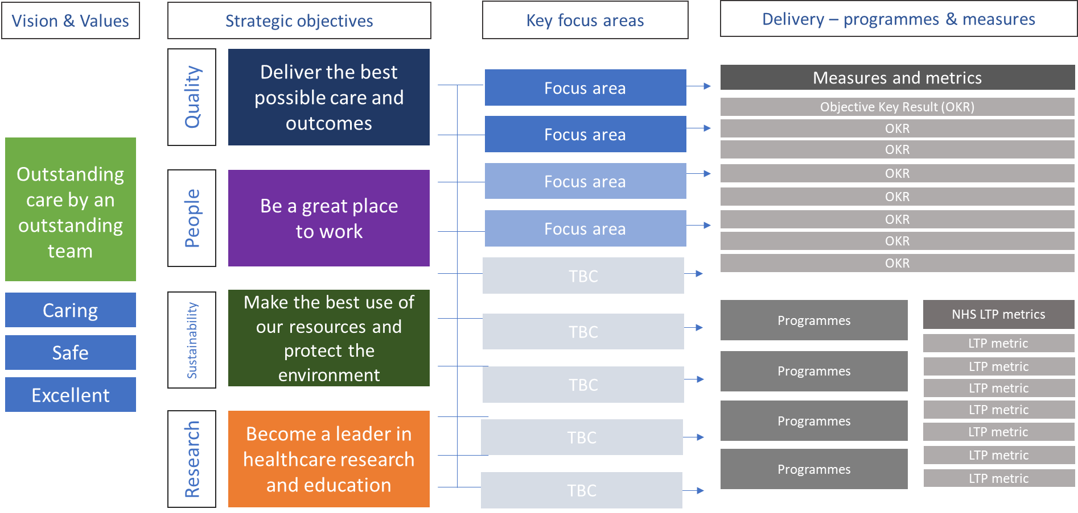

To move from strategy into delivery, the Trust’s has developed its strategic objectives into a set of key focus areas. These focus areas:
- help to describe the key areas of focus within a strategic objective and its individual elements;
- enable each strategic objective to be divided into discrete areas of attention and work, and;
- allow for oversight and development of measures to track progress - Objective Key Results (OKRs) and NHS Long Term Plan metrics

[Tables / Image to insert once finalised to show full list of OKRs across strategic objectives]

