

# Report to the Meeting of the

# Oxford Health NHS Foundation Trust

**BOD 20/2020**  
(Agenda item: 9)

# Board of Directors

# April 30th, 2020.

# INPATIENT SAFER STAFFING Report Period 30th December 2019 to 22nd March 2020

**For: Information**

**Executive Summary**

**Ward Staffing**

The purpose of this paper is to provide the Trust Board with an interim exception report in line with the requirements of: “How to ensure the right people with the right skill are in the right place at the right time”, Chief Nursing Officer for England & National Quality Board November 2013. From June 2014, there has been a Department of Health requirement for trust boards to receive monthly updates on ward staffing levels. Ensuring sufficient staffing levels are in place is crucial to deliver safe, effective and high-quality care. This report will be published on our website with a link from NHS Choices website.

The data within the report will outline the staffing levels (for both registered and unregistered nursing staff) on each ward. These figures will be measured against the required figures on a shift by shift basis for the period 30th December 2019 to 22nd March 2020 (three months roster period) in line with the requirements of the DH Unify reporting process and the data extract is attached (Appendix 1).

During this period:

Average weekly day shifts fill rates for registered staff & unregistered staff were above the Trust target of 85% with 86% or above for unregistered and 98% or above for registered staff.

During the period 30th December to 26th January five wards were below 85% for registered nurses:

Cotswold House Oxford, Cherwell, Highfield, Marlborough House Swindon and Vaughn Thomas there were above 94% fill rates of unregistered staff.

During the period 27th January to 23rd February two wards were below 85% for registered nurses Cherwell and Vaughn Thomas

During the period 24th February to 22nd March, eleven wards were below 85% for registered nurses, including Cherwell.

Average weekly night shifts fill rates for registered staff and unregistered staff across all wards was above the Trust target of 85% rates, they remained above 100% for registered staff for each week and 87% or above for unregistered staff.

The methods of filling these shifts includes substantive, flexible workers and agency registered staff and further detail in provided later in the report.

The average weekly % agency use was 11.5% an increase from 10.5% in the last reporting period.

Average sickness rates for ward staff were 6.7% a decrease from 7.3% in the last reporting period.

**Recommendations**

The Board is asked to note:

* There are processes in place to ensure safe staffing levels on all the wards in the organisation, those wards where there are concerns and the actions being taken to ensure safe staffing including project work and wider recruitment and retention work. There are no exceptions to report that directly link actual staffing levels to adverse outcomes for patients which have been identified through our Governance Structures and no direct escalation to the Chief Nurse regarding staffing concerns during this period.
* During the COVID19 pandemic a dashboard has been developed in order to see on a daily basis all inpatient staffing levels including medical cover. This details numbers of patients and staff who are COVID19 positive.

**Author and Title:** Kate Riddle, Deputy Director of Nursing and Clinical Standards

**Lead Executive Director:** Marie Crofts Chief Nurse

*A risk assessment has been undertaken around the legal issues that this paper presents and there are no issues that need to be referred to the Trust Solicitors. This paper links to all the five CQC Domains.*

***Strategic Objectives*** *– this report relates to or provides assurance and evidence against the following Strategic Objective(s) of the Trust*

*Driving Quality Improvement (Goals: patients will be safe from harm; patients will achieve the clinical outcomes they want; and patients and carers will have an excellent experience)*

*Delivering Operational Excellence (Goals: our services will be effective and efficient; information will be translated into knowledge; and our planned surplus will be delivered)*

**Inpatient Safer Staffing**

**Period 30th December 2019 to 22nd March 2020**

**Introduction**

This is the report to the Board of Directors outlining the staffing levels (registered and unregistered) on each ward against their required need on a shift by shift basis. These figures will be measured against the required figures on a shift by shift basis for the period 30th December 2019 to 22nd March 2020 (three months roster period). The context for some of this period is COVID 19 in the UK.

This report will focus on the percentage of day and night fill rates for registered and unregistered staff. This data is reported to NHSI and provides assurance of actual clinical staffing numbers being achieved. This report will be published on our website with a link from NHS Choices website.

**Management of Staffing Levels**

Anescalation process for the management of staff shortages is in place within each clinical area, to manage staffing safely on a shift by shift basis. As part of this process, senior clinical staff are providing appropriate support to ward teams as and when required. In addition, senior ward staff and immediate team managers review ward staffing levels on an on-going basis; shift by shift basis, and where there are changes in patient acuity. Ward Matrons review staffing daily as a minimum and more frequently where required.

In-patient staffing levels continue to be reported every week and discussed within the Weekly Review Meeting (WRM), which takes place each Monday morning with the Chief Nurse and/or Deputy present. To ensure that staffing levels are under continual review, every ward undertakes a range of immediate actions daily to ensure safe staffing levels are maintained appropriate to the needs of patients. These actions include booking flexible or agency staff via Staffing Solutions, revising rotas, moving staff between wards and utilising additional staff that are not included in the ward numbers as required for example modern matrons. Forward View meetings also occur weekly within directorates to plan forward for required staffing.

During this period of COVID19 pandemic a dashboard has been developed in order to see on a daily basis the position regarding staffing on all wards across the Trust. This includes registered; un-registered nursing staff as well as medical cover. Numbers of patients and staff who are COVID19 positive are included in the dashboard so at a glance the executive team are able to see the position across the organisation and any specific ‘hotspots’.

The current position is:

* 25 patients COVID19 positive
* 151 COVID19 positive patients in total since 15th March 2020
* Sadly we have had 20 patient deaths from COVID19 – 12 patients over 85 years of age and 8 between 65-84 years old
* All deaths, except 2 were within our community hospitals
* The 2 deaths within mental health were on Amber ward

**Summary position of inpatients wards staffing levels.**

Appendix 1 shows the staffing levels for all wards by ward for the period. The data presented includes details of staffing by shifts and details of registered nursing and unregistered staff skill mix, agency, total ward staff sickness and total ward vacancy figures. The thresholds presented in the table are measured against trust/ national targets and used for exception reporting.

During this period:

**Day shifts fill rates**

Average weekly day shifts fill rates for registered staff & unregistered staff were above the Trust target of 85% with 86% or above for unregistered and 98% or above for registered staff.

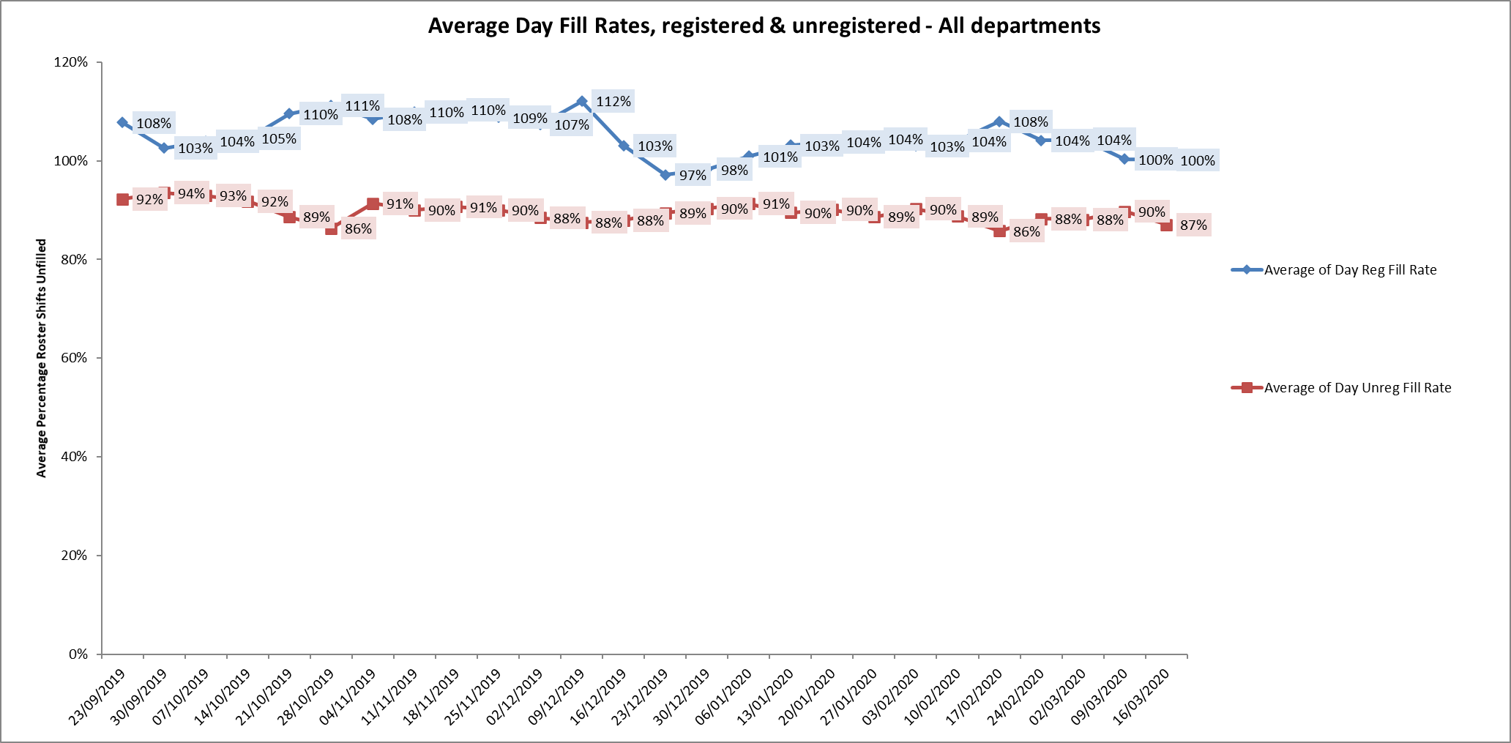

During the period 30th December to 26th January five wards were below 85% for registered nurses:

Cotswold House Oxford, Cherwell, Highfield, Marlborough House Swindon and Vaughn Thomas there were above 94% fill rates of unregistered staff.

During the period 27th January to 23rd February two wards were below 85% for registered nurses Cherwell and Vaughn Thomas

During the period 24th February to 22nd March, eleven wards were below 85% for registered nurses, including Cherwell.

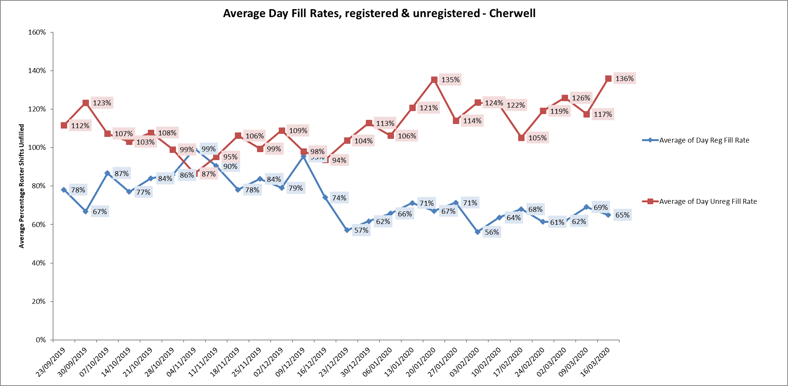

**Night shift fill rates**

Average weekly night shifts fill rates for registered staff and unregistered staff across all wards was above the Trust target of 85% rates, they remained above 100% for registered staff for each week and 87% or above for unregistered staff.

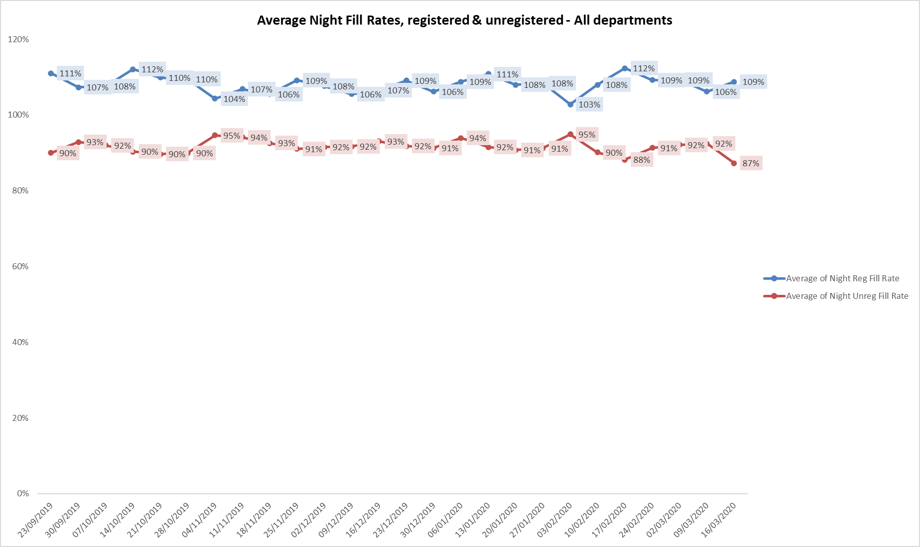

**Registered skill mix**

This was above 50% for 13, 12 and 14 wards during the three months roster periods, a decrease from 15 in the last period.

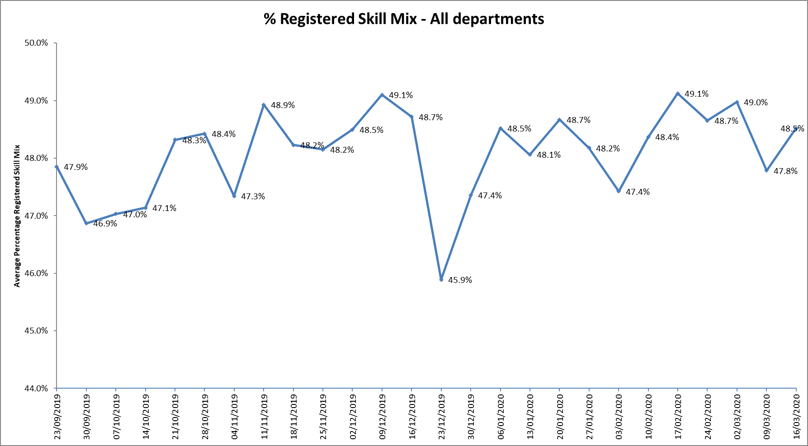

One ward Kestrel was below 35% average for the whole period, this is the same position as the last reporting period.

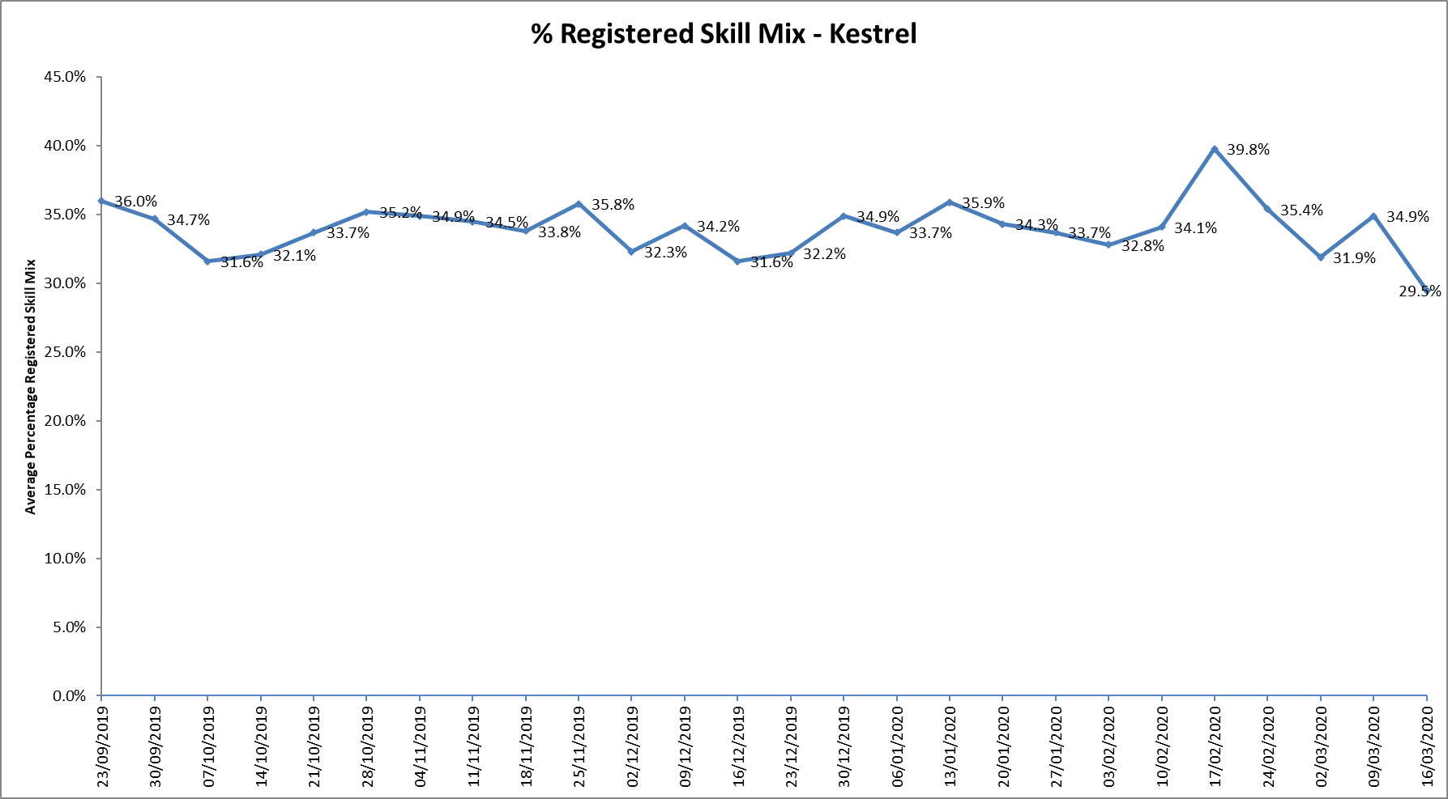

For those wards with below 50% registered skill mix, this is related to the continued registered nurse vacancies. Safe staffing is supported by the ward managers and matrons on the ward working clinically as part of the numbers where required to ensure registered nursing leadership is maintained.

Skill mix is achieved through use of our own staff and trust employed flexible registered workers and agency registered nurses.

**Agency use**

Ongoing work to reduce use of Trust wide use of agency is in progress. An ‘Improving Quality Reducing Agency’ programme board has been set up, one of the goals of this new Programme is be sustainable and over-arching agency reduction, for both the financial and quality goals.

The board is chaired by the Chief Nurse with the following work streams:

• Engagement & Retention

• Workforce development

• Managing Temporary Staffing - Rostering & Establishments

• Recruitment

The work streams include Operational leads, HR leads and engagement from clinical staff including matrons and senior matrons.

At the current time this work is on hold given the global pandemic. However the workstreams are up and running and will step up in the next 3 months.

The average weekly % agency use was 11.5% an increase from 10.5% in the last reporting period. This remains below the peak of 19.1% in February 2018. The context during this time was managing in the COVID 19 situation where wards have been caring for COVID19 positive patients and ta times needing additional nursing staff.

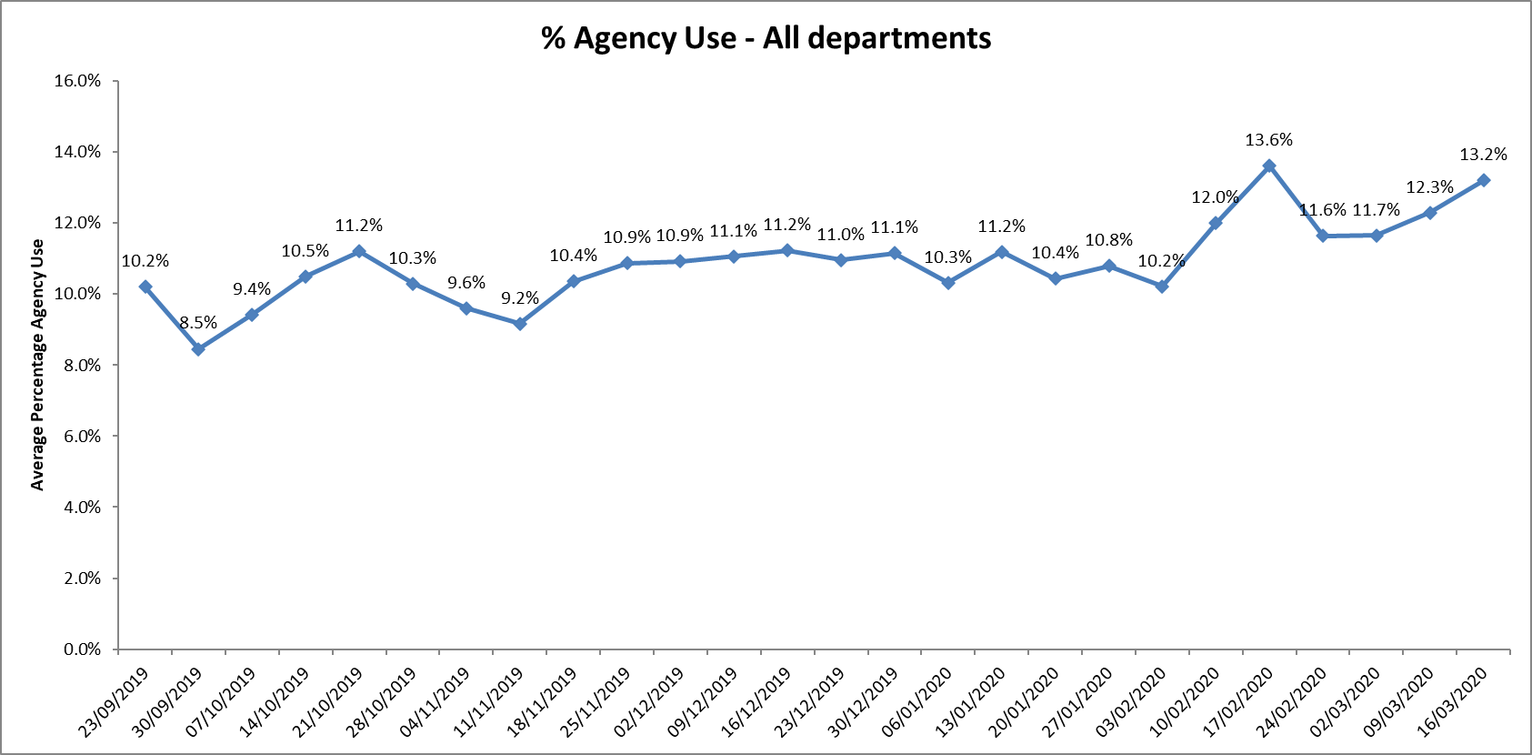

* Ten wards required less than 5% average agency use during first period and this decreased to two wards in the second period and increased in the third period to nine wards.
* Six wards required between 5 and 10% average agency in the first period this reduced to five in the second period and increased to seven in the third period
* Sixteen wards required more than 10% average agency in the first period this increased to twenty four wards in the second period and decreased to eighteen in the third period
* Two wards Allen and Highfield required above 20% average agency staff throughout this twelve-week period. This was related to a mixture of sickness, vacancies and specifically patient acuity at the Highfield Unit.

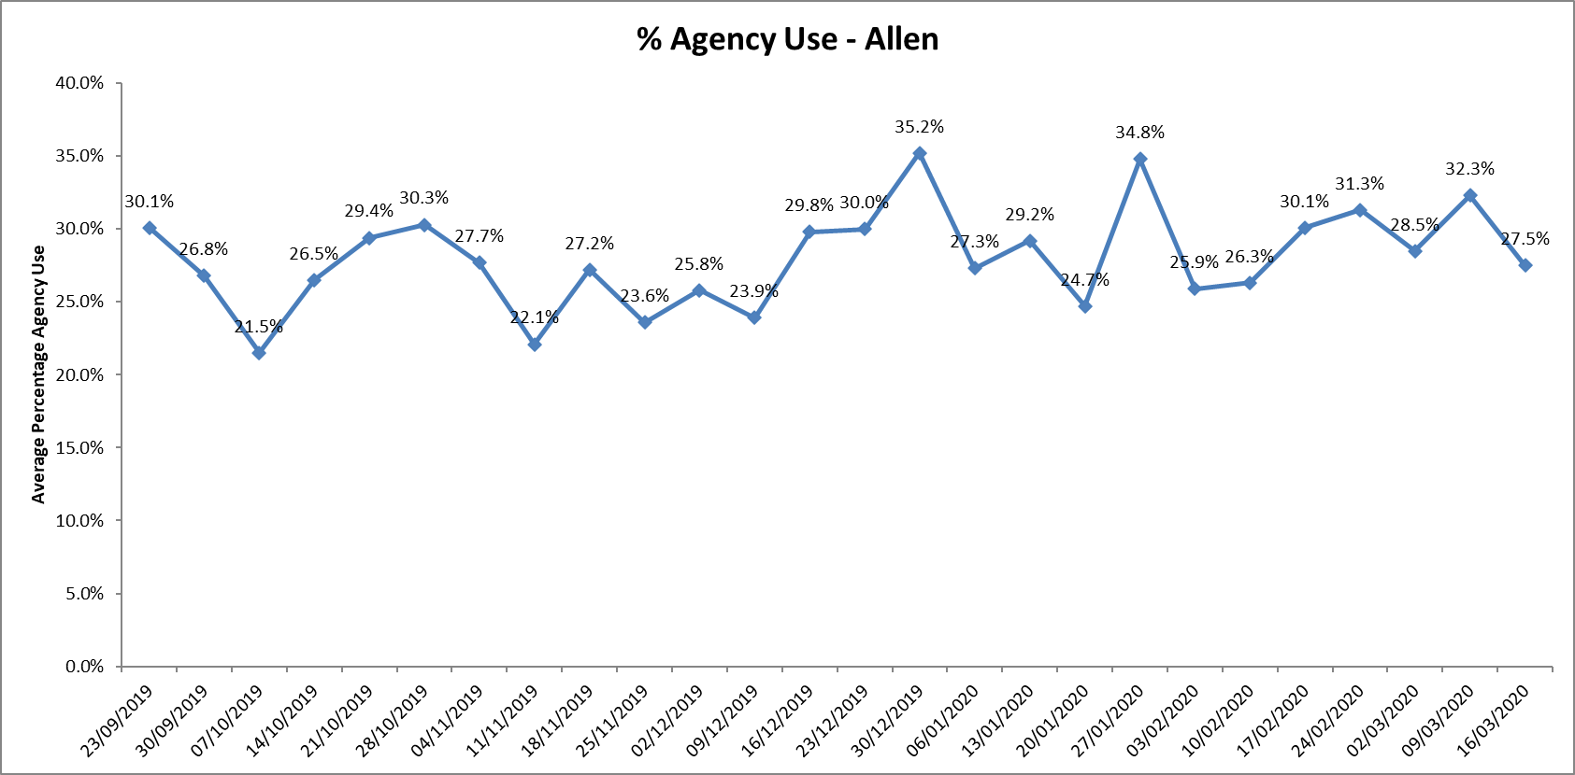

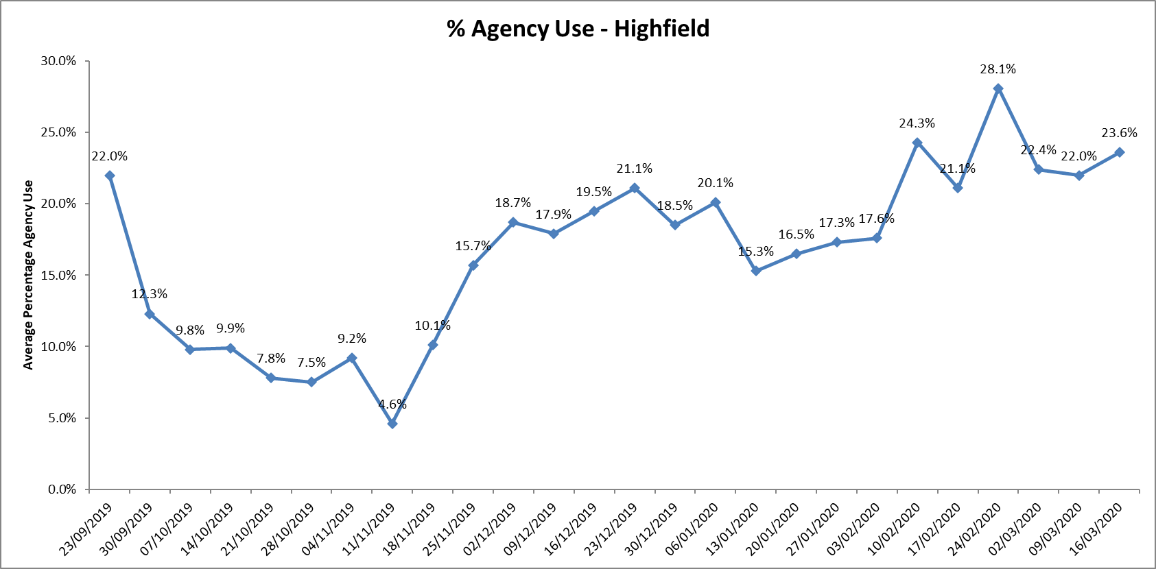

During this period there were no escalations directly to the Chief Nurse regarding staffing concerns.

Further detail of agency use and spend is provided in the Workforce report.

**Conclusion**

All ward staff and managers continue to make every effort to ensure wards continue to be staffed safely, fill rates remain high for most wards and that we continue to focus efforts on retaining our staff whilst recruiting new nurses to join Oxford Health FT.

**Author and Title:** Kate Riddle, Deputy Director of Nursing and Clinical Standards





