Report to the Meeting of the

Oxford Health NHS Foundation Trust
BOD 39/2021
(Agenda item: 13)

Board of Directors

09 June 2021

Annual Complaints and Concerns Report

For: Assurance

Executive Summary
This is the annual report on the management of formal complaints, patient advice and liaison service (PALS) contacts, MP enquiries and compliments received by Oxford Health NHS Foundation Trust (OHFT) from 1 April 2020 to 31 March 2021.

Key highlights of the report are:

- 206 complaints were received which is a 17% decrease compared to the previous year when 253 complaints were received
- 100% of complaints were acknowledged by the Complaints & PALS Team within the NHS Complaints Regulations (2009) of three working days.
- OHFT received 59 formal MP enquiries from 1 April 2020 to 31 March 2021 and 32 informal enquiries.
- PALS received 2,030 contacts during the year which is similar to the previous year (2019/20) when 2,065 contacts were received. 35 PALS surgeries have continued to be ran virtually during COVID-19 and more recently have included the input from volunteers again.
- OHFT received 2,384 compliments between 1 April 2020 and 31 March 2021.
- In 2020/21 the ombudsman (PHSO) made enquiries about seven closed complaint cases of which four have commenced to an investigation.
- Over the year 121 actions were identified across the Trust following the completion of a complaint investigation. The main reoccurring theme for improvement across the Trust is how involved patients and families feel in decisions about their care, including related matters around confidentiality, information provided and communication with staff members. A Quality Improvement programme has been initiated in relation to this theme being led by the Clinical Directors and supported by the Oxford Health Improvement (OHI) Centre.

There continues to be a high number of extension requests across Directorates (67%) resulting from a delay in allocation of complaints and a lack of availability of staff to undertake the investigation due to annual leave, sickness, current work pressure and the impact from Covid-19. The average response time to a complaint is 44 days. A pilot is due to start shortly to improve how timely the investigator officer or a senior clinician contacts a complainant within 3 working days of receipt of a concern to try and resolve issues more quickly and to help set more realistic timescales for responses based on the complexity of concerns to reduce the need for requesting an extension.

Oxfordshire, BaNES (Bath and North East Somerset), Swindon and Wiltshire Mental Health Services have received the highest number of complaints (93) and sought the most extension requests during the time. Trust-wide of the 165 complaints investigated and responded to, 63% were fully or partially upheld. Most complaints were made by carers/family members.

The Trust receives the most concerns and complaints in the category of ‘all aspects of clinical care’ (286) of which 100 related to insufficient care in the community and 31 related to medication issues. We also received complaints relating to staff attitude/behaviour (116), 160 cases were about communication/information sharing and 98 were about access to services/waiting times.

The teams highlighted as receiving the most formal complaints and concerns are; Oxon City and North East Adult Mental Health Team, Bucks Aylesbury Adult Mental Health Team and Oxon North and West Adult Mental Health Team. The main reasons for the complaints/ concerns are similar in relation to communication/ information sharing and staff behaviours. Work on customer service is being planned to try and resolve the regular concerns being raised.

From September 2020 we introduced two separate feedback forms for both complainants and staff involved in complaints (those interviewed as part of the investigation) to gain an understanding of people’s experiences and to look at ways of improving the complaints process. Currently we have received a very small number of responses however each response is reviewed to identify any changes that can be made.

A national review of the NHS Complaints Standards has been undertaken by the Ombudsman on how NHS services should approach complaints handling. The draft standards aim to support organisations in providing a quicker, simpler, and more streamlined complaints handling service, with a strong focus on early resolution. The Standards are being tested in 2021 and will be refined and introduced across the NHS from April 2022. The Complaints and PALS Team Manager and Head of Quality Governance have reviewed the Trust’s position against the draft Standards and identified some areas for improvement including;
- More timely contact by the investigating officer/ senior clinicians when a complaint is received to try and resolve issues as quickly as possible
- Improve how learning from complaints is disseminated

Governance Route/Escalation Process
The Annual report was presented to the Trust’s Quality Committee on 13th May 2021 and needs Board approval prior to being published. The Quality Committee is fully assured the Trust is meeting the necessary requirements.

The Trust’s Quality and Clinical Governance Sub-Committee receive a quarterly report and any escalations on complaints and concerns. Every new complaint and MP concern is also reviewed weekly by the Senior Clinical Weekly Review Meeting.

Statutory or Regulatory responsibilities
This paper provides assurance that the Trust is compliant with the statutory requirements around complaints handling detained in the following regulations, the;
- Care Quality Commission’s outcome 16: complaints.
- NHS Complaints (England) Regulations 2009
- NHS Constitution and patient’s rights
- Ombudsman’s principles of good complaint handling 2008.

It is a national requirement for NHS Providers to publish an annual complaints report.

Recommendation
The Board is asked to approve the annual complaints report for publication.

Author and Title: Jane Kershaw, Head of Quality Governance
Claire Price, Complaints and PALS Team Manager

Lead Executive Director: Marie Crofts, Chief Nurse

- A risk assessment has been undertaken around the legal issues that this report presents and there are no issues that need to be referred to the Trust Solicitors
- Strategic Objectives/Priorities – this report relates to or provides assurance and evidence against the following Strategic Objective(s)/Priority(ies) of the Trust;
Quality - Deliver the best possible care and health outcomes

Introduction
This is the annual report on formal complaints, patient advice and liaison service (PALS) contacts, MP enquiries and compliments received by Oxford Health NHS Foundation Trust (OHFT) from 1 April 2020 and 31 March 2021. This paper provides assurance that the Trust is meeting the legal regulations for the Care Quality Commission’s regulation 16: receiving and acting on complaints. It is a national requitement for NHS Providers to publish an annual complaints report.

Highlights
The Trust receives a variety of enquiries and requests for help and information through PALS and from local MP’s. OHFT receives complaints relating to all services provided by the Trust. The Trust remains up to date with complaints management despite the pressures of the COVID-19 pandemic. Many concerns continue to be resolved locally by senior clinicians who can resolve these promptly. This can also prevent the escalation of a complaint. Key highlights from the report are as follows:

- Between 1 April 2020 and 31 March 2021, OHFT received 206 complaints which is a 17% decrease compared to the previous year when 253 complaints were received. The number of complaints received by quarter is broken down as follows; 44 complaints in Quarter One (April to June 2020), 53 complaints were received in Quarter Two (July to September 2020), 54 complaints in Quarter Three (October to December 2020) and 55 complaints were received in Quarter Four (January to March 2021).
- OHFT received 59 formal MP enquiries from 1 April 2020 to 31 March 2021 and 32 informal enquiries.
- PALS received 2,030 contacts during the year which is similar to the (2019/20) when 2,065 contacts were received. The breakdown of the type of contacts is detailed below.
- OHFT received 2,384 compliments between 1 April 2020 and 31 March 2021 which is a 17% decrease when compared to the previous year.
- We have four ombudsman (PHSO/LGO) cases open currently. In 2020/21 the ombudsman made enquiries about seven closed complaint cases of which four have commenced to an investigation.
- Over the year 121 actions were identified across the Trust following the completion of a complaint investigation.

The Trust continues to actively monitor the key themes identified within complaints received alongside information produced through other sources of feedback such as Serious Incidents, Legal Claims, Inquests and HR investigations. Discussions to triangulate the information take place on a weekly basis at the Trust-wide Clinical Weekly Review Meeting and monthly at the Trust-wide Quality and Clinical Governance Sub-Committee.

The main reoccurring theme for improvement across the Trust is how involved patients and families feel in decisions about their care, including related matters around confidentiality, information provided and communication with staff members. A Quality Improvement programme has been initiated by the Chief Nurse in relation to this theme being led by the Clinical Directors and supported by the OHI Centre. There is also some customer service work being planned to try and resolve some of the concerns being raised.

Number of Complaints Received
There has been a small decrease in the number of complaints between 1 April 2020 and 31 March 2021 when 206 complaints were received, compared to the previous year when 253 complaints were received. The below graph shows the number of Trust-wide complaints received by month over the last 2 years, the average has remained at 19 complaints per month.
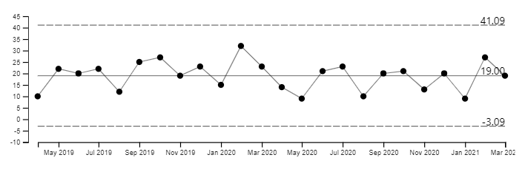
As shown in the graph above, in 2020/21 there have been increases above the average in specific months (June, July, September, October and February) however no significant trend showing consecutive points above/below the average. 22 complaints were re-opened, and further investigations were completed. Oxfordshire, BaNES, Swindon, and Wiltshire Mental Health Services received the highest number of complaints (23 in Q4 and a total of 93), Buckinghamshire Mental Health Services (14 in Q4 and a total of 51), Community Services (12 in Q4 and a total of 45), Specialised Services (5 in Q4 and a total of 14) and Corporate Services (1 in Q4 and a total of 3). 40 complaints were withdrawn during this period and were dealt with locally through the PALS route.

The largest group of complaints were received from carers/family members (n=100) and 79 complaints were received from patient’s/service users.

Timeliness of Responding
Between 1 April 2020 to 31 March 2021, 206 complaints have been received, of which 100% were acknowledged by the Complaints & PALS Team within the NHS Complaints Regulations (2009) of three working days.

Of the 206 complaints which have been investigated and responded to, all of these (100%) were within a timescale agreed and communicated with the complainant. However there continues to be a high number of extensions required by investigating officers across the Trust, out of the 165 complaints which have been investigated and responded to, 109 (67%) cases had an extension in place. The main reasons for extensions are a delay in the allocation of a complaint, an investigating officer being unable to complete the investigation within time due to their workload, annual leave, or a pause due to the response to the COVID-19 outbreak.

In 2020/21 very few complaints had to be paused due to COVID-19 and all were restarted within about a month of pausing. The extension figures broken down by Directorates are as follows;
- Buckinghamshire Mental Health Services 27 complaints were extended,
- Oxfordshire, BaNES, Swindon and Wiltshire Mental Health Services 51 cases,
- Community Services 17 cases,
- Specialised Services six and
- Corporate Services one case.

The number and themes from complaints, as well as extensions and delays are monitored and reported on a weekly basis.

Alongside extensions we closely monitor response times. In Oxfordshire, BaNES, Swindon and Wiltshire Mental Health Services the average number of days in 2020/21 to respond to a complaint is 41 days (currently the longest time it has taken is 144 days due to an SI investigation). Within Buckinghamshire Mental Health the average number of days for responding to a complaint is 40 days and the longest timescale was 126 days. Within Community Services the average number of days for responding to a complaint is 34 days and the longest timescale was 103 days. In Specialised Services the average number of days is 37 days and the longest time is has taken is 76 days.

As of 31 March 2021, the Trust had three complaints open (two about the same patient) which had been received more than 6 months ago. All three complaints were following a patient’s death were on hold whilst an SI investigation was being completed. The complainants were kept informed throughout. At the time of writing this report the longest open complaints are two that were received in Nov 2020 (coming up to five months) and are due to be completed in the next few weeks.

A pilot is due to start shortly to improve how timely the investigator officer or a senior clinician contacts a complainant within 3 working days of receipt of a concern to try and resolve issues more quickly and to better set realistic timescales for responses based on the complexity of concerns to reduce the need for requesting an extension.

Grading of Complaints
All complaints are graded based on severity of harm to the patient using a national risk matrix with a rating of green, yellow, orange or red. Every new complaint and all re-opened complaints are screened for any safeguarding concerns, sent to the Clinical Director and Head of Nursing, and discussed at the Weekly Clinical Review Meeting.
From the 206 complaints received:
- 179 (87%) were graded green,
- 14 (7%) were graded yellow;
- 11 (5%) complaints were graded orange and
- 2 (1%) complaint was graded red.

The graph below shows the number of complaints received by month and by risk rating.

Grade of Complaints
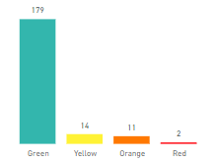

Outcome of Complaints
Of the 165 complaints which have been responded to, 34 complaints were upheld (21%), 53 complaints were not upheld (32%), 70 complaints were partially upheld (42%) and for eight cases there was no evidence to prove or disprove (5%). The graph below shows the outcomes of complaints.

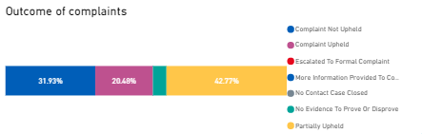

Actions
After the investigation into each complaint, if there are any upheld elements or any improvements in practice identified then an improvement plan is developed by the relevant service manager/matron. Between 1 April 2020 and 31 March 2021, of the 165 complaints which have been responded to, 121 actions were identified across the Trust following the completion of a complaint investigation. The number of actions broken down by Directorate are as follows; Buckinghamshire Mental Health Services (n=19), Oxfordshire, BaNES, Swindon and Wiltshire Mental Health Services (n=58), Community Services (n=37), Specialised Services (n=6) and Corporate Services (n=0). At the time of writing this report, there are 33 actions which require completion and are within time. The completion of actions is monitored centrally with weekly and monthly reporting. We have several action plans which are due for completed complaints, these have been escalated to the Head of Quality Governance to follow up.

During the current COVID-19 wave all actions in progress were reviewed and where possible action leads have been given more time to complete if no immediate risk has been identified.

Detailed below are some actions which have been taken following the completion of an investigation:

- All documentation needs timely completion and most importantly all care plans are discussed, drafted, and agreed with the patient with ASD as well as providing a copy for them to refer to. It therefore becomes important for the staff to ensure they adhere very closely to what is in the care plan as boundaries which are honoured will provide the patient with ASD with a sense of security and reduce their anxiety whilst on the ward. (Allen Ward)
- Information on medication to be fully reviewed once a patient has regained capacity and written information provided. This information should be explicitly recorded in the patients care plan and reviewed regularly. (Early Intervention Oxon)
- The Head of Inclusion for the Trust to be invited to the team business meeting to provide an education session for the whole team about gender preference and in particular the use of pronouns. (Mental Health Helpline)
- Service area to develop service leaflet for parents/carers outlining offer, group sessions, pathway and assessment process leading to possible provision of product. (Bladder and Bowel Service – Paediatrics)
- Parents to be directed the School Health Nurses website, immunisation page where there is information that draws attention to the postponement of immunisations if a pupil is diagnosed as COVID positive. (School Health Nursing City)
- Leadership team to look at the current process map for referrals to the team and ensure pathways, triaging and tracking of incoming referrals are robust and taking place. (AMHT Bucks Chiltern Crisis Response & Home Treatment Team)

Training
The Complaints and PALS Team provide regular complaints training for nominated investigating officers, as of 31 March 2021 65 staff had been trained, as well as hoc team sessions. The team also deliver a session on the management toolkit for managers, clinical leads, and deputies – in 2020/21 five courses were delivered to 121 staff. The content of the investigating officers’ complaints training is being reviewed and changed in 2021/22.

Parliamentary Health Service Ombudsman (PHSO) & Local Government Ombudsman (LGO)
At the time of writing this report, there are four current cases which are open with the Parliamentary Health Service Ombudsman (PHSO) and Local Government Ombudsman (LGO). Between 1 April 2020 and 31 March 2021, the PHSO/LGO made seven enquiries relating to closed complaints. Of these seven, two have commenced an investigation.

Feedback from complainants and staff involved in complaints
In September 2020 we introduced two separate feedback forms for both complainants and staff involved in complaints (those interviewed as part of the investigation) to gain an understanding of people’s experiences and to look at ways of improving the complaints process. Currently we have received a very small number of responses (3 from staff and 13 from complainants) however each response is reviewed to identify any changes that can be made. From the complainants who responded 11 out of 13 stated that they remained unhappy with the response they received, and their complaint has been re-opened. We have also noticed an increase in the number of re-opened complaints or people remaining unhappy with their response during the COVID-19 pandemic. Most of these concerns relate to insufficient care in the community and an increase in waiting times for treatment.

Complaint Review Panels
The last complaint review panel was held in December 2020 when 12 cases were reviewed by senior staff, a Non-Executive Director, and a carer to review the quality of our investigations, letters of response and learning. We are changing our approach in 2021/22 and instead of panels the Non-Executive Director who takes a lead for complaints has agreed to undertake a quarterly audit of 12 complaints against the national standards to ensure investigations are robust and our responses are timely and sensitive.

Changes to the NHS Complaints Standards
A national review of the NHS Complaints Standards has been undertaken by the PHSO on how NHS services should approach complaints handling. The draft standards aim to support organisations in providing a quicker, simpler, and more streamlined complaints handling service, with a strong focus on early resolution and using complaints to make improvements. The draft standards are being tested in 2021 and will be refined and introduced across the NHS from April 2022.

The Complaints team manager and Head of Quality Governance have reviewed the Trust’s position against the draft standards and identified some areas for improvement including more timely contact by the investigating officer or senior clinicians when a complaint is received to try and resolve issues more timely, and to improve how learning is disseminated from complaints. Below is a summary of the draft standards from the perspective of a complainant.

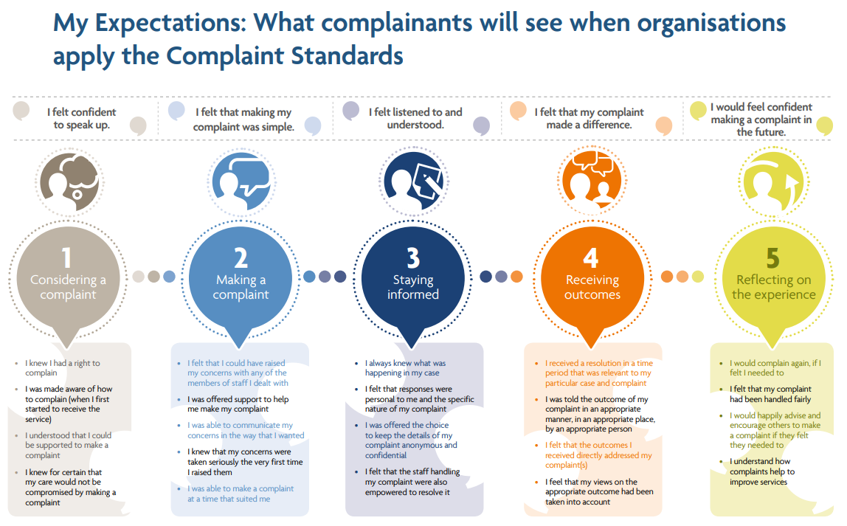
Patient Advice & Liaison Service (PALS)
Between 1 April 2020 and 31 March 2021, the PALS Team managed 630 local concerns, 1346 general enquiries, 28 PALS Surgery feedback/comments (not including concerns) and 26 pieces of feedback via social media. The PALS team are continuing to look at expanding the availability of PALS Surgeries held in clinical services across the Trust to help to resolve concerns and issues at a local level, if possible, before a complaint is raised.

In Q4, the PALS Team handled 159 local level concerns, 394 general enquiries, 3 PALS Surgery feedback/comments (not including concerns) and 6 pieces of feedback via social media.

The team also runs the PALS Volunteer initiative which focuses on volunteers attending PALS surgeries and being given the opportunity to listen to people’s experiences on our wards. Due to COVID-19 visiting restrictions, we are running the PALS surgeries virtually and I am pleased to say that we have managed to have a volunteer join us on some of the PALS surgeries during Q4 which has been a great success. At present work is being taken to recruit more volunteers.

PALS Surgeries
The PALS Team currently offer 35 PALS surgeries across the Directorates. PALS surgeries are a valuable way of seeking feedback about people’s experiences, both positive and negative, and about working with ward staff to resolve issues of concern at a local level, in a timely and positive manner. At this moment surgeries take place primarily via MS TEAMS and involve assistance from a member of staff to facilitate by walking an iPad around the ward, offering the patients the opportunity to speak to a PALS Officer. There can be issues with running the PALS surgeries virtually, mainly relating to IT glitches and staff availability, but I am pleased to report that these are becoming less as we continue to offer the service. This is a snapshot of some of the themes/trends following the feedback received from PALS Surgeries across the Trust. Each piece of feedback is discussed and shared with the ward/team manager or deputy and resolved. Any concerning issues are also appropriately escalated.

Day Hospitals across Oxon & Bucks
We are delighted to have finally been able to hold successful surgeries across these areas during Q4. Patients are reporting that the staff are very helpful and approachable, specifically in the Bucks services and that they are pleased with how their care/treatment plans are progressing.

Forensic Wards – low secure
Patients seem happy with the activities offered and staff are primarily friendly and helpful, resolving any concerns in a timely manner.

Forensic Wards – medium secure
Patients seem happy with their care and feel that any issues can be spoken about with the staff and resolved quickly. There have been comments in relation to noise levels during the night, such as doors slamming and staff speaking loudly with each other however these have been shared with the team and things seemed to have improved. The general consensus around activities is that they are ok and available if the patients wish to get involved.

Mental Health Wards
We had some positive feedback around the staff being very kind, thoughtful and helpful, especially with encouraging the patients to be more involved in ward activities. There have been mixed feelings around the activities on offer, with some patients feeling there aren’t enough offered and others feeling there is plenty to do but not always the staff to facilitate them. Patients have expressed that they feel their care and treatment needs are being listened to and met with a minority of patients feeling that the treatments could be more therapy focused.

Community Hospitals
The feedback remains very positive and encouraging from this area, especially in relation to patient care and treatment provided by all staff. Patients are finding staff respectful, thoughtful, and helpful and overall, highly professional. Patients feel the food is of a high standard and the portions sizes are ample but sometimes lacking in variety.

CAMHS
Across the service area, waiting times for CAMHS remains an issue especially in CAMHS Neuro development pathway, via MP concerns. This is a theme through both concerns and complaints. Due to COVID-19, there is a further delay due to not being able to hold face to face assessments. There has also been a slight increase across the Trust in relation to lack of communication between families and teams.

Analysis of themes from concerns and complaints
The Trust receives the most concerns and complaints in the category of ‘all aspects of clinical care’ (286) of which 100 related to insufficient care in the community and 31 related to medication issues. We also received complaints relating to staff attitude/behaviour (116), 160 cases were about communication/information sharing and 98 were about access to services/waiting times. There is some customer service work being planned to try and resolve some of the concerns being raised.

The below graph below shows the number of complaints and concerns received by directorate over time, most are received by services within the Oxfordshire and SW Mental Health Directorate.

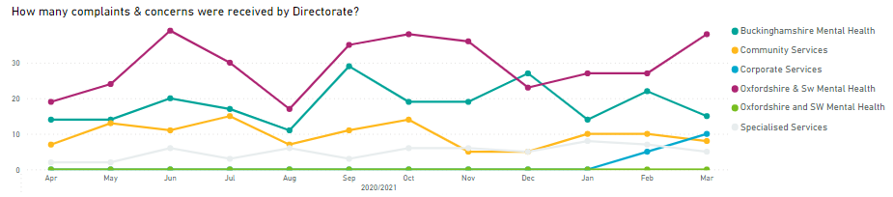

The graph below shows Trust-wide the number of concerns, complaints, and MP enquiries over time from April 2019. The information shows the number of concerns dropped from April 2020 possibly related to COVID-19. In 2020/21 the concerns have slightly increased in June and September-October 2020 with most received about adult mental health community and adult mental health inpatient services.
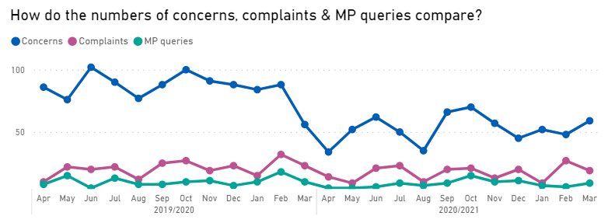

The six teams who received the highest number of complaints and concerns in 2020/21 are highlighted below;

AMHT (Adult Mental Health Team) Oxon City & North East: 18 formal complaints, 17 green and one orange (14 closed, two upheld, 10 partially upheld and four not upheld) and 80 concerns. 20 related to all aspects of clinical care (14 related to insufficient care within the community, six related to medication issues). 20 cases related to communication/information sharing and 15 were about staff attitude/behaviour.

AMHT Bucks Aylesbury Team: 18 formal complaints, 15 graded green, two graded orange and one graded red (15 closed, six upheld, 6 partially upheld and 3 not upheld) and 43 concerns. 32 related to all aspects of clinical care (16 related to insufficient care within the community), 12 related to communication issues, five related to appointments/referrals and five related to staff attitude behaviour.

AMHT Oxon North & West: 10 formal complaints, all graded green (two upheld, two partially upheld and for one there was no evidence to prove or disprove) and 22 concerns. 14 related to all aspects of clinical care (nine related to lack of care within the community). Five related to communication/information sharing, four related to staff attitude/behaviour and four related to an appointment/referral.

AMHT Bucks Chiltern Team: Three formal complaints, all graded green (2 cases not upheld and one case open) and 26 concerns. Seven cases related to all aspects of clinical care, six related to communication/information sharing, five related to staff attitude/behaviour and four related to discharge.

Sapphire Ward: Four formal complaints, three graded green and one graded orange (one not upheld, two partially upheld and one remains open). Ten related to all aspects of clinical care and five related to discharge.

Ruby Ward: Six formal complaints, five graded green and one graded red (one upheld, one not upheld, two partially upheld and two remain open) and 19 concerns. Eight related to all aspects of clinical care, five related to staff attitude/behaviour mand four related to communication/information sharing.

Compliments
The Complaints and PALS Team centrally collates the compliments shared by teams including thank you letters and cards. In 2020/21 a total of 2,384 compliments were received;
- Oxfordshire, BaNES, Swindon and Wiltshire Mental Health Services received 749,
- Community Services received 1195,
- Buckinghamshire Mental Health Services received 242,
- Specialised Services received 135 and
- Corporate Services received 63.

Extracts from compliments
“I cannot thank you enough for everything you have done to help make all this possible for **. She already looks a different person just with the knowledge that she is moving.” Bucks Older Adults CMHT

“I am writing to thank you for your kind help over the period in time in which we ‘met. I am grateful to have encountered your expertise and insight during such a difficult time in my life. I felt listened to and travelled with; both are considerable blessings when the going is hard.” Chiltern AMHT

“That was amazing I really loved the group and the support that I received was amazing, I got some great ideas to help with my grandson. It’s always helpful to hear that we are not alone with our children’s problems, which it does feel like most days. These team meetings are great to take part in, please keep up the good work.” Barnardo’s

“It is very challenging and it’s hard to accept but all my family and friends see how happy I am and how well I do look now which is a positive but also scary. I feel much freer with my thoughts and how I manage things now. There has been so much improvements, but the hard thing is definitely body image which as you said will take time. I just want these weeks to speed up so I can go out and live my life at home and have my future. It’s going to be hard, but I feel so ready now. Things are definitely different. Just wish it wasn’t so hard. Just had enough of this illness taking away my life, it is really time for me to let go now. This time round I feel very confident I can make it work. I have so many exciting things planned. Moving forwards, we are going to have a big celebration. I can’t wait.” Eating Disorders

“I just wanted to write and say an enormous thank you from myself and all the family for everything you have done over the past 7 months for our Mum. We couldn’t have asked for any more from you and we are so grateful that Mum is back to her old self.” Oxon Older Adult CMHT

“I have just finished my last Session, I felt I had to write to you to say how much I appreciated you working with me. Your professionalism is excellent, always prepared for our call which was refreshing, I felt really CARED for by you in doing this. Your voice is warm, friendly and just the right tone to reassure me when I didn’t feel confident about things. You went through things and was also patient with me when I felt I hadn’t really understood and I appreciated that, and quietly reworded things so I could. Thank you.” Talking Space Plus

“Thank you for your professionalism, care and support you gave not only to my late husband but also to me. For the times you returned to increase his medication when needed even if it was at the end of your working day. I will never forget this and hold you dear in my heart. The work you do is priceless.” District Nursing Service

“Thank you to the team for helping me so much and allowing me to get my jab. I really appreciated the help which made the situation much less stressful for me” School Immunisation Team

“I attended Abingdon Minor Injuries unit to see if I could get help with a rejected piercing I was concerned about. I didn't have to wait long until a very kind and understanding nurse quickly and professionally helped me resolve my problem. This nurse went above and beyond in making sure I was comfortable and answered all my questions and gave me some really great advice for piercings. I just wanted to bring this to your attention and say how happy I was with the treatment I received.” Minor Injuries Unit

“I would like to thank the staff for their kindness and efficiency, in caring for my son. They always answer my e mails by return and keep me up to date with my son’s needs. Forensic Community Team

“Please thank all the members of your team who worked with ***over the years in supporting her to get appropriate help and interventions. Learning Disabilities Team

“I just wanted to take the opportunity to say thank for the kindness you showed us as a family, and the communication about the treatment plan and the speed with what it was done was much appreciated by us as parents. We appreciate there are so many more urgent cases now and thank you for your care of our son.” Dental Services.

