Report to the Meeting of the

BOD 47/2021
(Agenda item 06)

Oxford Health NHS Foundation Trust

Board of Directors
28th July 2021
Chief Executive’s Report

Strategic Objective 1 – Deliver the best possible care and outcomes

Vaccination Programme

The Trust continues to play a leading role in delivering the COVID-19 vaccination programme across the Integrated Care System of Buckinghamshire, Oxfordshire and Berkshire West.

As lead provider for the programme the Trust has delivered in excess of 400,000 first and second vaccine doses. Approximately 175,000 of these have been delivered from the Kassam Stadium mass vaccination site which has a capacity of 1300 vaccination doses per day. 160,000 vaccine doses have been delivered from the Madesjki Stadium site, which has a capacity of 1600 doses per day and just under 75,000 from the mass vaccination site in Aylesbury. This is now based at the Guttman Centre having previously been delivered from the Bucks New University Campus.

In addition to the mass vaccination centres Oxford Health is supporting a number of ‘pop-up’ clinics, which deliver between 250 and 500 vaccinations per day. These clinics have been deployed to focus on areas with low vaccination uptake and/or higher infection rates. These clinics have included:

- Berkshire West
Bulmershe Leisure Centre, Wokingham
Civic Hall, Reading

- Oxfordshire
Mansfield Road University Club
Oxford Brookes
Iffley Road Sports Centre
Ewert House, Summertown

- Buckinghamshire
Wycombe library

The Trust is also supporting two “Health on the Move” vans, which are being deployed across the integrated care system. Each of these can deliver 120 vaccinations per day. The vans are being used to address areas with marked health inequality and/or vaccine hesitancy.

It is likely as we move into the third phase of the vaccination programme which will likely include Autumn booster vaccinations together potentially with vaccinating the under 18’s population that we will offer a more mixed model of vaccine delivery, which will include increased use of pop-up clinics and various walk-in options.

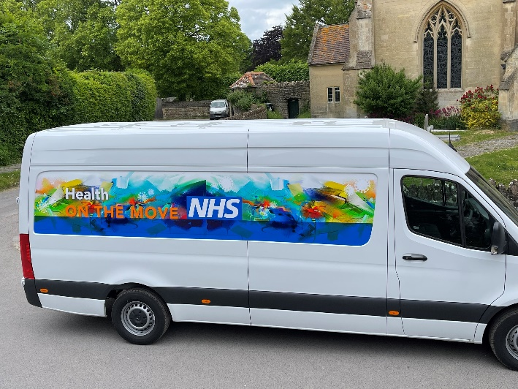

Health Service Journal Annual Awards

I am very pleased to report that Oxford Health teams have won three annual HSJ Awards.

The team from Vaughan Thomas ward at the Warneford Hospital were winners in two categories; the Most Effective Contribution to Patient Safety and Health Technology Partnership of the year. The first award was shared with colleagues from Coventry and Warwickshire Partnership NHS Trust, the South London and Maudsley NHS Foundation Trust and the technology company Oxehealth.

Both awards were in relation to the deployment of the Oxevision observation platform on Vaughan Thomas ward. This platform has been developed in collaboration with Oxehealth and enables staff to remotely observe the physical wellbeing of service users in their bedrooms.

In addition, the Trust’s integrated multi-disciplinary respiratory team won the ‘Best Pharmaceutical Partnership Award’ for its work in conjunction with the Boehringer Ingelheim Pharmaceutical Company to improve the care of patients across Oxfordshire suffering from chronic respiratory disease.

Provider Collaboration Review

The Care Quality Commission undertook a planned provider collaboration review of children and young people’s mental health services across the integrated care system between 5th and 13th July.

The review began with James Kent, the senior responsible officer for the integrated care system, Julian Emms, chief executive of Berkshire Health NHS Foundation Trust and myself, presenting an overview of the system and a summary of the collaboration that has developed, particularly in response to the pandemic, to the review team. A copy of the presentation is included in the reading room.

The review included interviews with colleagues from the key statutory organisations working in the system, including several members of the Oxford Health team.

We await formal feedback following the review.

Strategic Objective 2 – Be a great place to work

Building and sustaining an anti-racist Trust environment

I am very pleased that the Board Seminar that took place on 30th June this year focussed on exploring how the Trust can become an anti-racist organisation. This important session was facilitated by an external organisation, Deeds and Words. The aim of the workshop was to empower all Board members to be able to have positive and challenging conversations in order to collaboratively build a truly anti-racist environment across the Trust. In addition the workshop aimed to ensure that all Board members, especially white people, are able to proactively use their influence in order to better share the burden of anti-racism work across the Trust.

The three-hour workshop was both thought provoking and challenging. It has served as the start of some important work for the Board and it is clearly essential that this subject is one that we continue to revisit on a regular basis.

I would like to thank Tehmeena Ajmal and Marie Crofts in their capacities as co-senior responsible officers for the Race Equality Framework for Change Programme and their colleagues for organising the workshop.

Chief People Officer

I am pleased to confirm that following interviews on 16th June, Charmaine De Souza will be joining the Trust on 4th October, as our new Chief People Officer. Charmaine brings with her a wealth of experience in the public sector. She is currently working for the Greater London Authority as Assistant Director for human resources and organisational development.

Mark Warner will remain with the Trust as our interim HR director up until Charmaine’s arrival.

Managing Director Mental Health, Learning Disability and Autism

Debbie Richards, the Trust’s managing director for mental health, learning disability and autism, will be sadly leaving the organisation in early October to become the Chief Executive of Cornwall Partnership NHS Foundation Trust. I would like to congratulate Debbie on this appointment, which is a reflection of her considerable expertise and experience. During her two years with the Trust she has made a considerable contribution and proven to be a highly effective member of the executive team.

Given the importance of Debbie’s role the process to find her replacement has already begun and I hope that it will be possible to interview for this position in early September.

Health and Safety

As Board colleagues will be aware towards the end of last year, Mike McEnaney, in his capacity as the Trust’s Director of Finance, assumed executive responsibility for health and safety. I am pleased to report that during the months since, the profile of health and safety across the organisation has risen. In keeping with this the executive team now receive a weekly health and safety report. Moving forward a regular health and safety report will also be prepared for the Board reflecting the importance of this subject.

Strategic Objective 3 – Make the best use of our resources and protect the environment
Oxfordshire Integrated Care Partnership

The Oxfordshire Integrated Care Partnership (ICP) has established an ICP Executive which has the full support of regulators and the statutory organisations within the partnership. It will function, as a partnership across the NHS and local government and the membership will consist of key strategic leaders, who are the statutory organisation decision makers from across the partnership. The executive will meet on a monthly basis.

I can confirm that as Chief Executive of Oxford Health NHS Foundation Trust I am a member of the executive alongside Ben Riley in his capacity as chair of the ICP Primary Care and Community Services Board together with Rob Bale, who in addition to being clinical director for the Trust’s Oxfordshire, BaNES, Swindon and Wiltshire Mental Health Directorate is also, the chair of the ICP Mental Health Board.

Warneford Park Redevelopment

On 17th June Amanda Pritchard, Chief Operating Officer of NHS England, visited the Warneford site. It was a valuable opportunity to brief her regarding our plans to redevelop the site and showcase the services that we are currently delivering. Amanda visited Wintle Ward and the Highfield Unit where one of the young people currently under the care of the unit acted as her guide

Lead Executive Director: Dr Nick Broughton, Chief Executive

