Report to the Meeting of the

Oxford Health NHS Foundation Trust
BOD 71/2021
(Agenda item: 2)

Board of Directors

30 November 2021

Urgent Community Response Patient Story

For: Information

Lucia Winrow, Associate Director Intensive Community Care and Nicole Robinson, Patient and Carer Experience Coordinator will be presenting a story of the experience from a patient, his carer and staff members about the impact the new Urgent Community Response service (UCR) has made to their lives.

About the service

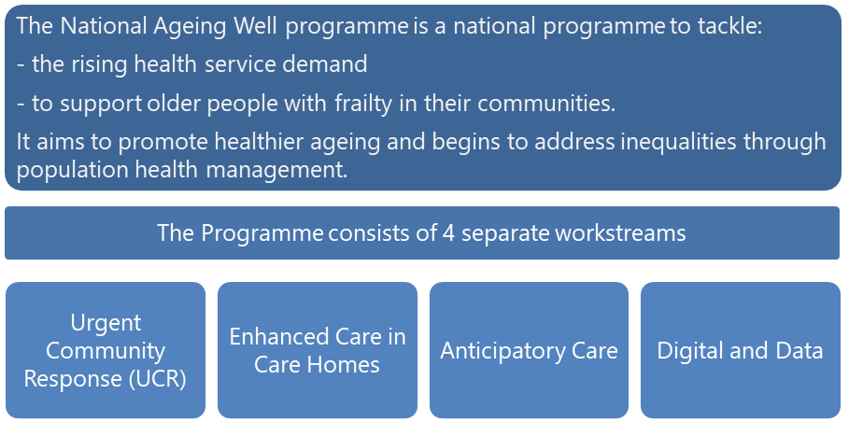

The aim is for the Urgent Community Response service is to provide a 2-hour or 2-day response at home for older people experiencing a health or care crisis in order to prevent avoidable admissions and readmissions. The service identifies their needs and responds to these at home with appropriate ongoing community support.

These 2-hour and 2-day urgent response standards are part of a range of commitments which aim to help keep older people well at home and reduce pressure on hospital and primary care services.

About the patients
Below is Urgent Community Response two-hour referral data for first year of operation, September 2020 to September 2021:

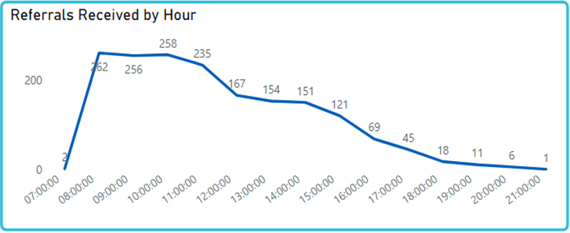

Urgent Community Response two-hour primary reason for referral, September 2020 to September 2021:

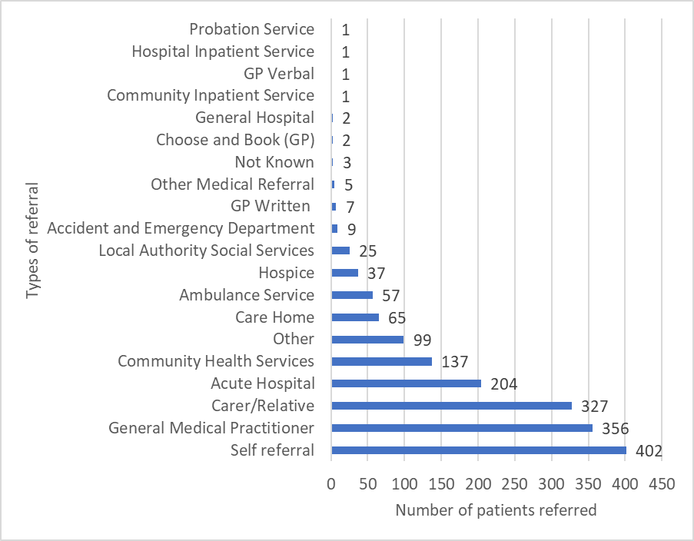

Benefits and achievements
- Excellent feedback from patients and carers who have used the service
- The programme has provided an important opportunity for new investment into the community services pathway and supported a shift of care out of hospital
- The service has significantly exceeded its performance targets on the 2-day reablement response it provides
- Strong working relationships have been developed with system partners at BOB ICE and Place (Oxfordshire) level
- New ways of working and innovation are being developed and tested

Challenges for the service
- The Urgent Community Response Service is a three-year transformational programme of work that has been challenging to deliver at times due to the complexity of working across a range of BOB and Oxfordshire partners.
- Unknown patient demand. As this is a new service, it is difficult to predict activity based on data from other areas.
- Implementing an agile change process across staffing groups when they were already suffering from change fatigue due to the pandemic.
- Recruiting sufficient staff to enable skilled staff to work in the Urgent Community Response pathway

Future plan for the service – we would welcome Board support in principle for the following direction of travel:
- There is great support from system partners to expand this service. This involves extending opening to include the overnight period. Plans are being discussed with OUH to explore opportunities to develop an expanded, shared workforce.
- Create a robust medical model to support the pathway. This will also be developed in partnership with OUH colleagues, bringing together specialist/geriatric and community medical/GP expertise
- More integration is planned with related services provided by acute and primary care partners to ensure a more joined-up and cost-effective pathway for patients and carers
- A system-level single point of access is planned to coordinate services across the Trusts and Adult Social Care, taking referrals from all sources, including 999, 111, Emergency Department, primary care and direct from the public.
- Support for evaluation will be needed to understand the benefits and costs of the service as it develops, to inform future commissioning.

Author and Title: Nicole Robinson, Patient & Carer Experience Coordinator
Lead Executive Director: Marie Crofts, Chief Nurse

