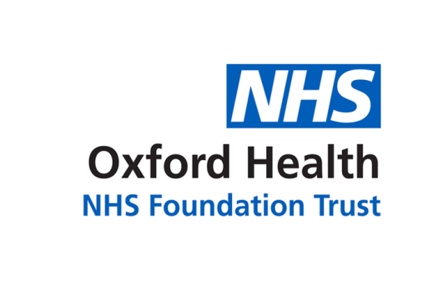

# Report to the Meeting of the

# Oxford Health NHS Foundation Trust

**BOD 77(ii)/2021**

(Agenda item: 9)

# Board of Directors

**30 November 2021**

**Covid-19 vaccination programme**

**For: Information**

**Executive Summary**

This report provides the Board with an update on the covid-19 vaccination programme and the activity managed by the Oxford Health NHS Trust. As at 24 November 2021, we have carried out 710,046 vaccinations mainly through our mass vaccination centres in Kassam Stadium (Oxford), Broad Street Mall (Reading) and Guttmann Centre (Stoke Mandeville, Aylesbury). This is a significant achievement and we are currently averaging over 3,500 vaccinations per day to support the continued roll out of the national programme to those aged 12 and above.

**Governance Route/Escalation Process**

Regular updates on the vaccination programme are presented to Board meeting.

**Statutory or Regulatory responsibilities**

The Trust is compliant with its statutory and regulatory duties to provide vaccination services, and assurance processes in place with NHS England.

**Recommendation**

The Board is asked to confirm its assurance with the progress made to deliver vaccinations across the Buckinghamshire, Oxfordshire and Berkshire West (BOB) Integrated Care System.

**Author and Title: Anita Sherwood, Interim Covid-19 Operations Lead**

**Lead Executive Director: Karl Marlowe**

1. *A risk assessment has been undertaken around the legal issues that this report presents and there are no issues that need to be referred to the Trust Solicitors*
2. ***Strategic Objectives/Priorities*** *– this report relates to or provides assurance and evidence against the following Strategic Objective(s)/Priority(ies) of the Trust:*

*1) Quality - Deliver the best possible care and health outcomes*

**SITUATION**

Oxford Health NHS Trust’s covid-19 vaccination programme commenced on 25th January 2021 and received its first member of the public through the doors of the Kassam Stadium, Oxford on 1st February 2021. Since that time we have expanded our offer of vaccinations and operate primarily out of three mass vaccination centres (Oxford, Reading and Stoke Mandeville). This paper provides an update on the progress of roll out of the covid-19 national vaccination programme.

**BACKGROUND**

Covid-19 vaccinations are essential to help fight the virus and reduce the risk of hospitalisation and serious illness. Oxford Health NHS Trust has played a pivotal role within the roll out of vaccinations across Buckinghamshire, Oxfordshire and Berkshire West (BOB) Integrated Care System.

We are continuously asked to adapt and respond to new challenges. In the summer we were asked to support the School Health Immunisation Teams to roll out vaccinations to secondary schools across BOB Integrated Care System. We had teams of up to 30 vaccinators visiting schools, successfully achieving a high uptake (59.1%) and the pace of delivery has put us in the national top 5 performing Integrated Care Systems for vaccinations in this age group. We now also offer 12-15 year old vaccinations as walk ins or bookable appointments every day of the week in our mass vaccination centres.

In the last week we have seen the age cohort for boosters being lowered to 40 and 16-17 year olds becoming eligible for a 2nd dose. We have vaccinations available as walk ins or bookable appointments every day of the week.

Our success in rolling out the covid-19 programme is underpinned by an innovative workforce model whereby a medical staffing agency are contracted to work for Oxford Health NHS Trust and to support the programme across the BOB Integrated Care System. This model has been able to meet all the workforce requirements whereas some other areas of the country have struggled in this respect. We continue to build the team of vaccinators who not only work out of mass vaccination centres but also work in pop up clinics, support GP practices, and within the school setting.

**ASSESSMENT**

Across Buckinghamshire, Oxfordshire and Berkshire West there are approximately 850,000 residents who are aged over 50 or clinically vulnerable. As at 8 November 2021, 90.4% of this group have had two vaccines and 60.8% had a booster. As eligibility for a booster occurs 6 months after a second vaccination we would not expect all boosters for this group to have been offered until the New Year.

We are continuing to offer the health on the move van (HOTM) to support vaccinations in harder to reach communities. We also offer clinics for staff covid vaccinations.

The table below summaries the number of vaccinations by area and site.

(please note -

*Warneford Hospital hub was only operational for staff first vaccinations over a period of a month at the start of the programme and in Buckinghamshire/Berkshire West we have relocated mass vaccination sites during the year).*

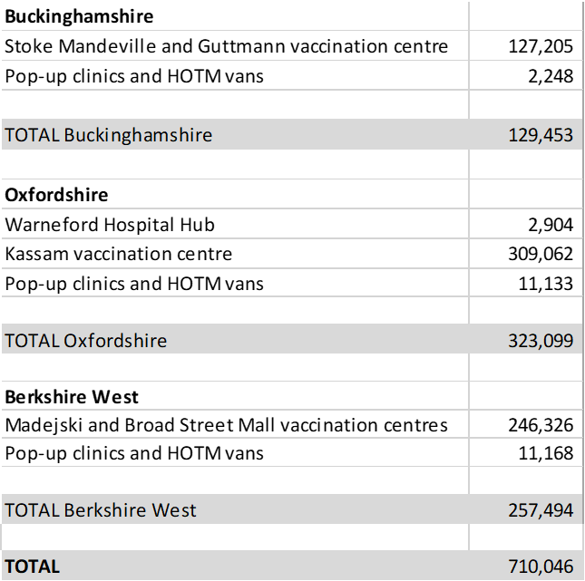

We are currently vaccinating approx. 3,500 people per day across the sites.

**RECOMMENDATION**

The Board is asked to note Oxford Health NHS Trust’s progress to deliver covid vaccinations across Buckinghamshire, Oxfordshire and West Berkshire.