Report to the Meeting of the
RR/App-GoG 09/2021
(Agenda item: 16)

Oxford Health NHS Foundation Trust

Council of Governors

09 September 2021

Integrated Performance Report (IPR)

For: Information

Executive Summary

This report is intended to provide the Council of Governors with the first integrated view of the Trust’s overall performance and has been divided into five key sections:

Section 1: A narrative that describes the Trust strategy and the key objectives

Section 2: Key headlines to help set context on what the Trust has delivered during the reporting period

Section 3: Delivery against the targets set nationally in the NHS Oversight Framework

Section 4: Measuring the Trust’s performance against its strategic objectives using the Objective Key Results (OKRs) agreed during the development of the Trust’s strategy

Section 5: Highlights from the Executive Managing Directors

The report has been designed specifically to provide an integrated view and should be read alongside the standard reporting on each specific area (Quality, Workforce, Finance and Operational Performance).

The diagram below provides a guide on how the report has been developed and the governance route to the Trust Board.

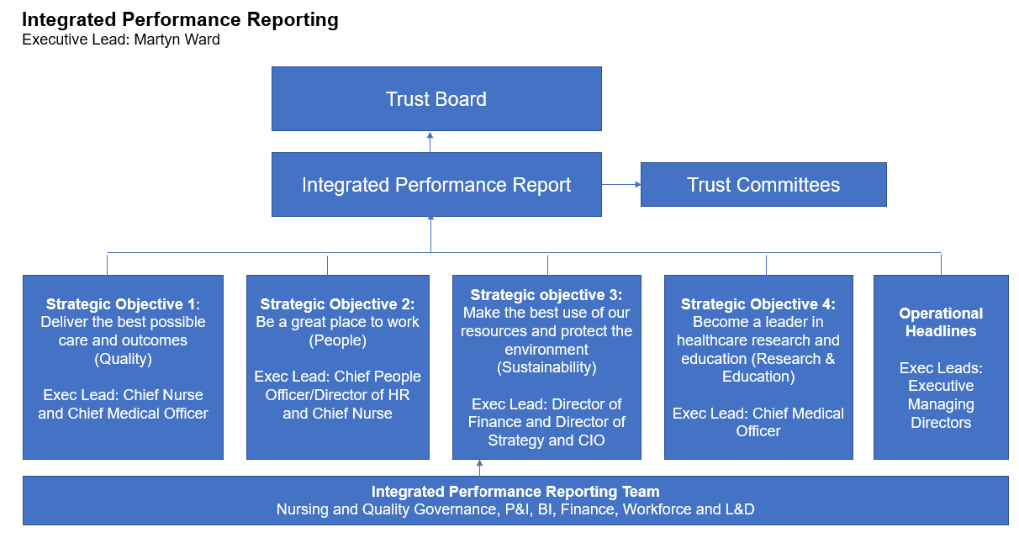
Recommendation

The Board of Directors are asked to review and provide comments for further development of this report.

Author and Title: Martyn Ward – Director of Strategy & Chief Information Officer

