

# Report to the Meeting of the

**RR/App_CoG 14/2021**

(Agenda item: 17)

# Oxford Health NHS Foundation Trust

# Council of Governors

**25th November 2021**

**Integrated Performance Report (IPR)**

**For: Information**

**Executive Summary**

This report is intended to provide the Board of Directors with the first integrated view of the Trust’s overall performance and has been divided into five key sections:

Section 1: A narrative that describes the Trust strategy and the key objectives

Section 2: Key headlines to help set context on what the Trust has delivered during the reporting period

Section 3: Delivery against the targets set nationally in the NHS Oversight Framework

Section 4: Measuring the Trust’s performance against its strategic objectives using the Objective Key Results (OKRs) agreed during the development of the Trust’s strategy

Section 5: Highlights from the Executive Managing Directors

The report has been designed specifically to provide an integrated view and should be read alongside the standard reporting on each specific area (Quality, Workforce, Finance and Operational Performance).

**Governance Route/Approval Process**

This report is shared monthly to the Executive Team and to the Board of Directors meetings when convened.

**Recommendation**

The Council of Governors is invited to note the report.

**Author and Title: Martyn Ward**

**Lead Executive Director: Executive Director – Digital & Transformation.**

**Current Covid Position:**

As at 18th November there are **8** Covid positive patients on inpatient wards.

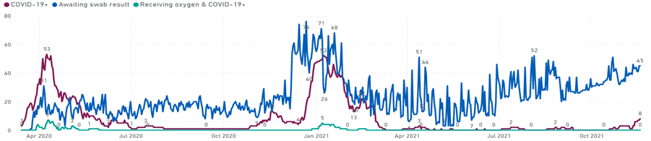

**Performance Summary:**

The Trust continues to receive a higher number of referrals than has been seen in previous years. Further work is required to understand in detail, how many of the new referrals are as a direct consequence of COVID and how many are part of the backlog that has developed over the past 18 months.

The increase in referrals has had a significant impact on waiting times across virtually all service areas. In many cases, waits for routine referrals have been most affected as the operational priority remains on Emergency and Urgent referrals. For those patients waiting, additional steps have been taken to mitigate clinical risks and prevent harm.

From the analysis of the data in quarter, the following areas have been escalated to the Operations Management Team as exceptions for awareness and action:

* Adult Eating Disorder services (Oxfordshire)
* CAMHS Eating Disorder services (Oxfordshire & Buckinghamshire)
* IAPT (Oxfordshire)
* Neuro Developmental Collaboration Pathway (Oxfordshire & Buckinghamshire)
* Adult Mental Health Urgent Care
* City Adult Mental Health Team (AMHT)
* District Nursing (Oxfordshire)
* Community Respiratory Service (Oxfordshire)
* Podiatry (Oxfordshire)

Workforce shortages continue to have had a significant impact on services such as District Nursing, Podiatry and the City Adult Mental Health Team.

Despite shortages in available workforce, the Trust continues to deliver a higher number of appointments overall than in previous years. This increase is due to a number of factors which include changes to the way services are delivered, the increased use of telephone/digital consultations and quality improvements. Areas to note in terms of increased levels of activity in the quarter include:

* Adult and Older Adult Mental Health (Oxfordshire & Buckinghamshire)

Admissions to the Trust’s mental health inpatient wards has been consistent with previous quarters. Average length of stay is in line with historical trends, with monthly variation attributed to discharge of patients with exceptional long length of stay.

The use of inappropriate Out of Area Placements (OAPs) has increased in the quarter with Buckinghamshire seeing a considerable increase over previous months. This was primarily due to a combination of factors including the temporary closure of Ruby ward to admissions and an increase in delayed discharges for male patients

There has been an increase in serious incidents reported, not related to an increase in a particular type or team. Work is underway to understand the root cause of the incidents and the learning so that these can be built into quality improvement initiatives.

The Trust continues to see a higher number of new starters, with September being 166% higher than the 2019/20 average. The number leaving was 6% higher in September than the monthly average for 2019/20.

Two specific areas of expenditure that remain excessively high are Out of Area Placements (OAPs) and the use of Agency. Whilst the Trust continues to reduce the need for OAPs through improvement initiatives, the number of available beds has been severely impacted by Infection Prevention Controls, especially in Oxfordshire.