Report to the Meeting of the

Oxford Health NHS Foundation Trust

Board of Directors

Monthly Performance Report
Month 1 - April 2021
For Board of Directors Meeting 9th June 2021

FOR: INFORMATION

Introduction

This report summarises the Trust’s performance for the month of April 2021 for the following areas:

Section 1: COVID-19 headlines

Section 2: Operational patient activity and demand
    - Trust-wide headlines and noteworthy exceptions
    - Directorate headlines

Section 3: Contractual KPI performance

SECTION 1: COVID-19 HEADLINES

The number of COVID19 positive patients on inpatient wards was zero as at 25th May 2021.

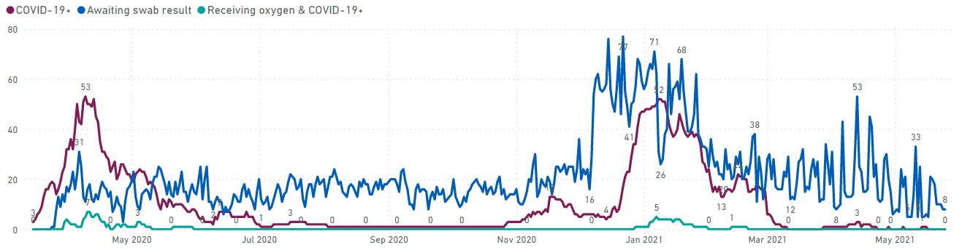

Group | Activity | No. at end Apr | Diff from end Mar | No. at 25th May
Patients | Cumulative number of inpatients confirmed COVID-19 positive | 397 | +9 | 406
 | Cumulative number of COVID-19 deaths in our inpatient settings | 32 | No change | 32
 | Cumulative number of community patients confirmed COVID-19 positive | 602 | +9 | 611
 | No. of vulnerable community patients (as identified by Trust clinicians) | 3308 | -89 | 3219
Staff | Number of staff impacted by COVID19 and not working | 54 | -15 | 29
 | Number of staff impacted by COVID and working from home | 0 | -1 | 0

Vaccination Update

At 25th May,

- a total of 5748 (78.9%) staff have received their first vaccination dose; 3883 (84.6%) of front-line staff have been vaccinated.
- a further 4283 (58.8%) staff have also received their second vaccination dose; 2859 (62.3%) of front-line staff.
- 581 (8.0%) staff (396 (8.6%) front-line staff) are currently exempt from receiving the vaccine or have chosen to opt out of the vaccination program. As per the guidance provided by NHSE, line managers/occupational health are supporting staff and ensuring that any questions or concerns about the vaccination are addressed.

SECTION 2: OPERATIONAL PATIENT ACTIVITY AND DEMAND

2.1 Trust-wide headlines

Currency | Graph | Narrative
Community Services (Mental Health and Physical Health)
Received referrals | 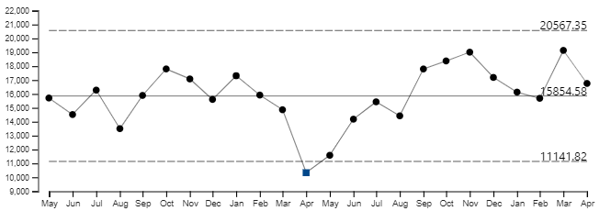 | Overall, referral levels are slightly above average. There continues to be a sustained increase in Urgent referrals which have been above average since June 2020.
Attended appointments | 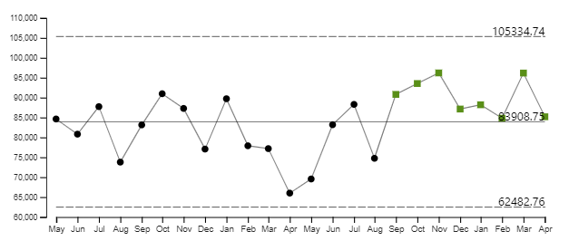 | Despite Covid the levels of attended appointments continue to be in line with or above average since September 2020.
Digital appointments | 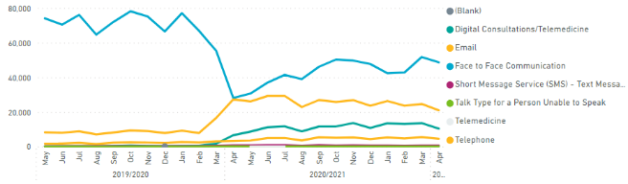 | Overall Trust wide face to face activity is the highest method of delivery of care, followed by telephone and then digital consultations.
IAPT (Oxon and Bucks combined)
Performance against trajectory | 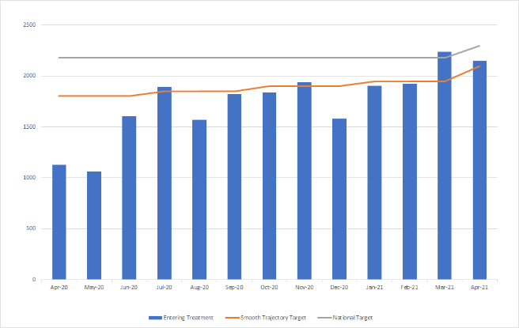 | Oxon and Bucks have agreed a smooth trajectory by which they will achieve the LTP (papers submitted to BOB last year). The existing trajectory was unrealistic (driven by changes in the measure of underlying population need which meant that some years required a very large increase in service and others a small increase and also both services are required to make up the short fall due to historic underfunding). Increases to achieve the LTP are still very challenging e.g. Bucks IAPT in FY21-22 are required to enter into treatment an additional 2,560 people and Oxon IAPT in FY21-22 are required to enter into treatment an additional 3,999 people. Note the specific trajectory for this year for Oxon & Bucks has not yet been agreed with commissioners, we have estimated for Q1.
Inpatient Services
Admissions | 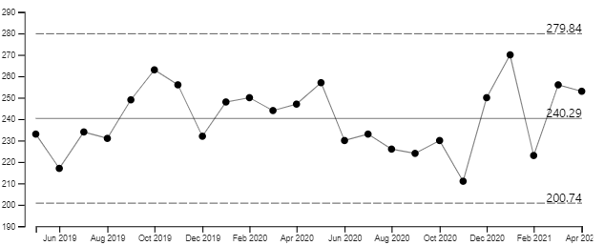 | Overall admissions in April were above average. Mental health admissions to Adult acute wards has returned to normal levels.
Length of stay | 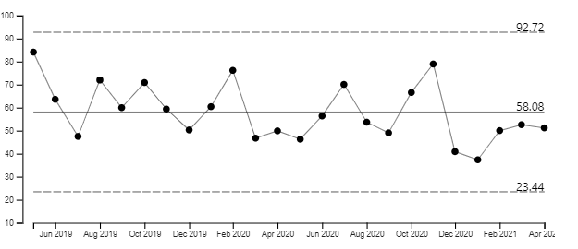 | Overall, length of stay (excluding delays and leave) was just below average in April. Mental Health was in line with the average and Community was just below average

2.11 Other operational information – Learning Disabilities

- Completed Learning Disability Mortality Review (LeDeR) reviews in April - 7 LeDeR reviews completed in April by OCCG staff. LeDeR system now on pause until the NHS digital platform goes live which is imminent.

- Annual Health checks undertaken in April - 47 Annual Health Checks completed in April this year, above last year’s figure.

2.2 Noteworthy exceptions

Service area | Currency | Graph | Narrative
Oxon & BSW Directorate | Urgent Referrals | 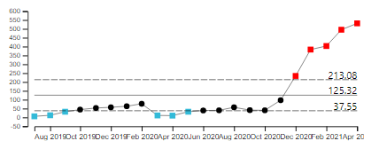 | MH Urgent Care – AMHO Street Triage and AMHO SCAS Triage  are receiving significantly higher urgent referral demand than usual. The graph illustrates the combined urgent referral data for these two teams. The trend is continuing its upward trajectory.
Oxon & BSW Directorate | Routine Referrals | 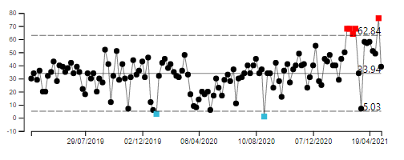 | Overall, routine referral activity across the directorate has remained within expected levels.  There are 3 areas that are receiving higher levels of routine referrals than normal – combined effect shown left  Referrals to CAMHS W Single Point of Contact (SPOC) teams has increased, however, an increase in onward demand to teams from the SPOC has not been seen as yet.
Bucks Directorate | Urgent Referrals | 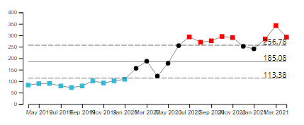 | MH Urgent Care – Crisis Response and Home Treatment Teams. Referrals to the 2 Crisis Response and Home Treatment Teams has been significantly higher than normal levels since July as shown. Pre COVID demand is illustrated by the blue dots.
Bucks Directorate | Routine Referrals | 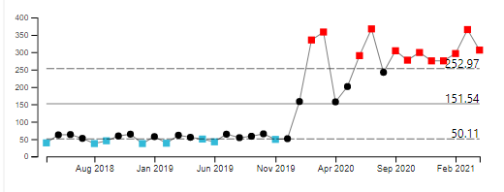 | AMHB Aylesbury CMHT, AHMB Chiltern CMHT and CAMHS B Targeted, CAMHS B ED. Overall, routine referral demand to the directorate is at expected levels.  The four teams listed above, however, have been receiving significantly higher levels of demand than usual.  The combined number of routine referrals to these teams is shown by the graph above illustrating significantly higher levels than pre COVID (blue dots)
Community Services Directorate | Children’s Integrated Therapies –Urgent Referrals | 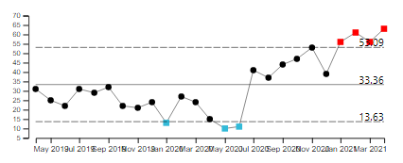 | The Children’s Integrated Therapies service is seeing an upward trend in urgent referrals
Community Services Directorate | Care Home Support Service  -Routine Referrals | 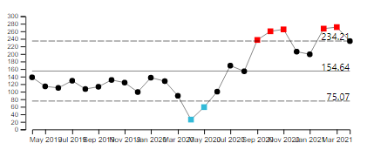 | The Care Home Support Service, however, has been receiving significantly higher levels of demand

2.3 Directorate headlines

Please note that this information relates only to services on Carenotes. Services not included at the present time are: Out of hours and Dental

Currency | Community | Oxon/BSW |  | Bucks |  |  | Specialised
Referrals | 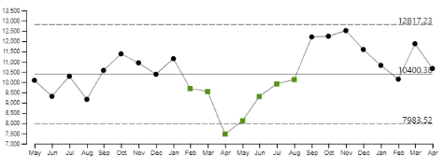 | 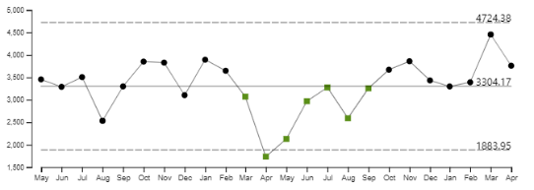 |  | 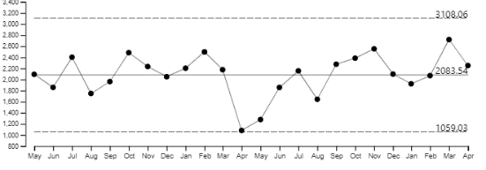 |  |  | 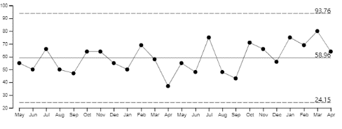
Commentary | Referrals in April were just above the average. Emergency and Routine referral urgencies were above average | Referrals in April were above average. Urgent referrals have been above the upper control limit for the last 4 months |  | Referrals in April were slightly above average. Urgent referrals continue trend of recent months and were in line with the upper control limit. |  |  | Referral volumes were slightly above average numbers received
Attended appointments | 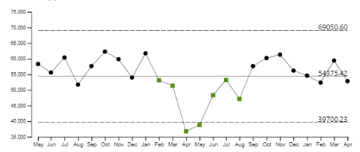 | 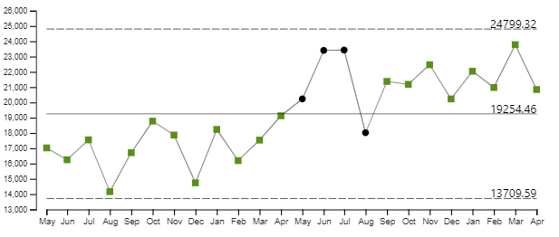 |  | 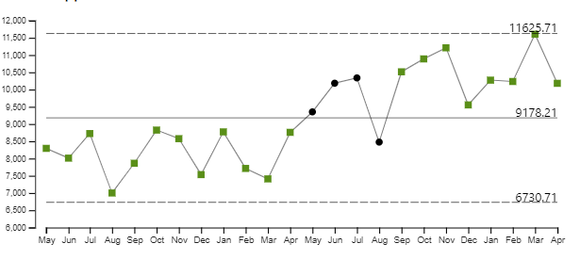 |  |  | 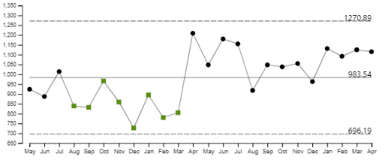
Commentary | Activity volumes in April were slightly below average. | Activity levels have been above average since September 2020. |  | Like Oxon, appointment activity has been higher than average since September 2020. |  |  | Activity volumes have increased and for the last 4 months have been above average.
Digital appointments | 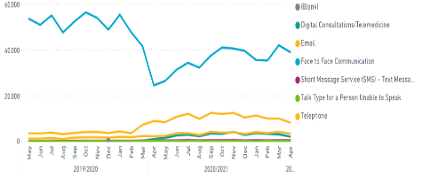 | 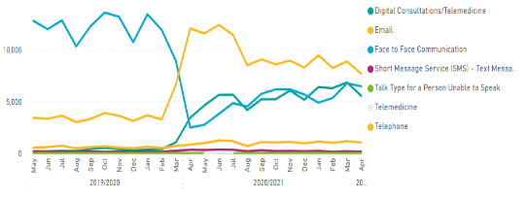 |  | 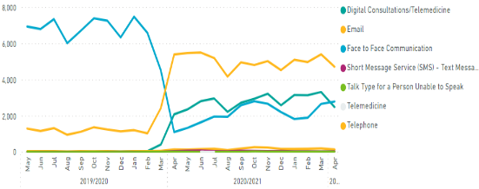 |  |  | 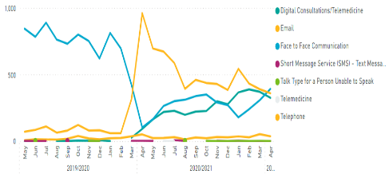
Commentary | Across all Directorates, the level of digital activity continues to be higher than pre Covid-19.
Admissions | 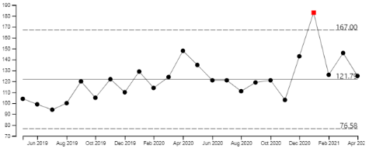 |  | 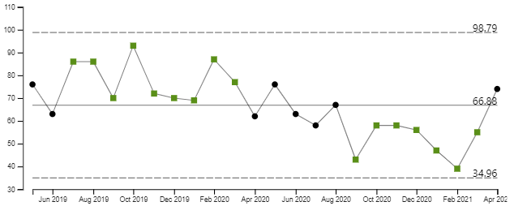 |  | 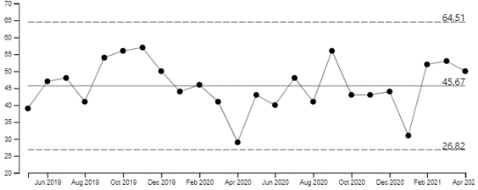 | 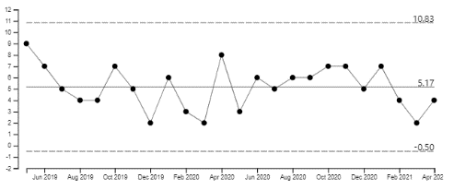
Commentary | Admissions in April were above average. |  | Admissions have increased in April to be in line with average numbers. |  | Admissions for April were above average | Admissions have increased in April. It should be noted that low admission numbers in this directorate impact on the variation.
Length of stay (excl leave and delay) | 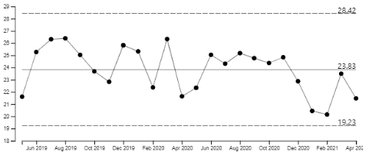 |  | 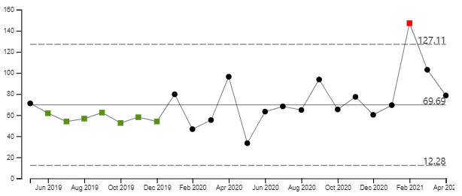 |  | 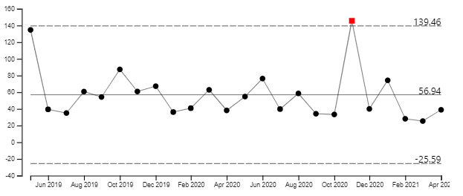 | 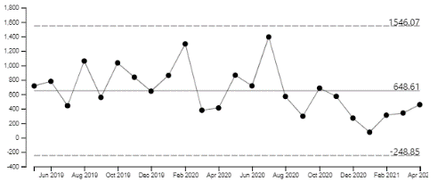
Commentary | Overall length of stay for community hospitals is below average. |  | Length of stay in April was in line with average |  | Patient average length of stay continues to be below average. | Patient average length of stay continues to be below average.

SECTION 3: CONTRACTUAL KPI PERFORMANCE

4.1 Contractual waiting times
The Trust is contracted to report its waiting times for the following services;
- Community Services Directorate: Community Therapy Service (CTS), Adult Speech and Language Therapy (ASaLT), Physical Disability Physiotherapy Service (PDPS) and Nutrition and Dietetics (N&D)
- Oxon and BSW Mental Health Directorate: Adult MH Community services (assessment and treatment teams), Older Adult MH Community Services (older adult CMHTs) and CAMHS community
- Buckinghamshire Mental Health Directorate: MH Urgent Care service (crisis response and home treatment teams), Older Adult Mental Health Community Service (older adult CMHTs) and CAMHS community.
Performance excluding CAMHS relates to waiting times from referral received date to first attended appointment delivered via any method i.e. digital, telephone. If a patient does not attend (DNAs) their first appointment, the start date of their waiting time changes from referral received date to first DNA appointment date. This is in line with National referral to treatment (RTT) rules. CAMHS rules differ in that the start date of the patients wait resets every time the patient DNAs an appointment.
Community Directorate
Service | Referral urgency | Number of patients seen | Median waiting time | Commentary
Community Therapy Service | Emergency | 3 | 3 hours | All emergency referrals received in April were seen on the same day
Community Therapy Service | Urgent | 97 | 18 days | The median waiting time for urgent referrals to be seen was 18 days in April, 1 day longer than the 19/20 median waiting time (pre COVID)
Community Therapy Service | Routine | 434 | 46 days | The median waiting time for routine referrals in April was higher than the pre-covid wait time of 18 days
Adult Speech and Language | Emergency | - | - | No referrals in April
Adult Speech and Language | Urgent | 3 | 5 hours | All urgent referrals seen on same day
Adult Speech and Language | Routine | 35 | 21 days | The median wait time in April for routine referrals was 21 days, a week longer than the median waiting time pre-covid
PDPS | Emergency | - | - | No referrals in April
PDPS | Urgent | - | - | No referrals in April
PDPS | Routine | 21 | 86 days | The median waiting time for routine referrals was the same for patients seen in April as pre covid.
N&D | Emergency | - | - | No referrals in April
N&D | Urgent | - | - | No referrals in April
N&D | Routine | 30 | 15 days | The median waiting time for routine patients seen in April was 15 days which is significantly shorter than the pre-covid waiting time.

Oxon and BSW Mental Health Directorate: Adult MH Community services (assessment and treatment teams), Older Adult MH Community Services (older adult CMHTs) and CAMHS community
Service | Referral urgency | Number of patients seen | Median waiting time | Commentary
Adult MH Community Services | Emergency | 6 | 3 hours | All patients seen on same day of referral
Adult MH Community Services | Urgent | 101 | 2 days | Longest waiting time was 4 days
Adult MH Community Services | Routine | 227 | 22 days | The longest waiter was 424 days in the City and NE assessment team. Patients waited longer in this locality than the other two.
Older Adult CMHTs | Emergency | 4 | 1 hour | All patients seen on same day of referral
Older Adult CMHTs | Urgent | 34 | 1 day | Median waiting time was 1 day
Older Adult CMHTs | Routine | 113 | 7 days | The longest waiter was 82 days in the central team.
CAMHS Community | Emergency | - | - | No referrals in April
CAMHS Community | Urgent | 14 | 8 days | The longest waiter was 62 days to the GMH North team
CAMHS Community | Routine | 303 | 90 days | The longest waits were for the NDC diagnostic and treatment teams at 1266 and 1923 days respectively

Buckinghamshire Mental Health Directorate: MH Urgent Care service (crisis response and home treatment teams), Older Adult Mental Health Community Service (older adult CMHTs) and CAMHS community.
Service | Referral urgency | Number of patients seen | Median waiting time | Commentary
MH Urgent Care | Emergency | 8 | 2 hours | The longest waiter was 2 days. All other patients seen same day
MH Urgent Care | Urgent | 230 | 1 day | All patients seen within 7 days bar 1 patient at 365 days
MH Urgent Care | Routine | 2 | 2 days | Longest wait was 4 days
Older Adult CMHTs | Emergency | - | - | No referrals
Older Adult CMHTs | Urgent | 20 | 2 days | All patients seen within 7 days
Older Adult CMHTs | Routine | 82 | 14 days | Longest wait was 311 days in the North
CAMHS Community | Emergency | - | - | No referrals
CAMHS Community | Urgent | 22 | 2 hours | Longest wait was 7 days for south GMH team
CAMHS Community | Routine | 156 | 28 days | The longest wait was 464 days to the CAMHS South Bucks Targeted team
4.1 Contractual KPI exceptions
Directorate | Service/Contract | Measure | Target | Actual | Months Below Target | Narrative/Plan | COVID RELATED
Buckinghamshire All Ages MH | CAMHS | % of Urgent referrals assessed within 7 days (Inc LD/OSCA/GMH/Targeted/SPA) | 100% | 88% (22/25) | 3 months | Description of the issue and plan: All 3 were administrative errors and patients were seen within 7 days, but system not updated before the working day 10 deadline.  Plan: Reports are sent monthly for teams to review in the Trust Online Business Intelligence system as a prompt to check data quality.  Resolution Timescales: Immediately resolved | No
Buckinghamshire All Ages MH | CAMHS | % of Routine referrals assessed within 28 days (Inc LD/OSCA/GMH/Targeted/SPA) | 90% | 64% (98/153) | 6 months | Description of the issue and plan: Most of the breaches were for Targeted – Getting Help but all CYP were seen within 40 days.  Plan: We are just finalising a Demand & Capacity project for CAMHS which will help re-design and rebalance where necessary.  Resolution Timescales: Demand & Capacity report due beginning of June. | Partially
Buckinghamshire All Ages MH | Perinatal | Urgent – 2-day assessment target | 95% | 0%  (0/1) | 1 month | This indicator has breached its target by >10% for one month. Further investigation will be carried out if this indicator remains red for a second month. | No
Buckinghamshire All Ages MH | Perinatal | Referral to treatment target of 6 weeks from referral for psychological interventions | 95% | 66.7% (2/3) | 2 months | Description of the issue and plan: Patient choice as they cancelled the appointment.  Plan: N/A  Resolution Timescales: N/A | No
Buckinghamshire All Ages MH | Perinatal | Women Seen  For FY21/22, the new access target is 8.6%. The number of people accessing perinatal services is set at 573 for BCCG, an uplift of 138 people over a 12-month period. | 8.6% | 3.7% (225/578) | 6+ months | Description of the issue and plan: Appointment was offered in time but due to staff absence had to be re-booked so missed the 6 weeks target by 1 day.  Plan: N/A  Resolution Timescales: N/A  Description of the issue and plan: The current target is based on 2016 birth rates of 6121, 2019 live birth figure for Buckinghamshire Local Authority was 5629. In April, 70 patients accessed perinatal services, 23 down on target. In order to remain on plan by the end of quarter one, in May 140 people (additional 15) need to access the service and 57 (additional 8) in June  Plan: The Performance & Information team have contacted the national team about this as Bucks LA have seen an 8% decrease in live births from 2016 compared to 2019 (latest available figures).  Resolution Timescales: We await their response. | Partially
Buckinghamshire All Ages MH | Adults | % people will have CPA review within the (timeframe) | 95% | 77.5% (611/788) | 6 months | Description of the issue and plan: The target for this measure has been in place since November 2020 and has improved from the 71% achieved at that time.  Plan: The service is working through the CPA breaches, with the help of the performance & information team – some data issues identified such as clients not being on CPA but recorded as being on CPA. Clinicians are updating the true breaches.  Resolution Timescales: January 2022 | Partially
Buckinghamshire All Ages MH | Older Adults | % people will have CPA review within the (timeframe) | 90% | 80% (145/181) | 6 months | Description of the issue and plan: The target for this measure has been in place since November 2020 and has improved from the 74% achieved at that time.  Plan: The service is working through the CPA breaches, with the help of the performance & information team – some data issues identified such as clients not being on CPA but recorded as being on CPA. Clinicians are updating the true breaches.  Resolution Timescales: January 2022 | Partially
Community Services | Continuing health care (Oxon) | Eligibility decisions are made within 28 days of accepting a referral. All assessments required for eligibility decisions are to be completed within this timeframe. | 95% | 33%  (10/30) | 6+ months | Description of the issue:  The delays are due to several reasons, namely increasing demand and limitations due to remote working. Care providers have reduced capacity for continuing health care (CHC) assessments while responding to COVID pressures. Working and assessing clients remotely has increased the complexity of the work of the CHC team. These are not within the power of Oxford Health Foundation Trust (OHFT) to correct. In addition, continuing health care has seen an increase in referrals and in the complexity of clients in recent years, and this has not had a corresponding increase in workforce.  Plan:  The service manager has submitted a capacity and demand assessment to the Oxfordshire CCG to demonstrate the gap in the service. Also, OHFT is working on a business case for their consideration.  Resolutions timescales:  This indicator should start improving once face to face working resumes. | Partially
Community Services | Continuing health care (Oxon) | Individuals eligible for CHC will receive a case review which will include care plan review 3 months after eligibility decision | 95% | 55%  (6/11) | 5 months | Description of the issue:  The delays are due to several reasons, namely increasing demand and limitations due to remote working. Care providers have reduced capacity for continuing health care (CHC) reviews while responding to COVID pressures. Working and reviewing clients remotely has increased the complexity of the work of the CHC team. The possibilities to involve families of those clients in nursing homes are reduced due to restrictions on visiting. These are not within the power of Oxford Health Foundation Trust (OHFT) to correct. In addition, continuing health care has seen an increase in referrals and in the complexity of clients in recent years, and this has not had a corresponding increase in workforce.  Plan:  The service manager has submitted a capacity and demand assessment to the Oxfordshire CCG to demonstrate the gap in the service. Also, OHFT is working on a business case for their consideration.  Resolutions timescales:  This indicator should start improving once face to face working resumes. | Partially
Community Services | Continuing health care (Oxon) | Individuals eligible for CHC will receive a case review which will include care plan review every 12 months | 95% | 83%  (19/23) | 5 months | Description of the issue:  The delays are due to several reasons, namely increasing demand and limitations due to remote working. Care providers have reduced capacity for continuing health care (CHC) reviews while responding to COVID pressures. Working and reviewing clients remotely has increased the complexity of the work of the CHC team. The possibilities to involve families of those clients in nursing homes are reduced due to restrictions on visiting. These are not within the power of Oxford Health Foundation Trust (OHFT) to correct. In addition, continuing health care has seen an increase in referrals and in the complexity of clients in recent years, and this has not had a corresponding increase in workforce.  Plan:  The service manager has submitted a capacity and demand assessment to the Oxfordshire CCG to demonstrate the gap in the service. Also, OHFT is working on a business case for their consideration.  Resolutions timescales:  This indicator should start improving once face to face working resumes. | Partially
Community Services | Continuing health care (Oxon) | If eligible, the package of care for Fast Track individuals will be in place within 2 working days | 95% | 45%  (31/69) | 6+ months | Description of the issue:  The delay is due to two main reasons, namely market restrictions and reduced ability for agencies to pick up new packages of care when responding to COVID19 pressures. These limitations are outside the power of Oxford Health Foundation Trust to correct. A service audit demonstrates that although the 2-day target is not met, most patients are placed within 7 days.  Plan:  Not applicable  Resolution timescales:  Not appliable. | Partially
Community Services | Speech and Language | % of patients who are classified as “urgent swallow” to be offered assessment within two working days of referral received. | 95% | 67%  (12/18) | 1 month | This indicator has breached its target by >10% for one month. Further investigation will be carried out if this indicator remains red for a second month. | Yes
Community Services | Looked After Children | Percentage of Children notified by LA to the LAC team as new to care to be offered a health assessment within 20 working days | 100% | 56%  (15/27) | 2 months | Description of the issue:  The offer of a health assessment to 12 children new to care in April has been delayed between 1 and 9 days. The Phoenix team has had reduced availability of clinic appointments due to the consistent high number of children coming into care and a reduction of available appointments with the specialist doctors.  Plan:  The Phoenix team is looking at ways to increase clinic appointments by using extra administrative support to support the medical staff with report writing.  Resolution timescales:  All 12 children have been given an appointment; 5 out of the 12 received their appointment with only 1 day of delay. The longest waiter experienced a delay of 9 days. | No
Community Services | Looked After Children (Oxfordshire) | Every child under the age of five will receive a review health assessment at six-monthly intervals. | 90% | 71%  (5/7) | 1 month | This indicator has breached its target by >10% for one month. Further investigation will be carried out if this indicator remains red for a second month. | No
Community Services | Looked After Children (Out of County) | Every child under the age of five will receive a review health assessment at six-monthly intervals. | 90% | 38%  (3/8) | 6+ months | Description of the issue:  Children seen outside the timeframe mainly due to reduced capacity in the Looked After Children (LAC) teams in other counties and delays in receiving up to date information from OCC Children’s services. This is not within the power of Oxford Health Foundation Trust to correct.  Plan:  Not applicable  Resolution timescales:  Not applicable | No
Community Services | Looked After Children (Out of County) | Every child over 5 will receive a health review annually | 90% | 44%  (4/9) | 6+ months | Description of the issue:  Children seen outside the timeframe mainly due to reduced capacity in the Looked After Children (LAC) teams in other counties and delays in receiving up to date information from OCC Children’s services. This is not within the power of Oxford Health Foundation Trust to correct.  Plan:  Not applicable  Resolution timescales:  Not applicable | No
Oxon & BSW MH All ages | OBC | % of service users who have had a physical health assessment | 90% | 39% (350/898) | 6+months | Description of the issue: Despite capacity issues Performance for this KPI has improved by 16% during the last 3 months.  Plan: OH have recruited a PH lead nurse for SMI in Community, they start in June 21. Additionally the directorate have successfully recruited to 9 physical health care assistants in the community teams – they will initially target patients missing PH assessments before broadening the roles  Resolution Timescales: We have a trajectory to get to 90% complete by November 21. | Partially

