Report to the Meeting of the

Oxford Health NHS Foundation Trust

Board of Directors

Monthly Performance Report
Month 2 - May 2021
For Board of Directors Meeting 28th July 2021

FOR: INFORMATION

Introduction

This report summarises the Trust’s performance for the month of May 2021 for the following areas:

Section 1: COVID-19 headlines

Section 2: Operational patient activity and demand
    - Trust-wide headlines and noteworthy exceptions
    - Directorate headlines

Section 3: Contractual KPI performance

SECTION 1: COVID-19 HEADLINES

The number of COVID19 positive patients on inpatient wards was 2 as at 16th July 2021.

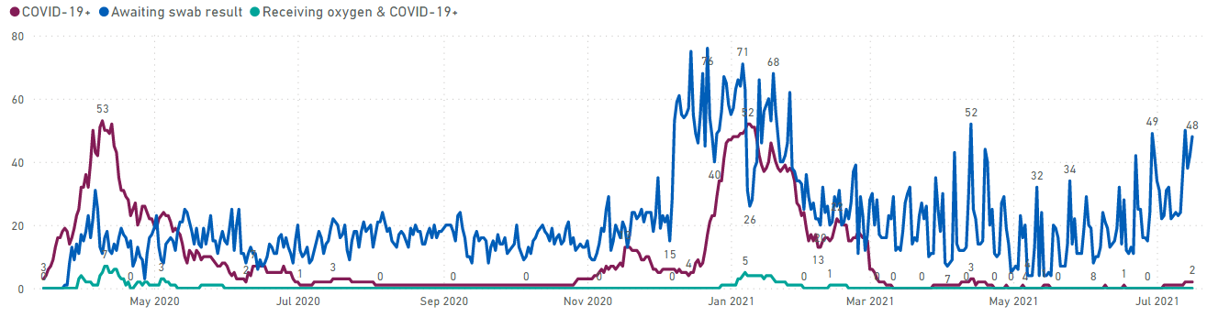

Group | Activity | No. at 25th May | Diff from end April | No. 13th July
Patients | Cumulative number of inpatients confirmed COVID-19 positive | 406 | +4 | 410
 | Cumulative number of COVID-19 deaths in our inpatient settings | 32 | No change | 32
 | Cumulative number of community patients confirmed COVID-19 positive | 611 | +13 | 624
 | No. of vulnerable community patients (as identified by Trust clinicians) | 3219 | -94 | 3125
Staff | Number of staff impacted by COVID19 and not working | 29 | -15 | 61
 | Number of staff impacted by COVID and working from home | 0 | -1 | 14

Vaccination Update

At 15th July,

- a total of 5925 (80.97%) staff have received their first vaccination dose; 3911 (85.3%) of front-line staff have been vaccinated.
- a further 4821 (65.88%) staff have also received their second vaccination dose; 3136 (68.4%) of front-line staff.
- 276 (3.8%) staff (220 (4.8%) front-line staff) are currently exempt from receiving the vaccine or have chosen to opt out of the vaccination program. As per the guidance provided by NHSE, line managers/occupational health are supporting staff and ensuring that any questions or concerns about the vaccination are addressed.

SECTION 2: OPERATIONAL PATIENT ACTIVITY AND DEMAND

2.1 Trust-wide headlines

Currency | Graph | Narrative
Community Services (Mental Health and Physical Health)
Received referrals | 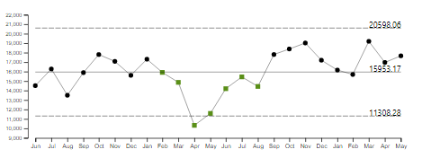 | Overall, referral levels are above average. There continues to be a sustained increase in Emergency and Urgent referrals.
Attended appointments | 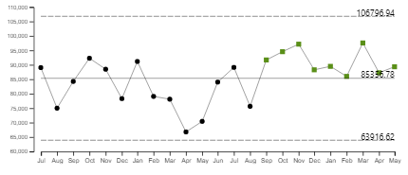 | Despite Covid the levels of activity delivered by the Trust continues to be equal to or just above average since September 2020.
Digital appointments | 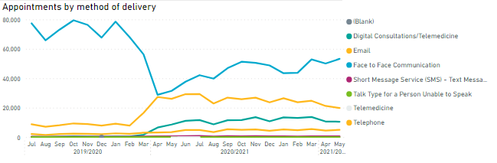 | Overall Trust wide face to face activity is the highest method of delivery of care, followed by telephone and then digital consultations.
IAPT (Oxon and Bucks combined)
Performance against trajectory | 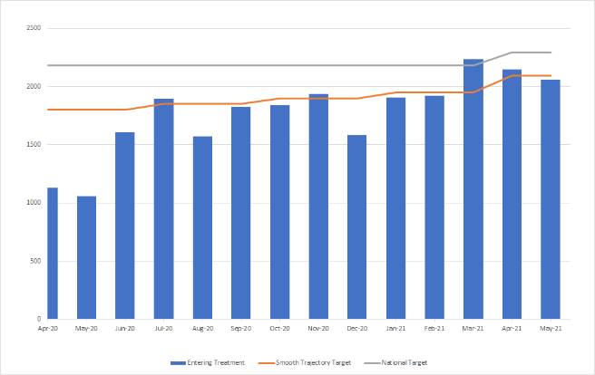 | Oxon and Bucks have agreed a smooth trajectory by which they will achieve the LTP (papers submitted to BOB last year). The increases to achieve the LTP are still very challenging e.g. Bucks IAPT in FY21-22 are required to enter into treatment an additional 2,560 people and Oxon IAPT in FY21-22 are required to enter into treatment an additional 3,999 people. Note the specific trajectory for this year for Oxon & Bucks has now been agreed with commissioners.
Inpatient Services
Admissions | 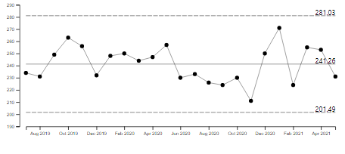 | Overall admissions in May were below average. Community Hospital admissions for May were slightly above average.
Length of stay | Mental Health:  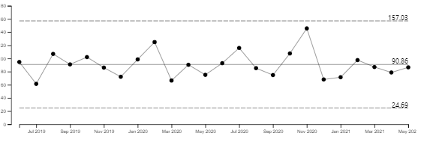 | Overall, length of stay (excluding delays and leave) was just below average in May. Bucks Mental Health continues trend of recent months of being below the Trust average at 53 days excl leave and 62 days inc leave. In comparison to national position of

2.2 Noteworthy exceptions

Service area | Currency | Graph | Narrative
Oxon & BSW Directorate | Urgent Referrals | 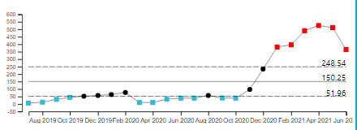 | The AMHO Street Triage and AMHO SCAS Triage teams are receiving significantly higher urgent referral demand than usual. This is part of a planned increase. AMHO SCAS Triage is illustrated by the graph
Bucks Directorate | Urgent Referrals | 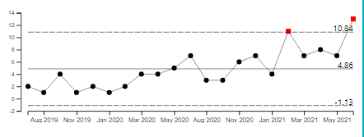 | B OA South CMHT in June received higher than average number of urgent referrals as illustrated in the graph left. The long term trend is showing a consistent increase in urgent referrals so further work to understand the reasons will be carried out within the Directorate.  CAMHS B OSCA Crisis also in May and June have received higher number of urgent referrals than normal.
Bucks Directorate | Routine Referrals | 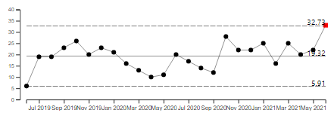 | Overall, routine referral demand to the directorate is at expected levels.  However, the Bucks Perinatal MH Teamwork team has received higher levels of routine referrals than normal in June – effect shown above.
Community Services Directorate | Children’s Integrated Therapies –Urgent Referrals | 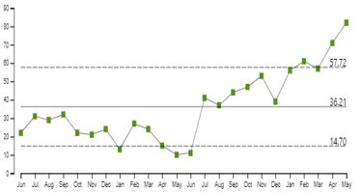 | The Children’s Integrated Therapies service is continuing to see an upward trend in urgent referrals.
Community Services Directorate | CTS Routine Referrals | 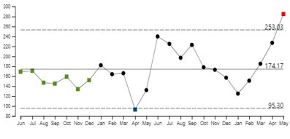 | The Community Therapy Service volume of referrals has been increasing month on month for the last 4 months. This is in response to referrals not made during  Covid period and also the service supporting the Ageing Well Urgent Community Response and Home First Initiatives.

2.3 Directorate headlines

Please note that this information relates only to services on Carenotes. Services not included at the present time are: Out of hours, IAPT and Dental

Currency | Community | Oxon/BSW | Bucks | Specialised – Forensics | Specialised - LD
Referrals | 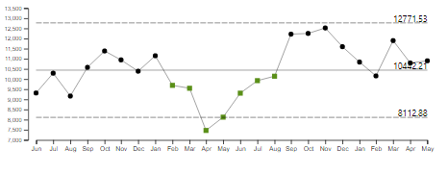 | 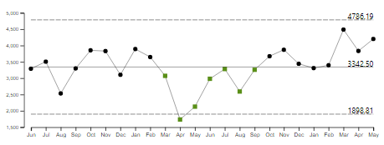 | 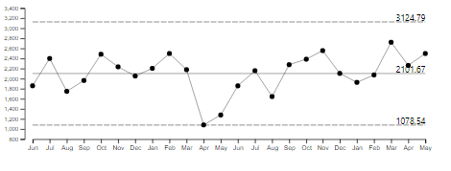 | 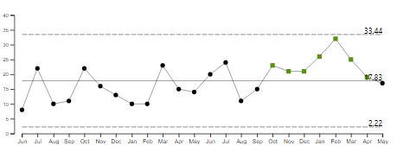 | 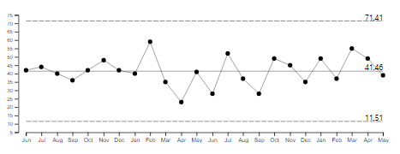
Commentary | Referrals in May were above the average. Emergency and Routine were above average | Referrals in May were above average. Urgent referrals have been above the upper control limit for the last 5 months | Referrals in May were slightly above average. Urgent referrals continue trend of recent months and were just below the upper control limit. | Referral volumes were in line with average | Referral volumes were in line with average
Attended appointments | 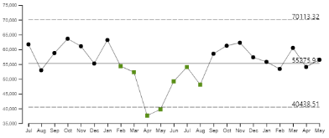 | 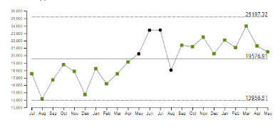 | 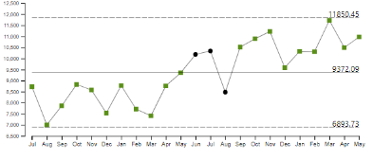 | 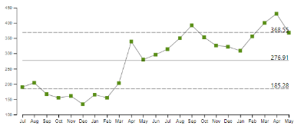 | 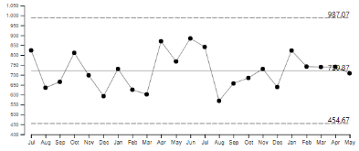
Commentary | Activity volumes in May were in line with average. | Activity levels continue to be above average. | Like Oxon, appointment activity continues to be higher than average. | Activity volumes in May are in line with the upper control limit. | Activity volumes in May are in line with average.
Digital appointments | 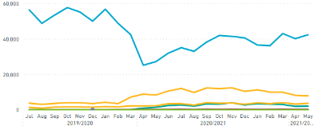 | 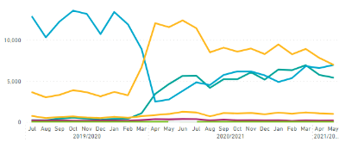 | 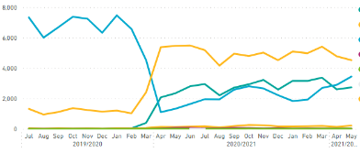 | 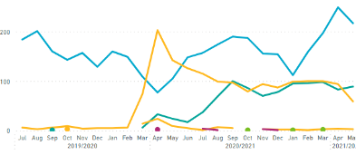 | 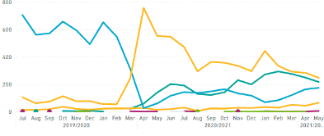
Commentary | Across all Directorates, the level of digital activity continues to be higher than pre Covid-19. In Community and Forensics face to face is the highest method of delivery, for all others it is telephone.
Admissions | 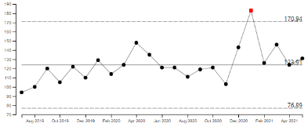 | 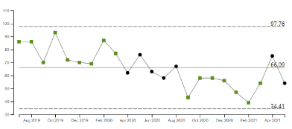 | 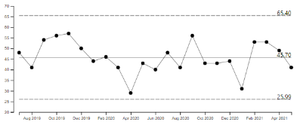 | 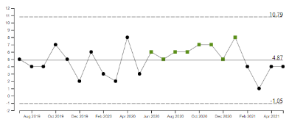
Commentary | Admissions in May were slightly above average. | Admissions in May decreased from April and were below the average | Admissions for May were below average | Admissions have increased in April. It should be noted that low admission numbers in this directorate impact on the variation.
Length of stay (excl leave and delay) | 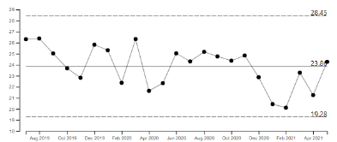 | 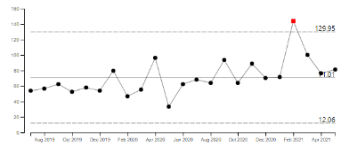 | 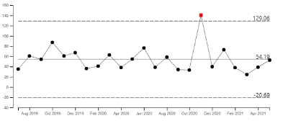 | 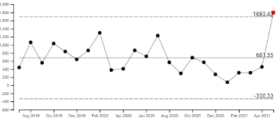
Commentary | Overall length of stay for community hospitals for May was slightly above average. | Length of stay in May was slightly above average | Patient average length of stay for May discharges was in line with average | LOS in this service is impacted by discharge on patients with high LOS.

SECTION 3: CONTRACTUAL KPI PERFORMANCE

4.1 Contractual waiting times
The Trust is contracted to report its waiting times for the following services;
- Community Services Directorate: Community Therapy Service (CTS), Adult Speech and Language Therapy (ASaLT), Physical Disability Physiotherapy Service (PDPS) and Nutrition and Dietetics (N&D)
- Oxon and BSW Mental Health Directorate: Adult MH Community services (assessment and treatment teams), Older Adult MH Community Services (older adult CMHTs) and CAMHS community
- Buckinghamshire Mental Health Directorate: MH Urgent Care service (crisis response and home treatment teams), Older Adult Mental Health Community Service (older adult CMHTs) and CAMHS community.
Performance excluding CAMHS relates to waiting times from referral received date to first attended appointment delivered via any method i.e. digital, telephone. If a patient does not attend (DNAs) their first appointment, the start date of their waiting time changes from referral received date to first DNA appointment date. This is in line with National referral to treatment (RTT) rules. CAMHS rules differ in that the start date of the patients wait resets every time the patient DNAs an appointment.
Work is underway within the Trust to agree service specific waiting standards for emergency, urgent and routine waits. In the meantime, a RAG rating has been provided based on the following generic standards;
- Emergency = <2 days
- Urgent = <7 days
- Routine = <28 days

Community Directorate
Service | Referral urgency | Number of patients seen | Median waiting time | Commentary
Community Therapy Service | Emergency | 24 | 22 hours | 19/20 Median Wait time 16 hours. The majority (21) of emergency referrals received in May were seen on the same day
Community Therapy Service | Urgent | 310 | 15 days | 19/20 Median Wait time 19 days. The median waiting time for urgent referrals to be seen was 15 days in May, 4 days shorter than the 19/20 median waiting time (pre COVID)
Community Therapy Service | Routine | 154 | 21 days | 19/20 Median Wait time 30 days. The median waiting time for routine referrals in May was lower than the pre-Covid wait time of 30 days
Adult Speech and Language | Emergency | - | - | No referrals in May
Adult Speech and Language | Urgent | 25 | 1 day | 19/20 Median Wait time 1 day. The majority (18) were seen within 1 day
Adult Speech and Language | Routine | 164 | 13 days | 19/20 Median Wait time 14 days. The median wait time in May for routine referrals was 13 days, shorter than pre Covid wait time
PDPS | Emergency | - | - | No referrals in May
PDPS | Urgent | 8 | 13 days | 19/20 Median Wait time 14 days. The median waiting time for urgent referrals in May was 13 days.
PDPS | Routine | 51 | 91 days | 19/20 Median Wait time 86 days the median waiting time for routine referrals in May was 5 days longer pre Covid.
N&D | Emergency | - | - | No referrals in May
N&D | Urgent | - | - | 19/20 Median Wait time 14 days. No referrals in May
N&D | Routine | 54 | 17 days | 19/20 Median Wait time 62 days. The median waiting time for routine patients seen in May was 17 significantly shorter than pre-Covid waiting time of 62 days.

Oxon and BSW Mental Health Directorate: Adult MH Community services (assessment and treatment teams), Older Adult MH Community Services (older adult CMHTs) and CAMHS community
Service | Referral urgency | Number of patients seen | Median waiting time | Commentary
Adult MH Community Services | Emergency | 9 | 1 hour | 19/20 Median Wait time 4 hours. All patients seen on same day of referral
Adult MH Community Services | Urgent | 114 | 2 days | 19/20 Median Wait time 4 days
Adult MH Community Services | Routine | 220 | 18 days | 19/20 Median Wait time 30 days.
Older Adult CMHTs | Emergency | 1 | 0 hours | 19/20 Median Wait time 2 hours. All patients seen on same day of referral
Older Adult CMHTs | Urgent | 37 | 0 days (5 hours) | 19/20 Median Wait time 2 days.
Older Adult CMHTs | Routine | 99 | 7 days | 19/20 Median Wait time 14 days. Shorter than pre Covid
CAMHS Community | Emergency | - | - | 19/20 Median Wait time 86 hours No emergency referrals seen in May
CAMHS Community | Urgent | 17 | 6 days | 19/20 Median Wait time 7 days.
CAMHS Community | Routine | 303 | 77 days | 19/20 Median Wait time 133 days. The longest waits were for the NDC diagnostic team at 1041 days

Buckinghamshire Mental Health Directorate: MH Urgent Care service (crisis response and home treatment teams), Older Adult Mental Health Community Service (older adult CMHTs) and CAMHS community.
Service | Referral urgency | Number of patients seen | Median waiting time | Commentary
MH Urgent Care | Emergency | 9 | 1 hours | 19/20 Median Wait time 2 hours. All patients seen same day
MH Urgent Care | Urgent | 205 | 1 day | 19/20 Median Wait time 4 days.
MH Urgent Care | Routine | 1 | 2 days | 19/20 Median Wait time 20 days.
Older Adult CMHTs | Emergency | - | - | No referrals 19/20 Median 3 hours.
Older Adult CMHTs | Urgent | 18 | 6 days | 19/20 Median Wait time 2 days. 17 patients seen within 7 days
Older Adult CMHTs | Routine | 62 | 9 days | 19/20 Median Wait time 17 days. Longest wait was 311 days in the North
CAMHS Community | Emergency | - | - | No referrals 19/20 Median Wait time 22 hours.
CAMHS Community | Urgent | 40 | 0 days (5 hours) | 19/20 Median Wait time 1 days. All seen within 7 days
CAMHS Community | Routine | 172 | 31 days | 19/20 Median Wait time 25 days. This is an increase on pre-Covid, the longest wait was 81 days to the CAMHS South Bucks Targeted team

4.1 Contractual KPI exceptions
Directorate | Service/Contract | Measure | Target | Actual | Months Below Target | Narrative/Plan | COVID RELATED
Buckinghamshire All Ages MH | CAMHS ED | % of routine ED referrals assessed in 4 weeks (national rules) | 90% | 33.3% (5/15) | 2 months | Description of the issue: 10 patients breached, 2 were patient choice as they cancelled their initial appointment. 3 patients show a consultation contact, but their assessment was outside the 4 weeks. The remaining 5 were seen on days 40/47/50/54/54 due to lack of clinic availability. Increased referrals into the service have meant there is a higher demand and a decrease in capacity due to running with vacancies in the team.  Plan: The service is currently recruiting to vacant posts we have increased assessment slots and have a locum RMN (nurse) in post to support this.  Resolution Timescales: By the end of September, it is hoped new staff will have been recruited to vacant posts and to have meaningful reduction in waits. | Partially
Buckinghamshire All Ages MH | CAMHS | % of Routine referrals assessed within 28 days (Inc LD/OSCA/GMH/Targeted/SPA) | 90% | 50.3% (75/149) | 6+ months | Description of the issue: The service has had issues with our third-party online assessment provider, there has been a reduction in their online assessment capacity since March due to the pressure of other contracts. Following discussions capacity has now been released and services have been referring in they should, from next month, see an improvement with this.  Plan: The service is just finalising a Demand & Capacity project for CAMHS which will help re-design and rebalance where necessary focussing on flexing the workforce where there is capacity to meet the demand.  Resolution Timescales: Demand & Capacity report due beginning of July, this will then give the service the opportunity to review where the demands are in the system and flex the capacity to meet this. | Partially
Buckinghamshire All Ages MH | Adults | % people will have CPA review within the (timeframe) | 95% | 77.1% (625/811) | 6+ months | Description of the issue: The target for this measure has been in place since November 2020 and has improved from the 71% achieved at that time.  Plan: The service is working through the CPA breaches, with the help of the performance & information team – some data issues identified such as clients not being on CPA but recorded as being on CPA. Clinicians are updating the true breaches.  Resolution Timescales: The service is aiming to meet target by January 2022 | Partially
Buckinghamshire All Ages MH | Adults | Emergency referrals to Mental Health Team will be seen within 4 hours for assessment. | 95% | 80.0% (4/5) | 2 months | Description of the issue: 1 patient breached the 4 hours. This is a data quality issue, and the patient was seen within the 4 hours.  Plan: The service has corrected the patient record.  Resolution Timescales: N/A | No
Buckinghamshire All Ages MH | Adults | Routine (non-emergency) referral to Mental Health Team will be seen within 28 consecutive days for assessment. | 90% | 69.2% (119/172) | 1 month | This indicator has breached its target by >10% for one month. Further investigation will be carried out if this indicator remains red for a second month.
Buckinghamshire All Ages MH | Older Adults | % people will have CPA review within the (timeframe) | 95% | 75% (126/168) | 6+ months | Description of the issue: The target for this measure has been in place since November 2020 and has improved from the 74% achieved at that time.  Plan: The service is working through the CPA breaches, with the help of the performance & information team – some data issues identified such as clients not being on CPA but recorded as being on CPA. Clinicians are updating the true breaches.  Resolution Timescales: The service is aiming to meet target by January 2022 | Partially
Buckinghamshire All Ages MH | Older Adults | Routine (non-emergency) referral to Mental Health Team will be seen within 28 consecutive days for assessment. | 90% | 79.3% (65/82) | 1 month | This indicator has breached its target by >10% for one month. Further investigation will be carried out if this indicator remains red for a second month.
Buckinghamshire All Ages MH | Perinatal | Urgent – 2-day assessment target | 95% | 83.3% (5/6) | 3 months | Description of the issue: 1 patient breached the 2 days. This was patient choice as they did not attend their initial assessment. They were followed up and offered a further appointment and were seen on day 15.  Plan: N/A  Resolution Timescales: N/A | No
Buckinghamshire All Ages MH | Perinatal | Women Seen  For FY21/22, the new access target is 8.6%. The number of people accessing perinatal services is set at 573 for BCCG, an uplift of 138 people over a 12-month period. | 8.6% | 3.6% (219/6121) | 6+ months | Description of the issue: The current target is based on 2016 birth rates of 6121, 2019 live birth figure for Buckinghamshire Local Authority was 5629. The 219 (3.6%) number is the access indicator rate and a percent achieved based on rolling 12-month period measured against 8.6% target for FY21/22. The refreshed April and May figures are (261/6121 = 4.3%) and (235/6121 = 3.8%).  Plan: The Performance & Information team have contacted the national team about this as Bucks LA have seen an 8% decrease in live births from 2016 compared to 2019 (latest available figures). They have advised that any reduction in the birth rate used for Bucks would also necessitate a reduction in funding!  Resolution Timescales: The service is working with Performance & Information to produce a trajectory for the year. | Partially
Community Services | Continuing health care (Oxon) | If eligible, the package of care for Fast Track individuals will be in place within 2 working days | 95% | 47%  (31/66) | 6+ months | Description of the issue:  The delay is due to two main reasons, namely market restrictions and reduced ability for agencies to pick up new packages of care when responding to COVID19 pressures. These limitations are outside the power of Oxford Health Foundation Trust to correct. The complexity of clients referred to the service continue to increase. A service audit demonstrates that although the 2-day target is not met, most patients are placed within 7 days.  Plan:  To mitigate increased complexity of the clients referred to the service, the team is taking on 2 WTE of agency assessor.  Resolution timescales:  Not appliable. | Partially
Community Services | Continuing health care (Oxon) | Individuals eligible for CHC will receive a case review which will include care plan review every 12 months | 95% | 63%  (17/27) | 1 month | This indicator has breached its target by >10% for one month. Further investigation will be carried out if this indicator remains red for a second month. | Partially
Community Services | Continuing health care (Oxon) | Individuals eligible for CHC will receive a case review which will include care plan review 3 months after eligibility decision | 95% | 68%  (14/21) | 1 month | This indicator has breached its target by >10% for one month. Further investigation will be carried out if this indicator remains red for a second month. | Partially
Community Services | Looked After Children | Percentage of Children notified by LA to the LAC team as new to care to be offered a health assessment within 20 working days | 100% | 13%  (3/25) | 4 months | Description of the issue:  The offer of a health assessment to 22 children new to care in June has been delayed between 2 and 20 days. In 6 cases, this is due to delays in receiving the information from Oxfordshire County Council (OCC) team or moving placements. The Phoenix Team has had reduced availability of clinic appointments due to the consistent high number of children coming into care and a reduction of available appointments with the specialist doctors.  Plan:  The Phoenix team is looking to employ additional medical staff to increase capacity in clinic. Processes have been reviewed to ensure medical time is focused on clinical activity.  Resolution timescales:  All 22 children have been given an appointment and 14 have already been seen. 5 children’s appointments have been affected by delays in receiving essential paperwork from the social worker. 2 will be seen in the 5 days following the 16th of July 2021. | No
Community Services | Looked After Children | Percentage of Children notified by LA to the LAC team as new to care to be offered a health assessment within 20 working days | 100% | 13%  (3/25) | 4 months | Description of the issue:  The offer of a health assessment to 22 children new to care in June has been delayed between 2 and 20 days. In 6 cases, this is due to delays in receiving the information from Oxfordshire County Council (OCC) team or moving placements. The Phoenix Team has had reduced availability of clinic appointments due to the consistent high number of children coming into care and a reduction of available appointments with the specialist doctors.  Plan:  The Phoenix team is looking to employ additional medical staff to increase capacity in clinic. Processes have been reviewed to ensure medical time is focused on clinical activity.  Resolution timescales:  All 22 children have been given an appointment and 14 have already been seen. Five children’s appointments have been affected by delays in receiving essential paperwork from the social worker. Two will be seen in the 5 days following the 16th of July 2021. | No
Community Services | Looked After Children (Out of County) | Every child over 5 will receive a health review annually | 90% | 33%  (11/33) | 6+ months | Description of the issue:  Children seen outside the timeframe mainly due to reduced capacity in the Looked After Children (LAC) teams in other counties and also delays in receiving up to date information from OCC Children’s services.  Plan:  Not applicable  Resolution timescales:  Not applicable | No
Specialised Services | CAMHS | Number of eligible staff who have received clinical supervision as per Trust/organisation policy | 85% | 67%  (54/81) | 3 Months | Description of the issue: There have been some improvements in receipt of supervision, but the units continue to experience increased demand. Both units have had high acuity patients, with multiple incidents which have contributed to falling numbers of supervision due to time restraints.  Plan: Matrons are contacting all staff members to highlight the importance of supervision, particularly when things are challenging on the ward  Resolution Timescales: This will be monitored by the Matron and Senior Matron. Predicted improvement deadline August 2021. | Partially
Oxon & BSW MH All ages | OBC | % of service users who have had a physical health assessment | 90% | 44% (350/898) | 6+months | Description of the issue: Despite capacity issues Performance for this KPI has improved by 10% during the last 2 months.  Plan: OH have recruited a PH lead nurse for SMI in Community, they started in June 21. Additionally the directorate have successfully recruited to 9 physical health care assistants in the community teams – they will initially target patients missing PH assessments before broadening the roles  Resolution Timescales: We have a trajectory to get to 90% complete by Jan 22. | Partially

