Freedom to Speak Up Guardians Annual Report to Trust Board
Main Report

Introduction

This is an annual report to the Trust Board for information on the activities of the Freedom to Speak Up Guardians (FTSUG) for the 12 months up until the end of September 2021. The Guardians play an important role as part of the Trust Strategic Objectives, Quality and People, in creating an open and transparent culture of improvement and learning, where speaking up and raising concerns are welcomed and seen as a gift.

Where appropriate, this report refers to the National Guardian Office (NGO) guidance. It gives a brief overview about FTSUG role. The Guardians collaboration and contribution to the speaking up culture with various networks nationally, regionally and locally are discussed.

This report highlights the activities undertaken by the Guardians to raise awareness about “Speaking Up” to encourage the ongoing cultural changes Trust wide. It includes key highlights from the FTSU October month. Detailed analytical data with regards to numbers and types of cases / concerns raised per directorate and by professional group are discussed. The emerging themes are explored with some recommendations and reflections based on the findings. Trust plans about the FTSUG input for 2021-22 are summarized.

Background to FTSUG

The FTSUG role has been in place since 2016 as an outcome of the Mid Staffordshire enquiry 2015 by Sir Robert Francis. It is now an established role in our Trust where the FTSUG fosters a positive culture by empowering staff to speaking up, listening up and following up.

The current Guardian was appointed in June 2018 initially on a fixed term contract which has now been made permanent for 18 hours. Following the Board Report 2020 recommendation, another Guardian was successfully appointed in May 2021 for 18.75 hours who continues to work as a Learning Environment Lead (LEL) for the rest of the hours. The new Guardian has completed the NGO mandatory training.

The Guardians meet regularly to discuss cases and for peer support. The Guardians report directly to the CEO and have access to the Executive Directors of the Trust. It is envisaged that the Chief People Officer will take on the line manager role for the Guardians who will continue to meet with the CEO regularly to share information. It is vital that the Guardian role is, and is perceived as, independent and is not seen by colleagues as part of one directorate or function.

One of the key elements of the FTSUG role is to provide independent, impartial, and confidential advice and support to the staff who want to raise a concern. The guardians follow the NGO guidance for case recording, concerns categorization and reporting. They report Trust data nationally to NGO quarterly.

Most colleagues have contacted the Guardians by e-mail or telephone, but a number were direct contacts during awareness raising activities and drop-in sessions. The use of MS Teams has been vital when face to face meetings have not been possible or advisable. The Guardians thank colleagues for their courage to speak up, make time to listen, provide support and signpost as necessary. They follow up on the concerns raised and then give feedback to the staff about any actions taken or outcomes reached.

Another important role of the FTSUG is to empower staff and foster a positive culture in which staff feel safe to raise those concerns which relates to the Trust Strategic Objectives about quality and people. It is not the role of the Guardians to investigate issues but to hold senior managers and directors accountable for addressing the concerns raised.

Cases / Concerns Raised

The Guardians have recorded 100 cases that were raised with them during this period of reporting 2020/2021. These cases were raised either by staff individually or in a group / team. More than one concern may be raised in each case. Some cases were resolved quickly, some remain open and are being followed by the Guardians. There is a significant increase of 33 cases compared to the previous year 2019/2020. This increase in numbers may be due to the FTSUGs reaching more staff and the route to contacting FTSUs is more widely known. There is a clear correlation of increase in numbers with more FTSU capacity following the appointment of the second Guardian in the second two quarters of the reportes period.

Concerns were raised by colleagues from all directorates, from both permanent staff and students/learners, trainees as well and flexible or locum colleagues . These have included health care assistants, administrators and ancillary staff. Registered staff have included nurses, community psychiatric nurses, district nurses, learning disability nurses, health visitors, social workers, physiotherapists, psychologists, psychotherapists, occupational therapists and medical staff. Some staff have been in leadership and management roles such as ward managers, community team managers and service managers.

Figure 1 below illustrates the breakdown of the number of cases from each Directorate. Highest number of cases (35) were raised from the Oxon and South West MH Directorate, followed by the Bucks MH Directorate (23) and Community services (17). On occasions some issues from Specialised and Forensic Directorate were discussed with the Guardians but not raised as concerns, and therefore are not reflected in the data below.

Figure 1
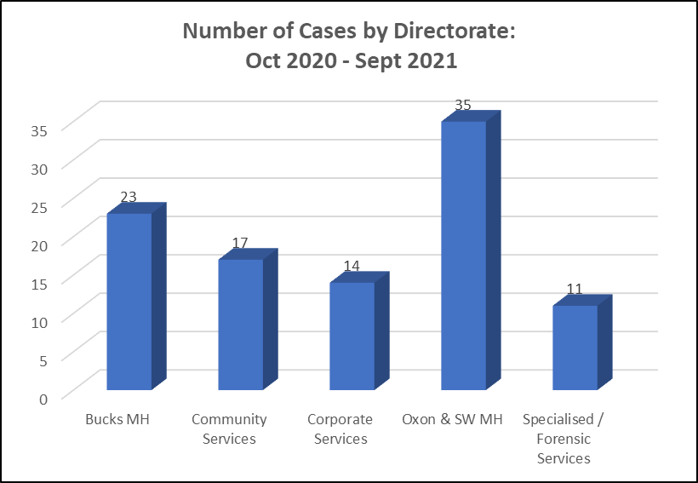

Services where there have been concerns raised from each Directorate include:
- Bucks Mental Health: Inpatient and community teams. Most concerns were raised from community teams (14 cases).
- Community Services: Out of Hours service, Single Point of access, Community Therapy Service, Children’s services, District Nursing, Health visiting
- Corporate Services: Administration, senior leaders, Staffing solutions, Human resources, Facilities and Estates; Medical staff.
- Oxon & SW Mental Health: AMHTs, CAMHs, In patient services in both adult and older adult settings. Most concerns came from community teams (18 cases).
- Specialised / Forensic Services: Learning Disabilities, Forensic services
Figure 2 below shows the details of the cases raised by staff by their professional groups. 42% were from registered nurses and midwives professional group which is the largest group of colleagues employed from all areas of the Trust. Although the percentage of concerns raised by the Administration/Clerical & Maintenance/Ancillary group appear to be in line with the numbers of colleagues employed in these roles there are far fewer concerns raised from the maintenance and ancillary colleagues.
Figure 2
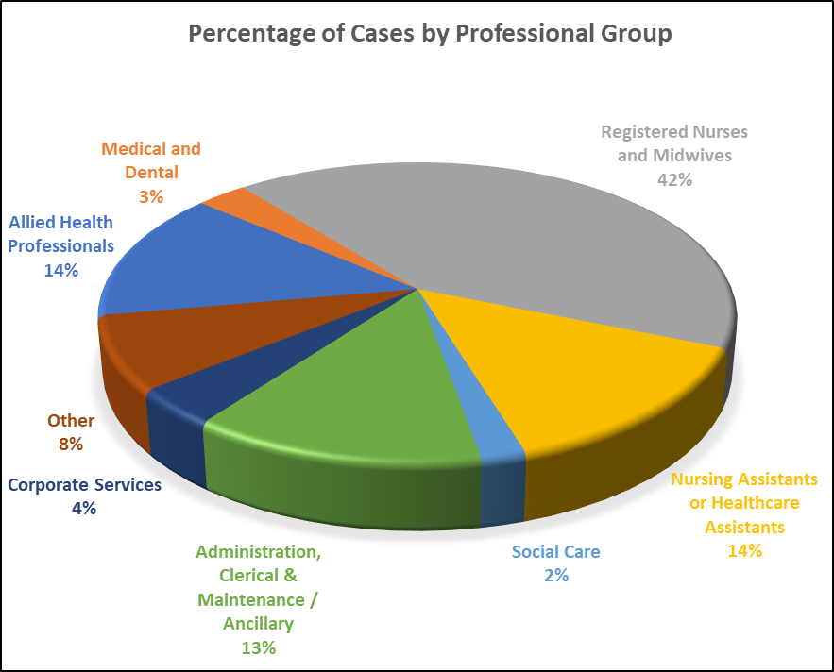

Types of concerns raised

Figure 3 below illustrates the number of each types of concern raised. As indicated above in this report, an individual staff or group of staff may raise more than one type of concern or vice versa. Bullying & Harassment (29), Worker safety (30); Mental /Physical health (26); Lack of Communication (26); and Leadership (21) seem to be the most prominent types of concern raised by the staff. Staff uncivil behaviours seem to contribute to many of the types of concerns raised.

Figure 3
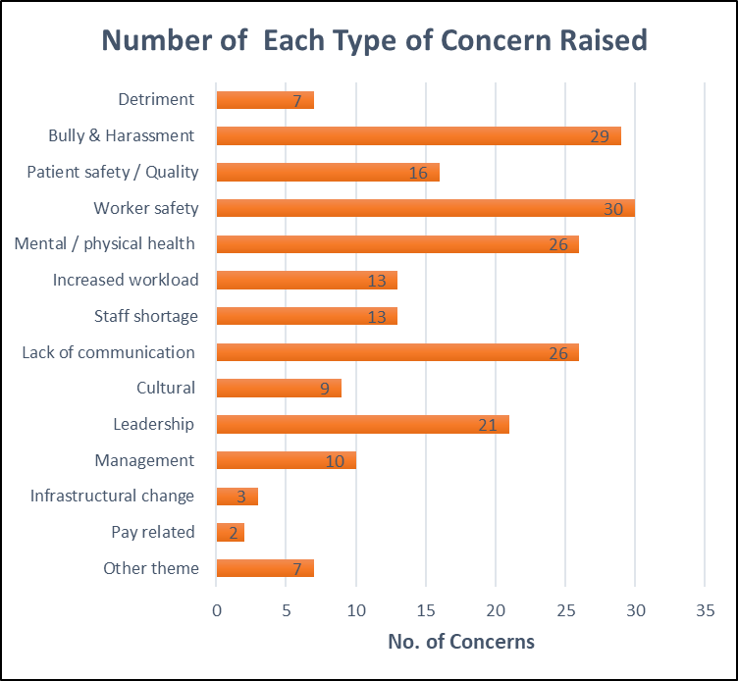

The most reported types of concerns raised with the Guardians are discussed further below:

Bullying and harassment: Whilst bullying may not be endemic in the Trust, it has been reported to the Guardians by staff from senior managers/leaders to frontline staff across the Trust. Often staff felt very anxious about formalising bullying allegations as they were worried that the situation would be made worse for them. Colleagues described distressing situations where they had been victimised by their managers. These included being shouted at, ignored, not given training opportunities, having reasonable requests refused, being treated differently than colleagues and being spoken to or about in derogatory ways. Bullying took place in 1:1 situation and in more open settings.
Some concerns included elements of favoritism, described as ‘one rule for the favoured few, another for the rest’. This experience was variously ascribed to a manager who had friends or relations in the team or who were part of what would be seen as a clique. In the latter case whole groups of staff were described as exclusive and unwelcoming.
Some managers were generally poorly supported in addressing these issues by their line managers or felt that as new managers they had to demonstrate their control of a team and therefore were reluctant to ask for support. Training staff how to challenge inappropriate behaviours could help tackle some of the recurring concerns raised here.

Patient safety: There have been no concerns of abuse similar to those seen at Stafford Hospital raised with the Guardians. Some of the patient safety concerns were because of poor practice where policies and procedures have not been followed up properly. However, many related to the level of demand and the expectation of quick throughput of cases and speedy discharge, as well as to the expectations of shift pattern changes and redeployment due to Covid response.

Worker Safety: The effects on colleagues of working through the pandemic have been demonstrated by an increase in those concerns relating to increased demand and complexity and the challenges of remote working. Many staff reported poor practice which was not only impacting on patient safety and quality of care, but rather compromising the staff safety at work. For example, during a control resolution procedure, some protocols were not followed properly which ended up in the staff getting hurt.
Some staff have reported that they were asked to carry out some procedures without having the appropriate training or appropriate resources like PIT alarm. Another group of staff have expressed the risk of lone working during late hours and accessing premises that are frequently visited by drug users. Many staff have raised their concerns about sharing their cars with others/learners specially during covid. Some staff have been asked to come to work from base without having appropriate covid risk assessment done. Most of these concerns were addressed quickly and easily by line managers.

Mental / Physical health: Many staff have contacted the Guardians in tears and distressing state. Some staff have reported being subjected to uncivil behaviours, undermined, not valued and micromanaged which are impacting on their wellbeing. Concerns have been raised whereby staff are feeling fatigued, drained and stressed due to increased workload and staff shortage. Staff have reported that they are struggling to meet the life work balance due the increased demands on their roles and are always expected to go the extra mile. Even when they have raised their concerns to the managers, nothing has been done. Some staff reported the support they are given on phase return to work are not structured and are asked to carry out tasks even there are plan that indicates for example they have a bad back.

Increased workload and staff shortage: Alongside 3 specific concerns, the Guardians have heard in team sessions reports of increasing numbers of referrals of more complex patients and having to care for them without an increase in resources. These pressures have been exacerbated by staff absence due to positive covid tests. There are significant numbers of vacancies in many teams. Often staff worked extra hours to try to meet this demand and would go home worrying about patients that they felt were at risk. This caused them stress and had an impact on their family lives. They were concerned that they could not provide care to the standard that they would like and some felt that they were compromising their professional standards. These concerns were reported previously to the Board and Directorate Management Teams.

Leadership, Management and communication: Staff described some managers as insensitive or lacking in management and leadership knowledge and skills. Others felt that there was a lack of communication when staffing or service changes were being made. Communication formed the basis of concerns raised regarding email style and tone. Staff also reported concerns about lack of communication and lack of feedback when they have taken courage to speak up. Frequently, they the staff report that “nothing changes or is done to address any concerns that have been brought to the attention of management”. Many have reported concerns about lack of support and supervision. Lack of appropriate training, inadequate time to listen and follow up on concerns raised appear to the emerging theme.

Actions taken by the Guardians in relation to concerns raised

The Guardians wish to stress that in almost every case the response from senior managers is to listen and to follow up. Often but not always the senior manager is aware of the concerns via another route and on some occassions action is being taken but has not been communicated to the team or individual. The Guardians do not share the name of the concern raiser( unless given permission) even if the manager suggests who that might be.

The discussions with the Guardians would often lead to the individual developing strategies to address their concerns with their managers or making changes to their own practice. Their concerns about being identified or possible repercussions meant that for some, the Guardians were only able to feedback or address their concerns in a general way (for example, discussing management style with the Directorate Management Teams). Most of the time, the Guardians would take the following actions depending on the cases brought to their attention:
- Advice given about how to respond to bullying and harassment
- Confirmation of actions being taken in the Directorate
- Recommendations to contact Occupational Health, Employee Assistance Programme, You Matter, Union advice and support
- Recommendation to ensure exit interview is carried out and information shared
- Advice sought from National Guardians office re cases
- Escalation to service heads to complete requested actions
- Reviews of similar cases published by National Guardians office
- Facilitated conversations between concern raiser and service leads
- Work with universities when learners / trainees have raised concerns

Changes that were made following the involvement with the Guardians included:
- Clarification of information given to staff and the routes by which this was given
- Mediation with resolution between staff members
- Review of culture in ward teams
- Increased awareness of the importance of civility in communication
- Improved support for new managers in liaison with Human resources
- Review and re writing of exit process regarding exit questionnaire and interviews.
- Work with HR on the formalization of how information from exit interviews is recorded and used for Trust wide learning

Freedom to Speak Up activities in the Trust

In addition to being available to listen and follow up on staff concerns, other activities have been undertaken to raise awareness of Freedom to Speak Up and to encourage cultural change in the Trust. All opportunities to meet with and speak with staff contribute to cultural change within the Trust reinforcing that cultural change is everyone’s business. The Guardians have also contributed to the national and regional developments in this area.

Contribution to changing the trust culture: The FTSUG activities are supported and complemented by many trust wide networks such as the Well- being, Equality & Diversity, Spiritual and Pastoral, Fair treatment at Work Facilitator among others.
Regular meetings were held with the Director of Human Resources and the Director responsible for Whistle Blowing/ Raising Concerns. Regular discussions with the

The Guardians have regular discussions with the CEO, HR and the Director of Finance/ whistleblowing lead about the current whistleblowing concerns and possible investigations. An annual report is provided to the Trust Board and interim report to Well-Led Quality Sub-Committee. The same reports are shared with the staff side at the SPNCC.

Promoting & Raising awareness about FTSU: Considerable amount of the Guardians’ time are spent on promoting and raising awareness. Information is provided and promoted via intranet communications, posters leaflets, video, webinar, FTSU webpage via Staff Support Hub.
Demands to provide trainings formally and informally have increased significantly.
Tailored face to face or virtual training sessions from 15 mins to 2 hours long are provided to staff. Here are some examples:
- Induction training sessions - Trust, HCA, Forensic, Psychology Doctoral trainees, preceptorship, the Flyer Programme, International Nurses, Nurse Associates, Nurse cadets, student nurses
- Team drop in / briefings in all the Directorates across the Trust - CMHTs in Oxfordshire, CAMHS community and Eating Disorder teams, Oxfordshire Community development leads, Forensic ward managers and clinical leads, District nurses. Community Therapists, AMHTS Buckinghamshire, Adult Mental Health In- patient teams, Older Adult In- patient Teams, Podiatry Teams, inpatient MH wards, Saffron House teams

FTSU information on The Staff Support Hub: There is a page on the intranet with information about the role of the Guardians, how to raise concerns and sources of support for staff. There have been announcements in the weekly communications bulletin and articles on the intranet. The FTSU animated video has been launched and modules on Speaking Up and Listening Up are now available on the Learning & Development Portal.

Speak Up Month October 2021 #Speak Up Listen Up Follow Up

A national campaign initiated by the NGO occurred throughout October 2021, provided the opportunity for further awareness promotions. During Speak Up Month, the Guardians held surgeries and drop-in sessions virtually and in person to the following sites: Aylesbury; Warneford; Littlemore; Chipping Norton; Swindon; Witney; Didcot; Wallingford; Savernake; Highwycombe and Fallbrook Centre.

Activities included: Information sharing and Q and A sessions in all directorates
- Word search competition
- Encouraging staff to make pledges about speaking up
- Further involvement with and contribution of the Communications team who have promoted and highlighted the campaign and the FTSUG role via the Intranet; leaflets; posters and social media #SPeakUpListenUpFollowUp
- A Webinar with the CEO including the launch of the FTSU animation.
- Recognition by the National Guardians Office of the campaign

Alongside the Intranet pages and links, Twitter and Facebook communications, the communication team and the Guardians continue to work to reinstate older technology methods, posters, hand bills, drop ins to reach workers who do not have viable access to an electronic device or do not have time to view the Intranet.
The process of speaking up is working for some and many took the opportunity to speak up during our visits. Workers are speaking up if they feel that their managers are not addressing their concerns.

National and Regional Developments

From April 2017, the NGO started collecting data quarterly on the work of the Guardians which it publishes. The Guardians contribute to this national data by reporting the numbers of concerns raised quarterly. The Guardians are expected to highlight keys emerging themes and learning from the concerns raised. This also includes a satisfaction question that Guardians are requested to ask all staff that contact them. In addition, the Guardians complete the yearly NGO FTSU survey for ongoing development.

The Guardians take an active role in the South East (West) regional network of Freedom to Speak Up Guardians which meets quarterly. Knowledge sharing and peer supervision is part of both the regional and the Buckinghamshire, Berkshire and Oxfordshire (BOBshire) informal group. The BOB group has contributed to discussion with the BOB ICS Enhanced Occupational Health & Wellbeing

Effectiveness of Freedom to Speak Up

The national NHS staff survey asks two questions about staff raising clinical concerns in their trust. The staff survey showed very small changes from previous surveys in that staff felt more secure to raise concerns about unsafe clinical practice but there was no increase in confidence that the Trust would address those concerns. Responses varied across teams. Overall staff who answered the survey were more positive about raising concerns than about being confident that the Trust would address concerns.

Anonymised feedback is requested from staff that have contacted the Guardians, is collated via a Microsoft form. Questions about equality which will enable a picture of the background of staff contacting the Guardians are included in the feedback. The feedback received was mostly positive but was a small sample. All respondents reported that they would speak up again.

Positive comments included:
‘I was so grateful to talk to someone confidentially ‘
‘I was made to feel comfortable to speak and was truly listened to and understood’
‘it really helped me to see my priorities’
‘Thank you very much for taking your time for me today. I truly feel better after talking to you. I believe empathy and listening skills are quite precious so thank you for being such an asset to this Trust. You play a big role in changing blaming culture to speaking up culture.’
One comment described dissatisfaction with the length of time to receive feedback. Another comment included frustration that despite reaching the highest level and being acknowledged as a concern, change had not yet happened or behaviour change was not consistent.

Reflection of the Guardians

Many colleagues commented that they appreciated seeing the Guardians visiting them in their workplace. Although Covid safe practices have made visiting sites difficult in the last year, it has been clear that staff valued visits from the CEO or other directors. Could we now return to planned ‘walkabouts’ or drop ins from members of the Board?

It is clear that direct threats to patient safety are not the most often raised concerns. Indirect risks to patient safety due to the lack of resources is most often raised. It has also been observed by the Guardians that our colleagues from Facilities and Estates like housekeepers, porters, Domestics are not given any opportunities about career progression. This may need addressing as it will help with retention.

Management behaviour and skills and inter-colleague behaviours are at the route of the majority of concerns raised. Addressing the underlying issue of management culture remains a task for leaders of the Trust. How do we develop our staff to be fit for management and support them once appointed? Do we have enough training, coaching, mentoring? Do we expect managers to reflect on their style and skills and allow them to acknowledge their need for development?

Ensuring that all the colleagues know the Values of the Trust and are supported to be fair and kind in their interactions with each other is an unending responsibility.
Numbers of concerns raised are increasing. In quarters one and two of 2021- 22, since we have had 2 Guardians, we have already reached 56 concerns in comparison to the whole of last year, 67. The Chief Executive has encouraged and supported an increase in hours for the Guardians role which has allowed greater possibilities for reaching colleagues with the Speak Up message. The Guardians continue to raise awareness about speaking up as part of the Trust cultural change. The demands for our input into training sessions and culture change keeps on rising and this use of time needs to be reviewed in relation to our capacity.

Our experience has been because we have reached out to more staff, more concerns have been raised. This has been possible due the increase in capacity of the Guardian roles and the consequent increase in promotion about speaking up more widely across the trust. Demand and capacity will continue to be reviewed and the discussion regarding creating a FTSU champions network or creating more Guardians will be revisited with stakeholders and the Chief People Officer.

The Objectives for Freedom to Speak Up Guardian 2021-22

The objectives from 2020-21 continue to be relevant and have been agreed with the CEO. The ongoing objectives are:

- To continue to raise awareness of the role of the Freedom to Speak Up Guardian with Trust staff.
- To target those staff who do not regularly use computers or see information on the Intranet. Measured using numbers contacted, numbers of concerns raised, variety of areas from which concerns arise
- To work with Human resources and Learning and development to improve the confidence of managers in responding to concerns raised with them by their staff through the Freedom to Speak Up Guardian. Measured by Feedback survey comparing year on year.
- To participate in the development of the role of the Freedom to Speak Up Guardian and the Office of the National Guardian. Working with the Chief People Officer to assess demand and Guardian’s capacity.
- To include in management training specific reference to the Staff Support Hub and its importance for all staff. Partially completed.
- Publicise and use via induction and promotion the National Guardians Office’ E learning package of awareness training for workers, managers and when launched e learning for Boards.
- Support the Board to complete the revised National Guardians Office Board Self Review

Recommendations
- The Board is asked to note the work done across the year by the FTSUG and to seek any necessary assurances arising from the report.
- The Board is asked to confirm its assurance that the present structure of the Freedom to Speak Up Guardian role supports the Trusts objectives, Quality and People, in regard to speaking up about patient and workers safety.
- The Board is asked to consider completion of the NGO FTSU Self- Review after the National Guardians Guidance to boards is published. (2021) National Guardian's Office

Rita Bundhoo-Swift & Caroline Griffiths,
Freedom to Speak Up Guardians.
November 2021

