Report to the Meeting of the
Oxford Health NHS Foundation Trust
CoG 02/2022
(Agenda item: 05)

Council Of Governors
24th March 2022

Forensic Learning disability inpatient service

For: Information

This patient story records the work undertaken in the Evenlode Voices Involvement group. The group meets once a week and undertake work to improve the experience of being a patient on Evenlode or to add their voice to wider consultations such as the Tiny Forest and the NHS Learning Disability, patient survey.
The group is open to all the patients and staff and is facilitated by Rachel Miller, Patient Experience, and involvement Lead. The groups work is based on taking a co-productive approach to all the projects.
This story will take a different form, than normal due to the patient group of Evenlode. The Presentation has been co-produced by the group and it was agreed that Rachel Miller, Patient Experience and Involvement lead would present it. This is due to the group have less access to technology and some are not able to or do not wish to be identified publicly.

About the service

Evenlode is a medium secure inpatient service. We support adult men with learning disabilities who have a history of offending behavior or are at risk of offending. They may also have mental health problems or Autism. Evenlode is a 10 bedded unit with a high dependency unit and seclusion room. There is currently refurbishment and building work ongoing in order to improve the environment for patients in the high dependency unit. Data from TOBI shows that over the past 12 months from 1st January 2021 to 1st January 2022 there have been 3 admissions and 1 discharge, the average length of stay is 1,093 days, and bed occupancy is 86%.

About the service users

The service users staying on Evenlode ward are adult men aged between 18 and 65. They have been diagnosed with a learning disability, may also have mental health problems and or Autism. They have all engaged in offending or serious risk behaviors.

Service delivery

Evenlode provides specialist care and treatment from a multi-disciplinary team comprising, Occupational Therapists, nurses, social workers, Psychiatrists, health care assistants, pharmacy a ward manager and matron. It is a locked environment where people are admitted at crisis point and rehabilitated to their potential for moving to the least restricted and health promoting environment possible for them.
Service challenges

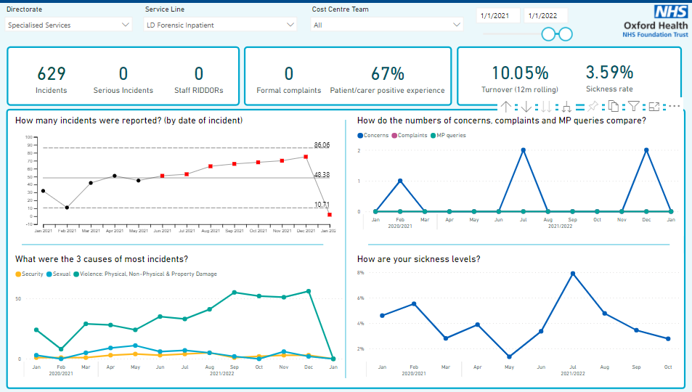

Evenlode ward have challenges around incident rates. Several interventions and service developments have been targeted at tackling the challenge of incident rates. The ward high dependency and seclusion suites are being refurbished and a new sensory room was installed during the pandemic. This provides opportunities for de-escalation and an environment that supports sensory regulation as some of the patients have sensory processing difficulties.
The ward timetable has also been reviewed and a new program introduced which includes regular sensory circuits to again help with sensory regulation. These sessions are run/overseen by an occupational therapist who has undertaken further sensory training. Positive behavior support has also been embedded on the ward.

Communication and involvement has also been a challenge during the pandemic with the wearing of masks, which has provided an additional barrier to communication with this group of patients, who often rely of facial expression to help to interpret what is being said. Involvement and communication virtually can also present a barrier for this group of patients who rely on visible communication cues and find the technology difficult to work.

