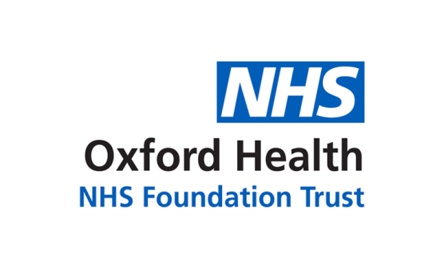

# Report to the Meeting of the

# Oxford Health NHS Foundation Trust

**BOD 10/2022**

(Agenda item: 4)

# Board of Directors

**30 March 2022**

**Trust Chair’s report and system update**

**For: Information/Discussion**

Boots the chemist is now offering ‘mental health support’ such as ‘psychological and emotional therapy’. The company, now owned by private equity, has spotted a market opportunity … but is it not one that the NHS should be filling? Our IAPT services have been tremendously successful, even without finding a less clunky name than ‘Improving Access to Psychological Therapies’. But there are many more people who might benefit from our services than we help. Meanwhile large numbers may have mentioned their depression or lack of mental wellbeing to a GP without it leading to any offer of help. Out there, in other words, there is an ocean of mental health need, in which our services are only an island.

There is nothing new in that observation. What is new is the promise of population health management that comes with the inauguration of the Integrated Care Systems, due in July this year, which points to much greater attention being paid to sub-acute health, which merges into the wider terrain of ‘wellbeing’. The local authorities, among them Oxfordshire and Buckinghamshire, say they want to address the wellbeing of residents. We surely should, as well. But our mental health resources are mostly directed towards acute conditions and are tied up in hospitals and crisis management. Of course there is no linear relationship between wellbeing in the more general sense and the volume of acute mental distress demanding psychiatric care, but it is worth asking whether, in time, we should realign our resources and clinical profile towards the wider territory of mental health. Among the many preconditions for that to take place is closer connexion between our services and primary care. The truism also applies in community services.

In that wider territory of mental health lie reasons why some people feel they cannot cope, why they become depressed, why underlying factors (some of them genetic) are allowed, even encouraged to cause mental illness. Money is an obvious candidate. Paying bills, meeting the rent, assuming you have got somewhere to live; coping with exams, being young, being old, being the subject of discrimination on grounds of ethnicity or sexual identity or disability, and so on. Not all of this can be dealt with even indirectly by public policy. But equally it is possible to say that certain policy choices – cutting the incomes of poorer families for example – are likely to raise stress levels. If inflation is allowed to cut incomes; if family budgets are put under further strain because of the consequences of war in the Ukraine … we may not be able to do much or indeed anything as an NHS foundation trust but we can at least identify reasons and not pretend that levels of demand for services are unknown or incapable of being influenced.

Since the Board last met in public, we have had a joint session with members of the Council of Governors. Elections to the Council are coming shortly and we have to hope there is a decent turnout of members in all the constituencies, in order to give this element in our life as a foundation trust full legitimacy. At best, we are fortunate to have governors who are willing to take a lively interest in the Trust and its services and to subject the Non-Executive Directors to pertinent questioning. At worst, the structure makes the NHS even more complicated and adds to the volume of meetings, validating those who cry ‘bureaucracy’ (often ignoring the fact that all health systems, private, insurance-based and public) are administratively complex.

COVID-19 brought us new ways of working but the relative ease of convening meetings on MS Teams or Zoom may have led to a proliferation of gatherings and generated more rather than less ‘business’ to transact. The trick is now to retain the best of the new ways – avoiding journeys, lessening our carbon footprint – while streamlining their use. Today’s Board meeting in public is a case in point. Yes, it would be good to be able to welcome the public to a safe, fully accessible space but no, such spaces are hard to find and meanwhile online meetings, fully available to the public, do meet the norms of accountability. The discussion is not closed.

**Recommendation**

The Board is asked to note the report.

**Author and Title: David Walker, Trust Chair**

1. *A risk assessment has been undertaken around the legal issues that this report presents and there are no issues that need to be referred to the Trust Solicitors*
2. ***Strategic Objectives/Priorities*** *– this report relates to or provides assurance and evidence against the following Strategic Objectives:*

*1) Quality - Deliver the best possible care and health outcomes*

*2) People - Be a great place to work*

*3) Sustainability – Make best use of our resources and protect the environment*

*4) Research and Education – Become a leader in healthcare research and education*