Mental Health Long Term Plan – Board Update

Executive Summary

The Long-Term Plan (LTP) outlined a very promising and ambitious period for mental health patients, carers and families, as well as the staff and organisations that care for and support them. The £2.3 billion that was committed is now making its’ way to front line services and is having an impact on the care that is delivered.

Overall, there is progress against all areas of the Long-Term plan that OHFT are leading and delivering on. There are though areas of growing concern about meeting the full ambitions and objectives of the plan.

Three significant challenges are clear and are crucial to tackling the implementation of the long-term plan. Firstly, the ongoing recovery from the Covid 19 pandemic which has hampered the progress that OHFT and partner organisations have made over the last 2 years. Despite major disruption to service delivery, the commitment and resilience that staff and their families have shown has been outstanding.

Secondly the workforce challenge that we face is not just in terms of expansion and recruiting to significant investment without a national pipeline of mental health clinicians matching the finance. But also, staff retention with an increasing sense of ‘burnout’ and fatigue.

Finally, the operational reality going into FY 23 in terms of financial and operational pressures that will rightly demand leadership and managerial time, away from the transformational agendas within the LTP.

A further contextual element that is impacting the LTP progress is the internal and external governance and leadership oversight of the LTP transformational programmes. The ongoing development of infrastructure and tension of planning and oversight at place or ICS within Mental Health often results in duplication, confusion and inertia.

Introduction

In October 2019, the Board were briefed on the Long Term Plan (LTP) for mental health transformation and expansion, period covering FY20 (year 1) to FY24 (year 5). A multiyear summary of planned activity, workforce and finance was provided. It is now year 4 of the LTP and this paper serves as an update on how plans have progressed for OHFT services and the population that they serve.

OHFT’s vision is ‘outstanding care delivered by an outstanding team’ delivered through a focus on four strategic objectives (listed below) all of which align to the delivery and transformation of Mental Health described in the LTP:
- Deliver the best possible care and health outcomes
- Be a great place to work
- Make the best use of our resources and protect the environment
- Be a leader in healthcare research and education.

The Coronavirus pandemic has had a significant impact on the mental health of the population as well as the services that care for and support them. Despite this, service delivery has continued throughout the pandemic and the transformation of mental health services as per the NHS Long Term Plan (LTP) is still very much relevant and underway. Expectations and targets from NHS England were clearly communicated throughout the pandemic, in some instances plans were accelerated to not only enhance the mental health support on offer, but also to reduce demand and strain on other health and social care services. This paper outlines the funding made available, high-level progress to date and risks to delivery.

Investment and Prioritisation

The LTP not only outlined the transformation and expansion required for mental health services, but it also provided systems with additional funding in the shape of Service Development Funding (SDF or Transformation Funding) and additional recurrent funding through the Mental Health Investment Standard (MHIS). As the MHIS flows from CCGs’s baselines, there is not a direct correlation between the indicative funding allocation in the national LTP “tool” which adds further complexity to financial tracking and performance expectations at regional and national levels. Figure 1 summarises the allocation of MHIS in Buckinghamshire and Oxfordshire over the last 3 years, this was agreed at place in collaboration with provider and commissioners.

Workstream | Buckinghamshire |  |  | Oxfordshire
 | FY20 | FY21 | FY22 | FY20 | FY21 | FY22
CYP | £0 | £351,919 | £406,894 | £0 | £161,334 | £942,337
Perinatal | £632,000 | £632,000 | £632,000 | £825,000 | £825,000 | £825,000
IAPT | £0 | £1,036,596 | £1,605,012 | £515,000 | £1,360,861 | £3,127,594
Crisis | £789,000 | £1,514,153 | £2,493,519 | £0 | £315,766 | £2,340,094
SMI | £0 | £534,302 | £850,028 | £0 | £1,115,225 | £4,154,826
Total | £1,421,000 | £4,068,970 | £5,987,453 | £1,340,000 | £3,778,186 | *£11,389,851
Figure 1. Summary of cumulative MHIS allocation in Buckinghamshire and Oxfordshire.
*FY22 value for Oxfordshire includes the additional funding to be made available through mediation for legacy under-commissioning, service developments and expansion as per 2020 agreement.

Non recurrent Service Development Funding (SDF) has been made available to Buckinghamshire, Oxfordshire and BSW in FY22. SDF conditions are determined by NHSE on a national scale to outline the desired scope and impact of service transformation. The application process for each opportunity varies, meaning that there is a combination of competitive and “fair shares” allocations. Considerable time and resource is expended on applying for these funds. The duration and profile of funding also varies on a case-by-case basis, meaning that exit plans and/or funding pickup commitments need to be considered at the outset.
County | FY22 | FY23 | FY24
C&YP
Bucks | £440,379 | £518,010 | £843,025
Oxon | £687,452 | £668,400 | £1,087,774
MHST
Bucks | £1,084,000 | £1,285,000 | £1,959,000
Oxon | £1,411,000 | £1,440,000 | £2,058,000
18 - 25
Bucks | £131,456 | £240,870 | £396,718
Oxon | £205,210 | £310,800 | £511,894
Maternal MH
Bucks | £151,254 | £0 | £0
Oxon | £178,088 | £0 | £0
Alternatives to Crisis
Bucks | £226,936 | £305,583 | £398,068
Oxon | £292,821 | £391,773 | £510,344
Liaison & Discharge Support
Bucks | £0 | TBC | TBC
Oxon | £0 | TBC | TBC
CMHF
Bucks | £875,845 | £2,150,896 | £2,643,390
Oxon | £1,130,123 | £2,778,126 | £3,410,826
Suicide Prevention
Bucks | £117,443 | £117,443 | £117,443
Oxon | £123,728 | £123,728 | £123,728
Figure 2. FY22 SDF Summary for Buckinghamshire, Oxfordshire and BSW.
*Additional MHST waves not confirmed within BOB at time of publication

To further support mental health services throughout the pandemic, NHSE announced non recurrent funding for FY22 to accelerate delivery of the LTP through the national spending review, this resulted in an additional £2 million for Buckinghamshire, £3 million for Oxfordshire and £3.9 million for BSW. There is no elective recovery fund for mental health currently.

As welcome as the additional funding streams have been, demand for investment is still greater than that available. To ensure investment was prioritised in our “critical clinical priorities” aligned to the Long-Term Plan, our Clinical Directors led the development of proposals within services and developed further in partnership with commissioners and other NHS and non NHS providers. Figure 3 summarises the decision-making process for proposals that are approved at place (county/CCG level).

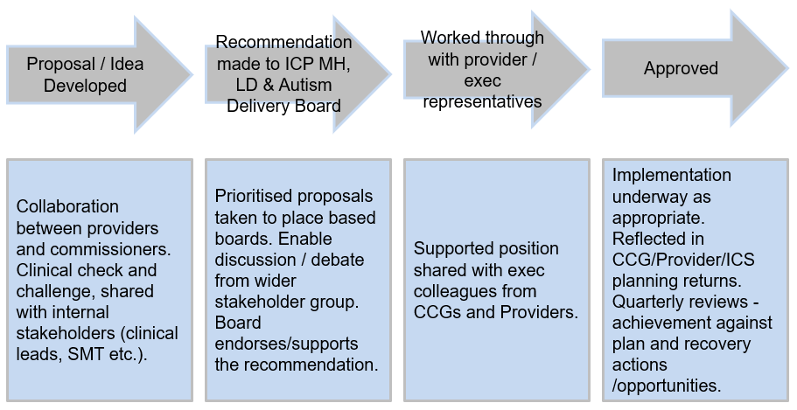Figure 3. Approval process for mental health proposals.
Implementation will commence throughout FY22 with continued oversight from an Integrated Care Partnership (place/county/CCG) and Integrated Care System (BOB and BSW) perspective.

Furthermore, figure 5 shows the OHFT funding from BSW MHIS and SDF.

Figure 5 | BSW funding profile (cumulative)
 | FY21 | FY 22 | FY 23 | FY 24
MHIS (Core uplift funding) | £699,88 | £1,890,944 | £1,997,386 | £1,997,386
C&YP Community and Crisis (SDF) | £39,000 | £895,105 | £959158 | £959158
MHST (SDF) | £806,967 | £1,468,638 | TBC minimum £1.4m | TBC minimum £1.4m
Eating Disorder’s (Adult)*  Eating Disorder’s (CYP)* | £0 | £688,447  £494,553 | £837090  £503,422 | £837090  £503,422
Total
*although in year funding received from Winter funding and Discharge funding pots supported ED services in Fy21

Considerable time and resource are expended on applying for these funds and similar to the Oxfordshire and Buckinghamshire experience there has been a significant profiled underspend in FY22 (£2m+) that will be less in FY23 as the recruitment planning bears fruit.

BSW will be formally adopting the ICS arrangements in the coming months, and the proposed arrangements are in figure 6 below. The Thrive board (circled) is the key body for oversight and decision making for mental health governance, with a MH finance oversight group & CSF steering group scrutinising proposals before approval at Thrive board.

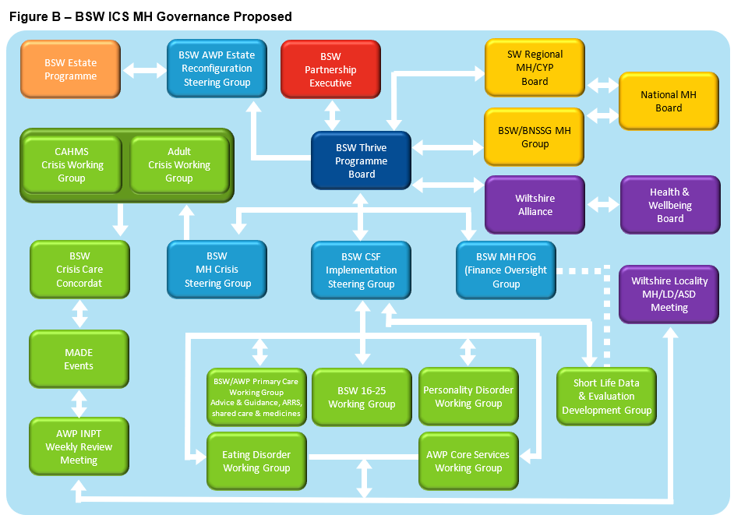

Governance in BOB remains in development.

Clinical Workstreams

Proposals and service developments have been categorised in line with the following NHSE Workstreams:
- Children & Young People
- Perinatal
- Improving Access to Psychological Therapies (IAPT)
- Acute & Crisis
- Adult and Older Adult Serious Mental Illness
- Suicide Prevention

Children & Young People

CAMHS provision across Buckinghamshire and Oxfordshire enables some of the highest access rates in the country, far exceeding the national ambition. Figure X below outlines the access rates (at least 35% of CYP with a diagnosable MH condition receive treatment from an NHS-funded community mental health service) of 2+ contacts within BOB CAMHs services, the LTP measure until March 2021. Figure Y shows the altered LTP access rate for BOB from April 2021 onwards, when it moved to a single contact.

Both demonstrate above target and incrementally increasing number of children and young people receive appropriate interventions to support them with their mental health. A specific area of interest is the ongoing deliver in partnership with a variety of digital organisations and 3rd sector providers to further enhance and diversify the ways in which C&YP, their families and carers engage with services.

For BSW, the access rate is lower than with Ox and Bucks and there is work on going, including targeted funding for increasing the clinical time to meet this ambition.

Mental Health Support Teams as a minimum LTP target should cover 25% (national target) of the relevant pupil numbers in the footprint that OHFT serve. An NHSE funded programme (via SDF) the expectation of the offer is to provide 400 – 500 CYP with mild to moderate MH presentations (mainly anxiety and low mood/ depression) an intervention per year. As of Feb 22) is:
Place | Number of teams | Access % against pupil coverage | Average # CYP a team | New teams | Updated coverage %
Oxfordshire | 4 | 28% | 180-220 | 3 | 50%
Bucks | 3 | 28% | 250-300 | 3 | 46%

In BSW OHFT provide MHST in the BaNES and Wilshire areas only, with Barnardo’s proving coverage in Swindon. They are counting coverage by school not pupil numbers and our current position (Feb 22) is:
Place | Number of teams | Access % against school coverage
BaNES & Wiltshire | 6 | 32%
Swindon (Barnardo’s) | 4 | 81%

There is no data yet on the average number of CYP per team accessing an MHST.

Crisis Provision – the LTP ambition is that by 23/24 all areas will deliver a 24/7 mental health crisis provision for CYP which combines crisis assessment, brief response, and intensive home treatment functions. The pandemic accelerated plans for the enhancement of open access crisis services for children and young people. Children and young people, their families and carers can now access mental health services, 24/7 via NHS 111. All three areas have outline plans to grow in phases their crisis & home treatment offer, but staffing these teams is proving difficult e.g. Oxfordshire has a 40% vacancy rate against the planned staffing profile.

C&YP Eating Disorder services have experienced some of the largest increases in demand and complexity of presentations over the course of the last 18 months. That is clearly showing in the LTP waiting time figures for all 3 areas. Overall, services prioritising urgent referrals and Oxon and Bucks are keeping pace BSW less so, yet all three though have a downward trend. Routine waiting times have taken a significant dip because of demand, complexity, and prioritising urgent cases. There has been investment, but this area is struggling to recruit fully to meet this demand as evidenced by Oxon vacancy rate at 26%, and the projected underspend on the investment across all 3 areas is 23% for Bucks, 39% in Oxon and 51% in BSW.

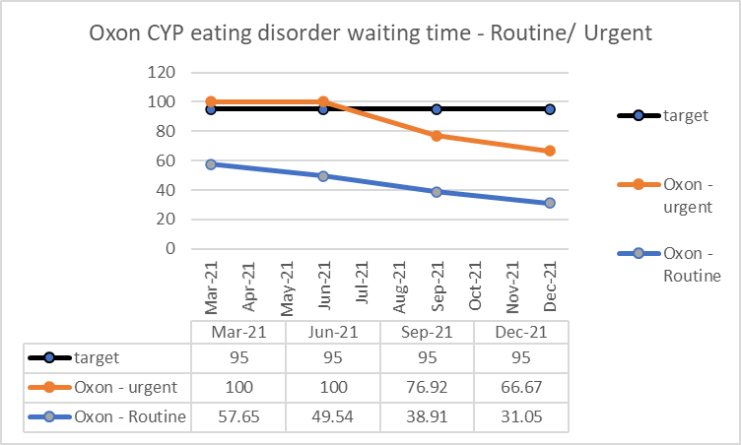

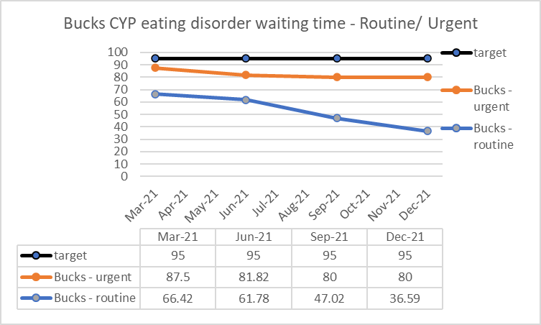

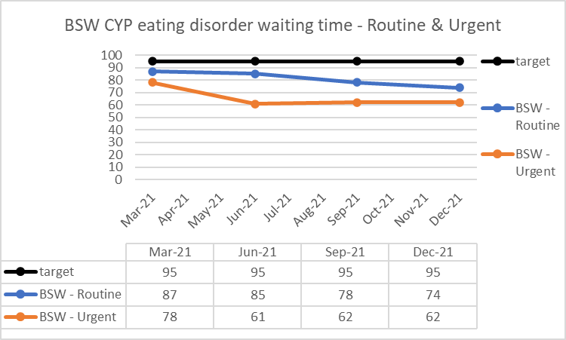

Perinatal

Specialist Perinatal Services in Buckinghamshire and Oxfordshire were fully implemented in 2019. There are now clear and well-formed pathways for those that require assessment and treatment. Access rates to the service are below national targets as demonstrated in Figure 6. Referrals have increased dramatically over the last 12 months and services are now at the point where demand is outweighing the available capacity. Given the critical clinical priorities, further investment has not been available since FY20 and has not been identified for FY23. Despite the no further investment, access targets continue to increase and the expectation is that Perinatal services will now offer signposting and support to partners and will also enhance the offer from pre-conception up to 2 years post birth.

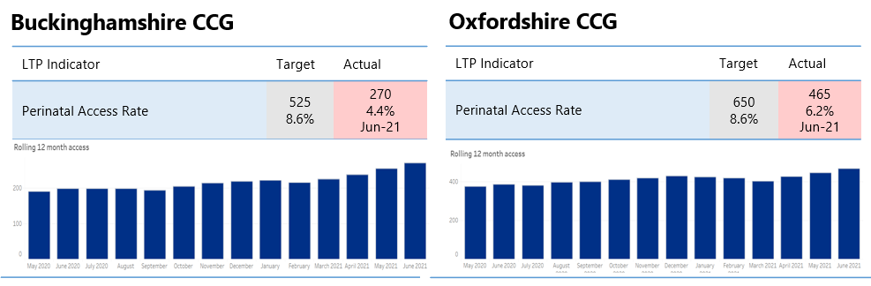
Figure 6. Perinatal Access Rates in Buckinghamshire and Oxfordshire

In FY23, maternal mental health clinics will be implemented in Buckinghamshire and Oxfordshire, this collaboration between Perinatal MH and Maternity services will enhance current pathways by establishing a clinic that delivers psychological support for women experiencing birth trauma, primary or secondary tokophobia as well as women who have experienced early pregnancy loss (both termination of pregnancy and miscarriage) and women experiencing removal of their infant due to safeguarding concerns.

Improving Access to Psychological Therapies (IAPT)

IAPT Services in Buckinghamshire and Oxfordshire are now treating more people than ever before. The significant expansion of talking therapies is a challenge that OHFT are undertaking in partnership with 3rd sector organisations to help and support those with common mental health problems such as a depression and anxiety. Historically, Buckinghamshire and Oxfordshire IAPT services have had lower access rates than the national expectation. This was predominantly caused by legacy funding decisions that were endorsed and supported by both CCGs and provider to enable investment in other clinically critical mental health services. A refreshed trajectory and plan have been agreed that will enable IAPT services to be operating at the target rate at the end of FY22. Further expansion would be required in FY23 in order to meet the increasing access targets, this has not been authorised.

Figure 7. IAPT Access Activity for Buckinghamshire and Oxfordshire CCG

Following the pandemic, IAPT services have led on the implementation of staff wellbeing hubs for health and social care staff across BOB so they have rapid access to appropriate interventions. Targeted in reach work to vulnerable groups will continue to be prioritised to ensure that those disproportionally impacted by Covid 19, including but not limited to BAME communities and older adults, are able to receive the much-needed support and care that is required. The continued uptake and maturity of digital technologies will enhance the offer to service users through solutions such as online scheduling and chat therapy.

Acute & Crisis

Crisis Resolution and Home Treatment Teams are now in place in both Buckinghamshire and Oxfordshire, although the maturity and functionality of the dedicated provision are at different stages. Home Treatment Teams have enabled quicker discharge from MH inpatient units as well as alternatives to admission. Despite this, there has been an increase in out of area placements as OHFT has been operating throughout the year with up to 15% less capacity on adult and older adult mental health wards as a result of infection prevention and control guidance. To increase continuity of care and availability of inpatient provision, OHFT have contracted Elysium (independent sector provider) for the purchase of additional beds. This arrangement will continue throughout FY22 and will be reviewed on an ongoing basis to ensure quality and value for patients and their families.

A newly implemented all age, 24/7 open access crisis line was established amidst the pandemic, initially one of the main drivers was to remove blockages and confusion from elsewhere in health and social care systems so that they were better configured to meet the immediate challenges of Covid. Accelerating this key achievement also means that those experiencing a mental health crisis can get the immediate help and support they need by calling 111, regardless of whether they are open or known to services. This collaboration with Southern Central Ambulance Service (SCAS) will also go a step further over the coming years in the form of improved triage and transport, this is being led by SCAS alongside a multi sector, multi-agency group including the likes of Thames Valley Police and local AMHP services.

Psychiatric Liaison Services support inpatients and those presenting with mental health need at the Emergency Departments of Stoke Mandeville, The John Radcliffe and Horton General Hospitals. Both the Buckinghamshire and Oxfordshire services deliver age-appropriate provision and a timely response to patients, but neither service is set up to be fully Core 24 compliant.

Residents of Buckinghamshire and Oxfordshire already have access to 2 Safe Havens in each county. The Safe Havens are delivered by local Mind charities to offer an alternative to traditional crisis care. This innovative approach will be further expanded throughout the next 3 years to not only increase some provision to 7 nights, but also bring on board more VCSE organisations to help support the needs of those attending in a more coordinated and streamlined manner.

Adult & Older Adult Serious Mental Illness

The Community Mental Health Framework (CMHF) is arguably the largest and most significant change outlined in the LTP for mental health services. Community mental health services across the country are undergoing this key transformation following guidance from NHSE and learning from pilot sites that started this journey in FY21. Local services are embarking on a 3-year transformation programme that will eventually see existing and new mental health services better integrated with Primary Care Networks (PCNs).

A variety of mental health roles and skillsets will form a team focussed around patients in their Primary Care Networks (PCNs) and delivering care to those with Serious Mental Illness (SMI) outside of a traditional stepped secondary care setting. Specialist pathways within the Community MH Framework will be further developed as the model embeds.

Buckinghamshire and Oxfordshire have taken different approaches to implementation and model design.

Recruitment is proving a challenge and there’s not yet been a formal launch of either service. Whilst this is a 3 year programme, we had hoped that some components would have been live and actively working with patients by the end of FY22. Identifying clinical and office space for the growing workforce is another challenge that is currently being navigated.

OHFT will also bolster Mental Health provision with the deployment of primary care practitioners in every PCNs across the footprint. These roles will be delivered as part of the primary care Additional Roles Reimbursement Scheme (ARRS) rollout, complimenting existing provision and having a focus on patients’ needs that may have previously fallen between the gap of IAPT and secondary care services. Approximately 85% of PCNs within Buckinghamshire and Oxfordshire have expressed an interest in working alongside OHFT to embed these workers in their local footprint, recruitment is very much underway and there is also a national ambition to further increase this workforce over the next 2 years.

Early Intervention Psychosis (EIP) services in Buckinghamshire and Oxfordshire have consistently met the waiting time standards. Additional investment in both services this year will enable them to increase the availability and timeliness of evidence-based interventions such as family therapy and access to Individual Placement & Support meaning that they will reach Level 3 in accordance with NICE guidelines. EIP services would like to extend / enhance their offer in terms of At Risk Mental State (ARMS) interventions, however this development has not yet been agreed in terms of additional funding, model development is underway but it is unlikely this would be approved to go live in FY23.

Other specialist pathways and teams have experienced high volumes of referrals and acuity throughout the pandemic. Community Eating Disorder services are a key clinical priority, additional funding has been identified in FY22 to bolster the service but there is a workforce challenge in this area. New roles and initiatives are being explored to mitigate this risk, but the high activity and acuity rates are a concern. An ED summit is planned to explore the opportunities that may lie within adult ED, C&YP ED and the redesign enabled within the Community MH Framework.

The LTP also outlined improvements within primary care for those with mental illness. Two key objectives measured in primary care are the Dementia Diagnosis Rate (DDR) and physical health checks for those with SMI. OHFT services contribute towards these objectives but the main activity is carried out in primary care. Both the DDR and uptake of physical health checks dropped throughout the pandemic but are now recovering. However, these targets were not met in either county pre-covid, so further improvements are required and the community mental health framework will underpin recovery.

Suicide Prevention

OHFT collaborated on a BOB initiative spanning across NHS and non NHS providers, Thames Valley Police, Public Health and academic institutes to implement a wave 4 Suicide Prevention bid in FY22. This will enable improvements to self-harm pathways across urgent care by offering follow up to those who have self-harmed or attempted suicide, providing an alternative for those that may not need, or wish to fully engage with, secondary care services. Thames Valley Police already produce some of the best Real Time Surveillance data of suicides in the country, and this will be improved further by deploying a similar approach to attempted suicides and clusters of self-harm and suicidal behaviour. SCAS will work alongside TVP to implement this key development, which will enable communities, health and social care providers and other agencies to carry out preventative interventions targeted to a specific cohort’s needs. The breadth and quality of training and education for suicide prevention will be increased, ensuring that resources are available for a variety of settings, fields and professions.

Enabling Workstreams

To support the expansion and transformation of mental health services, there are some key enabling workstreams and themes that are critical to succeeding.
- Digital Transformation
- Workforce
- Partnerships and Collaboration
- Estates

Digital Transformation

In 2017 OHFT joined the NHS England Global Digital Exemplar (GDE) programme as one of only seven mental health Trusts accepted onto the scheme. The aim of the GDE programme was to support Trusts to become “an internationally recognised NHS provider delivering improvements in the quality of care, through the world-class use of digital technologies and information”.
Since 2017 OHFT has delivered several transformational digital projects supported by match funding accessed through the GDE programme, including:
- Development of a new data warehouse and business intelligence tool (TOBI)
- Office 365 deployment
- Electronic health record mobile expansion to improve mobile access
- Digital dictation to help free up time to care
- Virtual reality as a psychological treatment
- Digital ward observations pilot (resulting in the current deployment of Oxevision technology across seven OHFT wards)
- Series of mental health short films on a range of common conditions, to improve public awareness.

The final and largest of the GDE projects is the procurement and implementation of an electronic prescribing and medicines administration (ePMA) platform across the Trust. The Trust is currently configuring the Better Meds platform and will be piloting the product on two wards in early 2022, with a phased roll out of ePMA across mental health and community services to be completed in 2024.

In July 2021 OHFT agreed the new Digital Health and Care Strategy 2021-26. This provides the framework for the delivery of an ambitious programme of digital activity over the next five years. Central to this is the review and potential replacement of the Trust’s main electronic health record (EHR) systems and the development of a new underlying digital architecture (the clinical data repository CDR, a centralised datastore holding information from multiple clinical systems). The CDR is the key enabler for the planned development of patient and clinical portals, the expansion of mobile and agile working capability, the continued development of shared care records and the Trust’s contribution to research, advanced analytics and population health management.

The Pandemic brought with it opportunities to advance the digital agenda in terms of how healthcare professionals engage with or “see” patients. Although face to face interventions remained absolutely available for those that required them, where clinically appropriate, alternative means of contact were offered. Figure 10 shows the shift in communication type for appointments across all OHFT services. From January 2020 to August 2021, 260,158 digital consultations were carried out across all OHFT services.

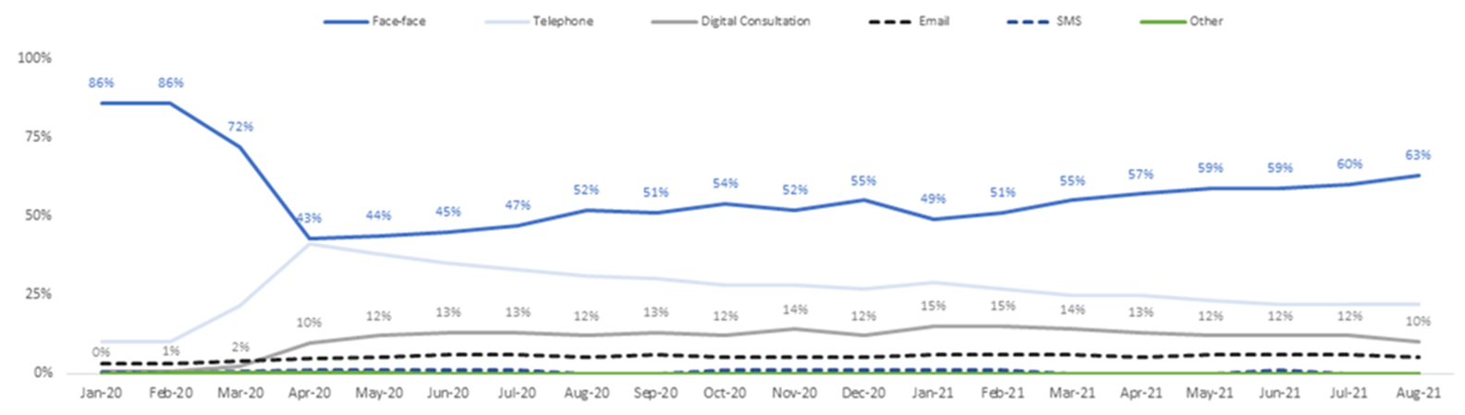
Figure 10. Change in Communication Type across all OHFT services, 01/01/2020 – 31/08/2021.

Workforce

The workforce expansion required to meet the Long Term Plan is significant, on top of this, OHFT are also faced with the challenge of bolstering existing services and pathways. Across the Buckinghamshire and OBSW directorates there are plans in place to increase the workforce by approximately 300 new posts throughout the course of 2021/2022. This growth covers a great variety of roles and disciplines, both clinical and non clinical. In order to meet these ambitious expansion plans, OHFT are working alongside other NHS and non NHS providers (including VCSE organisations) to identify opportunities for outsourcing and subcontracting posts and/or activity. To make OHFT a great place to work, there are retention and recruitment strategies in place that are underpinned by various plans and initiatives such as joint academic posts and incentivised recruitment.

Over the last 2 years OHFT have increased budgeted and actual staff in post in Buckinghamshire and Oxfordshire and BSW. Whilst this is welcome progress in terms of expansion, the rate at which new or replacement posts are filled is lower than the rate at which new posts are coming online, as demonstrated in Figure 11. Vacant posts are risk assessed and where considered essential, will be filled by either bank or agency staff in line with the established frameworks where possible.

 | Mar-19 |  |  |  | Mar-20 |  |  |  | Mar-21
 | Budgeted WTE | In post | Vacant posts | % filled | Budgeted WTE | In post | Vacant posts | % filled | Budgeted WTE | In post | Vacant posts | % filled
Bucks | 681.7 | 593.8 | 87.9 | 87% | 737.7 | 620.6 | 117 | 84% | 857.5 | 747 | 110 | 87%
OBSW | 1271.6 | 1148.7 | 122.9 | 90% | 1345.3 | 1219 | 125 | 91% | 1605.9 | 1305 | 300 | 81%
Figure 11. Budgeted, Actual and Vacant posts in Mental Health directorates.

Partnerships and Collaboration

The LTP has a clear emphasis on collaboration and partnership across multiple sectors. OHFT are fortunate to be involved in several well established and mature partnerships that deliver a variety of mental health services, the Parliamentary Award winning Oxfordshire Mental Health Partnership (OMHP) and several Children & Young People Partnerships are some of the most well-known examples. The expansion plans in place will continue to grow and further diversify the partner organisations involved in mental health delivery. This will help systems achieve the challenging growth in workforce and will also enable patients, families and careers to benefit from valuable skill sets, insight and experience.

Alongside the increasing partnerships in service delivery, OHFT have valuable partnerships with Clinical Commissioning Groups, Local Authorities and NHS England. This has enabled all parties to identify local strengths, pressures and areas of need to inform commissioning and investment decisions.

This also comes at a time when the formal establishment of Integrated Care Systems means that the assurance landscape is shifting away from a transactional provider / commissioner relationship and more towards self-assuring systems. This will likely pave the way for locally commissioned Provider Collaboratives, somewhat similar to those that currently operate in the Specialised Commissioning space (Thames Valley Low and Medium Secure, T4 CAMHS, HOPE Network). Within BOB and BSW ICSs this may be an opportunity to build on the some of the existing partnership and delegated budget arrangements, ultimately enabling a more responsive and agile approach to improving the healthcare of local populations by collaborating around pathways of care and shared populations.

Estates

The increase in revenue funding to enable the transformation of mental health services is very much welcome, however the growth in services and workforce has resulted in a pressure on space and estate. There is a clear need for an increase in space that meets the needs of patients and workers following the pandemic, but additional capital funding of a proportional scale has not been forthcoming. Saffron House in South Buckinghamshire is a new state of the art mental health hub that co-locates several mental health services and enables a better integrated service for patients, families and carers. OHFT are keen to further this approach within Oxfordshire to create an age inclusive hub with an emphasis on integration and collaboration through shared spaces, but still meets specific needs of individual teams and services as well as the patient groups that they serve.

As well as improving community and clinic spaces, OHFT are also further developing inpatient and crisis sites. The Safe Haven at Manzil Way will be expanded and will also incorporate a base for the Crisis Resolution and Home Treatment Team. A new CAMHS Psychiatric Intensive Care Unit (PICU) on the Warneford site is also planned, these beds will serve some of the most acutely unwell children and young people across the South East region. This will complement the large scale Warneford Hospital redevelopment plan.

Conclusion

As described in October 2019, the Board were briefed on the Long Term Plan (LTP) for mental health transformation and expansion, period covering FY20 (year 1) to FY24 (year 5). We are now entering year 4 of the LTP and this paper serves as an update on how plans have progressed for OHFT services and the population that they serve.

