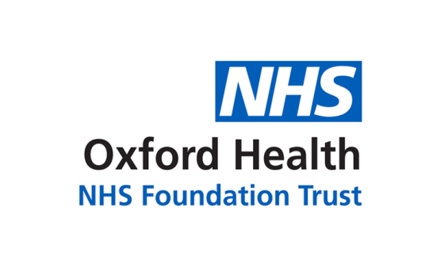

# Report to the Meeting of the

# Oxford Health NHS Foundation Trust

**BOD 26/2022**

(Agenda item: 09)

# Board of Directors

**25 May 2022**

**National Staff Survey results - 2021**

**For: Information**

**Executive Summary**

The NHS Staff Survey was conducted in October/November 2021, with the results being under embargo until 31st March 2022. The attached slide deck presents the headline information to the Board for their information.

Oxford Health results showed an improvement in response rates with 55% (up from 53% the previous year) of staff completing the survey. This is 3273 respondents from an eligible sample of 5996.

The average response rate across 24 Mental Health, Learning Disability and Community Services Trusts is 54.6%, with the best performing having a response rate of 67.7%.

Amalgamation of small teams and a targeted approach has resulted in nearly 50% more teams posting results compared to 2020.

This year, the NHS Staff Survey was redesigned to align with the NHS People Promise. A total of 117 standard questions were asked in the 2021 survey.

This includes 35 new questions for 2021 and 22 deleted from 2020.

Therefore 60 out of 117 questions can be compared historically.

We opted to include an additional 6 tailored questions on Research & Development, and Quality Improvement.

Comparable questions to 2020 showed scores were significantly better for 11 questions, significantly worse for 12 questions and no significant difference for 33 questions.

Most improved questions include team members feeling that they have a set of shared team objectives (up 4%), immediate manager asking for feedback (up 3%) and the Trust making adjustments for staff with a disability to carry out their work (up 4%).

One key area for improvement is capacity; there being enough staff in the organisation for staff to do their job properly (28% compared to 37% in 2020), and staff having realistic time pressures (22% compared to 24% in 2020). Another key area is appraisals; only 21% of staff reported that their appraisal helps them to improve how they do their job and 33% reported that their appraisal helped them to agree clear objectives.

The People, Leadership & Culture (PLC) committee have had the results presented to them in February and the action plan was presented to PLC on 5th May. The action plan centers around encouraging and supporting teams to take ‘one action’ based on the results. This approach was driven by feedback that the perception in previous years, was that the staff survey was widely discussed but no actions were taken.

In order to support teams to take this ‘one action’ the OD team have pulled together a suite of resources:

* Presenting at the Inspire event on 10th March to 250+ managers on the results of the survey, a presentation on the current work taking place (such as QI and IQRA) and the launch of the ‘One Action’ initiative which calls for one action based on the Staff Survey per team.
* A 10 minute ‘Managers Guide’ training video available on the Intranet
* The offer of a 30-minute 1:1 coaching session with managers
* A 60-minute, virtual interactive training session rolled out with the HR Ops Team within OBSW and Bucks MH Services
* Comprehensive Staff Survey Intranet pages

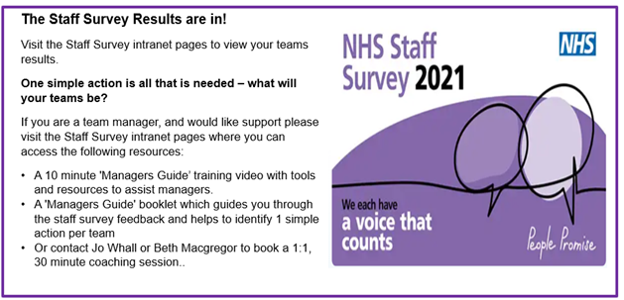

A Staff Survey Action Tracker has been created with all 130 teams from across the organisation listed, where the one action will be recorded and tracked over Q1 & Q2 to enable a large scale ‘you said – we did’ comms before the 2022 staff survey where are aiming to increase response rates by 10% to 65% (which would put us as one of the most engaged Trusts in the country).

PLC gave feedback and reflections on the data presented and action plan. They welcomed the organisational wide approach and wanted to understand the areas that performed well to learn from their successes as well as have a continued focus on the areas that need to improve. They requested a follow up paper is brought back to PLC with a summary of the action plans and of the ‘one action’ progress at the next meeting.

A summary of the Trust areas of focus (which were presented and agreed at PLC in May) can be found in Appendix 1.

**Governance Route/Escalation Process**

This report has been presented at the Executive Management Committee (EMC) and the People & Leadership Committee (PLC) with resulting action plans and progress being reported back to PLC on an ongoing basis.

**Statutory or Regulatory responsibilities**

To note

**Recommendation**

The Board is asked to confirm that it is assured with progress and actions taken to ensure the staff survey is noted and acted upon within the Trust.

**Author and Title: Joe Smart – Head of OD**

**Lead Executive Director: Charmaine De Souza – Chief People Officer**

Appendix 1 – Action plan agreed at PLC on 5th May

|  |  |  |  |
| --- | --- | --- | --- |
| Area of focus | What Staff Said | Corresponding Actions | Progress to date |
| Capacity | Staff feel that they have insufficient capacity to do their jobs well with the response rate to the question “There are enough staff at the Trust to do my job” falling by nine per cent since the last survey. ‘Able to meet conflicting demands’ and ‘have realistic time pressures’, also fall into the lowest scoring questions. | The Improving Quality Reducing Agency (IQRA) Board is putting measures in place to support teams to build their capacity. Measures cover the broad themes of recruitment, retention, in-patient funded establishments, e-rostering, as well as agency management. | * The Staff Survey results were discussed at the IQRA Recruitment Workstream on 6th April. * The Staff Survey results were discussed at the March IQRA Retention Workstream. * The Exit Questionnaire has since been updated and relaunched to gather further insights as to why people leave.   The initial focus of the Retention Workstream will be early leavers (those leaving within 2 years). Process mapping has taken place on the onboarding process for discussion in the April workstream. Planning is in place to conduct focus groups with new starters within the last 18 months in May/June.  Another area of focus is the retention of international nurses.   * Each programme of work has KPIs in place to monitor progress with both the IQRA Recruitment workstream, and Retention workstream meeting on a monthly basis. |
| PDRs | The quality of appraisals scored low in terms of how respondents perceive it helps them do their role (21 per cent) and helped them to agree clear objectives (33 per cent). Whilst this is broadly in line with the national average, it is clearly an area for improvement. | Organisational Development, Learning and Development, and Quality Improvement are working together to scope the project to improve the quality of PDRs. Following scoping, they are to set up a working group of representatives from across the organisation to take this forward. | Currently in diagnostic phase of project which is anticipated to take up to 3 months. The following actions are in development:-   * Deep dives have been undertaken into questions relating to the quality of appraisals as well as PDR compliance * A short questionnaire on appraisals for flexible / bank workers has been developed as bank workers were not included in the Staff Survey. * The PDR Project Group are meeting on a fortnightly basis. |
| Flexible Working | The ‘we work flexibly’ element of the People Promise was the one element that scored below the national average. | The Flexible Working Change Team will be developing actions to enhance managers’ capability and support, as well as the leadership and culture of flexibility, within the Trust. The team includes trade union colleagues and representative managers from all directorates. | * Managers and staff have been invited to take part in workshops taking place in May 2022, to identify the best ways to improve and embed flexible working. * We have targeted promotion of the workshops, via the Staff Survey Directorate Links, at teams who scored particularly low or particularly highly for satisfaction with flexible working opportunities in the staff survey. |