Report to the Meeting of the

Oxford Health NHS Foundation Trust
BOD 27/2022
(Agenda item: 11)

Board of Directors

25 May 2022

The Ockenden Report
For: Information and Discussion

Executive Summary

Around 200 babies and nine mothers would or might have survived had they received the right care from Shrewsbury and Telford Hospital NHS Trust (SaTH) a damming review of the Trust’s maternity services has concluded. Donna Ockenden was asked to review the Maternity Services in the Shrewsbury and Telford Hospital Trust by the Secretary of State. The final report was published on 1st April 2022

For organisations without maternity and neonatal services, this report must still be considered, and the valuable lessons digested. The report illustrates the importance of creating a culture where all staff feel safe and supported to speak up and particularly identifies that there was a lack of ongoing training, lack of effective investigation and governance at the Trust and not having enough staff. The report also highlights the importance of listening to women and their families and to ensure patients have the necessary information and support to make informed, personalised and safe decisions about their care.

Surprisingly the report concluded that the issues had not been challenged internally nor had the Regulatory Bodies held the Trust to account to ensure care provided to families was always professional and compassionate

It is important that Oxford Health NHS FT can reflect and learn from this report to ensure the culture of the organisation encourages listening to patients, families and staff and that learning from incidents is shared. It would appear that very similar conclusions and recommendations have also been echoed in The Francis report for Mid-Staffordshire and Bill Kirkup report for Morecambe Bay.
“A failure to lead, to listen and to work as a team”

The Board of Directors is asked to note the learning from the Ockenden Report as applicable to Oxford Health NHSFT

Author Rosalind Mitchell Clinical Director and Deputy Chief Medical Officer (Patient Safety and Quality)

Lead Executive Director Dr Karl Marlowe

Background

Donna Ockenden and her team reviewed 1,592 clinical incidents involving 1,486 families. The majority of these incidents were between 2000 and 2019. The review found ‘significant or major concerns’ around the maternity care provided by SaTH in 201 deaths, 131 stillbirths and 70 deaths during the neonatal period. Close to 100 other children suffered permanent injuries, including brain damage and cerebral palsy. Whilst many of the recommendations are directly relevant to Maternity Service providers the lessons learned and actions are relevant across all Trusts including Oxford Health NHSFT.
In addition to actions from the interim report in December 2021 the final report was published on 1st April 2022 and proposes over 60 ‘Local Actions for Learning’ for Shrewsbury and Telford NHS Trust and 15 areas for national action (with 90+ individual points) NHSE has written to all Trusts, Local Maternity Systems and Integrated Care Systems asking to consider the report

The National team plan to meet with each Region in early June 2022 to take stock of performance, reflect on the report, and inform national plans. There is a proposal to develop a refreshed delivery plan in the Autumn bringing together existing work with learning from Ockenden and East Kent

The review found that large-scale failings around governance and the quality of care had led to widespread avoidable harm and death. Failings identified include a nationally driven prioritisation of natural births, widespread workforce shortages, a lack of adequate training for staff, and concerns routinely not being listened to, investigated or learned from.

The review team identified thematic patterns in the quality of care and investigation procedures carried out by SaTH and identified where opportunities for learning and improving the quality of care and governance had been missed

According to Ockenden, one of the keys to developing better outcomes is shifting from a culture of blame to one of learning and listening. This would help the NHS as a whole move from reactive to proactive approaches to safety, including within high-risk settings, and encourage open conversations. The range of staffing gaps and resultant pressures on staff have a detrimental impact on progressing the cultural changes needed, with the latest results of the NHS Staff Survey providing a clear indication of the level of work-related stress and interplay here with quality of care.

Complaints which meet the threshold for Serious Incidents should be investigated, and trusts should involve service users in developing processes for responding to complaints. Any trends and themes emerging from complaints should be monitored by the team dedicated to governance within each trust to help identify underlying concerns earlier.

The review found that opportunities to address staffing shortages went unrealised, governance issues and concerns raised by families were not prioritised, and accountability for implementing recommendations and providing oversight was unclear. The review team added that they have heard from staff as recently as 2022, who voiced that they remain fearful of speaking up within the trust.

The report actions include the need to ensure there is proper training for staff who work together particularly around emergency scenarios, improving Trust board oversight of maternity services, as well as conducting robust investigations that lead to wider learning.

There is an expectation that every Trust board should have robust Freedom to Speak Up training for all managers and leaders and a regular series of listening events.

Areas of Concern

The four pillars of key concern which Ockenden has highlighted and all Trusts need to consider are:

1. Safe staffing levels
2. A well-trained workforce
3. Learning from incidents
4. Listening to families

The Ockenden report also highlighted 15 areas of immediate and essential actions for all maternity services in England as below

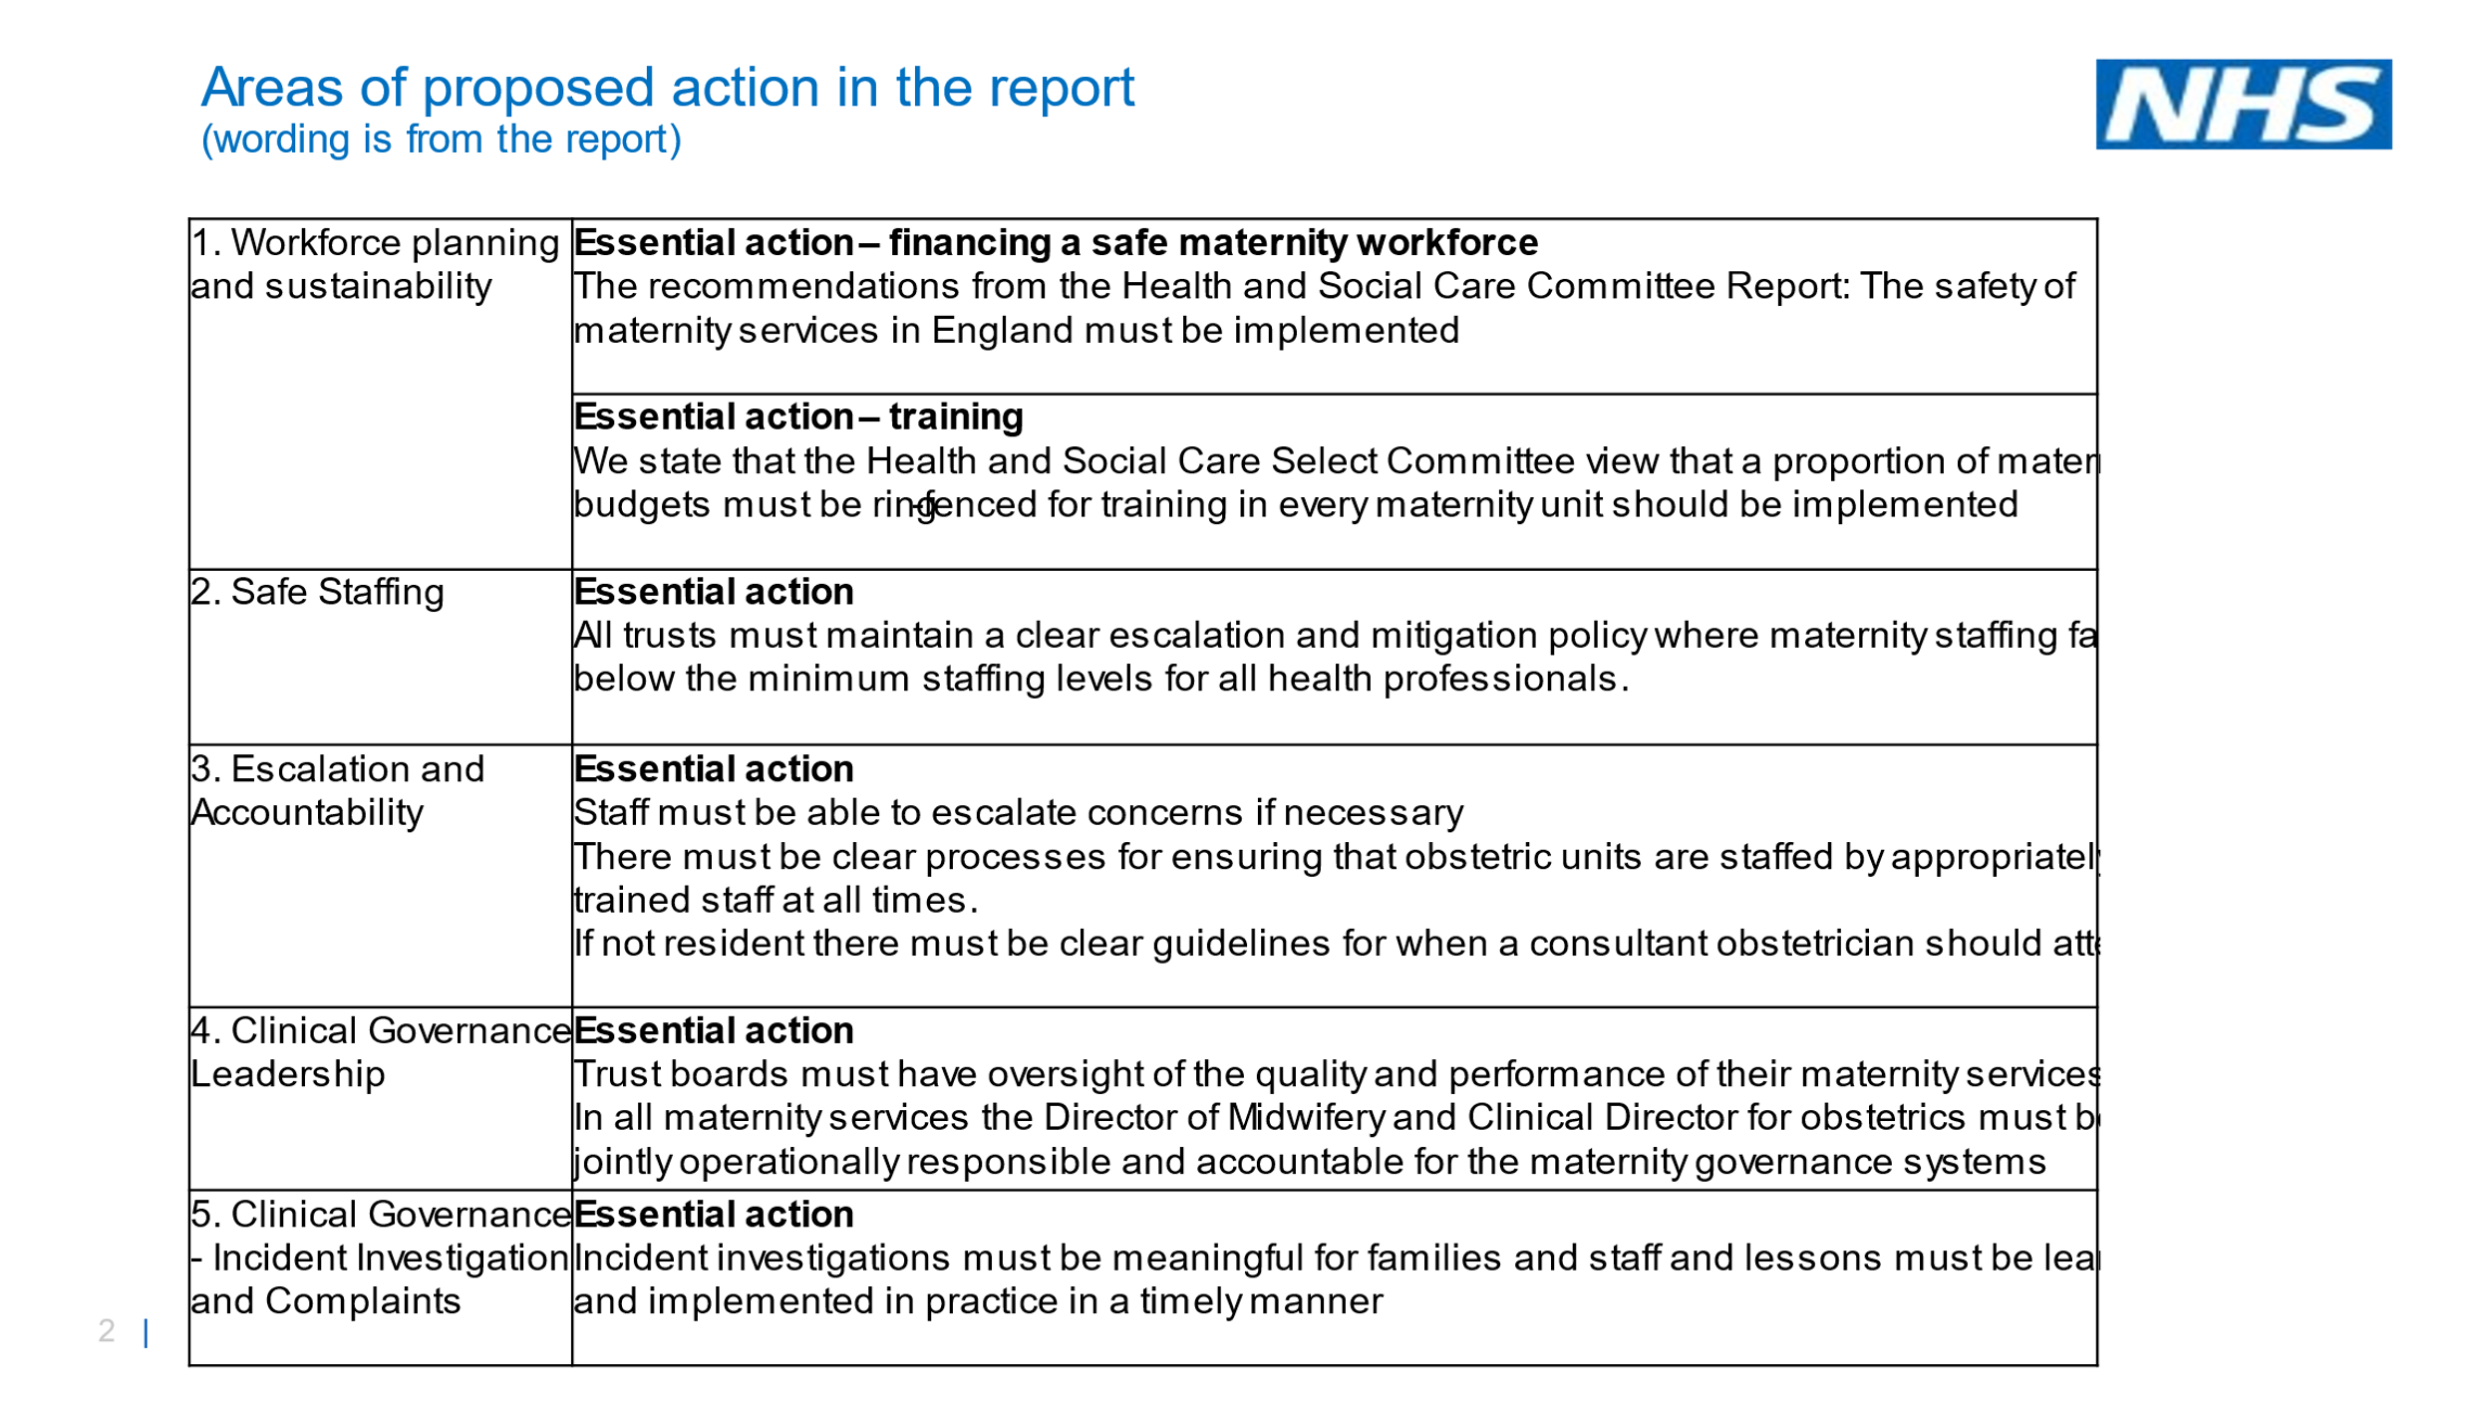
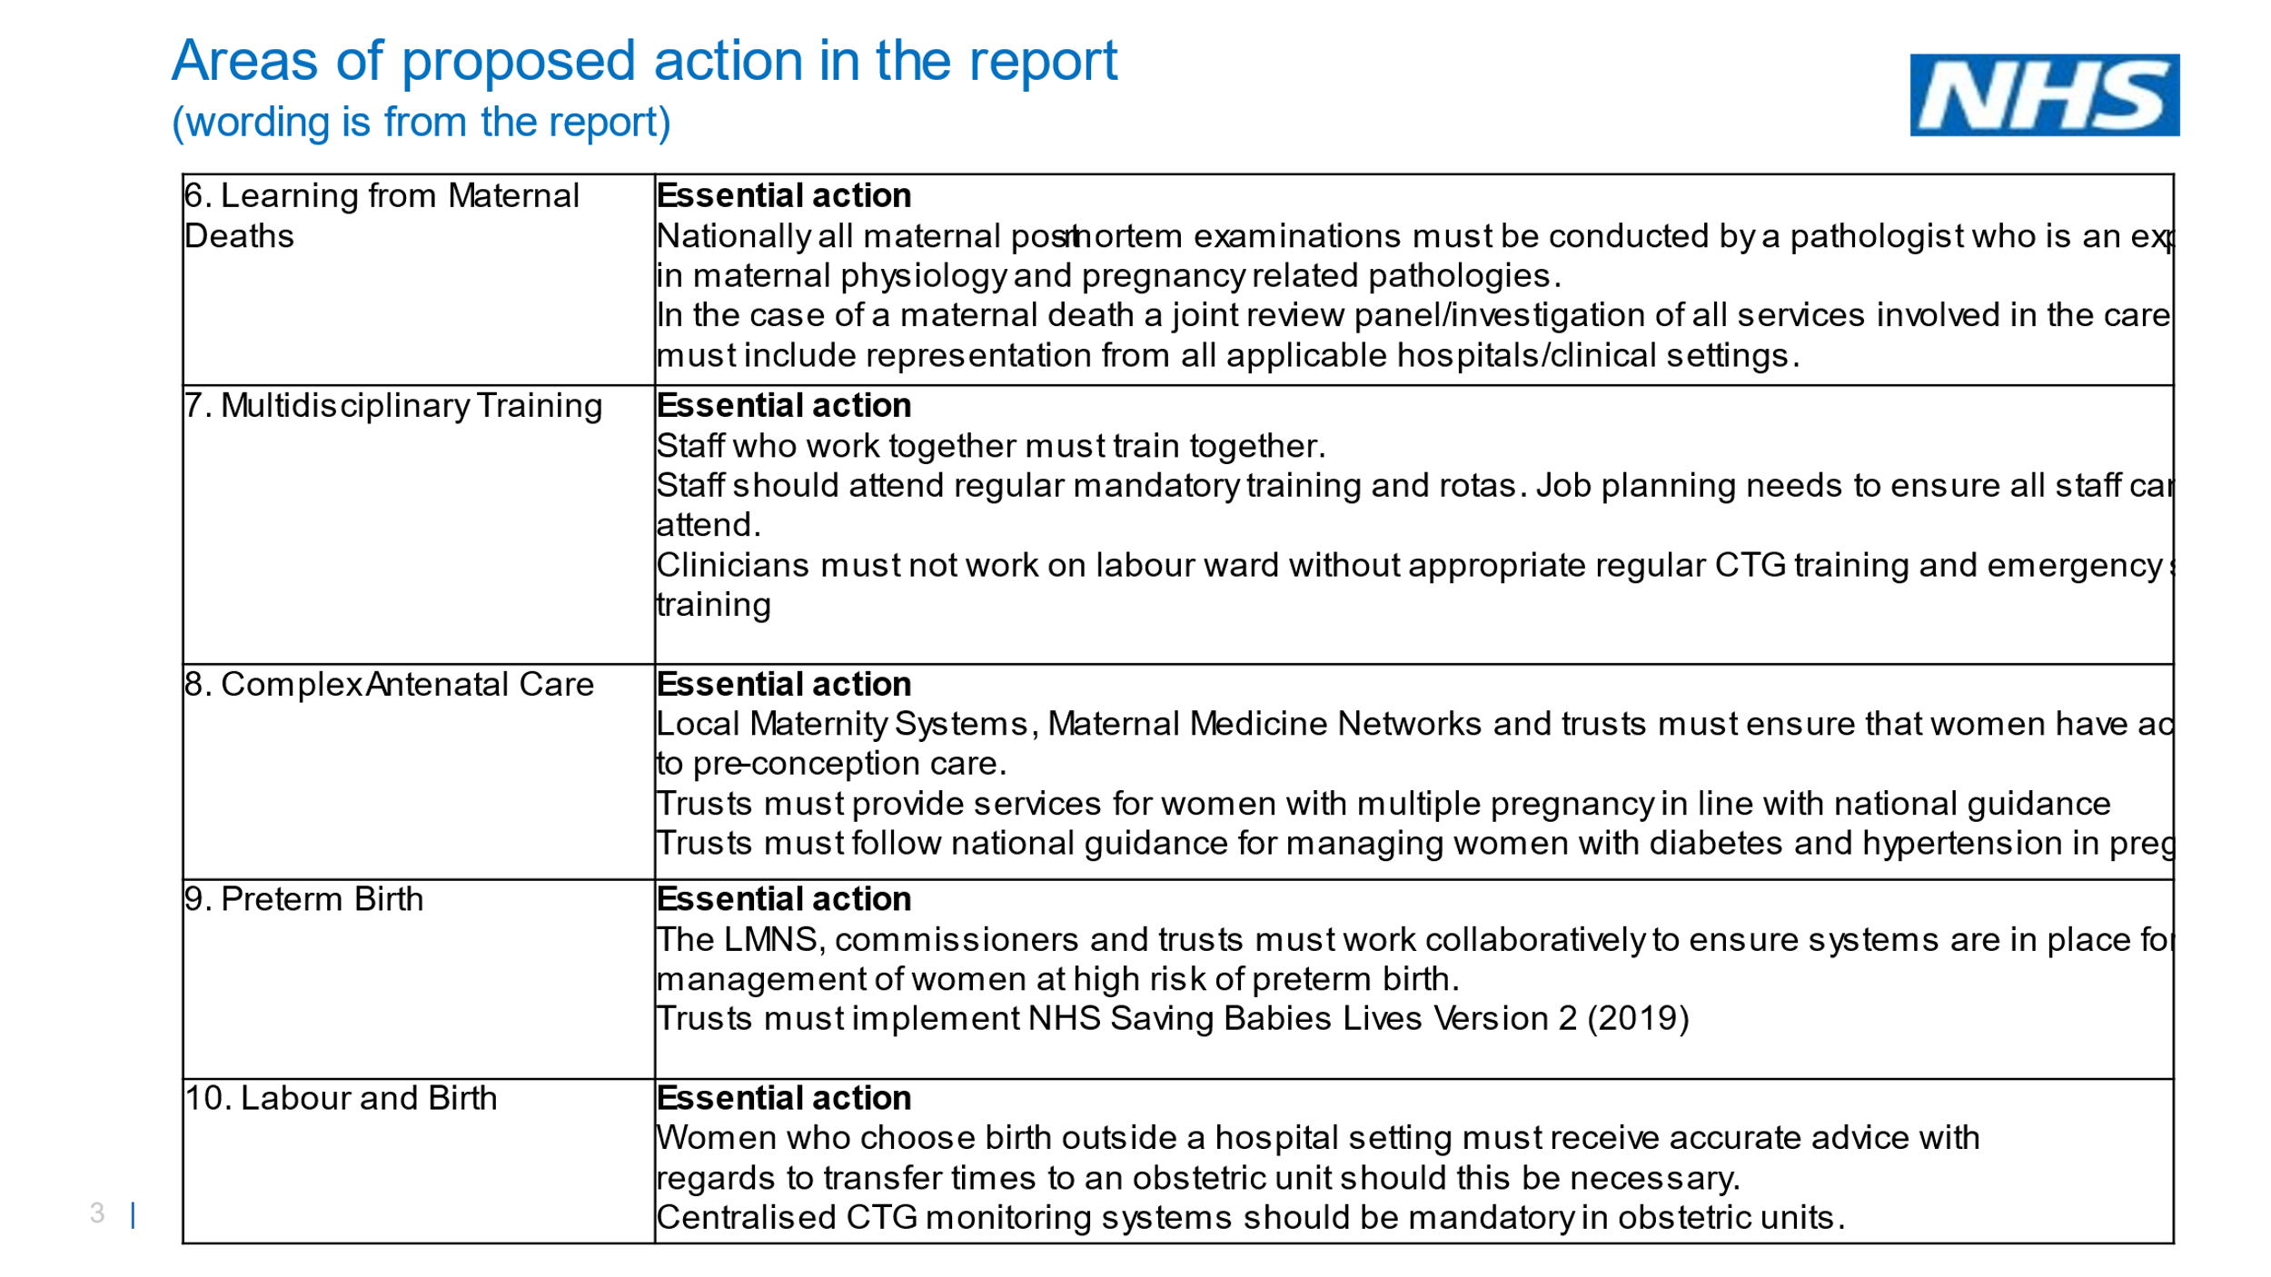
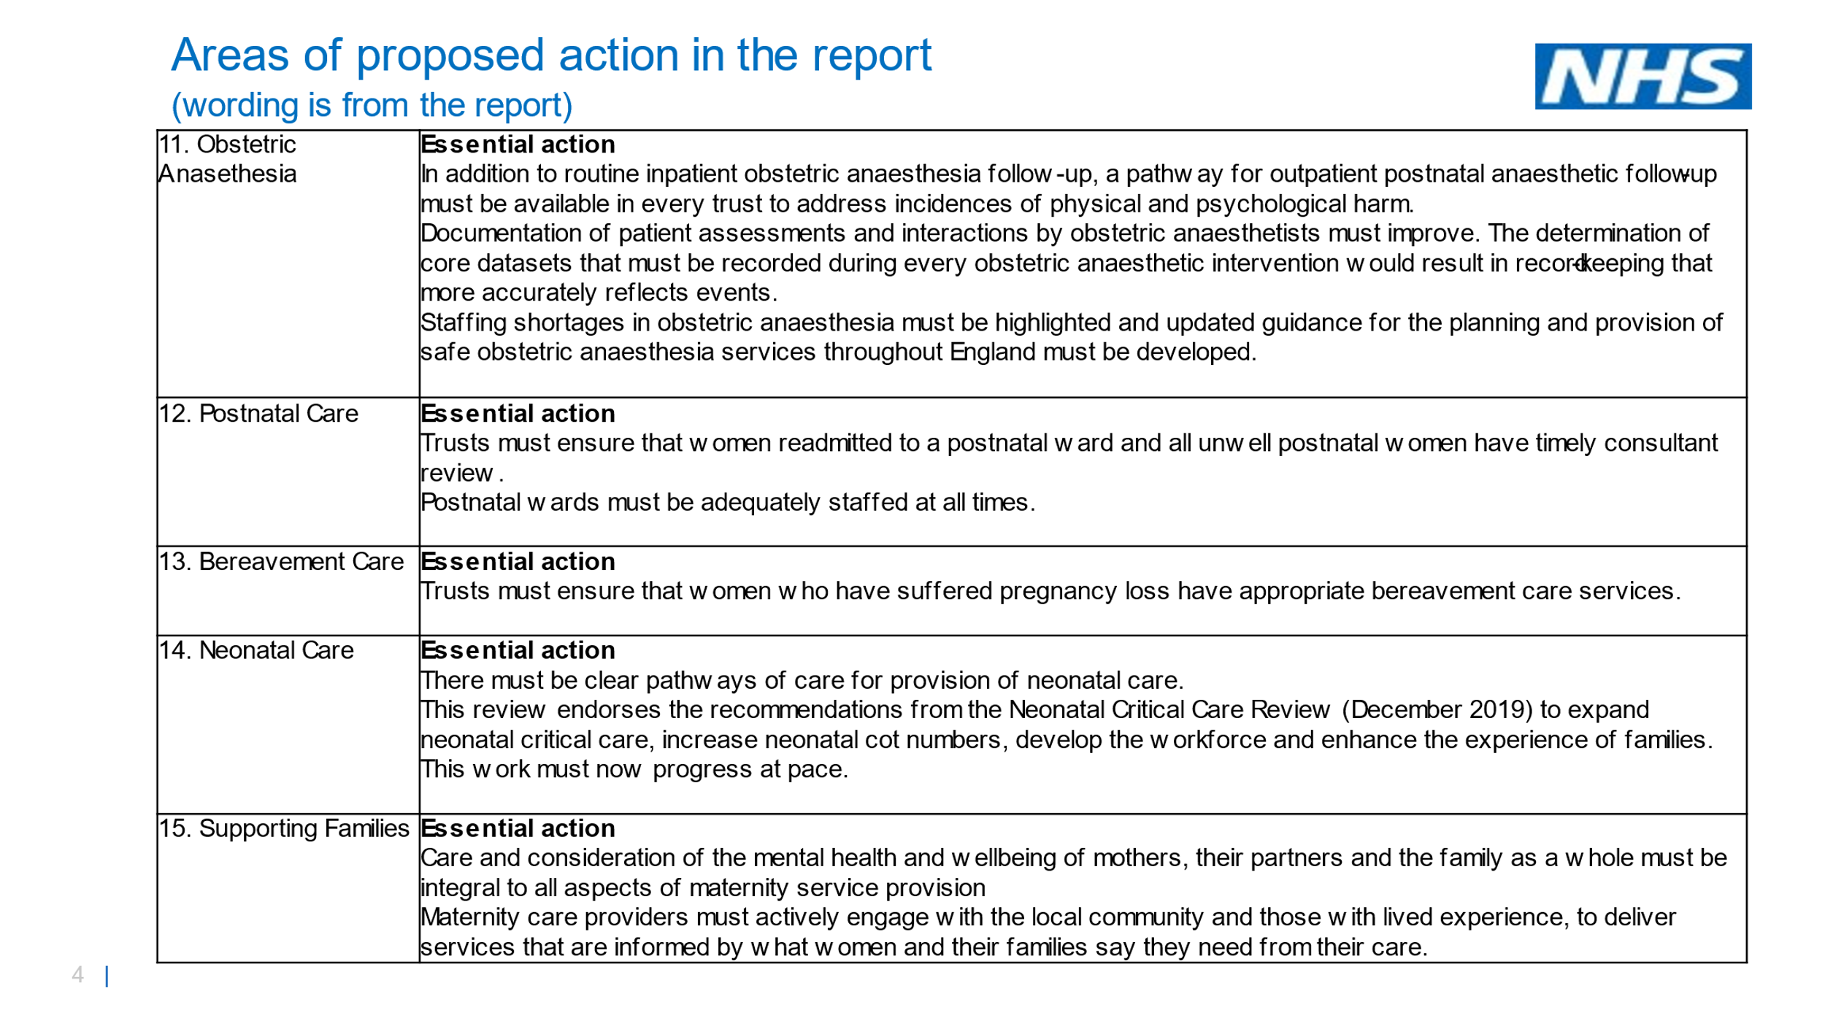
Safe Staffing levels
A shortage of midwives and Doctors meant staff were too thinly spread,
the communication between staff groups particularly midwives and Consultant Obstetricians was poor and certain staff appeared arrogant and dismissive,
Many Trusts including Oxford Health currently have workforce challenges which is escalated via many routes in the Trust and rated on risk registers Its important that the Trust Executive and Board continue to be aware of the areas with particular risks for staff and patients and able to triangulate data from safer staffing and workforce returns , patient safety incidents, patient feedback, complaints and concerns in a timely manner

A Well Trained Workforce
There was a failure to follow national clinical guidelines on a range of issues from foetal heart rates to management of gestational diabetes and resuscitation. The staff did not train together and there were concerns with clinical audit and a lack of supervision.
There was a toxic culture and staff described it as “us and them” between midwives and obstetricians and escalations were ignored by senior clinical leaders and evidence of bullying
Oxford Health has recently been having some challenges around the Employee L&D matrices with technical issues and not being assured that all staff are up to date with key Statutory and Mandatory training such as Resuscitation training etc This is still a risk but is being resolved
Oxford Health has appointed a Head of Organisational Development (OD) which along with a roll out of key staff having training in Restorative Just and Learning Culture should really help prevent the issues that were uncovered in Ockenden
Learning From Incidents
Longstanding failure of clinical governance where there was a “continual churn” of the Executive team and Board that led to an inability to deliver improvement
Hundreds of serious incidents including deaths had no investigations, so lessons were not learnt as were downgraded and avoided external scrutiny.
There was evidence of poor quality incident investigation and poor complaints handling
There was a failure to incorporate the Anaesthetists into the incident investigation to ensure learning
There was a culture of bullying which stopped staff speaking out and a view from the Board that all was well without checking out evidence.
Restorative Just and Learning Culture was not embedded
Should not have been “who” was responsible but “what” was responsible
Patient safety systems require investment in time and resources Learning from mistakes and near misses is healthy and to be encouraged. It is also ok to call things out if they are not as otherwise a complacency sets it and it becomes the norm.
Oxford Health in line with national requirements will be moving in 2022 to the new Patient Safety Incident Framework soon once the early adopters finish testing.
There will be a new national NHS learn from patient safety events service (LFPSE) which is replacing the current National Reporting and Learning System (NRLS) and Strategic Executive Information System (StEIS) with training and roll out.
It is clear from the Oxford Health Medical survey undertaken in 2021 that more work needs to be done as some doctors reported that they felt there is a blame culture and very wary of taking part in patient investigations and contact their own independent defence organisation for immediate advice. Support and Listening to staff is therefore critical and is a Quality Objective priority and part of the OD culture.

Listening from Families
Patients and families particularly women impacted (particularly those with high risks and complexities) were not listened to and not empowered.
Incidents were downgraded inappropriately by the Trust and the families were made to feel that it was all their fault
There was a lack of senior oversight and input into complaints handling and patient experience
There was a lack of openness and transparency
Women were not given the correct information to make informed choices
A failure to holistically consider the mother when providing Obstetric Anaesthesia
There were poor continual risk assessments as the mother’s circumstances changed
There was Little follow up for bereaved parents
Oxford Health has already introduced timely safety huddles and duty of candour is well embedded
Oxford Health Quality Objectives are currently being re drafted but are summarised as below so its important to note that one of the Trusts priorities is how we improve partnership working with patients and families.

Recommendation
The learning and action points are well described in this report but along with staffing and training, the health and Select Committee clearly articulated the need to learn from patient safety incidents and that families must be involved in the investigative process and lessons must be learned and implemented in a timely way to prevent further tragedies

Oxford Health NHS Quality Objectives 22/23
Support and listen to staff
To improve the quality of care over the next 12 months, as part of our Journey to Outstanding.
Considering the domains of Safety, Clinical Effectiveness and Experience.

Reduce Suicide and self-Harm

Reduce Violence and Aggression on
the wards the Wards

Improve Access and reduce
Inequalities

Embed Holistic Assessments to reduce
Harm

Improve How we work in Partnership with
patients and families

References
https://www.ockendenmaternityreview.org.uk/wp-content/uploads/2022/03/FINAL_INDEPENDENT_MATERNITY_REVIEW_OF_MATERNITY_SERVICES_REPORT.pdf

https://www.england.nhs.uk/wp-content/uploads/2020/12/B1318-ockenden-one-year-on.pdf

Ockenden, D. Emerging Findings and Recommendations from the Independent Review of Maternity Services at the Shrewsbury and Telford Hospital NHS Trust (2020) https://www.gov.uk/government/publications/ockenden-review-of-maternity-services-at-shrewsbury-and-telford-hospital-nhs-trust

Kirkup, B. (2015) The Report of the Morecambe Bay Investigation. https://assets.publishing.service.gov.uk/government/uploads/system/uploads/attachment_data/ file/408480/47487_MBI_Accessible_v0.1.pdf [Accessed 01 December 2021]

