Report to the Meeting of the

Oxford Health NHS Foundation Trust
BOD 32/2022
(Agenda item: 15)

Board of Directors

25 May 2022

Data Security and Protection Toolkit submission

For: Information/Assurance

Executive Summary

The Trust is required to complete and submit the Data Security and Protection Toolkit (DSPT) annually. The Toolkit is completed by self- assessment against 142 assertions. DSPT assertions are binary, Met or Not Met, but the expected outcome for the Trust is that all assertions are Met. 108 of 109 mandatory evidence items have been provided. 37 of 38 assertions are met to date and will be confirmed by June 30 2022.

The Trust has achieved “Met” status in each assertion, bar one to date (IG training compliance, Assertion 3.2.1). However, IG Training is in year a noted risk area, the Trust is yet to achieve the required level for reporting of Information Governance training. 95% attendance is required, 77% has been achieved to date (Assertion 3.2.1).

The DSPT will be submitted by 30 June 2022, the submission date has now been moved permanently

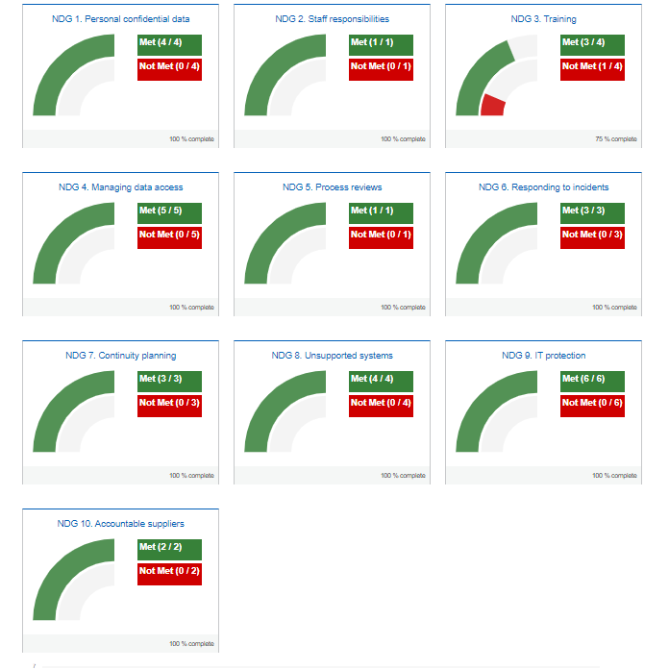

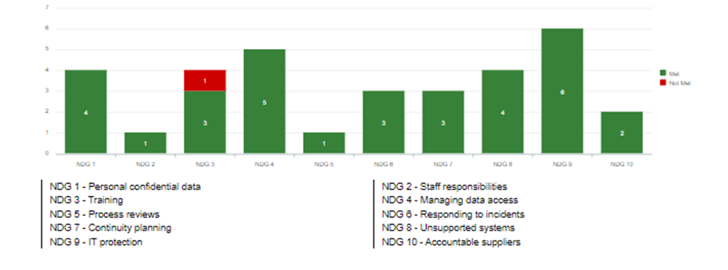

Audit requirements are now stipulated by the DSPT Assertion 9.4.5, and the Audit is conducted by an NHSX approved independent auditor. The Trust was assessed accordingly:

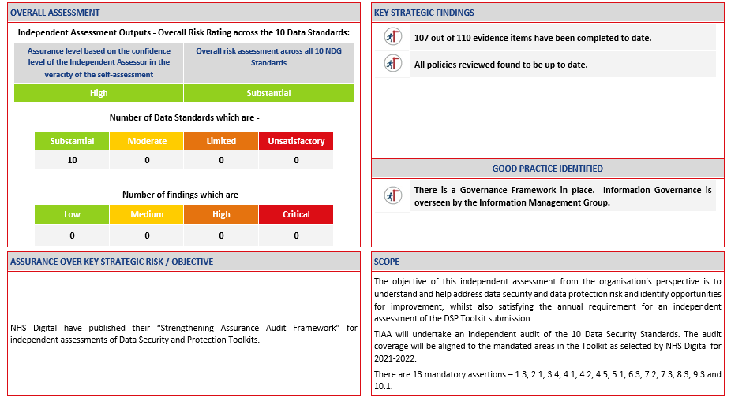

Governance Route/Escalation Process

DSPT is a standard item on the Information Management Group which meets quarterly, and members are from all Clinical Directorates and Corporate Departments. The IMG reports, via Escalation Report, to the FIC following each meeting of the Group.

Statutory or Regulatory responsibilities

Completion and submission of the Data Security and Protection Toolkit (DSPT) annually is mandatory. Adherence to the Assertions is a standard requirement of NHS contracts.

Recommendation

The Board are requested to note the report and Trust performance, and the potential for action post-submission to achieve the IT Training compliance level.

Author and Title: Mark Underwood, Head of Information Governance
Lead Executive Director: Martyn Ward, Executive Director Digital & Transformation

- A risk assessment has been undertaken around the legal issues that this report presents and [there are no issues that need to be referred to the Trust Solicitors] OR: [the Trust Solicitors have been consulted and their recommendation is included within the report] (please delete/amend as appropriate)
- Strategic Objectives/Priorities – this report relates to or provides assurance and evidence against the following Strategic Objective(s)/Priority(ies) of the Trust [OR N/A – no Strategic Objectives/Priorities apply] (please delete as appropriate):

1) Quality - Deliver the best possible care and health outcomes

2) People - Be a great place to work

3) Sustainability – Make best use of our resources and protect the environment

4) Research and Education – Become a leader in healthcare research and education

