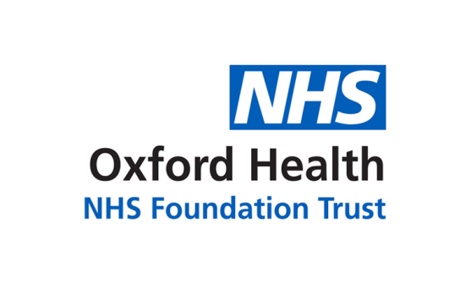

# Report to the Meeting of the

# Oxford Health NHS Foundation Trust

**BOD 40/2022**

(Agenda item: 2)

# Board of Directors

**20th July 2022**

**Sarah**

**Member of Bucks Voice**

**Patient Story**

**For: Information**

**Summary of the story**

Sarah has had contact with mental health services in Buckinghamshire since 2011, initially with our community and psychological services and more recently as an inpatient on Ruby Ward at the Whiteleaf Centre. Sarah wished to share her story to demonstrate the inconsistencies between her different inpatient admissions – one of which she has positive reflections on and the other was a much more negative experience. Sarah particularly wishes to reflect on the impact of communication, or a lack thereof, on her experience and her difficult and invalidating experience of how her complaint was dealt with.

***About the service***

Sarah will mostly be talking about her time spent on Ruby Ward, a female acute mental health ward at the Whiteleaf centre. She has also been under the care of psychological services in Oxford Health and also the community mental health team. Sarah currently attends the ‘Bucks Voice’ service user/carer forum where she is actively involved with co-production and using her experiences to improve care.