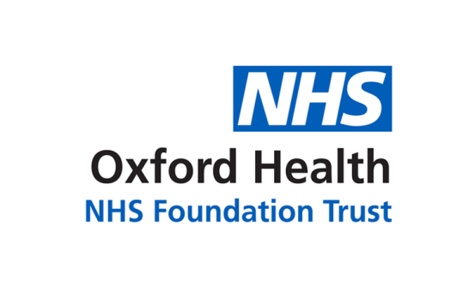

# Report to the Meeting of the

# Oxford Health NHS Foundation Trust

**BOD 60/2022**

(Agenda item: 07)

# Board of Directors

**28 September 2022**

**Integrated Performance Report (IPR) and IPR Supporting Report**

**For: Information & Assurance**

**Executive Summary**

The Integrated Performance Report (IPR) report provides the Board of Directors with an integrated view of the strategic domains of Operational Performance, Quality, People, Finance and Research & Education.

**The IPR has been updated to highlight specific areas for awareness and consideration following the feedback from the last Board meeting**

**IPR - Performance Summary**

**Delivery of the NHS National Oversight Framework**

The Trust continues to perform well against the targeted metrics with the exception of;

1. Inappropriate OAPs bed days used
2. Minor Injury Units (MIU) 4 hour performance and
3. IAPT; the percentage of people completing a course of IAPT treatment moving to recovery

Inappropriate OAPs bed days used

The Trust used **203 inappropriate OAP bed days in August; 114 in Bucks and 89 in Oxon** which is an increase on the previous month and reflects operational pressures in part but is mainly as a result of the planned transition from/reduction in contracted appropriate OAPs.

|  |  |
| --- | --- |
| Buckinghamshire CCG inappropriate OAPs:   | Oxfordshire CCG inappropriate OAPs: |

In comparison to the 8 Trusts across the region, Oxford Health is currently being reported nationally as having the second highest number of **inappropriate out of area placements** in the Southeast region**.**

Minor Injuries Unit (MIU) 4 hour performance

MIU performance in July was 88.8% which is 6.2% under the national target. However, in comparison, the national position is 71%.

The root cause of the variation is due primarily to:

* increased levels of activity (see visual below). Although Abingdon continues to see the highest numbers of patients, there has been an increase in virtually all MIUs
* longer consultation times due to increased patient complexity,
* staff sickness and staff vacancies. Recruitment is underway and there is a 111 campaign promoting the appropriate use of emergency services.

Referrals to MIUs in July at **highest levels in last 4 years**:

IAPT; the percentage of people completing a course of IAPT treatment moving to recovery

Performance is slightly under target but higher than the national position. This will be monitored but is currently considered to be low risk.

**NHS Benchmarking (latest data – June 2022)**

Benchmarking data is now published on a quarterly basis. A detailed report and action plan will be provided to the Board following receipt of the published annual benchmarking reports. Please refer to the IPR for a summary of the Trust’s performance in relation to 5 key currencies.

**SE Regional Performance and how we compare**

Performance is reported quarterly. There has been no change in the Trust’s performance in relation to its peers since the last report in May 2022.

**Delivery of strategic objectives (Objective Key Results (OKRs)**

The Trust has 32 OKRs (18 relating to quality, 9 to people and 5 to sustainability). 20 of the OKRs have targets; the Trust has successfully achieved 7 of the targeted OKRs by July 2022.

The table below provides an overview of the OKRs that are not yet being achieved and their performance compared to last month.

|  |  |  |  |  |  |
| --- | --- | --- | --- | --- | --- |
| **Strategic objective** | **OKR** | **Target** | **Last month’s performance** | **This month’s performance** | **Status** |
| **Quality** | Clinical supervision compliance | 95% | 44% | 48% | Improved position |
| **Quality** | Lester Tool completion in the community | 75% | 66.1% | 64% | Declining position |
| **Quality** | Lester Tool completion in the EIP service | 90% | 84.5% | 80.5% | Declining position |
| **Quality** | Evidence patients have been involved in their care plans | 95% | 92% | 82% | Declining position |
| **People** | Reduce agency usage to NHSE/I target | <10.2% | 15.3% | 14.8% | Improved position |
| **People** | Staff sickness | <3.5% | 6.2% | 5.3% | Improved position |
| **People** | Turnover | <10% | 15.1% | 14.9% | Improved position |
| **People** | Reduction in vacancies | <9% | 12.6% | 13.5% | Declining position |
| **People** | Personal Development Review (PDR) compliance | 95% | 27% | 29% | Improved position |
| **People** | PPST compliance | 95% | 82% | 84% | Improved position |
| **Sustainability** | Delivery of cost improvement plan | £- | £1.5m adverse | £3.1m adverse | Declining position |
| **Sustainability** | Achievement of all 8 targeted NOF measures | 8 | 5/8 | 5/8 | No change |

Please see the report for further information and plans to address.

**IPR Supporting Report - Performance Summary**

**COVID-19:**

* The current number of inpatients with COVID-19 has decreased to zero as of 15th September (it was 13 as of 2nd September)
* There has been a decrease in staff absent from work due to COVID. 45 staff as at 15th September. At the peak in wave 2, there were approx. 220 staff absent.
* COVID-19 vaccination uptake as of 15th September 2022: Dose 1 = 88.5%, Dose 2 = 86.6% and Dose 3 (eligible staff only) 71.2%. Patient Facing Dose 1 = 88.4%, Dose 2 = 86.5% and Dose 3 (eligible staff only) 71.4%

**Patient Activity and Demand:**

The report that accompanies the IPR provides an overview of activity levels by Directorate for referrals received, appointments delivered, inpatient admissions and inpatient length of stay.

**Referrals:**

Overall, referrals to the Trust in July 2022 were consistent with the numbers reported in previous months. See slides 36- 41 in the IPR for a summary of where referral numbers or higher or lower than usual and it is an area of concern.

**Activity:**

Despite shortages in available workforce, the Trust continues to deliver overall activity in line with normal/expected levels. Where higher or lower volumes of activity have been identified as a concern these are summarised in in slides 36 – 41 in the IPR.

**Admissions & Length of Stay:**

Admissions and Length of Stay (LOS) across wards within the Trust are within normal ranges. The number of patients medically optimised for discharge (MOFD) in community hospitals continues to reflect the considerable pressure within the Oxfordshire System, although there was a decrease in July compared to a peak in June 2022 (see below).

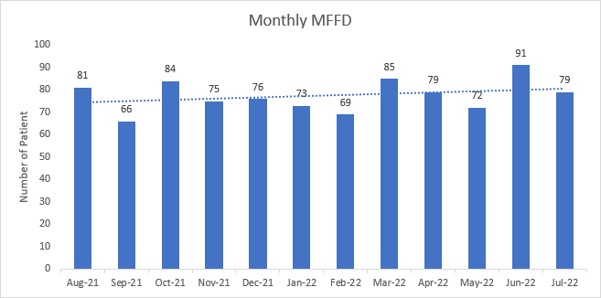

**Waiting Times*:** *against generic Trust wait time of >48 hour for emergency & >7 days for urgent, work is underway to develop service specific waiting time standards

Due to the outage of clinical information systems we are not currently able to report waiting time information automatically. Services have additional measures in place to manage risks whilst patients are waiting to be seen.

**Contractual Key Performance Indicator (KPI) Performance**

The Trust achieved 78% of its contractual KPIs in July, this is a decrease from the 83% reported to Board in May.

**Governance Route/Escalation Process**

The information that forms the basis for this report is part of the monthly monitoring in place with Directorates and overseen by the Executive Management Committee.

**Recommendation**

The Board of Directors are asked to note the contents of this report and provide further feedback for continuous development.

**Author and Title: Martyn Ward**.

**Executive Director – Digital & Transformation**

**Lead Executive Director: Martyn Ward.**

**Executive Director – Digital & Transformation**