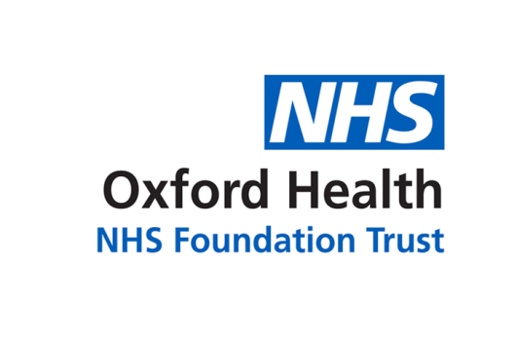

# Report to the Meeting of the

# Oxford Health NHS Foundation Trust

**BOD 76/2022**

(Agenda item: 11)

# Board of Directors

**30 November 2022**

**Freedom to Speak Up Guardian Annual Report**

This annual report is for information regarding the activities of the Freedom to Speak up Guardian (FTSUG) for the period of October 2021 to September 2022. The Board is asked to confirm its assurance with the work and developments described in the report.

**Executive Summary**

The Guardian continues to work within the remit of National Guardian Office (NGO) guidance and contributes to meeting the key objectives set out by People Promise and the delivery of “Quality and People” Trust Strategic Objectives. The Guardian contributes to various networks locally, regionally, and nationally. Regular reports are submitted to People, Leadership and Culture Committee (PLC), and quarterly to NGO to highlight the FTSU data, activities, and key learning.

In March 2022, Caroline Griffiths retired from her role as FTSUG and since then, Rita Bundhoo-Swift has been fulfilling the role on a fulltime basis. The Executive team agreed to increase the FTSUG capacity from 1 to 1.6 (WTE) in April 2022. Following a competitive recruitment process, Lianne Bowes, a podiatrist by background, has now been appointed and she will be starting in January 2023. Each Guardian will be working 0.8 WTE and will ensure that there is cover across the week.

The FTSUG role is both proactive and reactive in nature. The Guardian has continued to deliver a variety of formal in-house training in the drive to make speaking up business as usual. However, due to high number of cases, there has been limited capacity to carry out educational visits to teams across the Trust. The reactive nature of the role has taken up most of the Guardian’s time in speaking up, listening and following up on concerns raised by staff. The overall increase in FTSUG capacity will allow the Guardians to dedicate much needed time on the proactive nature of the role.

During this reporting period, 235 cases were raised with the Guardian compared 100 cases last year. Most cases have been heard and resolved with positive outcomes. A few cases remain to be resolved due to investigations or Trust processes. The numbers of cases and categories of concerns raised by each Directorate are detailed in the report. Worker safety or wellbeing remains the highest category of concerns reported by staff. Bullying and harassment is the second most common category of concerns raised. Patient safety & quality concerns are relating to processes and procedures not being followed appropriately. No cases of severe patient risk or harm have been raised with the Guardian during this reporting period. Lack of management support, fear of detriment or actual experience of repercussions appear to be the main barriers for speaking up. Some staff have chosen to speak up anonymously instead.

The Guardian continues to play a significant role in empowering staff in creating a positive Trust culture of openness and safety throughout the year through various routes. During Speak Up October Month 2022, many activities took place to promote the Speak Up culture more widely. Various senior leaders joined in the national Speak up campaign to raise the FTSU profile.

**Governance Route/Escalation Process**

This is an annual report which will be shared with Staff Partnership, Negotiation and Consultative Committee (SPNCC). Regular reports are submitted to People, Leadership and Culture Committee (PLC) and quarterly to NGO to highlight the FTSU data, activities and key learning.

**Statutory or Regulatory responsibilities**

In 2016-17, it became a contractual requirement for all NHS Trusts to have a Freedom to Speak Up Guardian. OHFT has adopted the model whistleblowing/raising concerns policy. This policy will need reviewing and aligning with the NGO FTSU policy by January 2024.

The Care Quality Commission assesses the speaking up culture of Trusts during inspections under the key line of enquiry (KLOE) 3 as part of the well-led question. No comments in the last CQC inspection.

The National Guardians Office (NGO) requests that Boards complete the Self-Assessment Tool regarding their role.

**Recommendation**

1. The Board is asked to note the work undertaken across the year by the FTSUG and to seek any necessary assurances arising from the report.
2. The Board is asked to confirm its assurance that the present structures of the Freedom to Speak Up Guardian role support the Trust objectives, Quality and People in regard to speaking up about the safety of patients and colleagues.
3. The Board is asked to consider completion of the NGO FTSU Self-Assessment Tool and implementation of FTSU new policy by January 2024.

**Author and Title: Rita Bundhoo-Swift, FTSUG**

**Lead Executive Director: Charmaine Desouza, CPO**

1. A risk assessment has been undertaken around the legal issues that this report presents and there are no issues that need to be referred to the Trust Solicitors.
2. **Strategic Objectives/Priorities** – this report relates to

1) Quality - Deliver the best possible care and health outcomes

2) People - Be a great place to work

**Freedom to Speak Up Guardian Annual Report**

**October 2021 – September 2022**

This is an annual report related to the activities of the Freedom to Speak Up Guardian (FTSUG) for the period between October 2021 and September 2022. It also includes key highlights of Speak Up October Month 2022. The Guardian continues to work within the remit of National Guardian Office (NGO) guidance and contributes to meeting the key objectives set out by People Promise and support the delivery of “Quality and People” Trust Strategic Objectives. The Guardian contributes to various networks locally, regionally, and nationally. Regular reports are submitted to People, Leadership and Culture Committee (PLC), and quarterly to NGO to highlight the FTSU data, activities, and key learning.

The FTSUG role was previously job shared between Caroline Griffiths and Rita Bundhoo-Swift, both working on part time basis (18.75 hours) making whole time equivalent (WTE). In light of increasing numbers of cases raised with the Guardians, a business case was put to the Executive to increase the FTSUG capacity before Caroline's retirement. In March 2022, Caroline retired from her role as FTSUG and since then, Rita has been fulfilling the role on a fulltime basis. The Executive team agreed to increase the FTSUG capacity from 1 to 1.6 (WTE) in April 2022. Following a competitive recruitment process Lianne Bowes, has now been appointed and will be starting in January 2023. Lianne is a clinician by background (Podiatrist) and will be moving internally from her role as a team leader. Each Guardian will be working 0.8 WTE and will ensure that there is cover across the week.

The FTSUG role is both proactive and reactive in nature. The Guardian has continued to deliver a variety of formal in-house training in the drive to make speaking up business as usual. However, due to high number of cases, there has been limited capacity to carry out educational visits to teams across the Trust. The reactive nature of the role has taken up most of the Guardian’s time in speaking up, listening and following up on concerns raised by staff. Hopefully, the overall increase in FTSUG capacity will allow the Guardians to dedicate much needed time on the proactive nature of the role.

**Speak up October Month 2022 Focus**

During this month of raising awareness and celebrating speaking up, the Trust joined in the national campaign organised by NGO “Speak Up for Everyone” with a different focus each week. With the support of the internal communication team and senior leaders, various events took place throughout the month. Many staff joined in the two Trust wide virtual raising awareness sessions, led by the Guardian. For the Speak Up Month, the Guardian was also supported by senior leaders in three webinars by Charmaine Desouza, Nick Broughton, Andrea Young, and Marie Crofts. Some teams were also visited by the Guardian face to face to raise awareness and distribute the FTSU posters and leaflets. These sessions were well attended by staff and empowered many staff to reach out to the Guardian during this month.

Nick Broughton, our CEO shared his thoughts and promoted Speak Up in his blogs and other key events. To celebrate the FTSU month, some of our staff bravely shared their stories about speaking up in a live webinar, weekly bulletins and also supported Rita in co-producing a short video about their speak up experience. Other activities such as make a pledge, Wear Green Wednesdays, FTSU quiz, undertake FTSU eLearning modules were actively promoted every week.

The Guardian was pleased to see that our staff and leaders are embracing the gift of speaking up. There appears to be a close correlation between active promotion of FTSU and an increase in number of staff feeling safe to reach out to the Guardian. The Guardian is also hopeful that the staff feel empowered to speak up to their managers.

**Speak Up Data Trend (2017 – 2022)**

The FTSU Index shows the % of Staff who feel safe to speak up based on four questions from the Annual NHS Staff Survey. This can help build a picture of what the Speaking Up culture feels like for workers in NHS Trusts. Table A shows that our Trust has been consistently reporting higher scores than the FTSU Index national averages; it indicates that generally our staff feel safe to speak up as they are encouraged and supported to raise concerns.

**Table A: FTSU Index National Averages Comparison**

**(Data available from NGO until 2020 only at time of reporting)**

|  |  |  |
| --- | --- | --- |
| **Year** | **FTSU Index - National averages** | **OHFT** |
| 2018 | 78.10% | 80.00% |
| 2019 | 78.70% | 81.30% |
| 2020 | 79.20% | 83.10% |

Table B illustrates that there has been an increase over the years in the number of cases reported to the NGO. This gradual increase is also reflected in the number of cases reported to the OHFT Guardian, perhaps a sign of positive Speak Up culture getting embedded across the Trust.

**Table B: Number of cases reported to NGO and OHFT (Oct – Sept reporting)**

|  |  |  |
| --- | --- | --- |
| **Year** | **No. of OHFT cases** | **No. of NGO cases** |
| 2017 / 18 | 43 | 7,087 |
| 2018 / 19 | 42 | 12,244 |
| 2019 / 20 | 67 | 16,199 |
| 2020 / 21 | 100 | 20,388 |
| 2021 / 22 | 235 | 20,362 |

**Cases by Directorate**

During this reporting period, a total of 235 cases have been raised with the Guardian compared to 100 cases last year (October 2020 - October 2021).

Table C below shows the breakdown of total number of cases reported by each directorate. The highest number of cases raised is from Community Services Directorate, where 80 staff have reached out for help. This is followed by Oxon & BSW MH (57) and Corporate Services (53). Specialised Services, mainly from forensic services remains the area with least referrals.

**Table C: Total number of cases reported per directorate (Oct 2021-Sept 2022)**



Number of cases reported by each directorate has varied over different quarters. Chart 1 below shows the number of cases raised quarterly by each directorate. There has been an increase in number of cases raised by individuals or teams in quarter one from the Corporate services. The spike in quarter four in Community services is mainly due to a team of more than 30 staff complaining about issues relating to organisational change.

**Chart 1: FTSU Cases by Directorate reported Quarterly**

All cases have been followed up either by empowering the staff to raise with their managers or escalated to senior managers / leaders by the Guardian on behalf of the concern raisers. Staff were kept up to date and given feedback regularly by the Guardian during the speak up process. Many cases have now reached positive outcomes, whereby the staff felt listened to and appropriate actions have been taken to address their concerns.

**Cases by Category**

Please note that the total number of cases raised by staff is not the same as the total number of cases raised by category. Following National Guardian Office (NGO) guidance published in February 2022, an individual case may include elements of patient safety/quality, bullying or harassment, worker safety or wellbeing, and/or other inappropriate attitudes or behaviours. Chart 2 below illustrates the various categories reported by concern raisers. Each category is further supported by common emerging themes that are raised with the Guardian.

**Chart 2: FTSU Cases by Category**

**Worker safety or wellbeing** remains the highest category of concerns reported by staff. The factors that contribute to this element are: staff feeling stress as a result of staff shortage; increased workloads / demands; uncivil or perceived bullying behaviour of staff or team culture; lack of support for career progression; lack of support from management and poor leadership style ; lack of engagement and unclear communication when dealing with organisational/services changes; impact of feeling discriminated due to disability, no reasonable adjustments put in place or followed up; Unfair treatment at interview whereby staff have been asked discriminatory questions about personal characteristics.

**Bullying and harassment** is the second most type of concern raised. Over the last few quarters, there has been a steady increase in cases with element of perceived bullying behaviours. This tends to include derogatory, unpleasant remarks to each other; micro-aggression; challenging staff credibility rudely and insensitively in front of others; exerting excessive control and undermining others autonomy. A few staff have expressed concerns about direct discrimination due to their race and personal protective characteristic such as having a disability and have suffered unfavourable / unfair treatment.

**Patient safety & Quality** concerns which have been raised are mainly relating to processes and procedures not being followed appropriately; and the impact of staff shortage, increased workload, increasing demands affecting delivery of high-quality person-centred care. No cases of severe patient risk or harm have been raised with the Guardian during this reporting period.

**Detriment** - some staff have reported that they have suffered detriment when they have spoken to their line managers and as a result have been excessively monitored, subjected to performance / capability or even grievance procedures. Some staff have spoken up anonymously instead.

**Observations and learning**

* HR colleagues and FTSUG have now started working together to triangulate the FTSU data with ER cases in HR to identify trends so that co-ordinated action can be taken.
* Issues are being raised collectively as teams since individual voices have not been heard and actioned, possibly undermining the speak up culture.
* Fear of detriment or actual experience of detriment is creating barriers for speaking up. Managers / leaders need to create a culture of openness and embrace the gift of speaking up as opportunities to improve and learn.
* Lack of support and poor leadership when staff have taken the courage to speak up seems to be another common barrier for staff speaking up to their managers. Managers need to make time to listen with empathy, acknowledge, take action and follow up with feedback / updates when staff do speak up.
* Promoting a positive culture to maintain civility and professionalism to tackle bullying and harassment.
* Staff to actively engage in Speak up eLearning modules to promote positive culture change and tackle barriers for speaking up (less than 50 staff have completed these modules since 2017 despite active promotion).
* Advising and promoting self-care to be prioritised by all, as staff are feeling stress, leading to sickness and some leaving the Trust altogether.
* Revising / clarifying some of Trust processes / policies as to how staff can speak up through the different channels would be beneficial.
* When visiting teams, the FTSUG noticed there are no clear leadership structures that are displayed. Frontline staff are not necessarily aware who is in their leadership structure from senior managers to directors/leaders. Each team should have a clear leadership structure on display on their notice board which may help staff in knowing who to reach out if they feel safe to do so.
* Very few staff from forensic services have accessed the FTSUG service.
* Some teams in Bucks keep on having issues with the same leadership structure.
* Increased number of cases from medical & psychological staff relating to incivility and challenges of teamworking have been reported.
* More work is needed in supporting staff with a disability as they are feeling discriminated due to their disability and lack of reasonable adjustments.
* Staff complaining how dealing with HR personnel and processes have been challenging and led to them feeling disempowered and having no confidence that they are being heard or supported. Staff reported being treated with lack of respect and insensitively during the HR processes.
* Some senior AHPs feel that there is less opportunity for career progression.
* Guardians to promote FTSU raising awareness sessions Trust wide more often with the help of communication team.

**Feedback from Staff who have used the FTSU service**

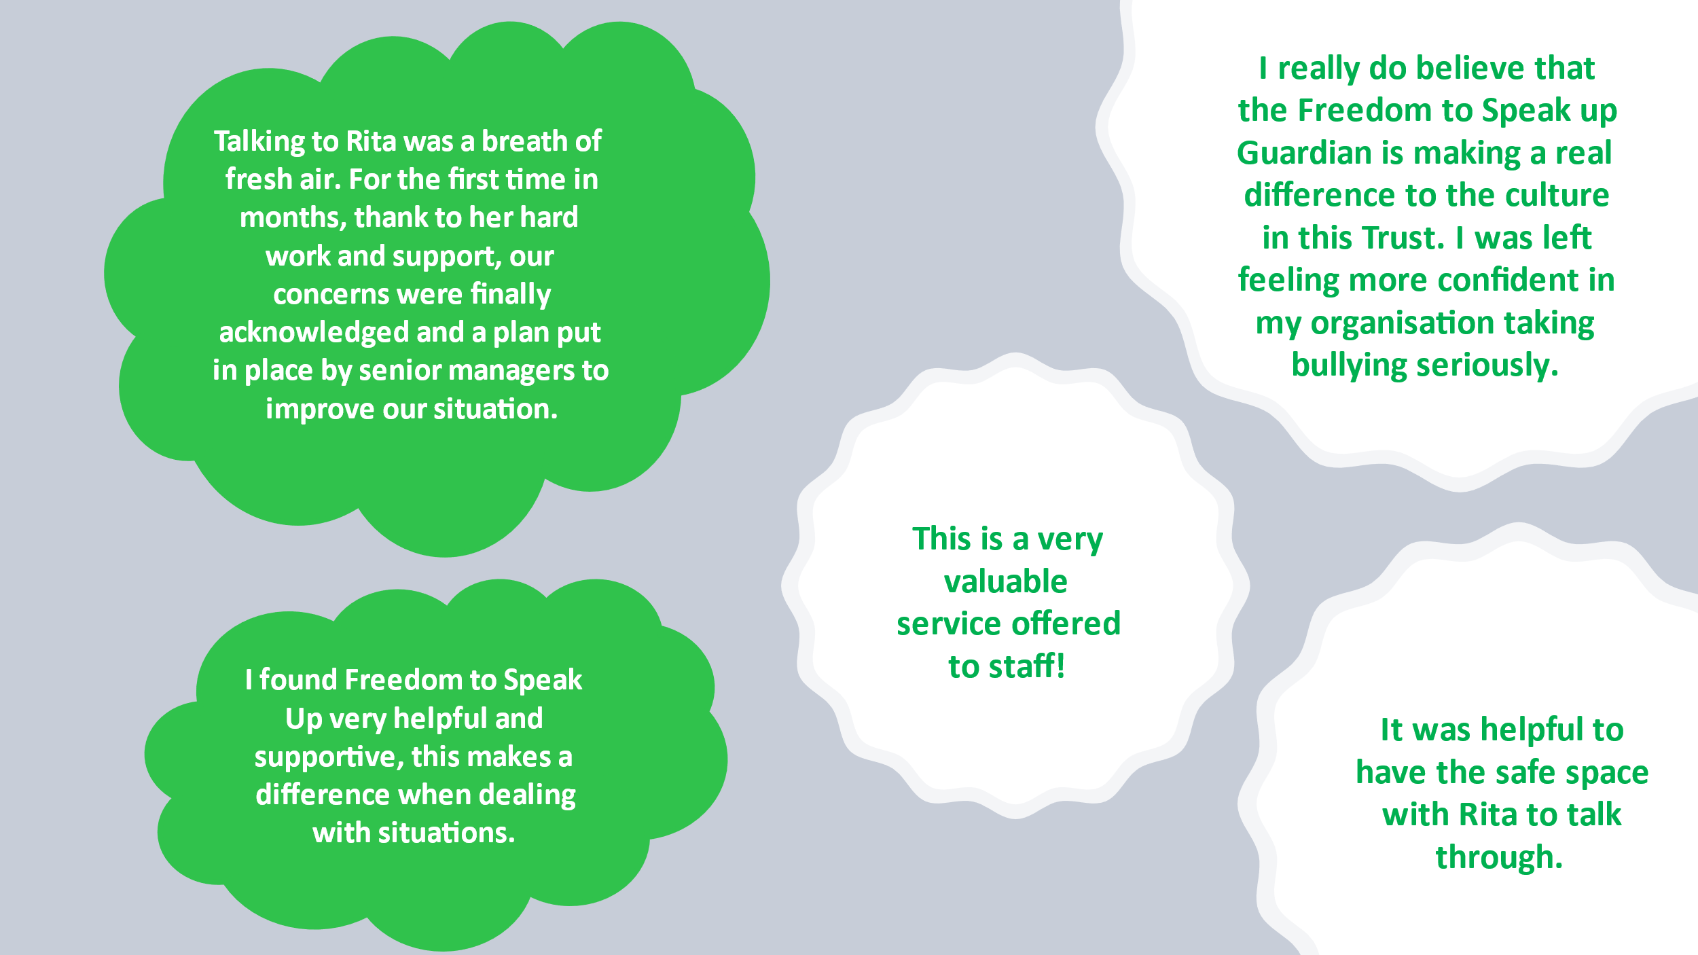The image below shows some of the feedback received from staff who have used the FTSU services. The themes below are compiled from verbal and completed feedback forms.

**Recommendations based on observation and national drivers (HEE & NGO) for Trust to consider for implementation:**

* Further training to be provided to staff in how to have difficult conversations constructively and in a sensitive way.
* Regular engagement and support from communication team in raising FTSU profile and making speaking up business as usual.
* FTSU policy to be aligned with NGO recommendation by January 2024.
* Leaders to undertake the FTSU Self-Assessment Tool to ensure assurance about the FTSUG role, any improvement and how to continue to support the culture of positive Speaking Up.
* Active engagement with FTSU eLearning modules for staff at all levels to help tackle barriers for speaking up and creating a positive culture.