Report to the Meeting of the

Oxford Health NHS Foundation Trust
BOD 78/2022
(Agenda item: 14)

Board of Directors

30th November 2022

Patient Safety Incidents reported September and October 2022
For: Assurance

Executive Summary
It is crucial that we learn from every incident and near miss that happens to identify and address system issues to continually improve the safety of care.

The report focuses on the period September and October 2022 following on from the last report. Six Patient Safety Incidents (PSI) have been identified:

- 4 Suspected suicides in the community
- 1 Deterioration in physical health (on a mental health ward)
- 1 Fall from hoist resulting in head injury on a community hospital ward

The report shared the reporting of PSIs over the past 5 years and summaries the recent improvement areas and safety actions being taken.

Governance Route/Escalation Process
Every Patient Safety Incident (PSI) is investigated which includes the involvement of patients/ families and those staff involved in the incident. A report is then scrutinised at an internal PSI panel by senior clinicians which is shared with clinical teams for learning and the patient/ family members involved. The report is then presented to the relevant commissioner (now the ICB) for review and closure. This process has executive director oversight via the CMO and the CNO.

There are a number of weekly and monthly forums and different methods used to share learning across the Trust to focus on our key areas for improvement.

Recommendation
For the Board to be assured regarding the current management and learning from PSI’s.

Author and Title: Victoria Harte, Patient Safety Service Manager
Jane Kershaw, Head of Quality Governance

Lead Executive Director: Marie Crofts, Chief Nurse

- A risk assessment has been undertaken around the legal issues that this report presents and [there are no issues that need to be referred to the Trust Solicitors]
- Strategic Objectives/Priorities – this report relates to or provides assurance and evidence against the following Strategic Objective(s)/Priority(ies) of the Trust):
1) Quality - Deliver the best possible clinical care and health outcomes

- Patient Safety Incidents reported in September and October 2022
There were 6 PSI reported to STEIS (national reporting of PSI database) in September and October 2022; 4 suspected suicides in the community, 1 deterioration in physical health (on a mental health ward) and 1 fall from hoist resulting in a head injury on a community hospital ward. We continue to monitor regional and national trends in terms of suicide rates and work towards reducing suicides. The graphs below represent PSI reporting over the past 5 years. The higher than usual figures in 2020/21 and 2021/22 relate to COVID-19 inpatient outbreaks. There has been a reduction in pressure ulcer PSIs so far in 2022/23, however the incident reporting number and rate of pressure ulcers in categories 1,2,3 and 4 developed in service is unchanged. There are a number of weekly and monthly forums and different methods used to share learning across the Trust to focus on our key areas for improvement.

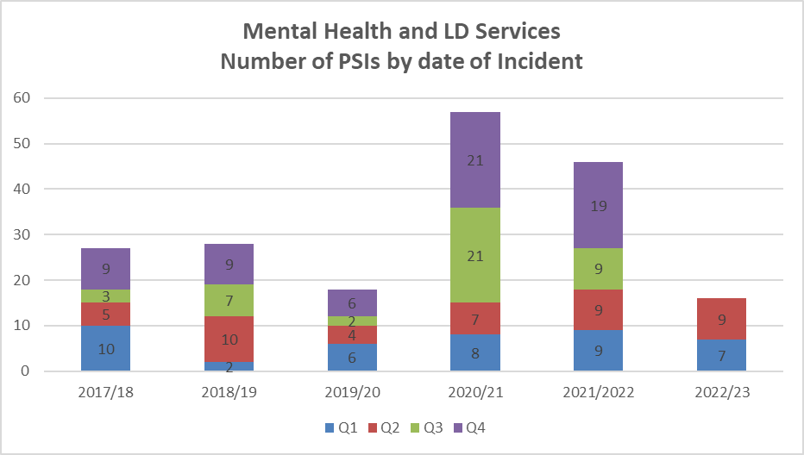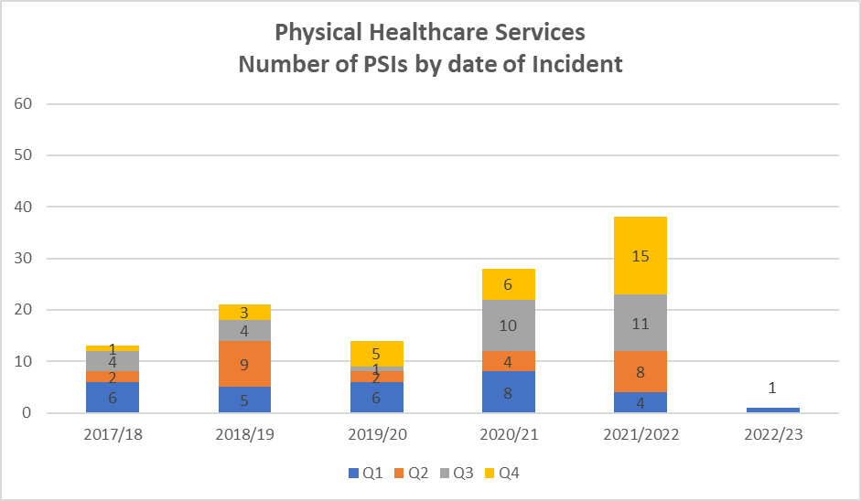

2.0 Completed Investigations and Learning
We use a systems-based investigation approach to identify and act on learning. The actions from the PSI investigations completed in September and October are shared below;

Improvement area 1. Three of the completed PSII reports identified a need to improve how community mental health teams communicate with families, in relation to: consent to share information, offering carers support, sharing information about risks and gathering collateral information.
Safety action. The teams have used the findings of the investigations to share learning across the team. One team has had additional training supported by the Trust’s Carer Involvement Lead. In addition there is work happening through the implementation of the Trust’s Carers, Friends and Family Strategy objectives and also a QI project on improving family engagement.

Improvement area 2. Improve the Mental Health Triage Team process of completing risk assessment and safety planning.
Safety action. The Mental Health Triage Team had a development day with a focus on risk assessment formulation and safety planning. They have improved the telephone triage process by developing a script to support staff, had bespoke training aided by the Suicide Prevention Consultant nurse. The team have enhanced their supervision with use of call auditing to support continual improvement.

Improvement area 3. Continue to review and evolve the post incident learning huddles which are held with the clinical team soon after a serious incident or unexpected death. The huddles were introduced from May 2021.
Safety action. A feedback form is sent to participants following every huddle. The feedback is reviewed and continual improvements are being made. The specific learning identified within this PSI related to consultant’s feedback so the Patient Safety Team joined the consultants meeting, the areas of improvement identified were a need for improved communication that huddles are not a psychological debrief, the timing and name of the learning events, and raising awareness that the huddle report may be shared with the coroner. The process has now been adapted to include in the overview document explaining purpose of huddle that is shared with everyone prior to the huddle and also the introduction at beginning of huddle has been altered to emphasis these points.

