For Me (Thames Valley and wessex) PROVIDER COLLABORATIVE PATIENT FLOW SYSTEM
How to submit a referral

Version No. | Reviewed By | Date
V0.1 | Bev Reid-McPherson | 19/11/2021
V1 | Bev Reid-McPherson | 12/07/2022

Contents
1 INTRODUCTION 2
2 ACCESSING THE SOLUTION 3
2.1 How to access Cambio PFM 3
2.2 Homepage View 3
3 TWO FACTOR AUTHENTICATION (2FA) 4
4 HOW TO MAKE A NEW REFERRAL 5
5 Password Change Security 9
6 USER ACCESS RIGHTS 10
7 ADD / REMOVE USERS 10
8 HELP GUIDE 10

INTRODUCTION

Welcome to the For Me (Thames Valley and Wessex) Provider Collaborative Patient Flow System Guide. From 18 July 2022, new referrals must be submitted through Cambio PFM and will replace the current manual processes in place such as submitting referrals via email.

Cambio PFM solution will:-

- Enable referrers to log onto the solution and complete their referrals electronically rather than the current system whereby they must submit their referrals as a word document.

- Provide an online function for providers of the access assessment service to review referrals, determine if all relevant information is available to progress and monitor the access assessment within the timeframes identified in the service specifications.

- Enable an online quality review of access assessments by the Panel so that timely decisions can be made on the recommendations presented by the assessor.

- Provide a “grid” function that shows the status of all referrals and access assessments in real time so that any delays in the process can be identified quickly and addressed on the weekly call with partners.

- Provide a view of all patients authorised for admission but waiting for a bed to be found, this is called “searching for a bed”.

- Enable all partners to use the online function to identify the bed, ward, and unit they wish to admit their patient which is available to view in real time.

- Enable key information to be available in real time about all mental health, learning disability and autism patients in secure medium and low units in the For Me Thames Valley & Wessex Provider Collaborative, as well as those placed out of area (this function replaces the weekly sitrep).

- Provide the ability to plan and monitor key interventions for patients while they are in secure units such as CPAs and CTRs.

- Provide the online function for partners to transfer patients to other units in the network as well as reviewing the out of area cohort and the “virtual” ability to bring them back into one of the in network secure units.

- Enable consistent and accurate online recording of delayed discharges and reasons for the delays for all patients in secure units.

- Enable consistent and accurate online recording of estimated date of discharge, actual date of discharge and the discharge destination.

ACCESSING THE SOLUTION

This guide has been developed to support you when accessing the For Me (Thames Valley and Wessex) Provider Collaborative Cambio Patient Flow Manager (Cambio PFM) solution.

How to access Cambio PFM

Step 1. Cambio PFM can be accessed via a URL link: https://oxfordpc.cambiouk.co.uk/pfm/

Homepage View

Welcome to Secure Provider Collaborative homepage shown below.

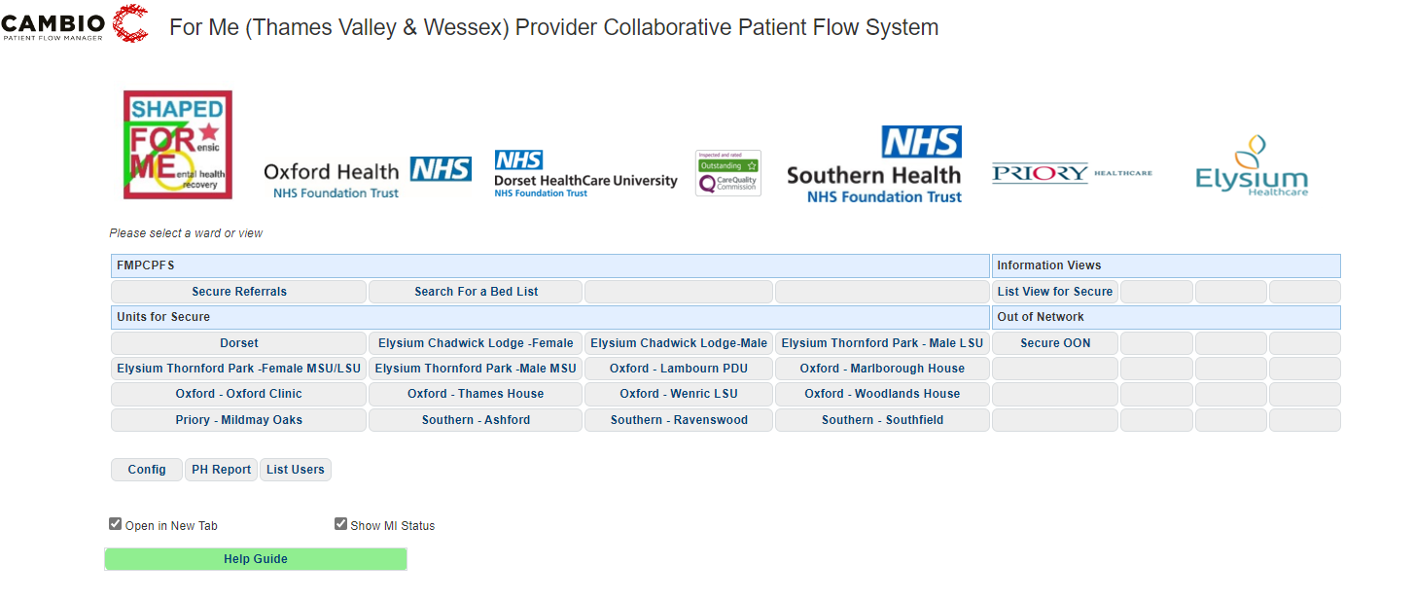

Step 2. From the homepage, select the ‘Secure Referrals’.

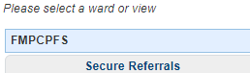

Step 3. Once you select the ‘Secure Referrals’, you will be asked to enter your ‘Username and Password’ which will be provided by the For Me or local Provider.

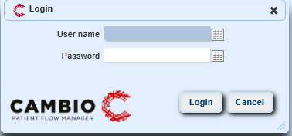

Step 4. Once you have entered your Username and Password, you will be prompted to follow the Two Factor Authentication process which provides an additional level of security when accessing Cambio PFM.

TWO FACTOR AUTHENTICATION (2FA)

Please ensure you set up 2FA prior login to Cambion PFM. If required, you will need to obtain permission from your local IT department to download Twilio Authy and request they mark as safe ‘do-not-reply@cambiouk.co.uk’ email alerts generated from Cambio PFM.

Step 1. You will need to complete the authentication process once.

Step 2. Once you generate a Passcode, copy to the clipboard and paste into the Passcode field below, then click Login.

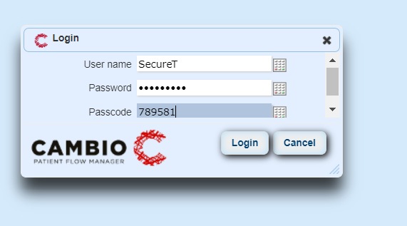

Step 3. Once you have logged in, you will be prompted to change your password.

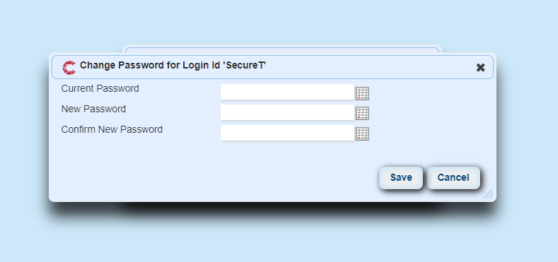

Step 4. Once you click Save you will be directed to Secure Referrals view.

HOW TO MAKE A NEW REFERRAL

Step 1. Once you have completed the authentication process, you will be directed to Secure Referrals view. Click on the tab entitled ‘Add Referral’ and the screen below will pop up.

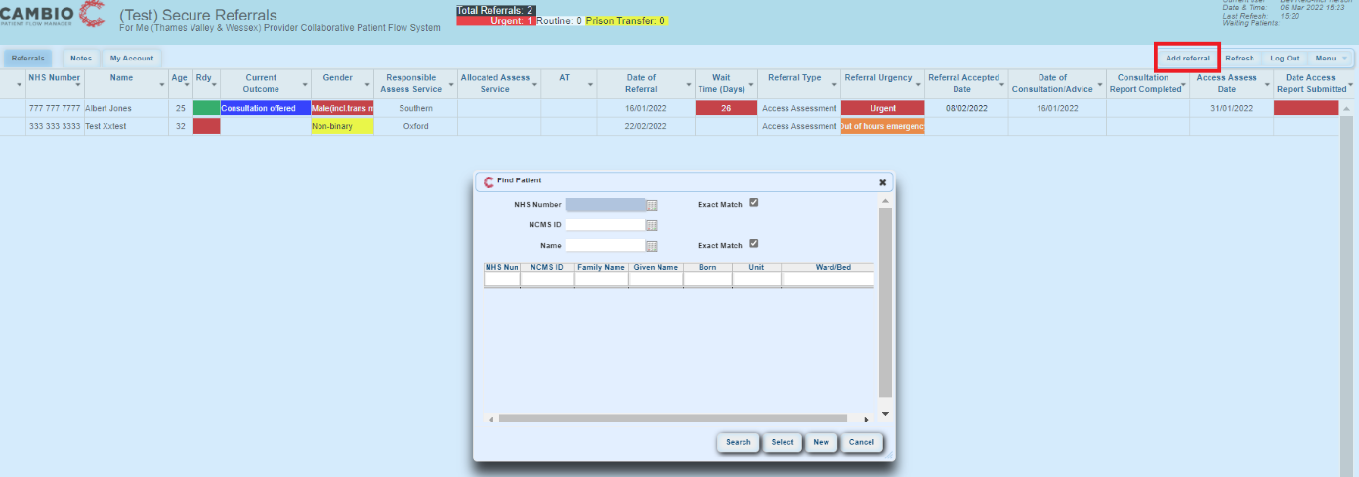

Step 2. Add the NHS number of your patient into the ‘Find Patient’ box below and click ‘Search’. It is important to enter the NHS number with the correct spacing. The system will return ‘No patient found’. Click on ‘New’ at the bottom of the page which will open a new window to allow you to add the patient’s details.

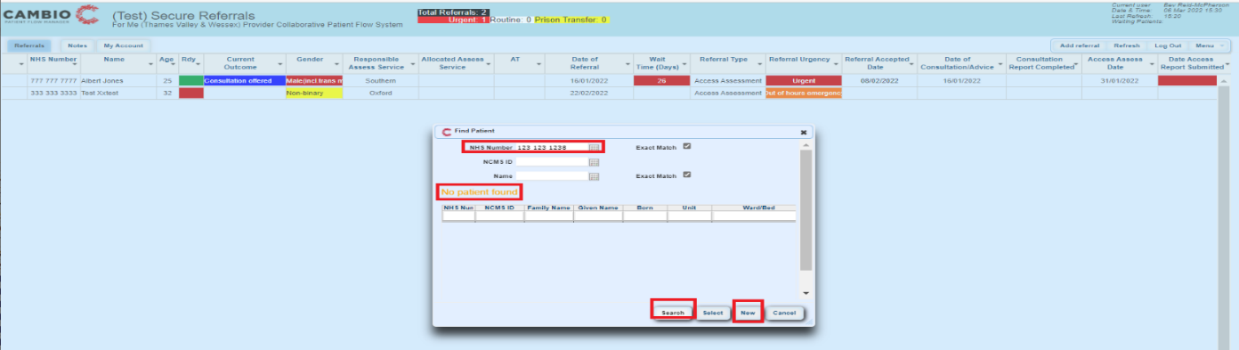

Step 3. The ‘Add Patient’ box will pop up. In order to identify the mandatory fields you need to complete at this stage, if you click ‘Save’ at the bottom of the page, you will see the mandatory fields highlight in ‘red’. Please complete the ‘Referral’ and ‘Attachments/File’ tab only. You can partially complete the referral which will allow you to save what you have completed so far and then complete the remainder of the fields at a later stage.

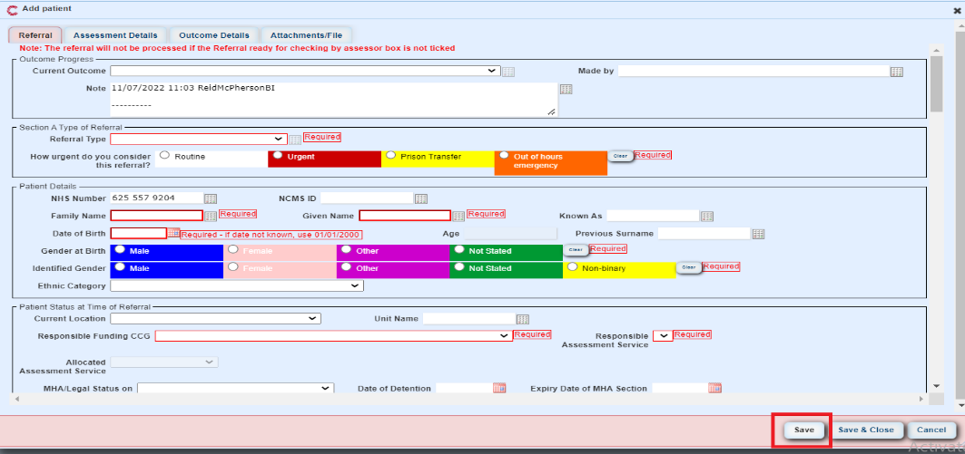

Step 4. Under ‘Section B Referrer Details’ you will have the option to indicate whether you are an individual Referrer or part of a Team. By indicating you are part of a team, your team will be able to see the referral you have submitted and continue to complete the referral on your behalf in the event you are unable to do so. If you are not part of a Team, please select ‘No Team’.
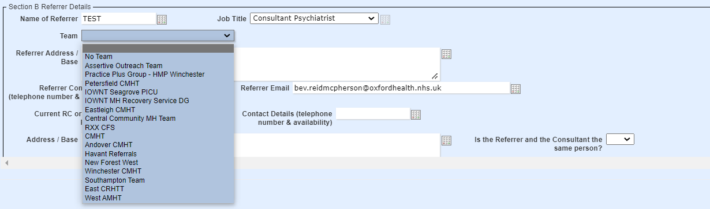

Step 5. Once you have completed the mandatory fields at this stage, click ‘Save’.
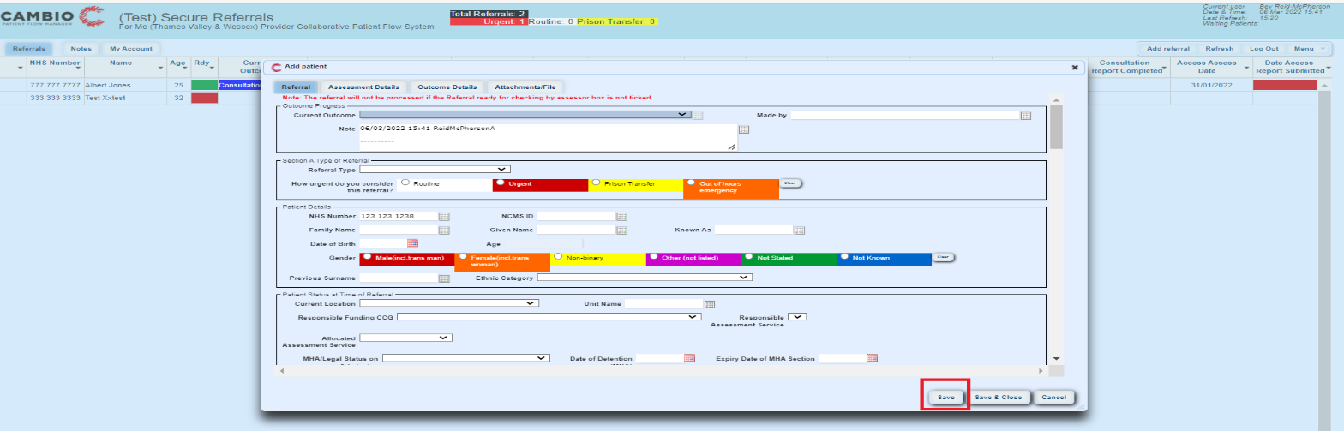
Step 6. You will see the patient details can now be viewed on the ‘Secure Referrals’ view. You will also note the ‘Rdy’ column has turned ‘Red’ which means the referral is awaiting further information.
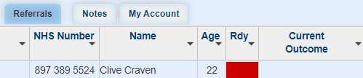

Step 7. The Assessing Unit will receive an email alert indicating a referral has been submitted.
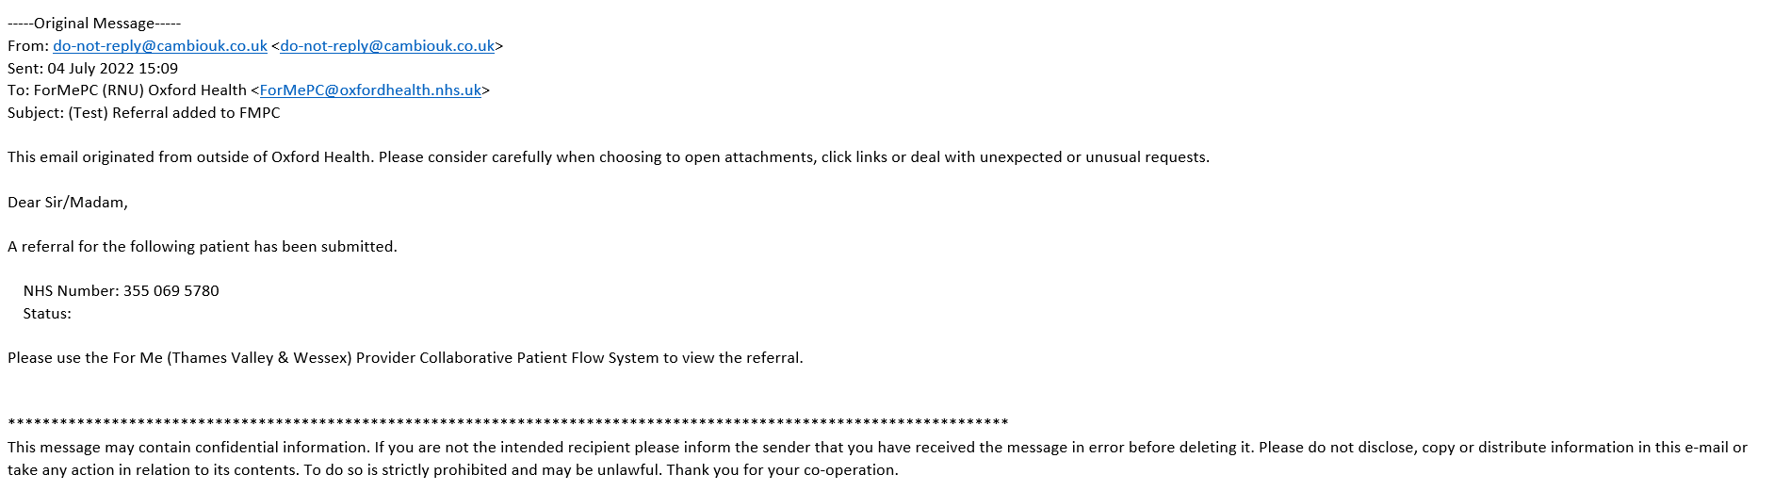
Step 8. If you wish to add supporting documentation, click onto the patient and click onto the ‘Attachments/File’ tab, click onto ‘manage file’, the ‘Add files(s)’. You will be directed to your local drive to select and upload the documentation. Once uploaded click ‘Save & Close’.

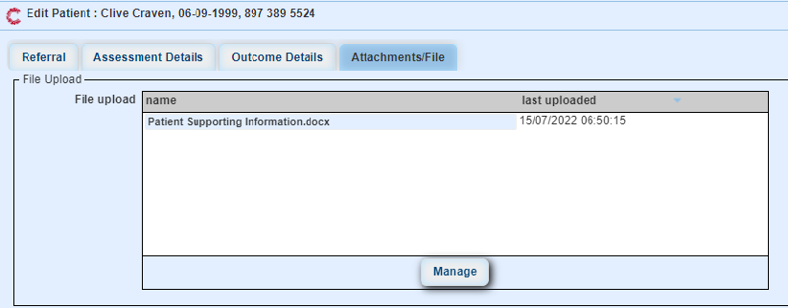
Step 8. You will see a paper clip appears on the left-hand side of the patient details indicating an attachment has been added to the referral.
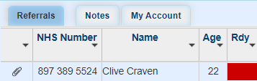
If the attachment has been added in error, click onto the ‘Attachments/File’ tab and click delete.
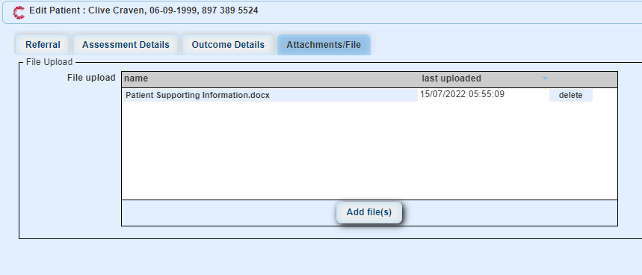
The paper clip will disappear from referral view.
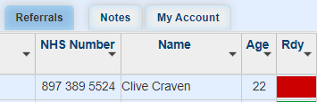

Step 9. To complete the remainder of the referral, double click on the patient, scroll down to the bottom of the page, and click ‘Save & Close’. You will be prompted to complete the remaining mandatory fields highlighted in red. Scroll to the top of the page and continue to complete the remaining highlighted fields. Once completed scroll down to the bottom of the page and tick ‘Referral ready for checking by assessor’ then click ‘Save and Close’.

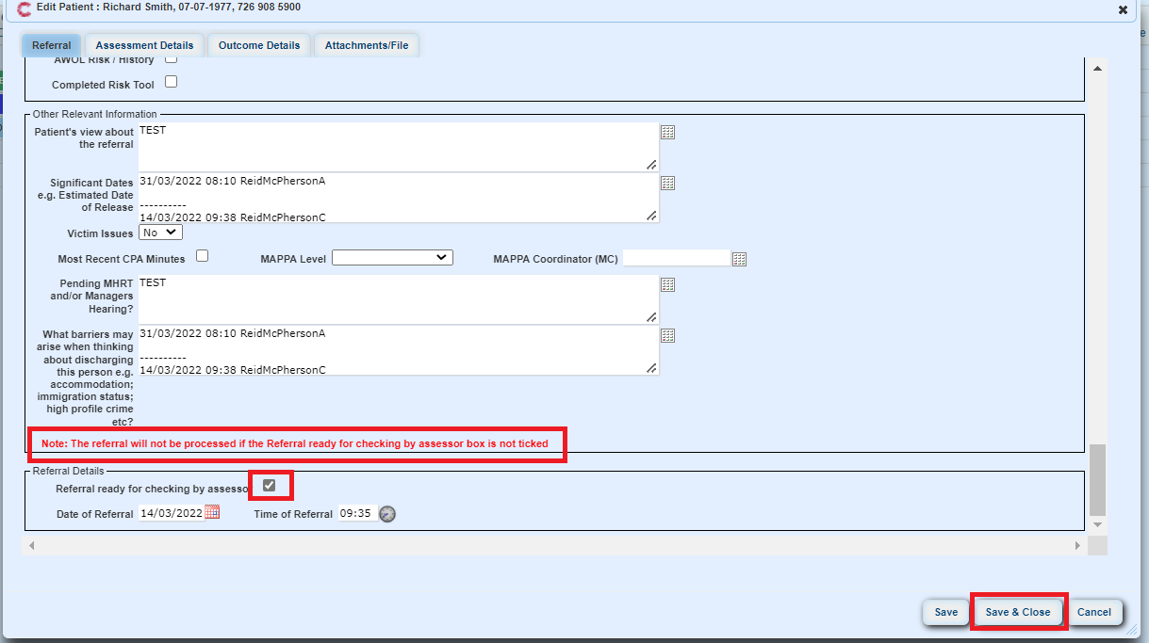.
Please note: The referral will not be processed if this box is unticked.

Step 10. Once completed you will see on the Secure Referrals view next to the patient’s details, the ‘Rdy’ column has turned ‘green’, which means the referral is ready to be assessed by the Assessing Unit.

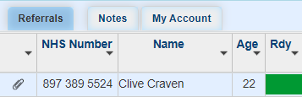

Your role as a Referrer is now complete.

Password Change Security

If you feel your account has been compromised, you can change your password within the solution.

Step 1. On access to your Secure Referrals, click onto the ‘My Account’ tab, then click onto ‘Change Password’, the ‘Change My Password’.

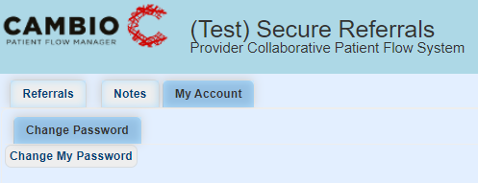

Step 2. The ‘Change Password for Login id’ box will appear. The password complexity should be a minimum of 0-9 characters consisting of upper and lower case letters, numbers, symbols, and mixed cases. You will be forced to change your password after 90 days.

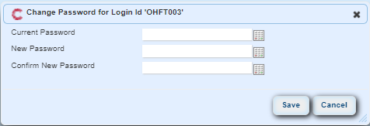

Step 4. The system will time out if no activity has been performed over short length of time.

USER ACCESS RIGHTS

Please complete the Referrer Team Access Form and return to For Me, details below.

Referrer / Team View Access Form

Please contact formepc@oxfordhealth.nhs.uk for further information on Provider Collaborative Referrer access rights.

ADD / REMOVE USERS

For New Users, please complete the Secure User Access Form and return to formepc@oxfordhealth.nhs.uk.

Please contact For Me or Provider if you require a user to be removed from Cambio PFM.

When accessing the system please be mindful of GDPR and rules governing legitimate use of personal data.

HELP GUIDE

If you require additional online support, please click onto the Help Guide on the homepage. The Patient Flow Manager Guide will appear. Your Provider Collaborative will provide a user guide and short e-learning videos to support your learning and knowledge of the system.

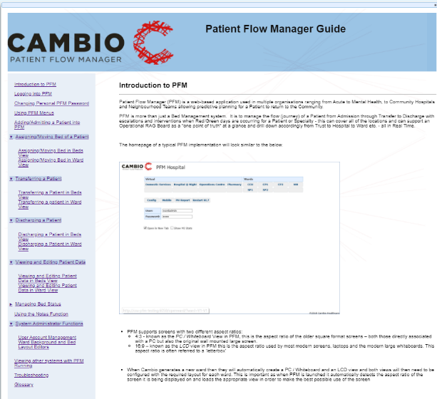

For further information please contact formepc@oxfordhealth.nhs.uk

NEXT STEPS

Your feedback

As you begin to use Cambio PFM we anticipate that there may be some adjustments and amendments to be made and welcome your feedback.

Please can you use the following format for your feedback and send to the secure inbox formepc@oxfordhealth.nhs.uk

Description of the issue | Describe where the issue is on the system and how you think it needs to be resolved | Indicate the urgency of resolution

Reference Guides
The following reference material will be shared with your respective Provider Collaboratives. The document will be reviewed and updated as and when any configuration changes or new features are made.

- Referrer How to Submit a Referral.

Frequently Asked Questions
Feedback on the solutions performance and benefits will be requested once the solution has gone live. The guide will be updated so everyone can see what has been asked and the resolution. This will be found on the Cambio Secure home page under ‘Help Guide’.

For more information please contact formepc@oxfordhealth.nhs.uk.

