

**RR/App 39(ii)/2022**(Agenda item: 23)

**Report to the Meeting of the**

**Oxford Health NHS Foundation Trust**

**Quality Committee**

**14 July 2022**

**Quality and Safety Dashboard**

**For: Information and Assurance**

**Executive Summary**

The Quality and Safety Dashboard reviews information up to 30th April 2022 combined with intelligence from the May and June 2022 Quality and Clinical Governance Sub-Committees. The Dashboard shows the range of quality, activity and workforce indicators to identify those teams which may need additional support or further deep dives to triangulate information. The report shares an **Inpatient Dashboard** covering all wards and a **Community Dashboard** which identifies teams by exception. The format of the report has been slightly changed since it was last presented to the Committee, to better highlight any changes over time at ward/ team level.

Overall, the analysis shows a number of wards and community teams are struggling with shortages of permanent staff due to vacancies and sickness combined with increased demand. This is having an impact on the quality of patient care and experience, and increases our costs as we use temporary and agency staff. Inpatient wards, community nursing services (District Nursing), child and adolescent mental health services, some of our adult community mental health teams and the GP OOH service are experiencing significant staff shortages alongside increased demand for care.

We have a Trust programme of work called ‘Improving Quality, Reducing Agency use’ which has eight workstreams with a focus on how we retain and recruit staff. This has included actions to centralise unregistered staff recruitment campaigns, targeted marketing and rebranding, virtual job fairs, co-creating jobs with candidates, continued expansion of apprenticeships, re-introducing a standard survey when staff leave and introducing international recruitment. The detail of the progress and impact of the programme is reported to the People, Leadership and Culture Committee.

The analysis highlights one ward and two community services where at least one workforce indicator is highlighted as an area of potential concern and at least two quality indicators are flagged.  All three teams were highlighted in the last Dashboard report. An update on actions by team/ ward is provided.

* Highfield CAMHS (Children and Adolescent mental health inpatient)
* District Nursing Service – particularly City and South West Teams
* Oxfordshire City and North East Adult Mental Health Team

**Governance Route/Approval Process**

The Dashboard was presented at the Quality and Clinical Governance Sub-Committee on 31st May 2022. The Sub-Committee reviewed and supported the information being presented in this report.

**Statutory or Regulatory responsibilities**

We are required to report on the inpatient staff fill rates to Trust Board members which has been delegated to the Quality Committee. This information is included in the Quality and Safety Dashboard.

**Recommendation**

The Committee is asked to note the report and the actions being taken to support the teams highlighted.

**Author and title:** Jane Kershaw, Head of Quality Governance

**Lead Executive Director:** Marie Crofts, Chief Nurse

1. *A risk assessment has been undertaken around the legal issues that this report presents and there are no issues that need to be referred to the Trust Solicitors.*
2. *Strategic Objectives/Priorities - this report relates to, or provides assurance and evidence against, the following Strategic Objective(s)/Priority(ies) of the Trust;*

*1)* ***Quality - Deliver the best possible clinical care and health outcomes***

1. *This report satisfies or provides assurance and evidence against the requirements of the following Terms of Reference of the Quality Committee; to oversee the effective development of the Trust’s corporate and clinical governance arrangements;*

**Introduction: How is this report structured**

Inpatient Dashboard

Community Team Dashboard

* 1. Dashboard shows a number of key measures relating to activity, staffing levels, workforce and quality reported for every ward.
  2. A heat map for all the wards is then produced.
  3. Action plan for those wards highlighted as RED

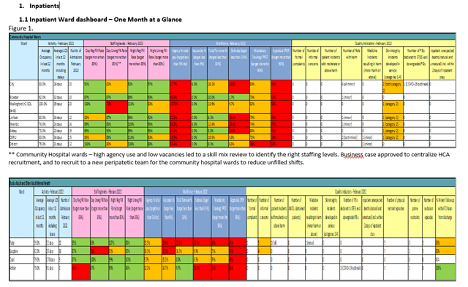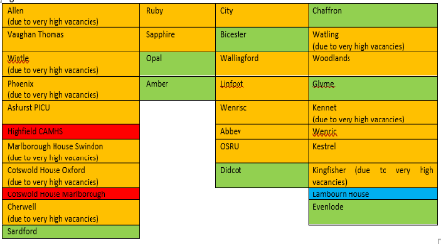

* 1. Dashboard shows a number of key measures relating to activity, workforce and quality reported for teams that are struggling.
  2. Action plan for those teams highlighted as RED

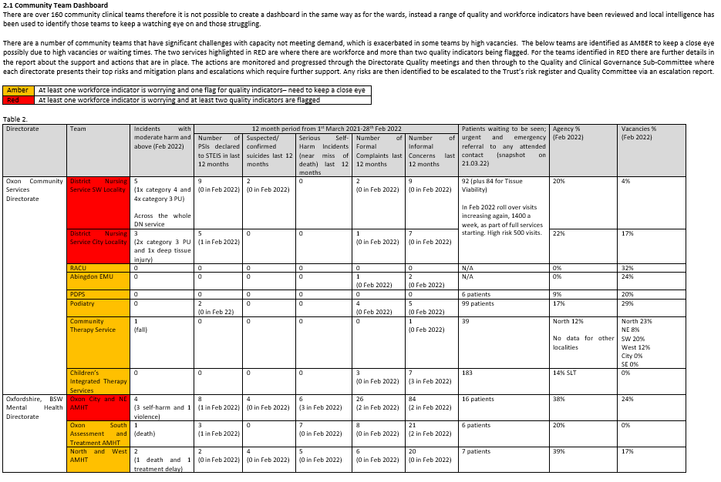

1. **Inpatients**
   1. **Inpatient Ward dashboard – One Month at a Glance**

Note mandatory training, clinical supervision and appraisal compliance are not provided in this report due to recording/ reporting concerns. Deep dives are being completed with services to ascertain reasons for levels of low compliance and any inaccuracies in reporting. The HR systems team is addressing the ongoing problems with the new OTR system. Coordination sheets across the inpatient wards on every shift ensure and check sufficient staff are trained in safety critical courses, such as resuscitation and PEACE, for each shift.

Figure 1.



** Community Hospital wards – high agency use and low vacancies led to a skill mix review to identify the right staffing levels. Business case approved to centralize HCA recruitment, and to recruit to a new peripatetic team for the community hospital wards to reduce unfilled shifts.







* Kestrel ward - clinically the restrictive interventions involving one patient is being sensitively managed at a very senior level by the Clinical Director and through independent reviews of care as well as referral to higher secure services. The CQC have been informed of the care and treatment and concerns surrounding this patient.

* 1. **Ward level Heat Map (based on section 1.1)**

See figure 2, the majority of wards have significant challenges with staffing at times owing to high vacancies and/or sickness, resulting in high use of agency staff and not always being able to fully meet the expected registered/ unregistered skill mix and numbers for each shift. It is important to note that severe staffing issues and high use of agency can impact on quality of care and service delivery. However, not all of the wards have been highlighted as a concern in this report because the impact on quality has been none or minimal, these wards are rated GREEN. Where there are no workforce issues or flags of quality indictors the wards are rated as BLUE. Staffing levels for wards are reviewed at the Weekly Review Meeting chaired by the Deputy Chief Nurse and any issues escalated to the Executive Committee the same day.

Workforce requirements have been mapped out for next 5-7 years for inpatient units, this will support future workforce planning decisions. This workforce tool considers current committed workforce education programmes such as nurse associate training, top up degrees and advanced clinical practice. The funded establishment review has been completed and budgets have been realigned from month 1 in 2022/23 to reflect additional investment for community hospitals and for mental health services, initially this will result in additional nurse vacancies for the inpatient teams. 69 nurses have started through the international recruitment programme which has resulted in zero Band 5 nurse vacancies in community hospitals and 23 agency lines of work being ended. A tender process for an agency guaranteed volume contract will start in August 2022. The agency management workstream has a target of reducing ad hoc agency use by 70% by the end of November and to stop agency grade swaps by the end of June 2023. The e-rostering workstream has a target of improving the overall management of rosters by the end of December.

One ward (Highfield Unit) is highlighted in RED there is a summary below of what support and actions have been put in place. The actions are monitored and progressed through the Directorate Quality meetings and then through to the Quality and Clinical Governance Sub-Committee where each directorate presents their top risks, mitigation plans and escalations which require further support. Any risks are then escalated through the highlight report presented separately to the Quality Committee.

|  |  |
| --- | --- |
| Blue | No serious concerns in staffing or flags for quality indicators |
| Green | Some staffing concerns, no flags for quality indicators |
| Amber | At least one workforce indicator is worrying and one flag for quality indicators– need to keep a close eye |
| Red | At least one workforce indicator is worrying and at least two quality indicators are flagged |

Figure 2.

|  |  |  |  |
| --- | --- | --- | --- |
| Allen | Ruby  (due to very high vacancies) | City | Chaffron |
| Vaughan Thomas | Sapphire | Bicester | Watling |
| Wintle  (due to very high vacancies) | Opal | Wallingford | Woodlands |
| Phoenix | Amber | Linfoot | Glyme |
| Ashurst PICU  (due to very high vacancies) |  | Wenrisc | Kennet |
| Highfield CAMHS |  | Abbey | Wenric |
| Marlborough House Swindon |  | OSRU | Kestrel |
| Cotswold House Oxford  (due to very high vacancies) |  | Didcot | Kingfisher  (due to very high vacancies) |
| Cotswold House Marlborough |  |  | Lambourn House |
| Cherwell |  |  | Evenlode |
| Sandford |  |  |  |

**1.3 Summary of Actions being Taken for Wards Highlighted**

Table 1.

| Directorate | Ward | Team Highlighted in data up to Dec 2021 | Summary of concerns | Actions and Mitigations |
| --- | --- | --- | --- | --- |
| Oxfordshire, BSW Mental Health Directorate | Highfield CAMHS | Yes | * Vacancies high 30%. * Agency use high 20%. * Quality flags: high number of AWOLs and use of restrictive practice. | The senior management team are supporting the ward with managing some very unwell patients. New build for CAMHS PICU beds has started to support managing more unwell patients in a purpose built environment.  Recruitment campaign underway. New roles are being considered to compliment the nursing fill rates. HCA vacancies are being recruited through a coordinated central recruitment project.  Where possible the ward are using the same agency staff on long lines. Work is ongoing to improve quality and reduce agency spend as part of a Trust-wide programme.  A large-scale QI project is in place to reduce the use of restrictive practice, progress is monitored through the Positive and Safe Committee. ​​ |

**2. Community**

**2.1 Community Team Dashboard by exception**

There are over 160 community clinical teams therefore it is not possible to create a dashboard in the same way as for the wards, instead a range of quality and workforce indicators have been reviewed for all teams and local intelligence has been used to identify those teams to keep a watching eye on and those struggling the most.

There are a number of community teams that have significant challenges with capacity not meeting demand, which is exacerbated in some teams by high vacancies. The below teams are identified as GREEN to keep a watching eye on, AMBER for closer oversight due to high vacancies or high waiting times. The two services (District Nursing Service and the City/ NE AMHT in Oxon) highlighted in RED are where there are workforce and more than two quality indicators being flagged. For the teams identified in RED there are further details in the report about the support and actions that are in place. The actions are monitored and progressed through the Directorate Quality meetings and then through to the Quality and Clinical Governance Sub-Committee where each directorate presents their top risks, mitigation plans and escalations which require further support. Any risks are then escalated through the highlight report presented separately to the Quality Committee.

|  |  |
| --- | --- |
| Green | Some staffing concerns, no flags for quality indicators |
| Amber | At least one workforce indicator is worrying and one flag for quality indicators– need to keep a close eye |
| Red | At least one workforce indicator is worrying and at least two quality indicators are flagged |

Table 2.

| Directorate | Team | Trend: did team appear in last Dashboard with data up to Feb 2022? | Quality Indicators | | | | | | | Access | | | Workforce | | |
| --- | --- | --- | --- | --- | --- | --- | --- | --- | --- | --- | --- | --- | --- | --- | --- |
| Incidents with moderate harm or above in month  (April 2022) | Number of PSIs which happened in last 12 months | Suspected/ confirmed suicides in last 12 months | Serious Self-Harm Incidents (near miss of death) in last 12 months | Number of Formal Complaints in last 12 months | Number of Informal Concerns in last 12 months | Activity levels: any exceptional changes in April 2022 compared to average per month in 2019/20 | | Urgent and emergency referrals still waiting to be seen (snapshot on 20.05.22) | Agency Use %  (April 2022) | | Vacancies %  (April 2022) | Sickness  (April 2022) |
| Oxfordshire Primary, Community and Dental Care Services Directorate | District Nursing Service SW Locality | Rated Red in Feb 2022 | 9  (5x pressure ulcers category 3 developed in service, 2x category 4 developed in service and 2x unstageable | 7  (0 in April) | 2 | 0 | 2  (0 in April) | 10 | +9% increase in all referrals compared to monthly average in 2019/20  (2634 referrals this month)  Tissue viability also saw a +762% increase in emergency referrals (with 112 referrals this month) | | Across the service - 110 patients waiting. Most for phlebotomy. | 13% | | 4% | 7.1% |
| District Nursing Service City Locality | Rated Red in Feb 2022 | 5  (3x pressure ulcers category 3 developed in service, 1x category 4 developed in service and 1x unstageable developed in service) | 5  (0 in April) | 1 | 0 | 0 | 7 | 19% | | 17% | 10.9% |
| District Nursing Service North Locality | New | 1  (1x delayed medical equipment) | 1  (0 in April) | 0 | 0 | 2  (0 in April) | 6 |  | | 37% | | 14% | 3.4% |
| RACU | Rated Amber in Feb 2022 | 0 | 0 | 0 | 0 | 0 | 0 |  | | N/A | 0% | | 29% | 6.3% |
| EMU (Abingdon and Witney) | Rated Amber in Feb 2022 | 0 | 0 | 0 | 0 | 2  (0 in April) | 3 |  | | N/A | Abingdon 0%  Witney 0% | | Abingdon 24%  Witney 14% | Abingdon 3.7%  Witney 2.4% |
| PDPS | Rated Amber in Feb 2022 | 0 | 0 | 1 | 0 | 0 | 0 |  | | 6 patients waiting. | 3% | | 12% (reduction) | 2.6% |
| Podiatry | Rated Amber in Feb 2022 | 0 | 2  (0 in April) | 0 | 0 | 4  (0 in April) | 5 |  | | 107 patients waiting. | 12% | | 31% | 8.5% |
| Care Home Support Service | New | 0 | 0 | 0 | 0 | 0 | 1 | +415% increase in appointments  (958 appointments this month) | | 1 patient waiting. | 0% | | 2% | 6% |
| Community Therapy Service | Rated Amber in Feb 2022 | 0 | 0 | 0 | 0 | 0 | 1 | Significant reduction in emergency referrals this month | | 49 patients waiting mostly in the SW Team. | North 6%  No data for other localities | | North 16% (reduction)  NE 12%  SW 12% (reduction)  West 10%  City 0%  SE 0% | North 3.3%  NE 6.7%  SW 7.4%  West 1.3%  City 11%  SE 7.5% |
| Children’s Integrated Therapy Services | Rated Amber in Feb 2022 | 0 | 0 | 0 | 0 | 3  (0 in April) | 12 | +312% increase urgent referrals  (103 referrals this month) | | 198 patients waiting, most for SLT from mainstream schools in the South. | SLT 15% | | 0% | OT 3.4%  Physio 4%  SLT 2% |
| Children’s Community Nursing | New | 0 | 1  (0 in April) | 0 | 0 | 0 | 1 | +185% increase referrals  (57 referrals this month) | | N/A | 0% | | South 22%  West 16%  North 5%  Central 0% | South 8.4%  West 5.9%  North 8.3%  Central 2.9% |
| Adult Speech and Language | New | 0 | 0 | 0 | 0 | 0 | 2 | Significant reduction in appointments this month | | 3 patients waiting. | 0% | | 24% (increased last month) | 2.6% |
| Oxfordshire, BSW Mental Health Directorate | Oxon City and NE AMHT | Rated Red in Feb 2022 | 0 | 8  (0 in April) | 7 | 6 | 28  (4 in April) | 80 |  | | 14 patients waiting. | 22% | | 30% (increased last month) | 4.2% |
| Oxon South Assessment and Treatment AMHT | Rated Amber in Feb 2022 | 2  (both overdoses) | 4  (0 in April) | 3 | 8 | 7  (0 in April) | 24 |  | | 11 patients waiting. | 12% | | 11% | 11.1% |
| North and West AMHT | Rated Amber in Feb 2022 | 1  (prescribing medication) | 2  (0 in April) | 10 (7 patients open at time of death) | 5 | 6  (0 in April) | 25 |  | | 6 patients waiting. | 27% | | 25% (increased last month) | 7.3% |
| Oxon CRHT | New | 1  (self-harm) | 0 | 0 | 5 | 2  (1 in April) | 2 |  | | N/A | 17% | | 20% | 12.2% |
| EIS | New | 0 | 2  (0 in April) | 1 | 0 | 0 | 3 |  | | 1 patient waiting. | 3% | | 19% | 7.9% |
| ADHD and Autism Service | New | 0 | 0 | 0 | 0 | 0 | 4 | +391% increase in routine referrals  (113 referrals this month) | | 1 patient waiting, note this is only urgent referrals. | 35% | | 0% | 6.5% |
| Oxon CAMHS (*20 community sub teams) | Rated Amber in Feb 2022 | 0 | 1  (0 in April) | 2 | 4 | 20*  (0 in April) | 64* | SPA: +606% increase in appointments (240 appointments this month) | | 37 patients waiting. | Medical 47%  South 8%  North 19%  Central 0%  SPA 0%  CRHT 13%  Eating Disorders 16%  Neuro 0% | | Significant Consultant vacancies.  South 29%  North 30%  Central no data  SPA 31%  CRHT 58%  Eating Disorders 30%  Neuro 31% | Medical 0%  South 3.6%  North 5.9%  Central 0%  SPA 1.4%  CRHT 8.5%  Eating Disorders 3.8%  Neuro 0% |
| BSW CAMHS (*11 community sub teams) | Rated Amber in Feb 2022 | 0 | 0 | 3 | 1 | 17*  (2 in April) | 32* | SPA: +16% increase in all referrals (150 referrals this month)  BaNES: +63% increase in appointments (444 appointments this month)  Swindon: Significant reduction in appointments this month  Wiltshire Risk: Significant reduction referrals and appointments this month | | 56 patients waiting. | Medical 46%  BaNES 0%  Swindon 6%  Wiltshire 0% (SPA 11%) | | Significant Consultant vacancies.  BaNES 28% (increased last 3 months)  Swindon 35% (increased last 3 months)  Wiltshire 22% (increased last month) | BaNES 3%  Swindon 4.8%  Wiltshire 6.8%  Medical 0% |
| Oxon Adult Eating Disorder Community Team | Rated Amber in Feb 2022 | 1  (unexpected death) | 1  (0 in April) | 0 | 0 | 2  (0 in April) | 6 |  | | 26 patients waiting. | 22% | | 25% | 0% |
| EDPS | Rated Amber in Feb 2022 | 0 | 1  (0 in April) | 2 | 1 | 2  (0 in April) | 4 |  | | N/A | 28% | | 27% | 5.3% |
| Buckinghamshire Mental Health Directorate | Bucks North CRHT | Rated Amber in Feb 2022 | 0 | 0 | 1 | 0 | 7  (0 in April) | 16 | +182% increase in all appointments  (1127 appointments this month) | | N/A | 17% | | 18% (increased last 3 months) | 8.8% |
| Bucks South CRHT | Rated Amber in Feb 2022 | 0 | 1  (0 in April) | 2 | 0 | 2  (0 in April) | 9 | N/A | 10% | | 26% (reduction) | 7% |
| ADHD and Autism Service | New | 0 | 0 | 0 | 0 | 1  (0 in April) | 4 | +100% increase in referrals and +178% appointments.  (89 appointments this month) | | 0, note this is only urgent referrals. | 36% | | Data not available | 0.9% |
| Bucks CAMHS (*15 community sub teams) | Rated Amber in Feb 2022 | 0 | 2  (0 in April) | 2 | 0 | 10*  (3 in April) | 21* | SPA: +9% increase in appointments  OSCA: +65% increase in appointments  CAMHS LD: Significant reduction in appointments this month | | 9 patients waiting. | Medical 63%  SPA 45%  LD 0%  LAC 0%  OSCA 62%  GMH 35%  Neuro 25%  ED 30% | | Significant Consultant vacancies (40%). Locums in place  SPA 33% (reduction)  LD 37%  LAC 27%  OSCA 50.7%  GMH 20%  Neuro no data  ED no data | Medical 3.1%  SPA 1.3%  LD 1.1%  LAC 0%  OSCA 0.7%  GMH 9.5%  Neuro 1.5%  ED 0.8% |
| Chiltern (South) CMHT | Rated Amber in Feb 2022 | 2  (both unexpected deaths) | 3  (2 in April, both deaths) | 3 | 2 | 8  (2 in April) | 32 |  | | 1 patient waiting. | 51% | | 52% | 4% |
| Aylesbury (North) CMHT | Rated Amber in Feb 2022 | 0 | 1  (0 in April) | 3 | 1 | 7  (1 in April) | 37 |  | | 0 | 35% | | 31% (increased in last 3 months) | 11% |
| Bucks OA South CMHT | Rated Amber in Feb 2022 | 0 | 2  (0 in April) | 1 | 0 | 3  (0 in April) | 8 |  | | 2 patients waiting. | 38% | | 51% | 17% |
| Bucks OA north CMHT | New | 0 | 1  (0 in April) | 0 | 0 | 3  (1 in April) | 4 |  | | 0 | 20% | | 23% (increased last month) | 13.8% |
| Bucks Adult Eating Disorder Community Team | Rated Amber in Feb 2022 | 0 | 0 | 0 | 0 | 0 | 4 |  | | 0 | 53% | | 40% | 0.6% |
| PIRLS | Rated Amber in Feb 2022 | 0 | 0 | 0 | 0 | 0 | 0 |  | | N/A | 11% | | 39.5% | 7.2% |
| Oxfordshire and Buckinghamshire Mental Health Services | Complex Needs Service | Rated Amber in Feb 2022 | 0 | 0 | 1 (Oxon) | 0 | 4 (Bucks)  1 (Oxon) | 7 (Bucks)  6 (Oxon) | Significant reduction in appointments this month | | 0 patients waiting, note this is only urgent referrals. | 0% | | 27% | 6.1% |
| Psychological Therapies | New | Oxon 0  Bucks 1 (self-harm) | 0  (plus 2 for Healthy Minds over the last 12 months) | 1 (Bucks PT, plus additional 5 for Healthy Minds) | 2 (Bucks) | 1 (Bucks)  3 (Oxon) | 3 (Bucks)  10 (Oxon) |  | | 0 patients waiting, note this is only urgent referrals. | Oxon 0%  Bucks 0% | | Oxon 0%  Bucks 12% (reduction) | Oxon 6%  Bucks 4% |
| SCAS and Street Triage | New | 0 | 0 | 2 (1 Bucks and 1 Oxon) | 0 | 1 (Oxon) | 0 | +807% increase in all referrals and +205% appointments  (354 appointments this month) | | N/A | Oxon 13%  Bucks 0% | | Oxon 34% (increased in last 3 months)  Bucks 10% | Oxon 7%  Bucks 28.4% |
| Specialised | LD Intensive Support Team | Rated Amber in Feb 2022 | 0 | 0 | 0 | 0 | 0 | 0 |  | | Data not available | 0% | | 49% | 1.1% |
| LD South Community Team | New | 0 | 0 | 0 | 0 | 0 | 0 |  | | Data not available | 3% | | 32% | 2.3% |

**2.2 Summary of Actions being Taken for Community Teams Highlighted**

Table 3.

| Directorate | Team | Team Highlighted in data up to April 2022 | Summary of concerns | Actions and Mitigations |
| --- | --- | --- | --- | --- |
| Oxfordshire Primary, Community and Dental Care Services Directorate | District Nursing Service – particularly City and SW Teams | Yes identified from Aug 2021 | * There is a continued mismatch between capacity and workload across the service. We have also seen an increase in activity levels. * High vacancies, agency staff are being used. * A high number of visits are having to be rolled over each day resulting in patients waiting for treatment and delayed packages of care. Around 1000 patients a week, of which 500 are to see high risk patients. * Incidents with harm and PSIs are high, particularly in the SW and City Localities. * Thematic reviews are identifying gaps around; capacity, staff morale, poor functioning of IT, ability to carry out holistic care and care agency provision to support treatment plans. | The District Nursing Service has been under significant pressure from August 2021 due to increased demand combined with patients having greater and more complex care needs, and the service having staffing challenges.  The pressures on the community nursing service have started to improve more recently, however there is still insufficient capacity in the service to meet demand. Discussions continue with GPs and commissioners about phlebotomy provision which varies across the county and takes nurses away from other patient care such as wound care.  Plans are in place for each team with mitigations and actions to reduce the potential for harm to patients, and workload pressure is managed through a daily countywide capacity planning call.  The key actions being taken have been reported in previous reports and continue, particularly with a focus on recruitment and retention. We are also having regular conversations with the CCG and GP to manage workload and to identify any funding gaps.  In relation to reducing pressure ulcers there is a separate improvement plan overseen by the Pressure Ulcer Steering Group. |
| Oxfordshire, BSW Mental Health Directorate | Oxon City and North East AMHT | Yes identified from July 2021 | * High staff vacancies (30%) which are continuing to rise. Resulting in in a high use of agency staff (22%). * Complaints and concerns remain high. * High PSIs (8 PSIs in 12 months). | An improvement plan is in place with internal review meetings, as well as meetings with our commissioner for support. Regular communication is also happening with system partners. Due to significant capacity issues the caseload is being closely managed with increased oversight.  One of the sub-teams has seen a reduction in pressure following focused work however the vacancy rate remains high. Our focus is on recruitment and retention. |