**MEMBERS & FRIENDS**

**SUPPORT FOR FAMILY**

**PSYCHOEDUCATIONAL WEEKENDS**

**OFAFE SUPPORT GROUP**

**When:**

The group meets fortnightly on Wednesdays from 4.30pm-6.30pm **[NB. during the Covid-19 pandemic, this has changed to Wednesdays 4.30-6.30pm on a 4 weekly cycle over Zoom – please contact us to see if this has reverted back to the fortnightly meetings in Manzil Way]**

**Where:**

Complex Needs Service, Entrance No.2, Manzil Way Resource Centre, off Manzil Way, Cowley, Oxford, OX4 1XE

*(Unfortunately there is no parking on site although there are a limited number of nearby 2 and 3 hour parking bays, and a pay and display car park off Union Street which is a five minute walk away, off Cowley Road at OX4 1JP)*

**Contact:**

If you would like to attend the OFAFE group, please call us on the number below to discuss whether this group is suitable for you:

(tel) 01865 904 300

(email) ofafe@oxfordhealth.nhs.uk

OFAFE

The OFAFE Psychoeducational Weekend offers a series of seminars and workshops on a variety of topics such as:

·  A clinical overview of Personality Disorders (including prevalence, contributing develop-mental factors, and diagnostic categories).

·  The setting and maintaining of inter-personal boundaries

·  Supporting someone with self-harm and suicidal behaviour

·  Issues of medication and personality disorder

·  The Drama Triangle and Co-Dependency

·  Coping strategies for carers

The weekend aims to provide a balance of informed teaching and open discussion, whilst promoting a space for supporting one another.

The weekends take place once or twice a year at the Complex Needs Service (details overleaf) from 10.30am – 4.00pm on a Saturday and a Sunday. Please get in contact if you would like to find out when the next weekend is scheduled to take place.

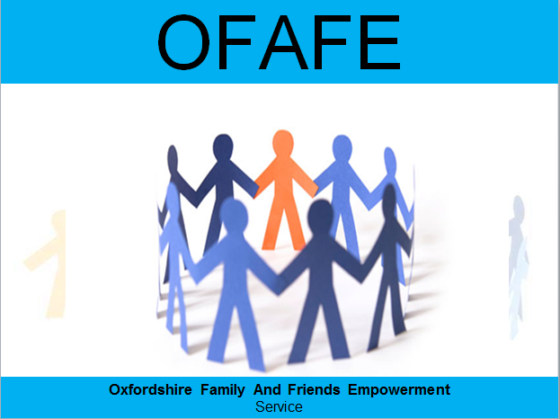

The Oxfordshire Family & Friends Empowerment service

**A group for friends or family members who offer support to someone with long-standing and complex emotional needs (which may have led to a diagnosis of a personality disorder)**



**Complex Needs Service**

Attending the group

Confidentiality



The OFAFE Group is completely confidential and whatever is spoken about in the group remains in the group.

If you are supporting someone who is attending the Complex Needs Service, the content of their therapy groups will not be shared with you and nor will the content of the OFAFE Group be shared with them.

Your confidentiality would only ever be breached if you shared something which clearly indicates that someone is at risk of very significant harm. In the unlikely event of this situation occurring, the group facilitators would discuss this with you in the very first instance.

Other than supporting someone with complex emotional needs, there is no other criterion for attending the group.

The group welcomes individuals who are able to attend on a regular basis, as well as those who are only able to attend occasionally.

If you are interested in attending, please contact the OFAFE Group facilitator using the contact details on the back of this leaflet. We will get back to you in order to have a brief discussion about the group and whether it is appropriate for your situation.

The OFAFE Group will occasionally forgo the normal agenda and have a ‘psychoeducational’ session. There will be a short presentation on a relevant topic (such as co-dependency, self-harm, maintaining boundaries, etc.) which will then lead to an open discussion in the group.

Educational sessions

What happens in the group?

Each OFAFE Group meeting follows an agenda and is facilitated by clinicians from the Complex Needs Service and Rethink. After an initial welcome, each group member is given the opportunity to provide an update on their current situation (if they wish to).

For those who choose to discuss their situation in more depth, there is the opportunity to receive support from others in the group. This may take the form of asking questions (so the group has a better understanding of what someone is going through), and it may also include suggestions and advice if appropriate.

The OFAFE Group is a ‘support group’ rather than a ‘therapy group’. Members of the group often comment that it is useful to hear other people’s experiences and coping strategies, and that it can be very helpful to realise you’re not alone in your struggles.

The group often emphasizes the importance of setting and maintaining your own boundaries—both to ensure your own well-being, but also to encourage the person you are supporting to take increasing responsibility for their own life.

Supporting someone with complex emotional needs can often be a lonely and challenging experience.

The OFAFE Group provides a confidential and supportive space where you can discuss your situation and receive support and advice from others who are going through similar experiences.

The group is aimed at family members or friends who are supporting someone with complex emotional needs. In some cases, these needs might have led to a diagnosis of a personality disorder. Typically, one or more of the following behaviours might be evident:

·  Unpredictable and quickly fluctuating moods

·  Unstable (and often intense) pattern of inter-personal relationships

·  On-going symptoms of depression and/or anxiety

·  Self-harm (e.g. cutting or burning)

·  Suicidal thoughts (including suicidal attempts)

·  Unpredictable and impulsive behaviours

·  Misuse of alcohol or illicit or prescribed drugs

·  Unhealthy and dysfunctional relationship with food and eating

The friend or family member you are supporting may be involved with the Complex Needs Service, but this is not a requirement of attending the group.

Who is the group for?