Oxford Health NHS Foundation Trust
Trust Headquarters
Littlemore Mental Health Centre
Sandford Road
Littlemore
Oxford
OX4 4XN
Switchboard 01865 901 000
Email enquiries@oxfordhealth.nhs.uk
Website www.oxfordhealth.nhs.uk

Adult Mental Health Teams
Become a member of our Foundation Trust
www.ohftnhs.uk/membership
If you would like to have information translated into a different language, please contact the Equality and Diversity Team at: EqualityandInclusion@oxfordhealth.nhs.uk

Oxford Health NHS Foundation Trust – Caring, Safe and Excellent
What is Cognitive Behavioural Therapy?
Psychological Therapies

What is Cognitive Behavioural Therapy
Psychological Therapies
Adult Mental Health Teams
Cognitive Behavioural Therapy (CBT) views problems as arising from beliefs and patterns of behaviour which are learnt during your life. CBT looks at unhelpful thoughts, emotions and behaviours and aims to overcome problems arising from them by focusing on the ‘here and now’ and exploring the cycles and patterns of behaviour that keep a problem going. CBT also explores underlying belief systems and how these maintain the unhelpful behaviour cycles.
This is a collaborative type of therapy, where you and your therapist are seen as equals and negotiate the main focus of the work between you. Engaging in CBT will help you to understand and challenge behavioural patterns and recurring cycles in order to change them and alter the way you think, feel, behave and respond in different situations.

What does CBT say about what keeps problems going?
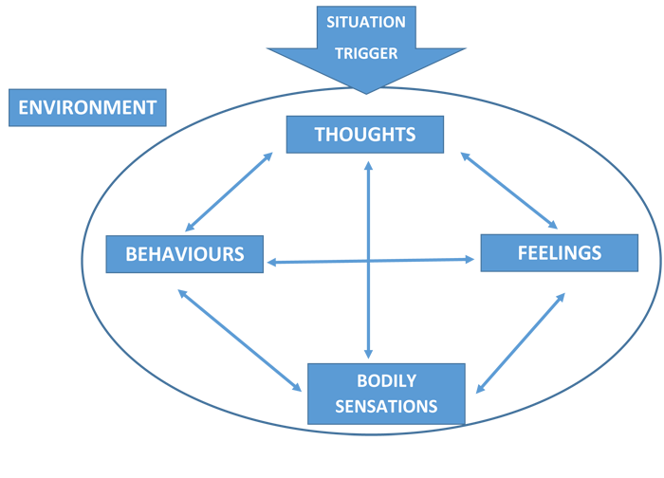
We all have beliefs about ourselves and others, and rules that we live our lives by. For example, you might have the rule, “unless I do things perfectly, I am no good”. Often these rules do not cause you too much difficulty unless something happens to break one or more of them.
Sometimes, a change in your circumstances or relationships can lead you into thinking and behaving in ways that are not helpful, and that can make you feel troubled or depressed. Similarly, if you are anxious you may worry a lot about meeting people; thinking everyone will dislike you or be bored by you. Such thoughts will tend to make you feel more anxious and lead you to avoid social situations.
CBT sees negative thoughts and behaviour patterns as crucial in keeping your problems going. For instance, if you are depressed you might be constantly plagued by thoughts about how useless you are. These thoughts then make it hard for you to try to do things because you feel defeated before you start. This is likely to feed into more negative thinking, making you feel worse, and leading to a vicious cycle.
The CBT approach to overcoming problems
Whilst it may sometimes be important to understand what caused your problems, CBT therapists usually approach problems initially by gaining an understanding of the ‘here-and-now’ negative cycles of your thinking and behaviour.
You will be helped to make practical changes to break the negative cycles. For example, learning ways to question your negative thoughts so that you can think in ways that are more balanced and helpful. You will also learn how to change your behaviour so that you gain more control over the symptoms that bother you.
Once you have made some progress with these changes, you will be helped to work towards re-thinking life rules and beliefs that are unhelpful and which may have contributed to you feeling vulnerable. The overall aim would be to reduce your risk of having similar problems in future, enabling you to lead a more fulfilling life.

What can I expect when I’m in therapy?
Psychological Therapies
Adult Mental Health Teams
CBT is not a treatment that can be done to you. It is something you do, with help from your therapist. Sessions will usually last between 30 and 60 minutes, probably once a week to start with. Often, an initial period of 4 or 5 sessions will be offered to enable you to see whether this kind of treatment suits you.
During therapy sessions you are expected to be an active and equal partner. CBT therapists are also quite active and talkative compared to other types of therapy. They will ask questions, try to help you to clarify ideas and options, and sometimes make specific suggestions about ways you might try to tackle your problems.
You will be expected to be open and honest in communicating any doubts or difficulties you may have with your therapy. These are very common but can only be tackled if you are able to talk about them.
You will also be expected to avoid actions that interfere with being able to think clearly, such as using drugs or drinking too much alcohol.
The work tends to be time-limited, with agreed goals set at the start of therapy. Each session is structured, and your therapist will discuss with you how best to use the time. You will look at specific issues in detail, working out new coping methods or exploring negative thoughts. Each session finishes with a plan for what you can do before the next session.
Because CBT is partly about learning practical coping skills, it is important that you continue to work on your treatment between sessions. Your therapist will agree tasks with you, such as keeping notes of what happens, practicing particular coping skills or trying out new ways of tackling problems.
We know that people who complete their tasks between sessions tend to gain most from their therapy.

What are the likely results of my CBT?
CBT is one of the best researched forms of therapy, and the evidence shows that typically two thirds or more of people who have CBT gain significant benefit from it. The exact benefits will of course depend on the individual and the nature of their difficulties.

Patient Feedback
“ ….”

