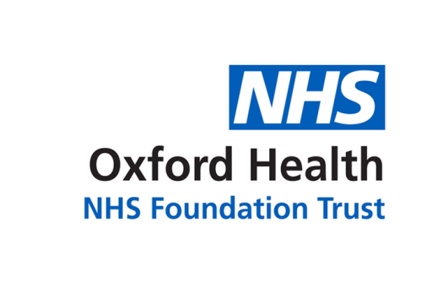

# Report to the Meeting of the

# Oxford Health NHS Foundation Trust

**BOD 03/2023**

(Agenda item: 5)

# Board of Directors

**25 January 2023**

**Trust Chair’s report and system update**

**For: Information/ Discussion**

**Executive Summary**

This privileged slot allows me to give you a flavour of my activities in recent weeks and make some observations, as our Chief Executive reports on the pressing issues of the day, including of course industrial action and pressure on our services.

I recently met the chair of South London and Maudsley NHS FT, Sir Norman Lamb, who had been a health minister in the David Cameron austerity government. He is a passionate advocate of deinstitutionalisation, shorthand for concerted moves further to reduce numbers admitted to acute mental hospitals and are treated instead either at home or in community hubs, offering very short-term admission. His is a compelling vision, founded on a negative – mental health hospitals can fall short as therapeutic environments – and a positive, that recovery is more likely amid friends, family and home.

But advocacy, however sincere, carries risks. One is that it neglects or pays insufficient attention to expertise, especially the accumulated wisdom of clinicians, the nurses, allied health professionals and doctors. The other is that it can sound like hectoring, in a context where persuasion is necessary. Invoking the ‘community’ means thinking well beyond the traditional boundaries of the NHS. We do not build accommodation at affordable rents, adapt flats to the needs of patients, provide advice about jobs or at least we do not do much of that. As for income support for people with disabilities and a grants regime that would underpin community functions, that is high politics.

Whatever our views about deinstitutionalisation, we are already committed to a new push to localise mental health services. That will require us, the Board of Oxford Health NHS FT, to pay even more attention to ‘place’. It is a new mantra which has recently acquired institutional form through the creation of ‘place directors’ under the Integrated Care Board for Buckinghamshire, Oxfordshire and Berkshire West. I come away from recent conversation with the place directors for Oxon and Bucks struck by their focus not on secondary let alone tertiary health care (what happens in hospitals) but on primary care and how we connect better with gaps. There is lots more to say here; in short, the Board probably needs to spend a lot more time thinking about place and focusing on the principal pathway that our patients are on, starting with and staying with gaps.

The University of Oxford has a new Vice-Chancellor, Professor Irene Tracey, who comes to the role of Warden of Merton College. I was pleased to represent the Trust at a reception to mark her inauguration and record her enthusiasm to work more closely with us, both in mind and brain research and in healthcare for the staff and students of the university. On a negative note, I was dismayed to meet some senior members of the staff of the university who still do not distinguish the Trust from our neighbours at Oxford University Hospitals NHS FT. What is in a name, you might ask. It matters if in not recognising Oxford Health’s separate existence, people downgrade our work in mental health and community services.

What is in a name – the NHS has rightly decided that the clunky title of the services we offer those with depression, anxiety and similar conditions (Improved Access to Psychological Services) should be replaced with something a bit more intelligible. It is to be called NHS Talking Therapies. That is a clear description of what John Pimm in Bucks and colleagues in Talking Space in Oxfordshire provide.

**Recommendation**

The Board is asked to note the report

**Author and Title: David Walker, Trust Chair**

1. *A risk assessment has been undertaken around the legal issues that this report presents and there are no issues that need to be referred to the Trust Solicitors*
2. ***Strategic Objectives/Priorities*** *– this report relates to the following Strategic Objective(s)/Priority(ies) of the Trust:*

*1) Quality - Deliver the best possible care and health outcomes*

*Strategic risk themes: triangulating data and learning to drive Quality Improvement; Demand and Capacity (Mental Health inpatient and Learning Disabilities); and Demand and Capacity (Community Oxfordshire).*

*3) Sustainability – Make best use of our resources and protect the environment*

*Strategic risk themes: planning and decision-making at System and Place level and collaborative working with Partners; governance of external Partners; Financial Sustainability; Governance and decision-making arrangements; Business Planning; Information Governance & Cyber Security; Single Data Centre; Business Continuity and Emergency Planning; Environmental Impact; and Major Capital Projects.*

*4) Research and Education – Become a leader in healthcare research and education*

*Strategic risk themes: failure to realise Research and Development potential.*