Report to the Meeting of the

Oxford Health NHS Foundation Trust
BOD 10/2023
(Agenda item: 12)

Board of Directors

25th January 2023

Patient Safety Incidents reported November and December 2022
For: Assurance

Executive Summary
It is crucial that we learn from every incident and near miss that happens to identify and address system issues to continually improve the safety of care.

The report focuses on the period November and December 2022 following on from the last report. 11 Patient Safety Incidents (PSI) have been identified:
- 4 suspected suicides in the community
- 1 delay in treatment (GP out of hours service)
- 2 medication errors
- 3 pressure ulcers (all on community hospital wards)
- 1 child death from Strep A infection (GP out of hours service).

The report shares the reporting of PSIs over the past 5 years and summaries the recent improvement areas and safety actions being taken.

Governance Route/Escalation Process
Every Patient Safety Incident (PSI) is investigated which includes the involvement of patients/ families and those staff involved in the incident. A report is then scrutinised at an internal PSI panel by senior clinicians which is shared with clinical teams for learning and the patient/ family members involved. The report is then presented to the relevant commissioner (now the ICB) for review and closure. This process has executive director oversight via the CMO and the CNO.

There are a number of weekly and monthly forums and different methods used to share learning across the Trust to focus on our key areas for improvement.

Recommendation
For the Board to be assured regarding the current management and learning from PSI’s.

Author and Title: Victoria Harte, Patient Safety Service Manager
Jane Kershaw, Head of Quality Governance

Lead Executive Director: Marie Crofts, Chief Nurse
- A risk assessment has been undertaken around the legal issues that this report presents and [there are no issues that need to be referred to the Trust Solicitors]
- Strategic Objectives/Priorities – this report relates to or provides assurance and evidence against the following Strategic Objective(s)/Priority(ies) of the Trust):
1) Quality - Deliver the best possible clinical care and health outcomes

- Patient Safety Incidents reported
Following the last report in November there were 11 PSI investigations reported to STEIS (national system) in November and December 2022:
- 4 suspected suicides in the community
- 1 delay in treatment (GP out of hours service)
- 2 medication errors
- 3 pressure ulcers (all on community hospital wards)
- 1 child death from Strep A infection (GP out of hours service).

The graphs below represent PSI reporting over the past 5 years. The higher than usual figures in 2020/21 and 2021/22 relate to COVID-19 inpatient infection outbreaks. The amount of serious pressure ulcer damage with learning identified in 2022/23 has slightly reduced, so all incidents with category 3 and 4 ulcer damage have been reviewed by the Head of Nursing.

There are a number of weekly and monthly forums and different methods used to share learning across the Trust to focus on our key areas for improvement. We also continue to monitor regional and national trends in terms of suicide rates and work towards reducing suicides.

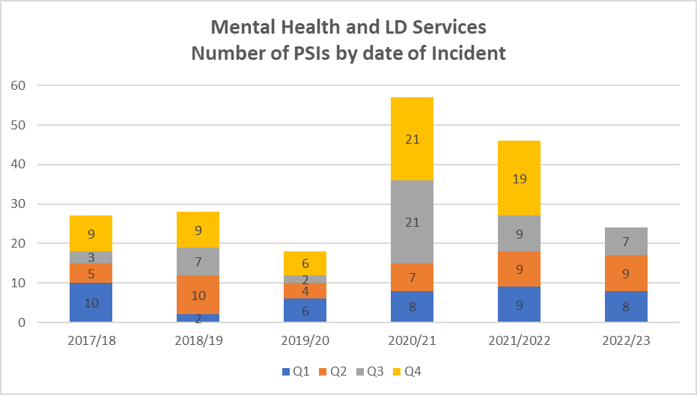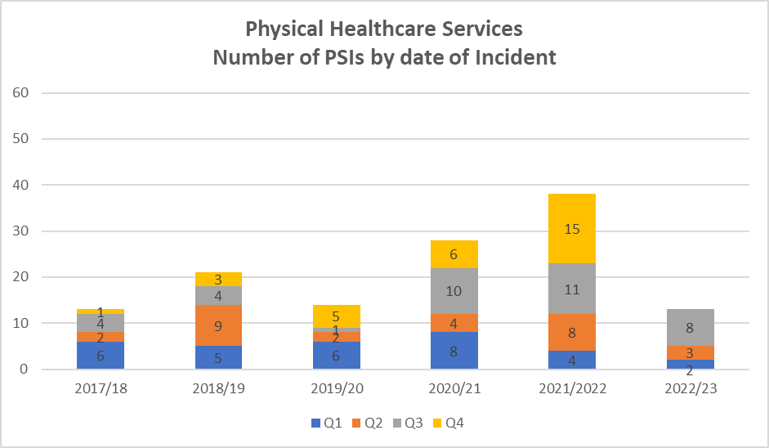

2.0 Completed Investigations and Learning
We use a systems-based investigation approach to identify and act on learning. The actions from the PSI investigations completed in November and December are shared below:

Improvement Area | Action
Joint working with police where risks are known, such as weapons. | For risk situations especially where weapons are involved mental health teams are to consider requesting support to undertake a joint visit with the local Police by calling 101. Additionally raise awareness across clinical teams of the internal panels available to discuss/review high risk and complex cases both within Oxford Health and led by the local Police.
Clear documentation of clinical discussion and decisions in patient record. | Share example and learning across Directorate via local leadership meeting, and Ops and Governance meeting.
How to escalate when out of areas placements are declined, and pharmacy guidance of how to obtain and transfer medication out of hours for duty managers. | Duty managers guidance for both mental health Directorates to be updated to include escalation process and pharmacy advice. Then disseminate to all duty managers and discuss at next duty managers meeting.

The themes identified from previous investigations continue to be progressed through QI work – the two main areas being:
- Communication and involvement of family members during care (mental health)
- Risk assessment and formulation including documentation (mental health)

