Report to the Meeting of the

Oxford Health NHS Foundation Trust
BOD 17/2023
(Agenda item: 9(a))

Board of Directors

29th March 2023

Integrated Performance Report (IPR)
For: Information & Assurance

Executive Summary

The Integrated Performance Report (IPR) report provides the Board of Directors with an integrated view of the strategic domains of Operational Performance, Quality, People, Finance and Research & Education.

IPR - Performance Summary

- Delivery of the NHS National Oversight Framework

The Trust continues to perform well against the targeted metrics with the exception of Inappropriate OAPs bed days used.

The Trust used 168 inappropriate OAP Bed days in February 2023 (67 inappropriate OAP bed days in Bucks, and 101 inappropriate OAP bed days in Oxon).

This is an improvement following directorate focus on reducing the use of OAPs to improve the quality of patient care and improve cost control.

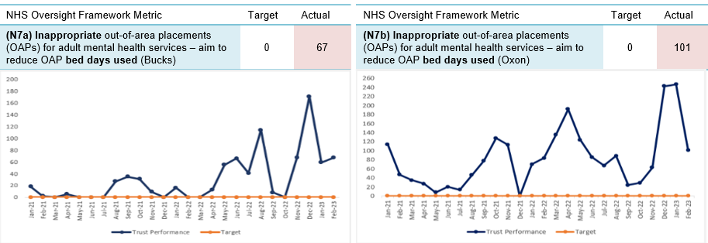

- Delivery of strategic objectives (Objective Key Results (OKRs)

The Trust has 32 OKR. 21 of the OKRs have targets attached to them

- Quality – 18 OKRs (8 have targets)
- People - 9 OKRs (8 have targets)
- Sustainability - 5 (all have targets)

The Trust is achieving 29% (6 out of 21) of its OKRs. The table below provides an overview of the 15 OKRs that are currently not achieving target, their performance compared to last month and the trend (I.e. whether performance is improving or worsening)

Strategic objective | OKR | Target | Last month’s performance unless stated otherwise | This month’s performance unless stated otherwise | Status/  Trend
Quality | Clinical supervision compliance | 95% | 57.8% | 57% | è
Quality | Reduction in use of prone restraint | 208 YE | Not known due to change in reporting approach | 258 YTD
Quality | Patient safety partners employed | 2 YE | 0 | 0 | è
Quality | Lester Tool completion in the community | 75% |  | 64% (July*) | Current status not known
Quality | Lester Tool completion in the EIP service | 90% |  | 80.5% (July*) | Current status not known
Quality | Evidence patients have been involved in their care plans | 95% | 83% (June performance) | 80% (December) | ê
People | Reduce agency usage to NHSE/I target | <10.2% | 12.4% | 11.3% | ê
People | Staff sickness | <3.5% | 5.5% | 5.4% | ê
People | Reduction in turnover | <10% | 16.4% | 16.4% | è
People | Reduction in early turnover | <10% | 19.5% | 19.4% | ê
People | Reduction in vacancies | <9% | 13.7% | 11.7% | ê
People | Personal Development Review (PDR) compliance | 95% | 44.5% | 46.3% | é
People | PPST compliance | 95% | 84.8% | 85.2% | é
Sustainability | Delivery of cost improvement plan | £- | £1.7m adverse | £1.9m adverse | ê
Sustainability | Achievement of all 8 targeted NOF measures | 8 | 2 not achieved (OAPs) | 2 not achieved (OAPs) | è
Please see the report for further information and plans to address.
* latest available due to clinical systems outage and need to recover reporting

Patient Activity and Demand:

Activity and demand are usually reported in the IPR supporting report, however, as a result of the National clinical systems outage, data is not available in usual formats. The Trust has contracted with a third-party supplier to accelerate the work to refresh and reinstate the operational reporting that would normally be presented within this section of the report.

In the interim the Performance & Information team are developing reports on basic headline information recorded on the newly implemented clinical information systems. We anticipate that some headline information will be available for the next board meeting.

Recommendation

The Board of Directors are asked to note the contents of this report and provide further feedback for continuous development.

Author and Title: Claire Page
Head of Performance and Information

Lead Executive Director: Amélie Bages
Executive Director – Strategy & Partnerships

