Report to the Meeting of the

Oxford Health NHS Foundation Trust
BOD 32/2023
(Agenda item: 11(a))

Board of Directors

24 May 2023

Integrated Performance Report (IPR)
For: Information & Assurance

Executive Summary

The Integrated Performance Report (IPR) report provides the Board of Directors with an integrated view of the strategic domains of Operational Performance, Quality, People, Finance and Research & Education.

IPR - Performance Summary

- Delivery of the NHS National Oversight Framework

The Trust continues to perform well against the targeted metrics with the exception of Inappropriate OAPs bed days used.

The Trust used 125 inappropriate OAP Bed days in April 2023 (35 inappropriate OAP bed days in Bucks, and 90 inappropriate OAP bed days in Oxon).

This is an improvement following directorate focus on reducing the use of OAPs to improve the quality of patient care and improve cost control.

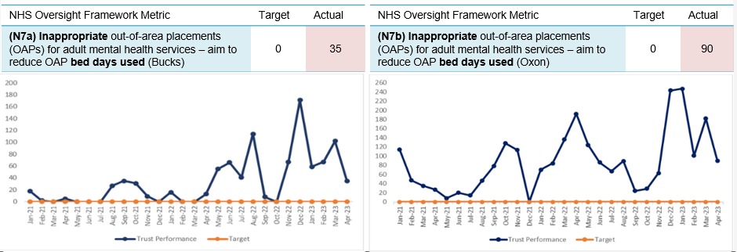

- Delivery of strategic objectives (Objective Key Results (OKRs)

The Trust has 32 OKRs. 22 of the OKRs have targets attached to them

- Quality – 18 OKRs (9 have targets)
- People - 9 OKRs (8 have targets)
- Sustainability - 5 (all have targets)

The Trust is achieving 32% (7 out of 22) of its OKRs. The table below provides an overview of the 15 OKRs that are currently not achieving target, their performance compared to last month and the trend (I.e. whether performance is improving or worsening)

Strategic objective | OKR | Target | Last month’s performance unless stated otherwise | This month’s performance unless stated otherwise | Status/  Trend
Quality | Clinical supervision compliance | 95% | 57% | 59.6% | é
Quality | Reduction in use of prone restraint | 156 YE (208 22/34 target minus 25%) | Start of new year | 16 YTD
Quality | Patient safety partners employed | 2 YE | 0 | 0 | è
Quality | Lester Tool completion in the community | 75% |  | 64% (July*) | Current status not known
Quality | Lester Tool completion in the EIP service | 90% |  | 80.5% (July*) | Current status not known
Quality | Evidence patients have been involved in their care plans | 95% | 83% (June performance) | 80% (December) | ê
People | Staff sickness | <3.5% | 5.4% | 4.5% | ê
People | Reduction in turnover | <10% | 16.4% | 16.3% | è
People | Reduction in early turnover | <10% | 19.4% | 19.7% | è
People | Reduction in vacancies | <9% | 11.7% | 12.7% | é
People | Personal Development Review (PDR) compliance | 95% | 46.3% | 11.8% | Start of new reporting year (reset)
People | PPST compliance | 95% | 85.2% | 86.4% | é
Sustainability | Delivery of cost improvement plan | £- |  | £0.2m adverse | Start of new reporting year
Sustainability | Favourable performance against financial plan |  |  | £0.2m adverse | Start of new reporting year
Sustainability | Achievement of all 8 targeted NOF measures | 8 | 2 not achieved (OAPs) | 2 not achieved (OAPs) | è
Please see the report for further information and plans to address.
* latest available due to clinical systems outage and need to recover reporting

Patient Activity and Demand and Recovery of Reporting:

Activity and demand is usually reported in the IPR supporting report, however, as a result of the National clinical systems outage, data is not available in usual formats.

The Trust has initiated a project working with a third party (Concept Analytics) to support the recovery of reporting. The project runs from mid-May 2023 until January 2024, with some key reports made available to operational services from May onwards. Our priority remains to enable prompt recovery of our reports to support the work of our teams whilst ensuring that robust processes are put in place when restarting automated data reporting from the Trust’s data warehouse. A more detailed timeframe for this recovery work will be available by the end of May and shared.
The recovery work will report on the data available. However, the Trust has, and will continue to have, gaps in its data for two reasons;

- Data gap 1: The clinical systems outage due to the cyber attack. Between August – December 2022 for majority of services using Carenotes prior to outage and between August 2022 – July 2023 for Community Hospitals, Hospital @ Home, RACU and EMU services.

- Data gap 2: Reduced functionality of the new systems; RIO and EMIS, due to the pace at which they needed to be implemented. This means that some data cannot be entered and therefore will not be available for reporting and analysis purposes

Further updates will be shared with this Board outlining the impact of the gaps on reporting and where possible, planned mitigations

Recommendation

The Board of Directors are asked to note the contents of this report and provide further feedback for continuous development.

Author and Title: Nic McDonald
Head of Business Intelligence

Lead Executive Director: Amélie Bages
Executive Director – Strategy & Partnerships

