Report to the Meeting of the
Oxford Health NHS Foundation Trust

Quality Committee
RR-App 10/2023
(Agenda item: 26)

9th February 2023

Quality and Safety Dashboard
For Information and Assurance

Executive Summary
This report provides a summary of the key escalations from the Quality and Safety Dashboard as of 31st December 2022.

From reviewing a range of quality and workforce (vacancies, turnover, agency use, sickness) indicators the below wards and community teams are highlighted by exception as flagging with an area of concern based on position in December 2022 and trend over the last 3 months. Data on activity indicators such as bed occupancy, referrals and waiting times have been unavailable since August 2022 but will be reintroduced when possible.

The accompanying excel sheet provides the full dashboard for ease of viewing with a tab for the 33 wards and a tab for the community teams. The monthly inpatient staff fill rates are included in the information, although further work is needed to validate the accuracy as this often differs to the daily SITREP on staffing levels. The presentation for the community teams dashboard is different to the wards because of the number of teams, so it is by exception.

The highlighted wards/teams have been split into 2 groups; to keep a watching eye and alert status. A watching eye means the area has workforce challenges such as vacancies and 1 quality indicator flagging, whereas alert status means the areas has workforce challenges and at least 2 quality indicators flagging. The teams/wards highlighted in the last dashboard at alert status are shown in blue text.

Highlighted wards/teams by exception:

 | Alert Status | Keep a Watching eye
Community Teams | - District Nursing teams  - GP OOH  - Bucks OA South CMHT  - Oxon City and NE AMHT | - Oxon North & West AMHT  - Oxon South AMHT  - Oxon Children’s Integrated Therapies
Inpatient Wards | - VT  - Phoenix  - Sapphire | - Allen  - Wintle  - Ashurst  - Cherwell  - Ruby  - Abbey  - Woodlands  - Glyme  - Kestrel  - Kingfisher

The report includes further detail about each of the wards/teams at ‘alert status’ and the mitigations and actions being taken.

In addition, to the teams/wards highlighted above there are a number of areas with high vacancies although none of the key quality indicators are flagging. These teams are listed below to show a complete picture. The Trust has an improvement programme of work called ‘Improving Quality, Reducing Agency use’ which has eight workstreams, each implementing a number of Trust-wide recruitment initiatives. In addition each month the wards and teams with the highest vacancies are discussed with the HR recruitment campaign consultants.

Areas with High Vacancies - 30% or above but no quality indicators are flagging
- LD intensive support team 43% vacancies decline from Nov
- Oxon Street Triage 31% vacancies decline from Nov.
- Oxon Adult Eating Disorder community non-medics 32% decline from Nov and medics 31% decline.
- Wiltshire Adult Eating Disorder non-medics 45% improved from Nov.
- Bucks Adult Eating Disorder non-medics 40% similar to Nov and medics high.
- Oxon Talking Space Plus 30% decline from Nov.
- Oxon CAMHS specialist teams - Fass 43% vacancies similar to Nov and forensic 57% similar to Nov.
- Oxon CAMHS getting more help south 39% vacancies similar to Nov. Oxon CAMHS Crisis 47% improved from Nov.
- Banes CAMHS community 30% slightly improved from Nov. Wiltshire SPA 33% similar to Nov. BSW Inreach 59% improved from Nov.
- Bucks Aylesbury CRHT 31% decline from Nov.
- Bucks Adult Chiltern/South CMHT 36% decline from Nov.
- Bucks PIRLS 40% similar to Nov.
- Bucks CAMHS medic 47% same as Nov.
- Bucks OA CMHT medic 35% decline from Nov.
- Kennet ward 33%

Governance Route/Approval Process
The Dashboard is a regular paper, developed with input from the Clinical Directorates and was presented to the Quality and Clinical Governance Sub-Committee on 31st January 2023.

Statutory or Regulatory responsibilities
We are required to report on the inpatient staff fill rates to Trust Board members which has been delegated to the Quality Committee. This information is included in the inpatient dashboard.

Recommendation
The Committee is asked to note the report and the actions being taken to support the teams highlighted.

Author and title: Jane Kershaw, Head of Quality Governance
Lead Executive Director: Marie Crofts, Chief Nurse

- A risk assessment has been undertaken around the legal issues that this report presents and there are no issues that need to be referred to the Trust Solicitors.

- Strategic Objectives/Priorities and strategic Board Assurance Framework (BAF) risk themes - this report relates to, or provides assurance and evidence against, the following Strategic Objective(s)/Priority(ies) of the Trust;

Quality - Deliver the best possible clinical care and health outcomes
Strategic risk themes: Triangulating data and learning to drive Quality Improvement (QI); Unavailability of beds/demand and capacity (Mental Health inpatient and LD); and demand and capacity (Community Oxfordshire).

- This report satisfies or provides assurance and evidence against the requirements of the following Terms of Reference of the Quality Committee;

- to oversee the effective development of the Trust’s corporate and clinical governance arrangements;

- to ensure that there is an objective and systematic approach to the identification and assessment of risk and delivery of the organisation’s priorities in the context of all national standards;

- to ensure effective interfaces between the quality sub-committees and the co-ordination of risk management processes across the Trust, both clinical and non-clinical;

1. Introduction
This report provides a summary of the key escalations from the Quality and Safety Dashboard as of 31st December 2022.

From reviewing a range of quality and workforce (vacancies, turnover, agency use, sickness) indicators the below wards and community teams are highlighted by exception as flagging with an area of concern based on position in December 2022 and trend over the last 3 months. Data on activity indicators such as bed occupancy, referrals and waiting times have been unavailable since August 2022 but will be reintroduced when possible.

The accompanying excel sheet provides the full dashboard.

The following wards/teams have been highlighted, split into 2 groups; to keep a watching eye and alert status. A watching eye means the area has workforce challenges such as vacancies and 1 quality indicator flagging, whereas alert status means the areas has workforce challenges and at least 2 quality indicators flagging. The teams/wards highlighted in the last dashboard at alert status are shown in blue text.

Highlighted wards/teams by exception:

 | Alert Status | Keep a Watching eye
Community Teams | - District Nursing teams  - GP OOH  - Bucks OA South CMHT  - Oxon City and NE AMHT | - Oxon North & West AMHT  - Oxon South AMHT  - Oxon Children’s Integrated Therapies
Inpatient Wards | - VT  - Phoenix  - Sapphire | - Allen  - Wintle  - Ashurst  - Cherwell  - Ruby  - Abbey  - Woodlands  - Glyme  - Kestrel  - Kingfisher

The rest of the report provides the detail for the each of the wards/teams at ‘alert status’ and the mitigations and actions being taken.

2. Wards Highlighted at Alert Status
The accompanying excel sheet provides the full dashboard for the 33 wards.

Three wards have been highlighted; VT, Phoenix and Sapphire, with further details below and the actions being taken.

VT ward
Reason: average day shift fill rate for registered staff 75%. High vacancies 34%, turnover 24% and agency use 31%. 3 detained patients went AWOL in December and 2 informal concerns received in a month both about the AWOL incidences (this is against an average of 1.6 AWOLs a month in the last 12 months).

Actions:
- All AWOLs are reviewed by the Associate Director of Nursing weekly.
- Recruitment;
  - 1 New B6 charge nurse appointed and started end of Oct.
  - 2 Band Staff Nurses at conditional offer due to start/wating for PINs as part of the recent newly qualified campaign.
  - Most recent recruitment campaign was for Peer Support Workers and this closed in January with 14 applications.
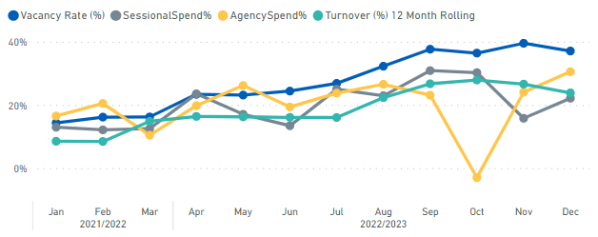

Phoenix ward
Reason: average day shift fill rate for registered (73%) and unregistered (82%) staff. High vacancies 36%, turnover 13% and agency use 23%. 2 uses of prone restraint in a month and 2 detained patient AWOLs. Clinical supervision rate much lower than other wards. 1 informal concern raised about staff professionalism and no formal feedback collected via IWGC in month.

Actions:
- All AWOLs and use of prone are reviewed by the Associate Director of Nursing weekly.
- There is a Trust-wide QI project happening around reducing the use of prone focused on when it is used for an IM injection or seclusion exit.
- There is a Trust-wide supervision steering group which meets monthly to lead on the recovery plan. Work is focused on; accuracy of reporting, developments to the OTR system for recording, training for supervisors and targeting services with the poorest rates​. There has been a small improvement seen.
- Recruitment;
  - 1 new Deputy Ward Manager started end of November and second due to start in January.
  - Applicant for a B5 Staff Nurse withdrew in January so new advert campaign being planned.

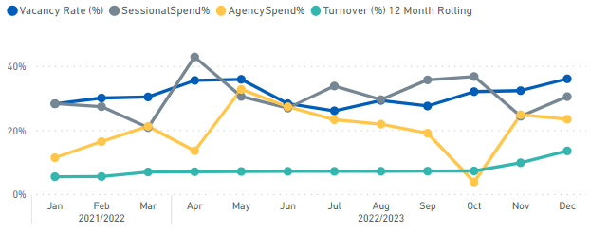

Sapphire ward
Reason: average day shift fill rate for unregistered staff (73%). High vacancies 34%, turnover 19% and agency use 34%. High sickness rate at 27%. 2 medicines incidents with harm and 2 uses of prone restraint in a month. Appraisal rate low at 21%, clinical supervision rate low but similar to other wards. 1 informal concern raised about level of care provided and no formal feedback collected via IWGC in month.

Actions:
- There is a Trust-wide QI project happening around reducing the use of prone focused on when it is used for an IM injection or seclusion exit.
- There is a Trust-wide supervision steering group which meets monthly to lead on the recovery plan. Work is focused on; accuracy of reporting, developments to the OTR system for recording, training for supervisors and targeting services with the poorest rates​. There has been a small improvement seen.
- Recruitment;
  - Main focus across all Bucks wards has been on the recruitment of B5s and newly qualified students. 25 students attended an event in November and 9 students are being interviewed as part of the first round in January for all Bucks wards. 2 new B5 nurses started on Sapphire in November and January.
  - A large scale interview day is planned for February at the Whiteleaf.
  - A return to practice candidate is planned to start on Sapphire in January.

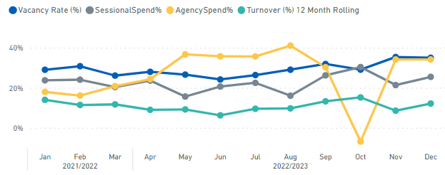

3. Community Teams Highlighted at Alert Status
The accompanying excel sheet provides a by exception dashboard for the community teams.

Four team have been highlighted; District Nursing service, GP OOH, Bucks OA South CMHT and Oxon City/NE AMHT, with further details below and the actions being taken.

District Nursing Service
Reason: high number of patients incidents with harm relating to pressure ulcers, mostly for the City and SW teams. 3 PSIIs in 3 months, 0 in December, relating to pressure ulcers and a medication error. Overall pressure ulcers developed in service have remained static, although the number of category 4 ulcers has reduced with 5 of the last 6 months below average but new unstageable ulcers have increased. High number of staff RIDDORs 3 in 3 months across different teams. Vacancies high in one team but reducing. Turnover high. 2 informal concerns and 1 MP query received in Dec about level of care provided and transport.

Service has been in OPEL escalation 4 since August 2021 due to high levels of demand and insufficient capacity to meet the population needs. Impact is an increase in rolled over visits reducing timely treatment, a reduction in continuity of care and less time for personalised, holistic care as appointments become task focused.

Actions:
- As detailed in last month’s dashboard a number of actions have been taken. The service has an improvement plan in place with monthly review by the Directorate SMT. A recruitment plan is in place and a decline in vacancies has been seen. The service has also reviewed their skill mix increasing the number of B7s.
- Concerns about demand and capacity have been raised in system meetings and with the ICB. There has been insufficient investment in the service over a prolonged period. The national community nursing safer staffing tool will be launched soon and we expect this will help support discussions that OHFT have a low establishment for the population we serve.
- A risk based approach continues to be applied to prioritise daily appointments. When there are issues with capacity for high risk patients there is a process to escalate this to the Head of Nursing/ Clinical Director.
- Recruitment: newly qualified/student advert launched end of 2022 and 2 offers have been made, 4 return to practice nurses due to start in January, and social media campaign live for 2 areas.

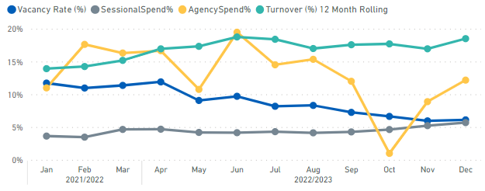

GP OOH Service
Reason: vacancies remain high 56%, although have decreased from November. Sickness is at 14%. 1 informal concern received in December and a total of 4 concerns in the last 3 months. 2 PSIIs in December regarding a delay in response because of capacity issues and a mis-diagnosis. There is a delay in responding to referred patients due to capacity and system pressures, resulting in residual activity going into in-hour work. The number of patient harm incidents has been above average level in 4 out of the 6 past months.

The service declared a critical incident from mid-December 2022.

Actions:
- As detailed in last month’s dashboard a number of actions have been taken.
- The service has a critical incident improvement plan in place to manage the issues around capacity and demand, actions include: a clinical sifter to check every telephone triage has an appropriate categorised response time, an administrator calling patients when waiting for a response – called a comfort call and a reduction in the number of follow up attempts moved to 2 calls rather than 3. The plan is continually being reviewed.
- The recruitment of sessional GPs has seen a positive improvement and there are monthly meetings to review the recruitment plan. There is also a daily report on staffing levels.
- There is a wider review of the service underway to develop a sustainable and more resilient delivery model based on the changes in demand since the pandemic. The outcome has been presented to the Executive Team.
- The incidents reported by the service from October 2022 to early January 2023 have been reviewed and an analysis presented to the Quality and Clinical Governance Sub-Committee to understand the harm to patients as a result of longer response times.

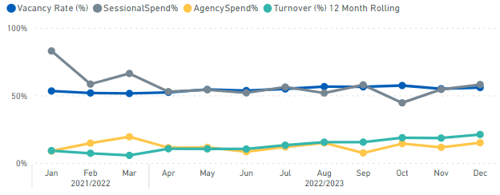

Bucks OA South CMHT
Reason: high vacancies (37%) although reducing month on month. Turnover has increased and sickness is at 11%. 2 PSIIs in last 3 months related to learning from unexpected deaths. No formal feedback collected via IWGC in month.

Actions:
- As detailed in last month’s dashboard a number of actions have been taken.
- There has been a focus on working with the team about the service model going forward. In the short term resource from memory assessments has been diverted into the CMHT. The new gateway team (single point of access) is supporting with triage and new assessments, and senior clinicians have increased visibility by sitting alongside the team. All unallocated patients have been reviewed face to face, however there is still limited capacity to allocate a care coordinator.
- Recruitment plan is in place with rolling adverts and a larger scale recruitment campaign being planned.

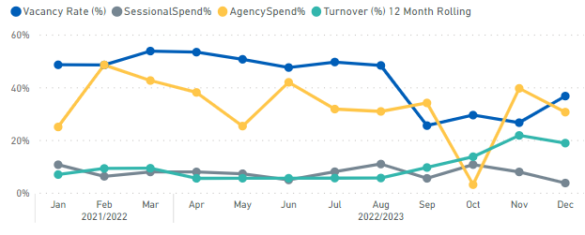

Oxon City and NE AMHT
Reason: high vacancies (38%) similar to November. Around 9 agency workers (long lines). Turnover increased in Nov and Dec. 1 PSII in December related to learning from an unexpected death. High number of complaints (2 in December) and informal concerns (5 in December) mostly relating to level of care provided and staff approach/communication. The number of concerns had been higher earlier in the year and then dropped and has started to increase again.

Actions:
- Ongoing recruitment initiatives, all vacant roles being advertised. Paid Facebook/ twitter recruitment campaign in December and January. Student job fairs being attended, first round of interviews completed and 6 more applicants have applied for second round. Working on supporting B3 to go onto nurse associate training and then nurse training. Regular review of recruitment plan.
- Reablement pilot with OTs in City to start in January.
- Focus on learning from incidents/ safety huddles and support teams, as well as supervision.
- Increased oversight around patients not unallocated to a care coordinator.
- Working with team to identify possible solutions and continuing to review caseload and how best to use resource available.

