Weight Management -
www.nhs.uk/change4life
Sleep -Sleep tips for teenagers - NHS (www.nhs.uk)
Drug use - www.talktofrank.com
Being safe online - www.thinkuknow.co.uk

Emotional wellbeing and mental health
For self-help resources and information on how to access mental health support: www.oxfordhealth.nhs.uk/camhs/wellbeing/
youngminds.org.uk or www.mind.org.uk/
www.oxfordhealth.nhs.uk/service_description/adult-community-mental-health-teams
Getselfhelp.co.uk

Sexual health and lifestyle information
For Oxfordshire sexual health services and general information: www.sexualhealthoxfordshire.nhs.uk
www.nhs.uk/livewell/sexual-health
Compliments and Complaints
We aim to provide you with the best service at all times. However, if you have any concerns or comments about your experience, do tell a member of the team or contact the Patient Advice and Liaison Service on freephone 0800 328 7971.
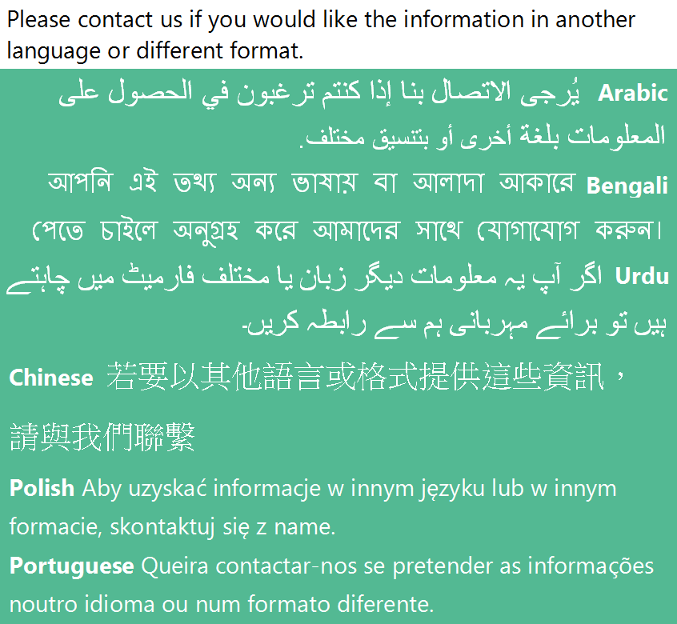
Oxford Health NHS Foundation Trust Headquarters
Warneford Hospital Warneford Lane Oxford
OX3 7JX
Switchboard: 01865 901 000
Email: enquiries@oxfordhealth.nhs.uk Website: www.oxfordhealth.nhs.uk

Phoenix Team, Level 3, East Oxford Health Centre, 1 Manzil Way, Oxford, 01865 904 331

Phoenix Team
The Phoenix Team

How to – find a GP, dentist and other

health services

The Phoenix Team are part of an NHS Organisation - Oxford Health, and are a team of nurses, doctors and administrators who work with children and young people.
The nurses meet with young people to talk about their health and wellbeing and identify any health worries they have. They will look at what actions need to be taken to improve their health and whether help is required from other professionals.
The doctors complete the first health assessment for children who have recently become looked after by Children’s Social Care.
Who is this leaflet for?
As you get older you will be learning about how to access health support. This leaflet provides useful information and links about how to access your GP, and other local and national health services available to you.
It also provides information on health websites you may find useful.

Visiting your GP
We should all remain registered with a GP, Dentist and Opticians local to our home address. To find a GP near you search:
www.nhs.uk/service-search/find-a-GP
Once you have found a GP you will need to contact them via their website or telephone and ask to do a patient registration with them. You will be asked to complete some paperwork and once this been processed you will be able to arrange to see your GP. You may already be registered with a practice and just need to keep note of the which one you use.
Your GP practice will explain to you the methods of arranging an appointment with them e.g. using an online form; or telephoning, below is a useful link and explaining how to access your GP:
https://healthtalk.org/seeing-gp-advice-and-tips-young-people/making-a-gp-appointment-over-the-phone-in-person-and-online-https://www.youtube.com/watch?v=gXHPWbEmp5s
Visiting your Dentist
To find a Dentist search:
www.nhs.uk/service-search/find-a-dentist
If you have a medical condition, disability, or mental health issue e.g. anxiety and require special dental care, you can ask your Dentist or GP to refer you to the Community Dental Service. www.oxfordhealth.nhs.uk/dental-services-oxfordshire
General health and wellbeing information
For Oxfordshire information about health, lifestyle, learning/work, safety and more:
https://oxme.info
For general health advice and information:
www.nhs.uk/pages/home.aspx
www.healthforteens.co.uk

