Who will know about my health information?
Details about your health meetings is kept on your electronic health record.
When we meet, we will discuss confidentiality with you and who you are happy to share your health information with.
For further information about how Oxford Health keep your information safe and private, please look at the website below:
www.oxfordhealth.nhs.uk/privacy/
Feedback
We would appreciate feedback about the care you received via the I Want Great Care survey which can be found at and enter code 1279: http://oxfordhealth.iwgc.net
All responses remain anonymous and confidential. Thank you for taking part.
Compliments and Complaints
We aim to provide you with the best service at all times. However, if you have any concerns or comments about your experience, do tell a member of the team or contact the Patient Advice and Liaison Service on freephone 0800 328 7971.
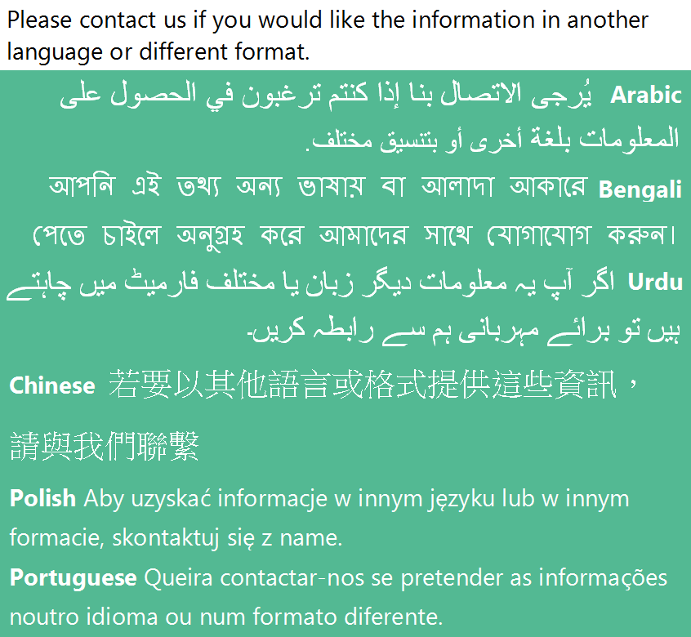
Oxford Health NHS Foundation Trust Headquarters
Warneford Hospital Warneford Lane Oxford
OX3 7JX

Phoenix Team

Switchboard: 01865 901 000
Email: enquiries@oxfordhealth.nhs.uk
Website: www.oxfordhealth.nhs.uk

Your Health Review

Contact Us
Phoenix Team
Level 3, East Oxford Health Centre
1 Manzil Way
Oxford, OX4 1XD
Tel: 01865 904 331

Who are we?
The Phoenix Team are part of the NHS and are a team of nurses, Drs and administrators who work with children and young people.
The nurses meet with young people to talk about their health and wellbeing and identify any health worries they have.
The Drs complete a health assessment for children who have become looked after by Oxfordshire County Council. This looks at current and previous health issues and provides health recommendations
Your Health Check
A health check may be offered to you if you have a ‘Children We Care For’ Social Worker (offered once a year), or if you have a Youth Justice, REOC, or worker with the Emerald Team.
This will be with a qualified Nurse and can be carried out at a place of your choice. You may wish for this to take place where you live, at school, or in a public space.
Or you may prefer not to meet face to face and wish for us to connect with you by videocall using a phone, iPad, or computer.
The Nurse will:
- Talk to you about your physical, emotional, sexual and social health and wellbeing.

- We will offer to measure your height and weight.

- There is no physical examination and you do not have to remove your clothes.

- No injections are given.

- No-one is going to judge you.

- You can see the Nurse on your own or with your parent/ carer/ social worker. You can also start by having someone with you then ask them to leave later on.

- You can ask any questions about your health – even the embarrassing ones! We want to listen to what you have to say.

- You can ask your parent/ carer/ social worker to share information on your behalf.

- You can tell the Nurse what you would like help with.

- Together we will form health recommendations to support your health and wellbeing.

Topics that may be discussed include:
- Anything of concern to you
- Your physical health
- How you are feeling
- Your immunisation history
- How well you are eating or sleeping
- Relationships and sexual health
- Lifestyle choices

