Laryngectomy and voice: What to expect…

**Useful links for information on living with a laryngectomy:**

<http://www.macmillan.org.uk/Cancerinformation/Cancertypes/Larynx/Treatinglaryngealcancer/Voicerestoration.aspx>

<http://www.laryngectomy.org.uk/>

**For more information on local and national support groups:**

<http://www.macmillan.org.uk/Cancerinformation/Cancertypes/Larynx/Furtherresources/Resourcesorganisations.aspx>

**Videos of speech after a laryngectomy:**

<https://www.youtube.com/watch?v=Qdbg_DZqe3g>

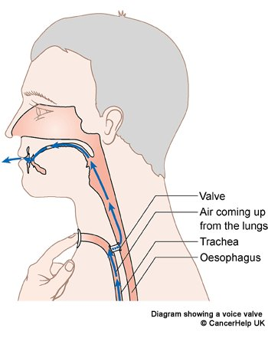<https://www.youtube.com/watch?v=R4azcU6i2IE>