Often, people with Autism can give the appearance of having ‘mastered’ communication. However, it’s important to understand that communication and [social skills](https://www.autism.org.uk/about/communication.aspx) need to be taught and practised.

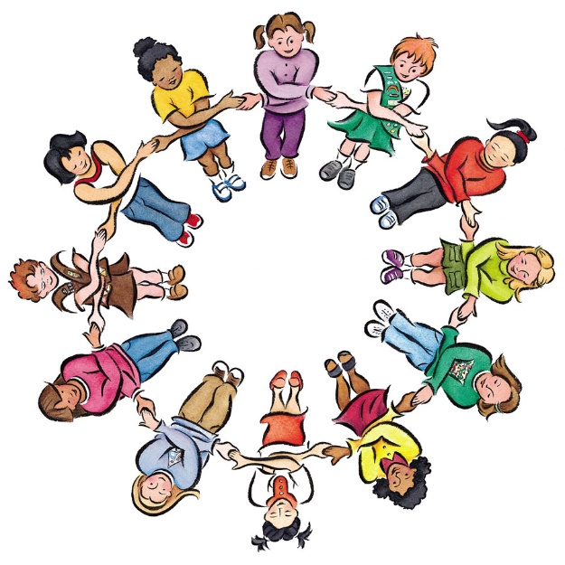

**Further support/ advice on speech, language and communication:**

<https://talkingpoint.org.uk/>

<https://www.afasic.org.uk/>

Child & Interaction team (can support communication in schools, on school’s request)

NHS Children’s Integrated Therapy services - Speech and Language Department

**Neuro Developmental Conditions Pathway**

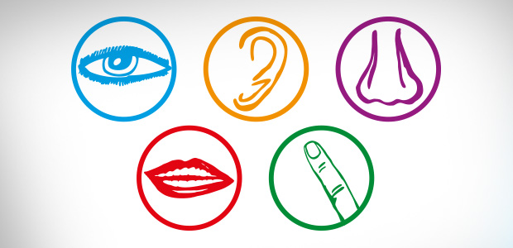

**Communication**

**Neuro Developmental Conditions Pathway**

**How Does Autism affect Communication?**

**Repetitive or rigid language.** Verbal children or young people (CYP) with Autism may say things that do not relate to the conversation. They may repeat words he/ she has heard (echolalia). Some CYP with Autism have an unusual voice quality and may not pick up tone of voice. Other children may use stock phrases (e.g. “My name is Tom,” even when he talks with friends or family). Still others may repeat what they hear on television programs, films or adverts.

**Restricted interests.** Some children may be able to talk in detail about a topic that holds their interest, even though they may not be able to carry on a two-way conversation about the same topic.

**Uneven language development.** The CYP may develop a strong vocabulary in an area of interest very quickly. Some may be able to read words before age five but may not understand what they have read.

**Seeing someone else’s perspective/point of view:** People with Autism often need support to understand other’s thoughts, feelings, desires, motivations, intentions.

**Processing difficulties:** People with Autism can find it difficult to filter out the less important information. If there is [too much information](https://www.autism.org.uk/get-involved/campaign/tmi.aspx), it can lead to ‘overload’, where no further information can be processed. They may interpret words in a sentence literally and not take account of the context.

**Nonverbal conversation skills.** People with Autism may use gestures or facial expressions less frequently (or not at all) and have difficulty interpreting others nonverbal communication. They may avoid eye contact.

**Communication Strategies**

Teaching children with Autism to improve their communication skills is essential for helping them reach their full potential. All people involved in the CYP’s everyday environmnet should be involved so that it becomes part of daily life. Miscommunications are common and frequently lead to behavioural issues, poor self-esteem, anxiety etc. Some strategies include:

**Establish a Routine & prepare in advance of any changes** – children with autism respond well to routines because they allow them to feel safe and in control.

**Teach social skills** e.g. how to start & stop a conversation

**Use Visual** [**supports**](http://www.twinkl.co.uk/resources/visual-timetable) **(e.g. symbols, timetables, calendar, diary)**  - this supports attention, helps reduce memory load, supports understanding of the words we use, rules and behavioural expectations.



**Use social stories and comic strip conversations –** thesehelp to develop greater social understanding and stay safe.For more information go to<https://www.autism.org.uk/about/strategies/social-stories-comic-strips.aspx>

**Support Attention –** reduce distractions. Get the CYP’s attention prior to giving them information, call them by name.Use their special interest, or the activity they are currently doing, to engage them.

**Support Processing** – this is likely to vary according to mood, situation, and anxiety. Sometimes it is best to withdraw to a quiet area. You may need to use the following techniques:

* be specific, say less, say it slowly & repeat if necessary
* Pause between words and phrases to give the person time to process what you have said, and to give them chance to think of a response. Check understanding**,** especially of social situations
* Do not use too many questions or choices
* Use less non-verbal communication (e.g. eye contact, facial expressions, gestures, body language) when a person is showing signs of anxiety
* Avoid using irony, sarcasm, figurative language, rhetorical questions, idioms or exaggeration. If you do use these, explain what you have said and be clear about what you really mean to say