

**🗹 Neuro Developmental Conditions Pathway**

Support at school

If your child is waiting for an assessment and is currently struggling with his/her learning or social-communication needs at school, the relevant teaching staff should be made aware to help ensure that the best possible educational support is put in place for your child.

Envelope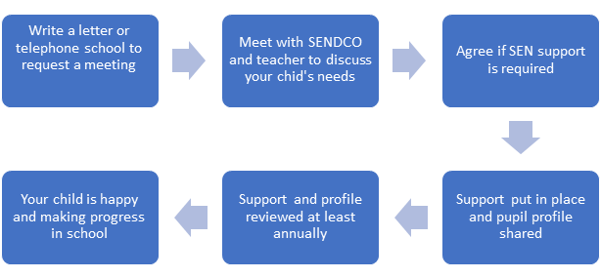

                                             

If at a SEN review your child is not making satisfactory progress or there are needs which you feel are not being met, then school may wish to consider seeking advice and support from their named Specialist Advisory Teacher from the SENSS Communication and Interaction Team. Free advice and support, or staff training may be offered. Support can be tailored to meet individual needs.

More information about this school-based service is available on the council’s local offer.



cid:image011.png@01D55756.65068DF0Information about the SENSS local offer is available at: <https://www.oxfordshire.gov.uk/cms/content/services-support-children-learning>

SENDIASS Offers impartial information, advice and support to parents of children and young people with special education needs. [www.oxfordshire.gov.uk/sendiass](http://www.oxfordshire.gov.uk/sendiass)

01865 810516 or text 07786 524294 or [sendiass@oxfordshire.gov.uk](mailto:sendiass@oxfordshire.gov.uk)

If the school believe further funding is required to meet your child’s needs, they can start the education, health, and care (EHC) assessment process. An EHC plan is for children and young people aged up to 25 who need more support than is available through special educational needs support. EHC plans identify educational, health and social needs and set out the additional support to meet those needs. This process can be started without a diagnosis as the behavioural and educational needs are already existent and current legislation highlights how the process should not be delayed whilst waiting for further assessments.