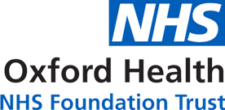

**🗹 Neuro Developmental Conditions Pathway**

Medication

## What is medication?

Medication is just one of the treatment options that CAMHS can offer as part of your care plan. CAMHS doctors have special training in mental health and whether medication is needed for young people with mental health problems. If CAMHS doctors think that medication might be able to help they will talk to you and your parents/carers.

There are different types of medication with good and bad effects. It is important to remember that everyone responds differently to the medication and what might work for someone else might not work for you. If you are worried about bad side effects of medication, then you should inform CAMHS straight away.

Your physical health will be closely monitored when taking medication by your CAMHS doctor, specialist nurse prescriber or GP. Medications sometimes come in tablet or liquid form. You will have the opportunity to ask the doctor any questions you have about taking medication including how regularly you will need to be seen in clinic and how long you will take the medication for.