**Map for Maple House, The Slade, Oxford Health.**

**Address:** Horspath Driftway, Headington, Oxford, Oxfordshire, OX3 7JH.

Maple House is the building at the far end of the site. You will need to drive into the Oxford Health grounds, past the Lodge and Step Down buildings on your left (Abell House and Slade on your right), until you get to the car park at the back. If you drive through the car park, you will see signs for Maple House. There is some visitor parking by Maple House. Please report to Reception.

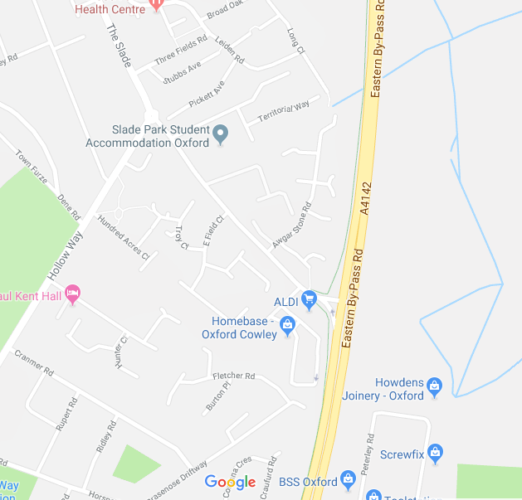

Maple House and Step Down

Map 1.

**Step down**

**Slade House**

**Abell House**

**Car Park**

**The Lodge**

**Maple House**

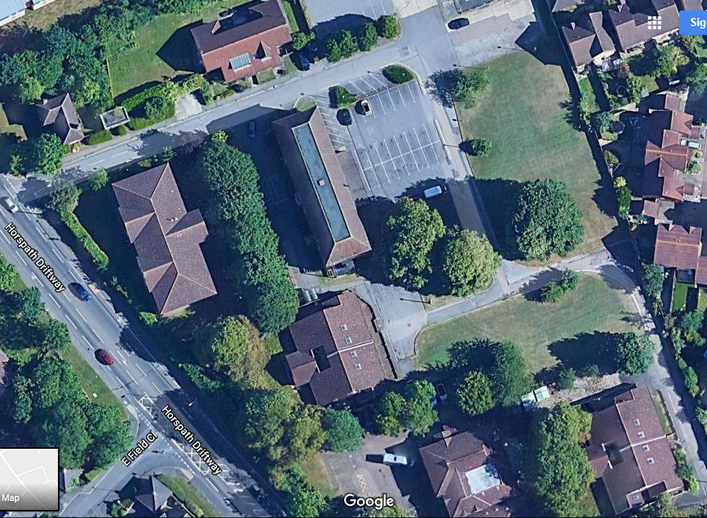  
Map 2.