Body cues worksheet

There are many different symptoms of anxiety and it is helpful to recognise the signs that you are becoming more anxious. You may respond differently in different situations and your experience may be very different to another person’s.

Circle the signs you notice and circle the strongest ones twice. Add other signs you notice in the blank spaces.
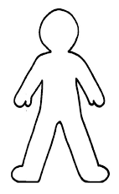
​
​
Dry mouth​

Fast breathing
​
​
​
Headache​
Go red​

​

​
​
………………………….

Heart racing​

​

………………………….

Feel dizzy​

​
​
Need to go to the toilet​

Butterflies in stomach​

​
​
​
Get hot

Shake or tremble

​
​
………………………….

Stiff neck

Feel tense and alert

