**Who are the trainers?**

The speakers and facilitators are all clinicians within the Oxfordshire Neurodevelopmental Conditions Service and include:

We will also be joined by colleagues from Education and the SENSS Team and other agencies that offer support to families.

**Who can attend the course?**

Any parent or carer with a child who has recently been diagnosed with an autism spectrum disorder through the Child and Adolescent Neurodevelopmental Conditions Service (CAMHS).

**When and where will the courses be held?**

Friday 1st May 2020

Friday 2nd October 2020

Courses will be run at Abell House, The Slade, Oxford, OX3 7JH, between 9:30am and 4:30pm.



The course is free of charge, but **booking is essential**.

Please email:

**NDC.oxonCAMHS@**

**oxfordhealth.nhs.uk**

And put: **For the attention of Jane Gough** as the subject header.

Please confirm your name, your child’s name, and any specific requirements you have, as well as how many people will be attending (each family have been allocated two spaces to use as they wish).

**CAMHS Neurodevelopmental Conditions**

**Maple House,**

**The Slade,**

**Horspath Driftway,**

**OX3 7JH**

**www.oxfordhealth.nhs.uk/camhs/oxon/service/ndc/**





**A day for parents and carers of young people newly diagnosed with Autism**

This course is provided by:



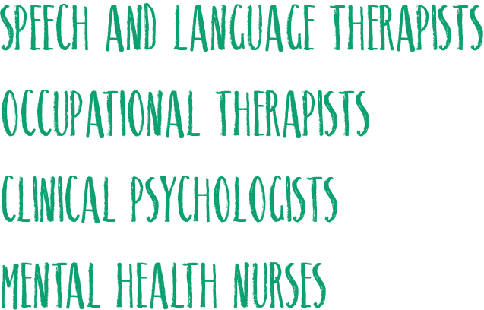

Version: December 2019

**What can I expect to gain by attending the course?**

The day is designed to help increase your knowledge and understanding of autism in the following areas:



***Understanding Autism***

is a course specifically for parents and carers who have a child or young person who has recently received a diagnosis of an autism spectrum disorder by the Child and Adolescent Mental Health Service (CAMHS).

During the course we hope to support you and increase your knowledge and understanding of your child’s autism by:

* Exploring strengths and challenges, and developing skills and strategies you can use to support your child.
* Exploring ways to share the diagnosis with others e.g. school.
* Providing opportunity for parents to ask questions to the professionals, if they wish to.
* Sharing resources, and sign post you to other places that can offer support and information.
* An opportunity for parents to offer each other mutual support during breaks and over lunchtime.

The day is based upon the ‘All Things Autism’ Course that we also run.

It is expected that parents attending this day will be attending this one-day course instead of the longer ‘All Things Autism’ Course. We are aware that this format will suit some parents better.**\***

It will be a larger group event much like a small conference. Parents need to be aware that there will be a lot of information covered in the one day.

We will incorporate time for you to ask questions to the clinicians if you wish to. Resources will be made available for you to look at during the breaks.

***\****If you do not feel that this format will suit you then please apply for the six-week group, see the leaflet titled ‘All Things Autism’.

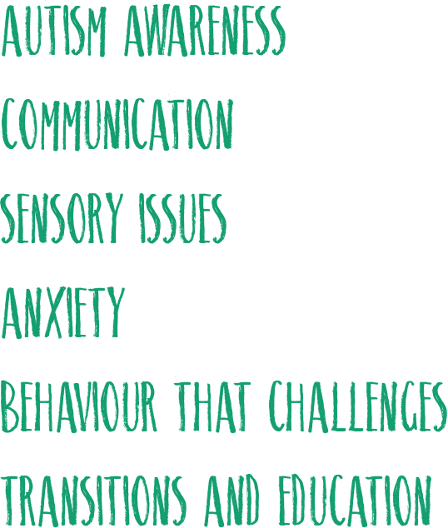

***I learnt a lot of useful and helpful information and strategies to deal with all the aspects of our child’s difficulties.***

***We now have a better understanding of our child’s autism and how to help them cope better.***

***I liked having the question time and having so many professional perspectives and advice.***

***The format of one day made it accessible to me, I wouldn’t have been able to attend weekly sessions, the day was excellent.***