Session 1 Workbook

NAME: ……………………………………………………………..
1
Welcome
For the next 6 weeks, you are going to be taking part in the online ‘Taking Charge of Anxiety’ course.
The course will be run by Dr Sue Wimshurst and Miranda Wheeler

Aims of the course
To reduce your anxiety by;
- Helping you to understand anxiety and autism:
- Understanding emotions
- Exploring thoughts
- Understanding behaviour
- Practicing skills
What is Autism
Autism is a lifelong condition that affects how a person communicates and interacts with other people. People with autism also experience a need for sameness or familiarity that leads to them having, for example, unusually strong interests and/or rigid behaviour. Autism is also referred to as Autism Spectrum Disorder (ASD) or Autistic Spectrum Condition (ASC). Autism has had various different names in the past (e.g. Asperger’s, classic autism).
Everyone’s experience of autism is different. The ‘Amazing Things Happen’ video by Alexander Amelines (https://www.youtube.com/watch?v=7JdCY-cdgkI) provides an interesting and useful explanation of autism. This can be accessed via You Tube and can be found in several different languages. There are also additional episodes which look at diversity, communication, perception, behaviour and strengths.
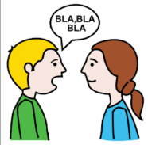
Autism is not an illness or disease. However, people with autism experience a variety of difficulties that can have a significant impact on what they are able to do and their quality of life. People with autism will struggle with;
Social communication and interaction
You might have;
- Difficulties communicating what you need or want
- Struggle to do ‘chit-chat’ or keep a conversation going
- Find it hard to understand other people’s non-verbal communication (facial expressions, gestures) and tone of voice.
- Find metaphors and idioms confusing.
- Struggle with unwritten social rules around what is ok and what is not ok to say
- Struggle to understand and interpret other people’s thoughts, feelings and actions.
- Have difficulty in predicting what will happen next
Restricted and repetitive behaviours, interests, and activities
- You may experience the world as unpredictable and confusing. To make life more predictable you may have created routines or set ‘ways’ of doing things.
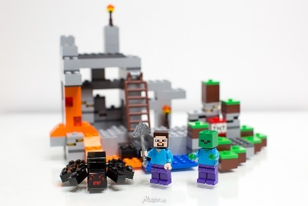
- You may have intense interest in certain activities, objects or people. These can change over time or they can remain the same over many years.
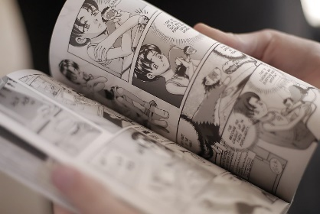

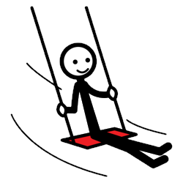
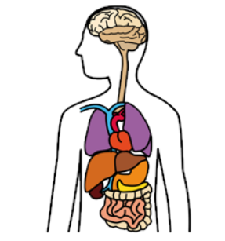
Sensory preference and sensitivities
Vestibulation
Touch
Hearing
Proprioception
Taste
Sight
Smelina
Interoception

You may be under-sensitive or over-sensitive to sensory input.
Sensory input includes tastes, smells, sounds, visual input, bodily movements (proprioception), balance and spatial orientation (vestibulation), and internal physical body states such as feeling hungry or knowing when to use the toilet (interoception).

Difficulty with executive functioning
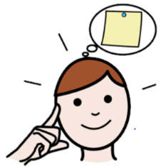
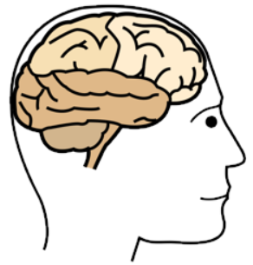
You may also struggle with:
- Differentiating fiction from fact
- Planning and organizing things
- Struggle to manage your emotions
- Managing time and your attention
- Holding key information in your mind
- Avoiding saying or doing the wrong things

Anxiety and Autism
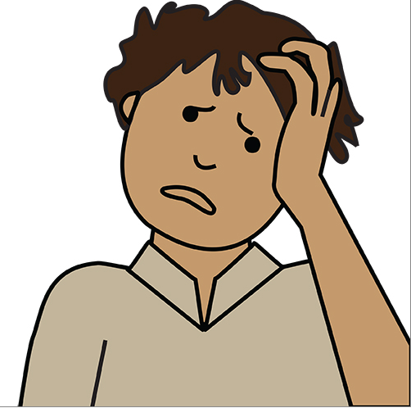
Anxiety is a normal part of development, but you may experience anxiety more intensely than others.
Typically, anxiety is experienced as unpleasant, but not unmanageable and quickly decreases once the threat has gone. In fact, when we are in danger anxiety is very useful because it motivates us to take action to prevent us from being harmed or to avoid the threat in the first place. For example, when standing on the edge of the roof of a tall building, most people would feel some fear or anxiety and step back or hold onto something. In this way the feeling of anxiety helps us to take action and keep ourselves safe.
Although short experiences of anxiety are part and parcel of daily life, it becomes challenging when anxiety begins to be a regular feature in our lives. Anxiety is a problem when feelings of worry and panic become persistent, overwhelming and beyond a person’s control.
Anxiety can happen for a range of reasons and people can vary in their ability to cope with it. Anxiety is a word often used to describe when we feel 'uptight', 'irritable', 'nervous', 'tense', or 'wound up'.

Physical symptoms of anxiety
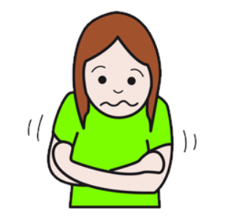
When we are anxious we normally experience a variety of uncomfortable physical sensations.
- a racing heart rate
- feeling short of breath
- feeling agitated and distressed
- feeling shaky
- sweating and feeling sick
- tense muscles
Thoughts related to Anxiety
When we have anxiety, we can have ‘worry thoughts’ for large periods of time, so much so that our worry can feel out of control. These worries are often about a variety of issues and commonly our mind jumps quickly from one ‘worry thought’ to another.
What if….
I knew I would mess up
They don’t like me..

Feelings or emotions related to Anxiety
Anxiety is an emotional state experienced when we anticipate a threat of some kind. The type of threat and the experience of symptoms can vary from situation to situation, and from person to person, but it is a normal part of everyone’s life. Other emotions or feeling related to anxiety include;
- Anxious
- Scared
- Sad
- Angry
- Fearful
- Frustrated

Behaviours related to Anxiety
Anxiety also influences how we behave. For instance, when we feel anxious, we often avoid doing things that we want to because we are worried about how they will turn out.
- seeking lots of reassurance
- avoiding situations and objects – like refusing to go to school
- meltdowns, outbursts and tantrums
- a strong preference for routine and sameness
- repetitive behaviour like rocking, stimming or flapping
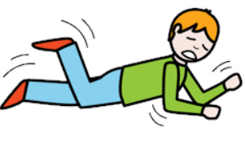
- obsessive routines

Triggers
Everyone experiences anxiety differently but there are some common triggers for autistic people
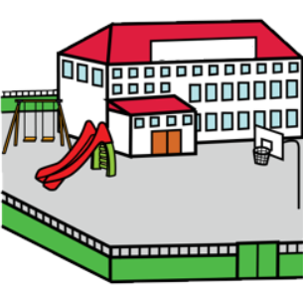
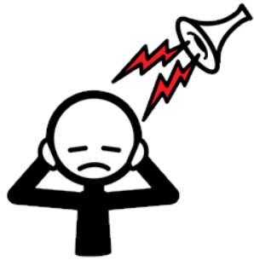
- sensory triggers, for example noise or smell
- uncertainty and change
- social situations
- expectations, pressures and demands
- anticipating specific situations (like school or work)
- specific fears like crowds, dogs or needles

Practice Task
Identify what goals you have for taking part in this online anxiety course. How would you know you have achieved your goal? How would you be feeling? What would; you be thinking? What would other people notice?

