

**Session 2 Workbook**

NAME: ……………………………………………………………..

2

**Recap on session 1:**

What is Autism

* Social communication and interaction
* Restricted and repetitive behaviours, interests, and activities
* Sensory preference and sensitivities
* Difficulty with executive functioning

Anxiety and Autism

* Physical symptoms of anxiety
* Thoughts related to Anxiety
* Feelings or emotions related to Anxiety

**Cognitive Behaviour Therapy (CBT)**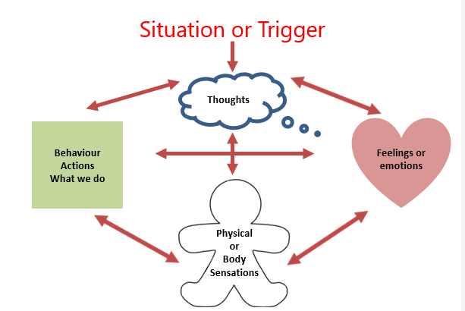

**Feelings (Emotions)**

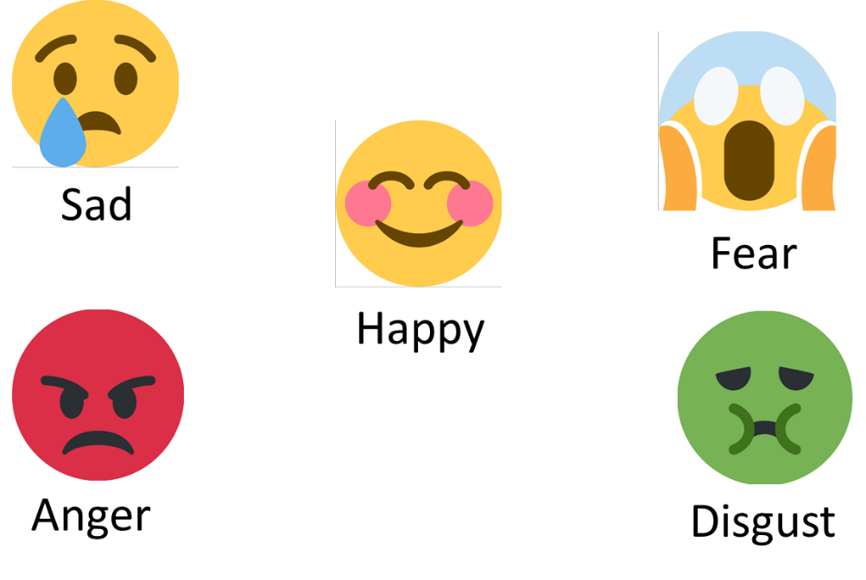

Emotions can play an important role in how we think and behave. In any one day or even 1 minute we can feel different emotions. Anger, fear, happy, sad, disgust and surprise are considered to be our core emotions but we do experience a lot more.

Sometimes emotions can be helpful but sometimes they are unhelpful. For example, when faced with a nerve-wracking exam, most people will experience some anxiety which can motivate them to take action and do something that improves their chance of getting a good grade. For some people however, the anxiety can be so overwhelming that they are unable to do anything.

We also tend to try and do the things that give us positive emotions and minimise the likelihood of experiencing negative emotions. For example, you might seek out activities or hobbies that provide you with a sense of happiness and excitement. On the other hand, you would probably avoid situations that might potentially lead to boredom, sadness, or anxiety.

**What things make you feel happy or not happy? You can list them here;**

|  |  |  |
| --- | --- | --- |
| ***Happy*** |  | ***Not happy*** |
|  |  |  |
|  |  |  |
|  |  |  |
|  |  |  |
|  |  |  |
|  |  |  |
|  |  |  |

**Fight, Flight, Freeze**

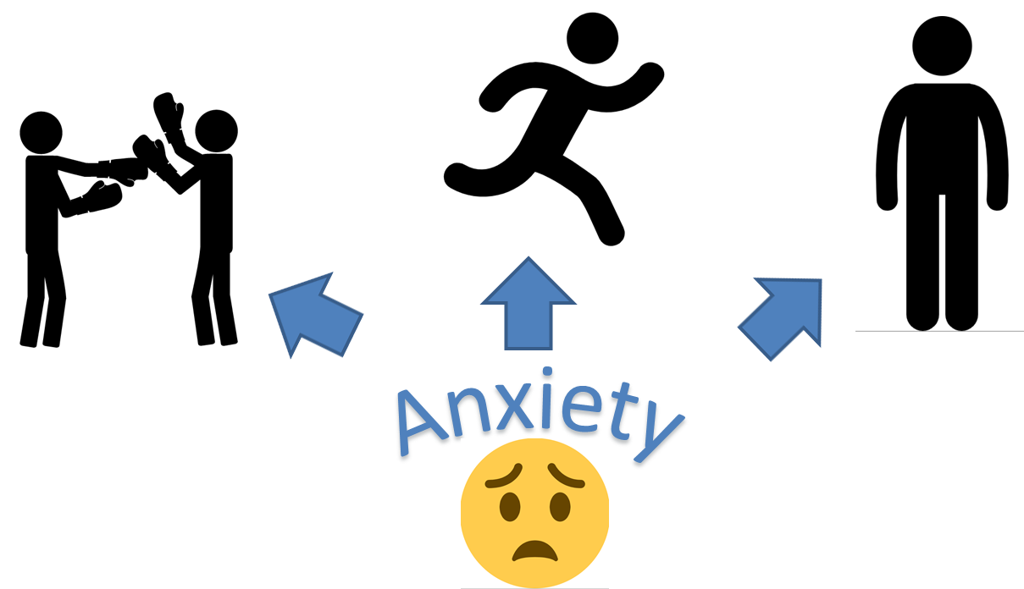This is our bodies automatic, built-in system designed to protect us from threat or danger

**Body sensations**

Think about a situation that made you feel anxious, think what physical sensations you felt and mark them on the ginger bread man below.

|  |  |
| --- | --- |
| Situation: |  |
|  |  |
|  |  |



**Practice Task**

Create a scrap book or poster include things that make you feel happy and relaxed. Could include, places, foods, activities, sounds, smells and a description of why they make you feel happy.

For example:

