Session 3 Workbook

NAME: ……………………………………………………………..
3
Recap on session 2:
- Autism and Anxiety (Session 1)
- Feelings
- Physical and Body Sensations
- Flight, Flight, Freeze
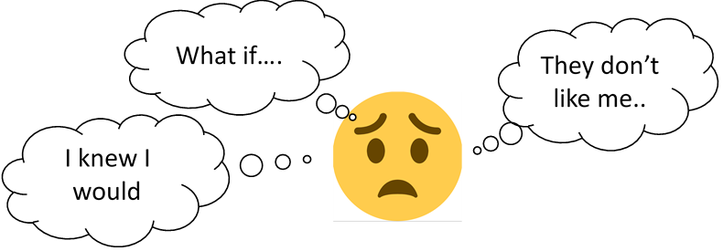
Thoughts that keep anxiety going.
Thoughts can be;
- Positive
- Negative
- Self-talk inside our head
- Triggered by situations,
- Connected to feelings, behaviours and physical sensations
Thoughts are what people think about and pay attention to when anxious. Noticing our thoughts and attention is particularly important in treating anxiety, because what we tell ourselves has a great impact on how we react and feel.
When we have anxiety, we can have ‘worry thoughts’ for large periods of time, so much so that our worry can feel out of control. These worries are often about a variety of issues and commonly our mind jumps quickly from one ‘worry thought’ to another or we might overthink things or overestimate the likelihood of bad things happening.
Unfortunately, when we feel anxious we become even less likely to think as clearly. The physical symptoms or feelings of anxiety (the ‘fight or flight’ response) can be frightening if we don’t understand what is happening to us. If this happens, many people react by thinking that they are going to faint, they might die, that people will stare at them or that they will make a scene and can’t cope with the situation. These very thoughts only serve to make our anxiety and panic worse. So instead of our body going back to normal after it has sensed a threat and becomes anxious, these thoughts keep anxiety going for longer … like an anxiety spiral.

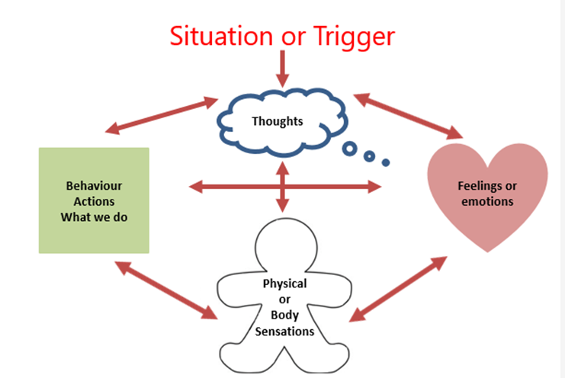
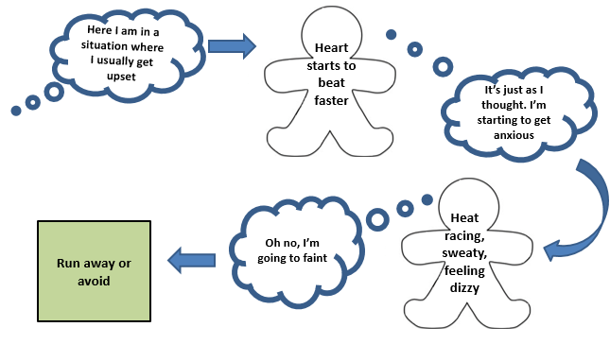
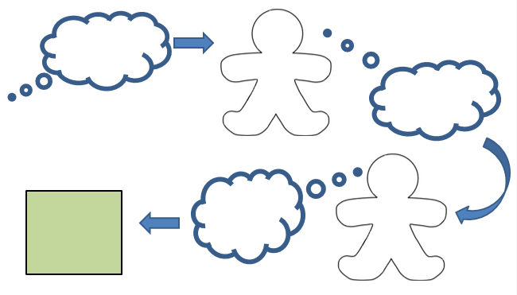

Thoughts that keep my anxiety going

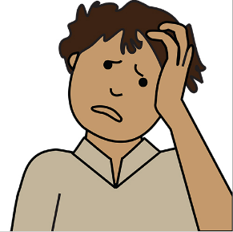

Quiz
Decide whether the following thoughts are helpful thoughts or if they are worrying thoughts that will make you feel more anxious. Mark H (Helpful) or W (worrying) beside each phrase.

I’m a loser ☐
They will laugh at me ☐
I can stay calm ☐
I have friends that are kind ☐
I’m no good at home ☐
It’s not winning, it’s enjoying the game ☐
I can’t get to school or college ☐
Everyone hates me ☐
Relaxing makes my thinking better ☐
I will be better next time ☐
I will look stupid ☐
I am going to show how mature I am ☐
I could die of fright ☐
I will be pleased if I stay calm ☐
Think, then choose ☐
Relax, it is only words ☐

Behaviour that can keep anxiety going
Behaviour is what someone does in response to a situation or stimulus. Behaviours can include;
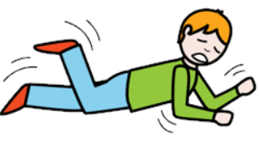
- Shouting
- Swearing
- Withdrawing
- Avoiding
- Sleeping or not sleeping
- Repetitive or ritualistic behaviors
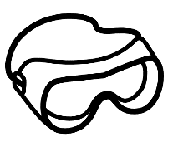
- Meltdowns
In situations that are perceived as dangerous people automatically act to keep themselves safe (remember the evolved responses to promote safety –fight, flight or freeze). We use safety behaviours to reduce the likelihood of the feared thing happening. Some examples of behaviours include;
- Making excuses to avoid going out or doing things.
- Only going to quiet places where there aren't many people.
- Not saying anything in front of others.
- Sitting near doors and exits or at the back.
- Walking to avoid buses; crossing the street to avoid people.
- Putting up your hood or covering you face with your hair
Unfortunately, while safety behaviors can lead to a feeling of relief in the short term, they have the effects of reinforcing what we think might be a threat.
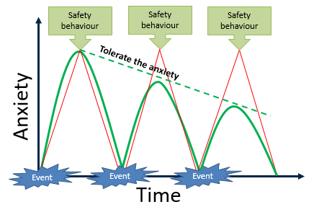

Practice Task
Create your own helpful responses to your worrying thoughts. Fill in as many as you can!

Worrying thought |  | Helpful thought/ response
 | or
 | or
 | or
 | or
 | or
 | or
 | or
 | or
 | or
 | or

