Session 4 Workbook

NAME: ……………………………………………………………..
4
Recap on sessions:
- Autism and Anxiety (Session 1)
- Feelings, Physical and Body Sensations, Flight, Flight, Freeze (Session 2)
- Thoughts; What thoughts we have that keep anxiety going, helpful responses to worrying thoughts
- Behaviour; What behaviours we do that keeps anxiety going, helpful responses to unhelpful behaviours
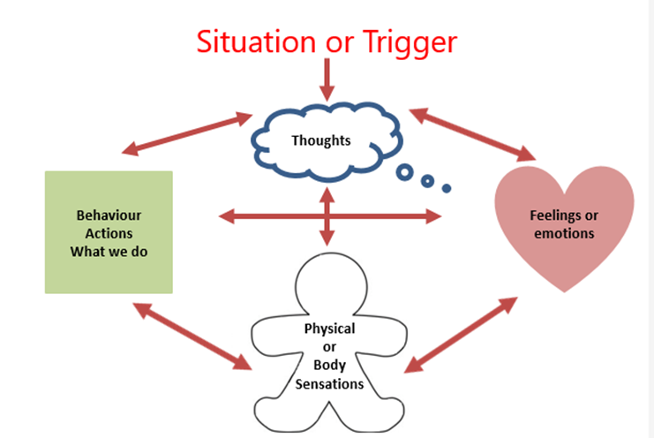
Current coping strategies

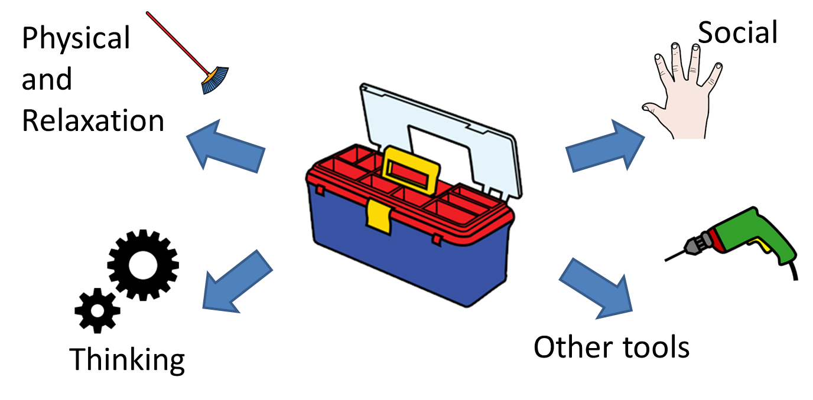
Emotional Toolkit

Physical and Relaxation
1. Deep Breathing
The goal of this activity is to breathe slowly and deeply from your diaphragm. First, lay on the floor. Lying on the floor will make it easier for you to breathe from your diaphragm. Next, put your hand on your tummy and try to breathe in so that you lift your hand up. Your tummy should expand and fill with air as they breathe in. When you first try this, your chest might rise instead of your tummy. Make sure your chest stays stable and your tummy expands with air. When this occurs, you are breathing from their diaphragm.
After this step is mastered, count slowly and silently to three as you breathe in, hold your breath for the count of three, and then slowly count to three as you breathe out. We want you to be breathing very slowly, particularly as you let the air out. Do these ten times in a row.
Practice this every day. It will be most beneficial if you practice doing this every time you start to feel stressed, anxious, or upset. Since it’s not always practical to lie down, practice standing up and sitting down once you have mastered it when lying down.

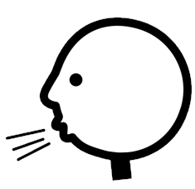

2. Progressive Muscle Relaxation
The goal of this activity is to relax the muscles in the body, while teaching you the difference between feeling tensed and feeling relaxed.
- Get in a comfortable position. Lying down is best but sitting is also fine.
- Close your eyes and breathe deeply.
- Squeeze, hold for 3 seconds, and relax each part of your body in the following order;
- Feet (curling up your toes as hard as you can and then relax)
- Legs (lifting your legs and squeezing them and then relax)
- Tummy (squeezing your tummy and then relax)
- Shoulders (squeezing your shoulders up to your ears)
- Arms (squeezing your arms, either by your side or held out in front of you and then relax)
- Hands (squeezing hands into fists and then relax)
- Face (squeeze face and then relax)
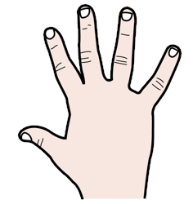

Practicing this daily will help you to feel more relaxed in the long term. Often, people like to practice this right before they go to bed because it helps their body calm down. In addition, you can use this technique when you start to feel stressed, anxious, or upset – at home or in school.

- Guided imagery
The goal of this technique is to help you feel calmer and happier in the middle of any situation. It can also be used at the same time as progressive muscle relaxation. The technique suggests to the body and unconscious mind to act "as though" the peaceful, safe and beautiful (and thus relaxing) environment were real.
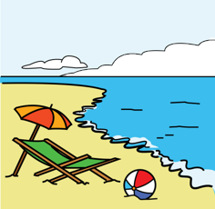
Close your eyes, get comfortable, and breathe deeply.
- Imagine the most peaceful place you can think of. It could be somewhere real or imagined. Some people visualize a beach, a mountain, a forest, or a being in a favorite room sitting on a favorite chair.
- Imagine yourself becoming calm and relaxed. Alternatively, imagine yourself smiling, feeling happy and having a good time.
- Focus on the different sensory attributes (sights, sound, smell, touch, taste) present in your scene to make it more vivid in your mind. For instance, if you are imagining the beach, spend some time vividly imagining the warmth of the sun on your skin, the smell of the ocean, seaweed and salt spray, and the sound of the waves, wind and seagulls. The more you can invoke your senses, the more vivid the entire image will become.
- Remain within your scene, touring its various sensory aspects for five to ten minutes or until you feel relaxed.
- While relaxed, assure yourself that you can return to this place whenever you want or need to relax.
- Open your eyes again and then rejoin your world.
Sight: Look all the way around you, what do you see? What time of day is it? What colors are there? Can you see any other people or animals?
Sound: What do you hear? Do you hear any animals? Can you hear any nature sounds, such as water rushing?
Smell: What can you smell?
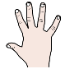
Touch: What is the weather like? What does the air feel like on your skin? What does the ground feel like on your feet?
Taste: What does the air taste like? Are you eating or drinking anything?

There are also some guided imagery apps or CDs which you can also use. If you are struggling to visualize try looking at a picture of the place where you feel relaxed. Practicing this regularly will help you to feel more relaxed in the long term. You can use this technique when you start to feel stressed, anxious, or upset – at home or in school. It can also be useful if you are having trouble falling asleep.

Describe in words your relaxing scene that you can visualize;
My special place is: ________________________________________________________________
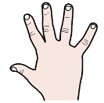

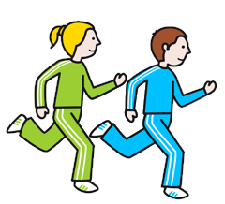
- Exercise
Exercise such as walking, running, swimming, yoga, skateboarding, using weights etc. is a great form of relaxation. Exercising to music is even better!

- Other relaxation strategies
There are lots of other relaxation strategies such as massage, stretching, meditation, and mindful colouring that can also help you to relax. Why not try out different activities to see what works best for you
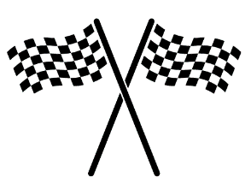
Practice Task
Think of some physical and relaxation activities that you can do to help you feel less anxious. Ask members of your family or friends for their ideas or research on the internet. Find out what will work best for you.

