Session 5 Workbook

NAME: ……………………………………………………………..
5
Recap on sessions:
- Autism and Anxiety (Session 1)
- Feelings, Physical and Body Sensations, Flight, Flight, Freeze (Session 2)
- Thoughts and Behaviour; What thoughts and behaviour keep anxiety going, helpful responses to worrying thoughts and unhelpful behaviour (Session 3)
- Physical and Relaxation tools (Session 4)
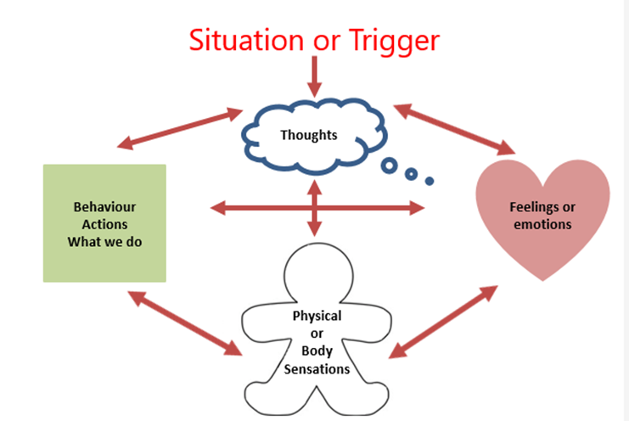
Emotional Toolkit
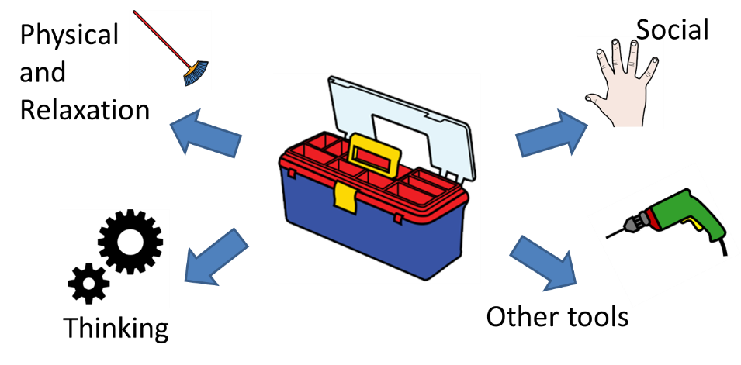

Thinking tools
When we experience anxiety, our self-talk can become over critical of ourselves. In session 3, we looked at what thoughts we have that can keep anxiety going and what helpful thoughts we can have that can help combat the worrying thoughts.

Thinking Traps
Thinking Trap | What’s going on | Examples
All or nothing/black and white thinking | Thinking only of possible outcomes at either extreme (really good or really bad) and not seeing all the possible outcomes in-between (or the "grey"). Most of life is somewhere in the middle. | - One friend gets angry at you = "Nobody likes me, I'm totally unlovable and selfish."  - Failing one test = "I'm obviously a stupid loser."
Catastrophizing | Imagining the worst-case scenario, no matter how unlikely in reality. | - Getting one bad grade = "I won't get into university and I'll end up homeless."  - Mom and Dad have a fight = "They are obviously going to get a divorce."
Overestimating  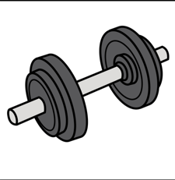 | Exaggerating the likelihood that something bad will happen. | - “If I have another panic attack I'm going to have a heart attack and die!"
Fortune telling | Believing you can predict the future. | - "I couldn't find a job last summer so I won't be able to get one this summer."  - "No one is going to talk to me at the party."
Overgeneralising | Making sweeping judgments about ourselves (or others) based on only one or two experiences. These thoughts typically contain the words "always" and "never." | - One friend gets upset at you = "I always screw up friendships. I have no real friends."  - Dropping you phone and smashing the screen = "I never get things right. I’m always so clumsy"
Mind Reading | Believing you know what others are thinking (and assuming it's negative), without any real evidence. | - "I know they are talking about me right now. They are thinking about how weird I look."  - “I know she doesn’t like me”
Negative Brain Filter  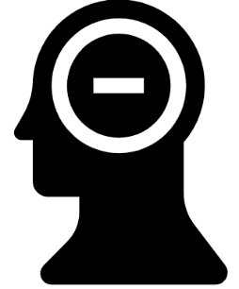 | Focusing only on the negative without seeing any of the positive or what is going well. | - Thinking about the one person you didn't have a smooth conversation with at the party, rather than the three people with whom you had great conversations.  - Thinking about the question you couldn't answer on the test, rather on the ones you could.
When we perceive something – like a noise outside the bedroom window at night – very short, quick thoughts or images enter our mind almost automatically. These thoughts and images happen so fast that they are called automatic thoughts. Automatic thoughts are part of our self-talk. Often, we are not even aware that we have them. If you heard a noise outside your bedroom window at night, what might your automatic thoughts be? Maybe something like:
"Outside – attacker – dark – window locked? Break in – phone is where? Hide."
You might also have an automatic image flash in your head of a dark figure hiding in the shadows, peering around to see how to get in. These automatic thoughts are what set off your anxiety alarm, sending you into a fight, flight or freeze response (session 2). So, what if, instead of those alarming thoughts, your automatic thoughts were:
"Noise outside – what? Animal? Tree branch? Did Sam let dog in? Door is locked. Mum is here, safe. Listen more."
Noticing these automatic thoughts might alarm you a little at first, but you’ll also be more composed and able to make rational choices and calmly take action if needed (instead of freaking out!).
So just to recap, we know that anxious thinking is often extreme, unbalanced, and overly negative. But it can feel true, especially if it feels very familiar to you. This is because you have told it to yourself thousands of times.
Once you are aware of your negative inner or self-talk these can be changed and challenged. This can include practicing a more positive inner voice. For example, a footballer in the National League taking a penalty who tells himself, "I’m not going to get this goal" will need to practice replacing that negative statement with a positive "I’m going to score this goal." While this may not seem like it can work, over time and with repetition you can develop a new habit of thinking positive statements and thoughts and expect a more positive outcome. It’s this connection between the words and the belief that is the ultimate goal of this technique.
Another important factor of positive self-talk is that it must be possible and believable. The footballer telling himself he can score a goal is entirely possible. Telling himself that he is going to be the next Christano Ronaldo or will be signed for the Premier League won’t have the same impact because there isn’t any immediate feedback to reinforce the self-talk. Also, the message may not be believable or even possible, and therefore, it’s unlikely to have any impact.
Steps for Developing a Positive Self Talk Habit
- Mantra: choose two or three mantras you can use and repeat over and over such as;
- Feel the fear and do it anyway
- Other people feel this too
- This will pass
- Affirmations: choose some affirmations for anxiety is one way of dealing with anxiety problems. Repeating these affirmations over and over again can have a calming and soothing effect.
Try your best, that’s all that matters.

Practice makes perfect.

If your anxiety is caused by thoughts of the fear of the unknown, then thoughts of calmness, peace, security, confidence, etc. can be a solution. Affirmations are one way of having such thoughts.
- Create a positive mental image or visualization: The phrases and words you choose should be those that you can immediately call up and create a visual picture of yourself doing exactly what you say. The image along with the words is a powerful combination.
- Putting things in perspective/reality check. Questions to ask yourself to help challenge your negative thoughts or self-talk:
- Am I falling into a thinking trap, e.g. catastrophizing or overestimating danger?
- What is the evidence that this thought is true? What is the evidence that this it is not true?
- Have I confused a thought with a fact?
- What would I tell a friend if he/she had the same thought?
- What would a friend say about my thought?
- Am I 100% sure that ___________will happen?
- How many times has __________happened before?
- If it did happen, what could I do to cope with or handle it?
- Is my judgment based on the way I feel instead of facts?
- Am I confusing “possibility” with “certainty”? It may be possible, but is it likely?
Social tools
Help manage emotions and change moods through interaction with a person or an animal
- Go see a person you trust
- Talk to or text a friend, teacher, parent, grand-parent, counselor or support person
- Be kind to others or even do some volunteering
- Spend time with a pet
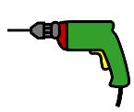
Other tools
Let’s think of other things that might help to reduce anxiety:
- Special interests can provide pleasure, relaxation and serve as an “off switch”. Incorporating your interests into daily routines can help to you to cope with anxiety.
- Humour: laughing can really help to improve mood and reduce anxiety. Try watching something funny that will make your laugh!
- Sensory – use your senses to south; southing nice smells, things to touch and nice things to eat.
- Acting like a person you know or admire. Think about how someone who you admire would act and imagine you are them
Face your fears
We know that using safety behaviours and avoiding situations that make us feel anxious can reduce our anxiety in the short term, but make our anxiety worse in the long-term. If we face our fears by staying in a situation that makes us anxious for a longer period of time, our anxiety will come down.
Have a go yourself! Rate your anxiety before, during and after you stay in the situation (0 = no anxiety, 10 = most anxiety you have every felt):

Before:
0
10
3
4
6
9
8
7
2
5
1

During:
0
10
3
4
6
9
8
7
2
5
1

After:
0
10
3
4
6
9
8
7
2
5
1

Test your worries – Experiment Worksheet:

Date  When did you do the experiment? | Situation  Where will you do the experiment? | Prediction  What do you think will happen?  How much do you believe it will, 0-100?  How would you know if it had?  e.g. what would you see or hear or what would other people do?  What could happen instead?  How much do you believe it will, 0-100?  How would you know if it had? | Experiment  What can you do to test the prediction?  Remember to focus on what actually happens rather than your feelings & let go of Safety Behaviours. | Outcome  How anxious do you feel now?  What actually happened?  Was the prediction correct?  Has your prediction changed? | Learning  What did I learn?  How can I build on this?
Practice Task
Revisit your goals from week 1 and re-rate.

