Session 6 Workbook

NAME: ……………………………………………………………..
6
Recap on sessions:
- Autism and Anxiety (Session 1)
- Feelings, Physical and Body Sensations, Flight, Flight, Freeze (Session 2)
- Thoughts and Behaviour; What thoughts and behaviour keep anxiety going, antidotes to unhelpful thoughts and behaviour (Session 3)
- Developing an emotional toolkit (Sessions 4 and 5)

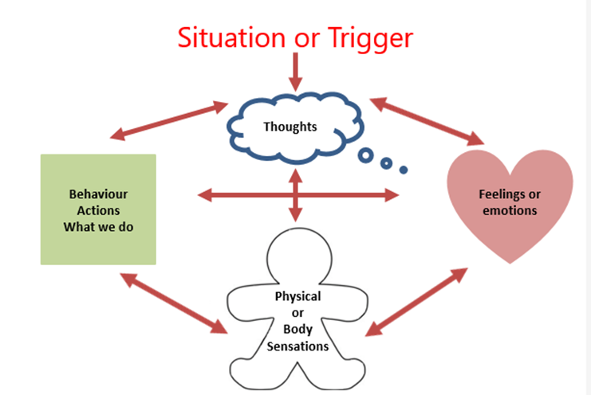

My overall goal was:

How equipped do I feel now in achieving this goal?

0
10
3
4
6
9
8
7
2
5
1

How do I know that I have achieved my goal?
Am I doing anything differently?

Am I feeling differently?

Am I thinking differently?

What have other people notice?

Practice Task
We encourage you to keep practicing everything you have learnt!

